Santiago High School
SDS/2 2016 Structural Steel Detailing
Hands-on Tutorial
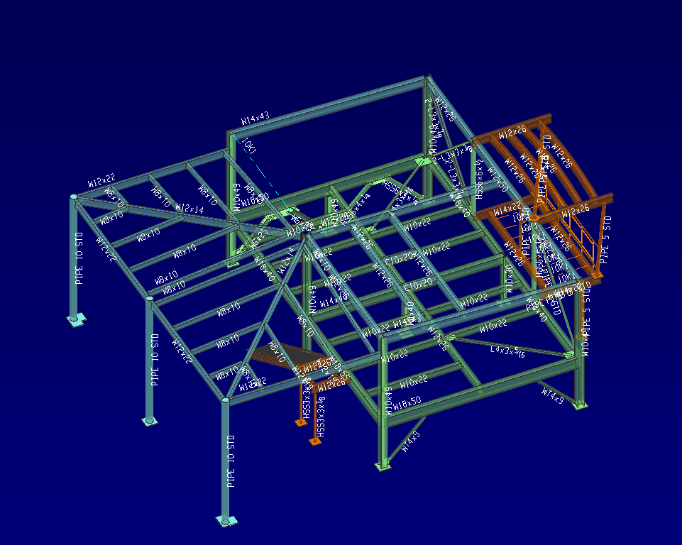

Contents
Resources 4
Detailer Training Series Online Course 4
Starting the Project 5
Job or Fabricator Options 6
Modeling 10
Construction Lines 14
Grid Lines 16
Create Plan Views 18
Plate Definition Schedule 20
Columns 26
Beams 31
Roof Plan 31
Joist 37
Interface 38
Bracing 39
Vertical Braces 43
Front Deck 50
Stairs 61
Handrail 71
Group Members 76
Sequencing 77
Hip Roof 78
Material 80
Detailing Erection Views 84
Erection Views cleanup 92
Detailing Members 94
Detailing Submaterials 100
Sheet Outlines 102
Labels 104
Gather Sheets 108
Loading sheets 110
Detail Sheet Autoloading 112
Gather Sheets 114

Resources
AISC American Institute of Steel Construction
https://www.aisc.org/content.aspx?id=38846

Detailer Training Series Online Course
The AISC Detailer Training Series was originally developed in 2000 by AISC and the National Institute of Steel Detailing (NISD) as a series of 12 CDs. Thanks to funding from the Ironworker Management Progressive Action Cooperative Trust (IMPACT), the series is being made available as a free web-based service. This online course provides an introduction and overview of the roles and responsibilities of the steel detailer. This program consists of 10 modules -- most with multiple parts. Each of these parts consists of a series of videos, followed by a quiz pertaining to the concepts covered in that section. After completing all 10 modules, the user may take a final exam. Upon passing the exam, the user is issued a certificate of completion.
The Detailer Training Series is free, and open to everyone. You work thought the course at your own pace, and it takes approximately 100 hours to complete. It is STRONGLY recommended that you go through these videos if you want a job in the industry or plan on Structural/Architectural Engineering as a major in college. They are a little dated…..and a little dry…..and a little confusing. They make more sense as you go through the training.

Starting the Project

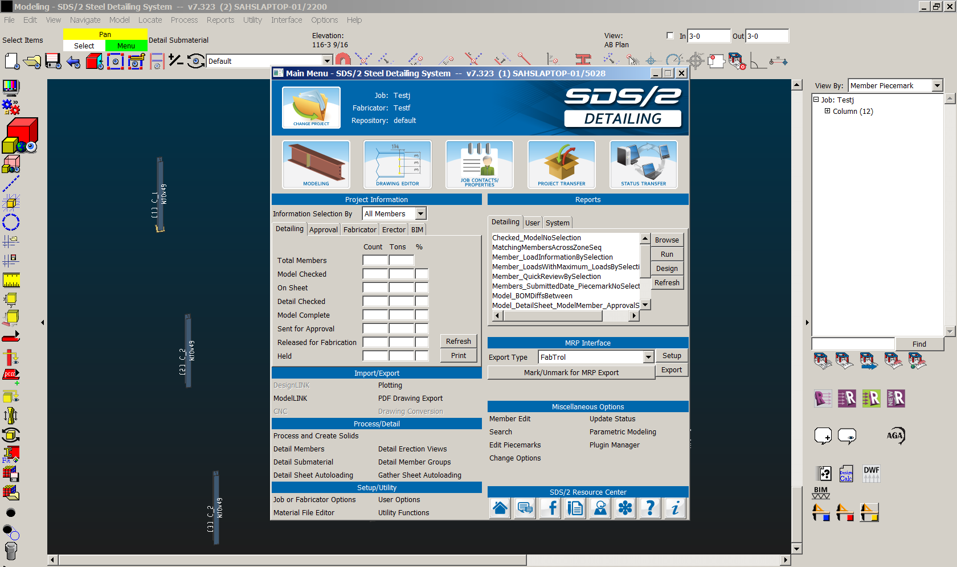
Change Project (upper left corner of Main Menu)
New
Name Job: FirstLastj
Name Fabricator: FirstLastf

Job or Fabricator Options (under Setup/Utility)
Job Setup (tab) top, left
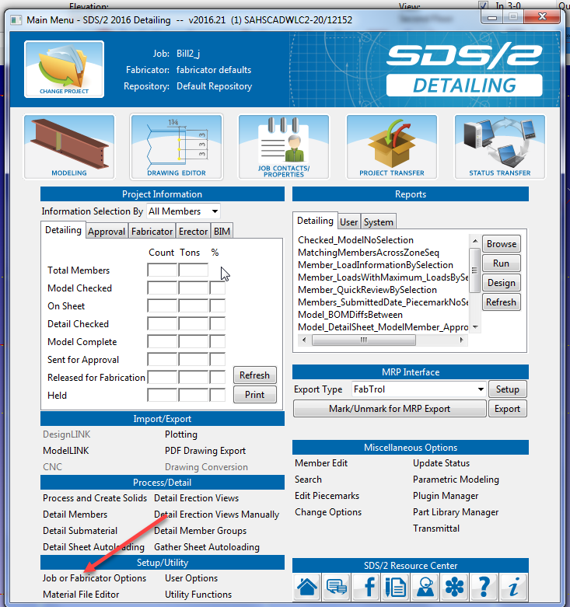
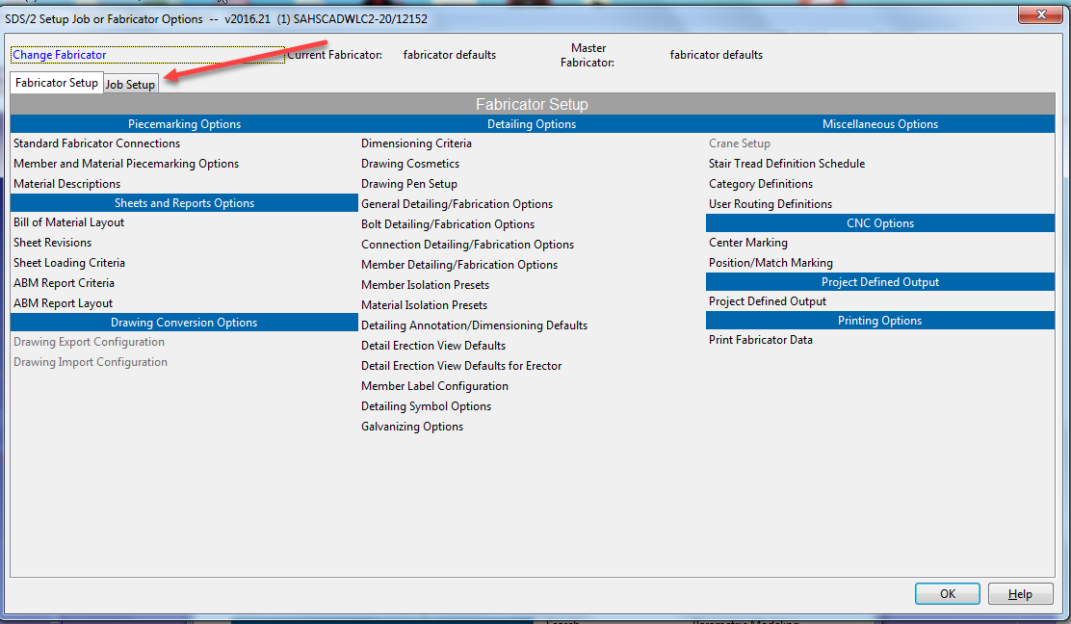
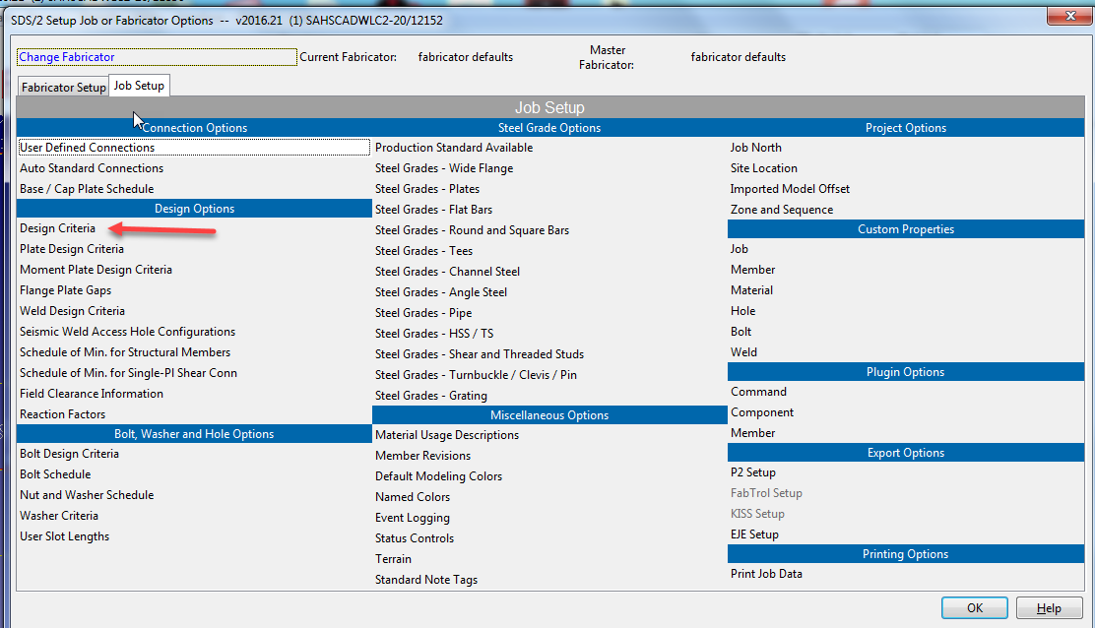
Note: Resource Center bottom right: forum posts jobs, etc SHOW
Design Criteria (Review) Note ASD 14th edition (the current code) OOTB settings in SDS/2 SHOW
Note: Help menu…shows really good info…SHOW
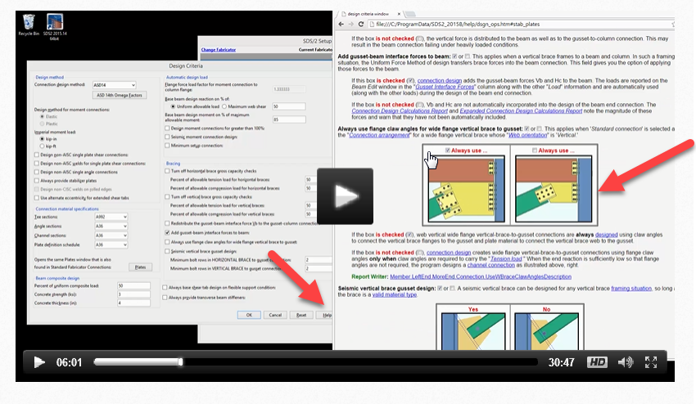
Plate Design Criteria Show Help again OOTB
Show shared gusset, beam/column gusset, stiffener clearance
Moment Plate Design Criteria Show Help again OOTB
What is a “Moment”? Take a moment to watch the video (me so funny)
https://www.youtube.com/watch?v=NULtvdoq1rQ
Weld Design Criteria
Field Welds, Shop welds
Students watch AISC Module 3A #2-8 and 19-22
Bolt Design Criteria Show Help again OOTB
¾ A325N
AISC 14th Edition Design Code
Nut and Washer Schedule
Washer Criteria (Note: RC in field to get decimal equivalent….RC to go back to fraction)

Zone and Sequence (in Job Setup)
Zone and Sequence
Max: 4 tab
See Zone names 1,2,3,4? That allows for sequencing the job……like a “phase” in Revit.
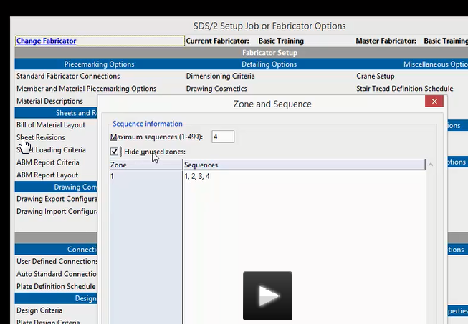
Ok…OK
We will use these later when we add “Sequences”

Provide students with SDS2 “Online” drawings
Note Format for entering dimensions: 99-2 not 99’2 or 99 2 16 (would be 16 inches)
2 ½ (space between) SHOW

Modeling
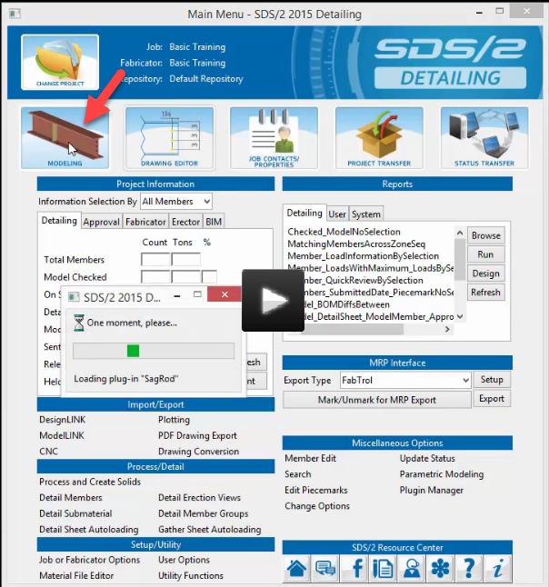
Save new view as Ground Level
Set the Elevation to 106-0
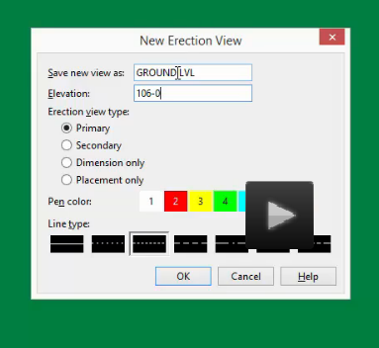
Note intersection is 0,0
See the green box? That is “Terrain”
See the TV icon in the top left corner? That is your “Display Options”. (DD also works)Pick the TV icon.
Uncheck Terrain OK
Bam! Gone!
Change the Background color:
Options…..User Options….Colors
Set to a light background so we can see the darker colored lines. You could do dark background w light lines….

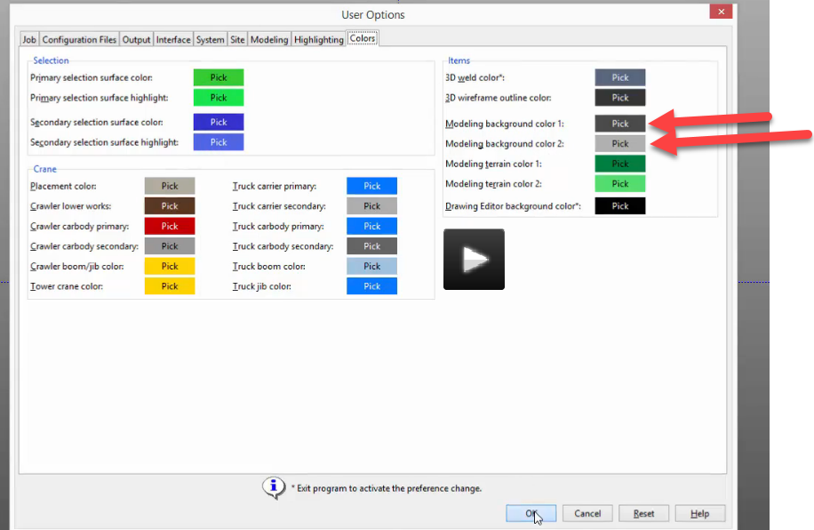
Show drop-down menus
Show tear off (dashed lines at top of window)
If “select Items” is showing, there are no current commands going
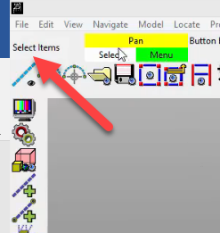

Pan MC (middle mouse click)
Select LC (left click)
Menu RC (right click)
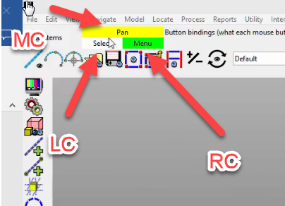
Show x,y,z
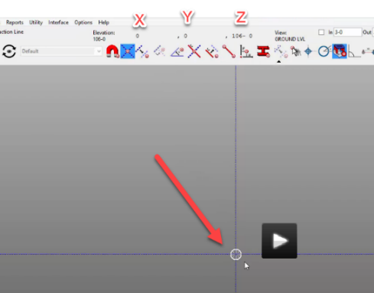
Show Depth Check
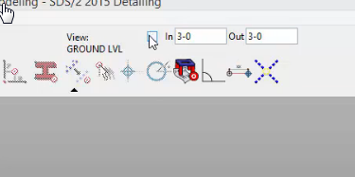
Show collapsible icon arrows for more model space
Show Point Locators (like OSNAPS)
Show alt key and shift key to change commands in those colored boxes
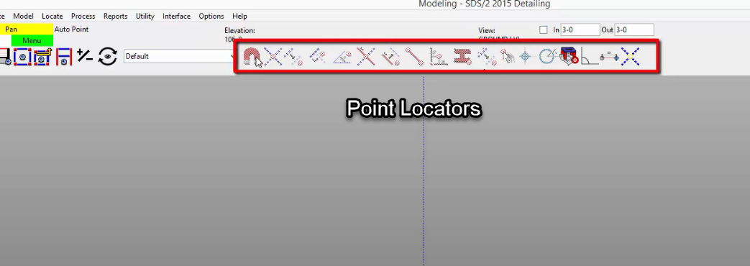
Options
Toolbar configuration
Left click and drag ON
Give students a couple commands to add to their toolbar
Make one: Solids Opaque all
Make one: Undo View change
Save changes …just save over name
For saving default toolbar
Options…User Options
Configuration Files
Modeling
Browse….name…OK

Show: Options….keyboard shortcuts (Give students shortcut sheet)
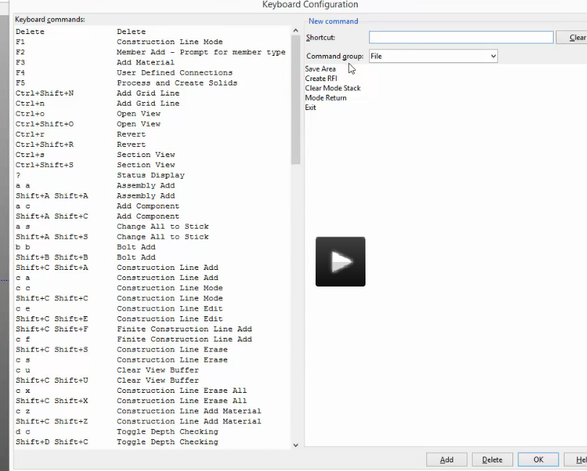
Note: keyboard shortcuts save to toolbar file

Construction Lines
Grid Lines S1: Go to that sheet
Construction lines don’t print. They just help with placing things like grids, columns, beams, bracing, etc. Their intersections are key. They can be deleted when you are done with them. As you get into the process, you will want to delete some to make the screen less cluttered.
Construction Lines icon
Finite Construction Line Icon
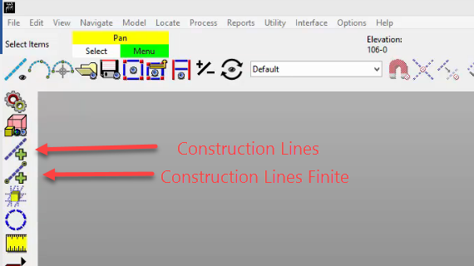
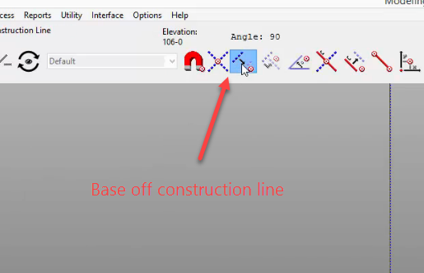
NOTE: LOOK AT THE PIC ABOVE!! BASE OFF CONSTRUCTION LINE when laying out construction lines.
Layout construction lines per drawing Ground Level
Show a finite construction line….then how to delete it (using filter)
SHOW DELETING CONS LINE
Model….construction line….erase or (CS keyboard shortcut)

Show Ruler (to get distances)
NOTE: +
-
+

-
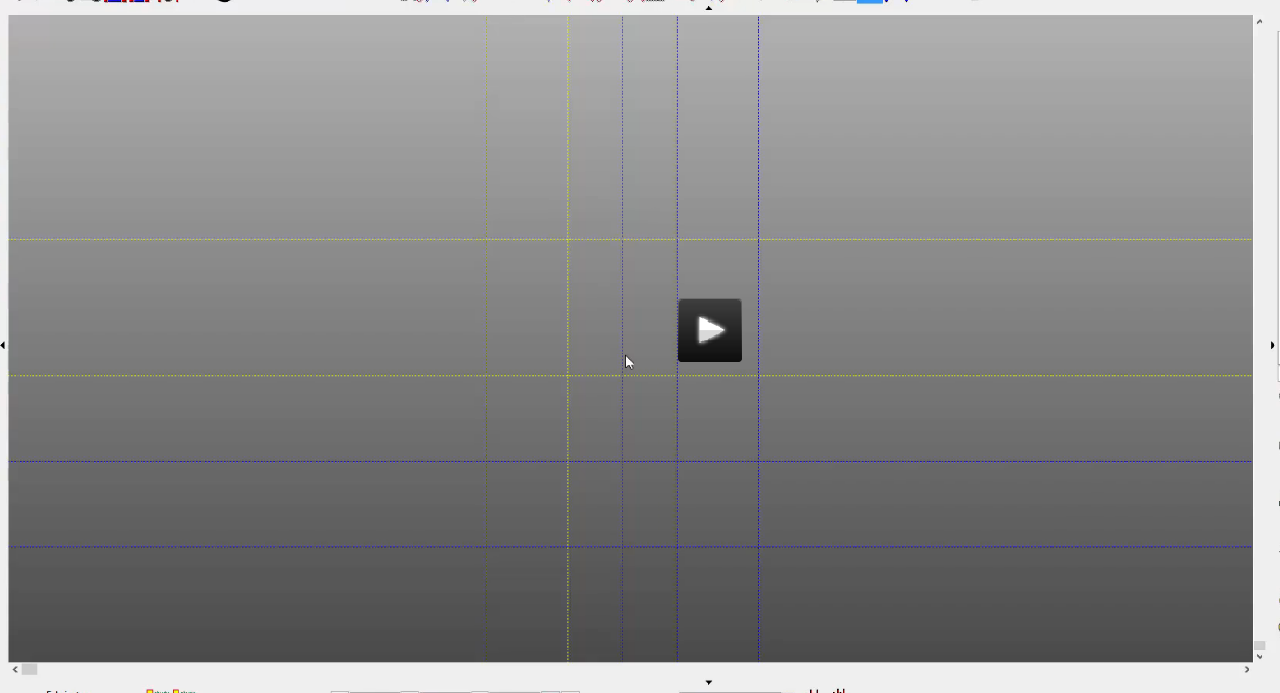
Note:Grid A1 should be in the top, left corner
A B C D
1
2
3
4

Note: Plan Views are “Erection Views”
To make Grids from construction lines:

Grid Lines
Grid bubble setback in view properties. Use 6’-0”
Check Finite
View Depth (bottom to top) like section
Top: 126-0
Bottom: 99-2
Double clicking on bubble takes you to view. Some with Plan view names (in section)
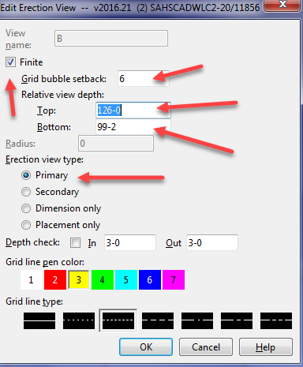
Make A.1 and B.1 and 1.5 Secondary views with 3’-0” grid bubble setbacks
Rename Grid/View
Utility Function on main Menu…..rename job items…
Modify Erection View
Select Filter to Grid Lines (white box)….edit (double click)…then back to default.
DELETING A GRID LINE: File…..Views/Grids…..Delete View
MOVING A GRID LINE: Make the Grid line where you want it. Name it exactly the same as the mis-placed grid line. Accept the over-ride message. The grid line represents a view (like a section)
Filter: Change it back to “Default” Keep an eye on this choice….they change as you perform different tasks! I guarantee you will try selecting an object and won’t be able to pick it because the filter setting wasn’t changed GUARANTEEIT!
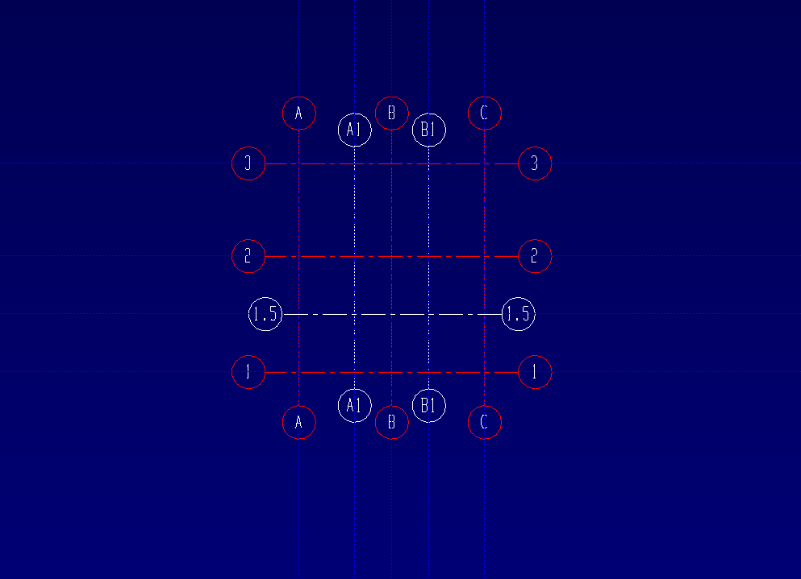

Create Plan Views
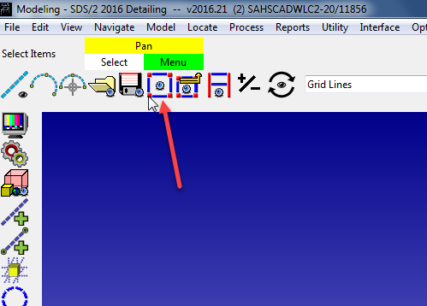
Plan View Icon
114-6
Save View as: First Floor
Ok
Plan View Icon
99-2
Save View as: Basement Level
Ok
Plan View Icon
107-2
Save View as: Anchor Plan

Ok
Plan View Icon
126-0
Save View as: Roof Plan
Ok
Note (again): If Grid is in wrong place, create another grid….give it the exact same name….OK to replace…Yes. You can’t move a grid in SDS2
Note: Deleting a Grid line deletes the view. Am I getting repetitive??

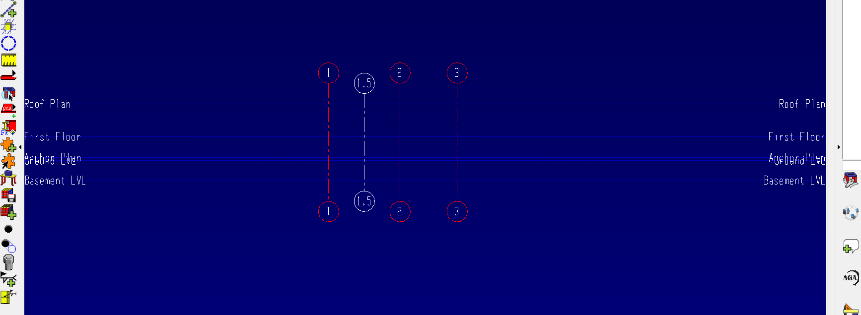

Plate Definition Schedule
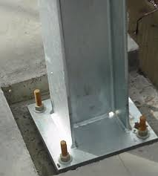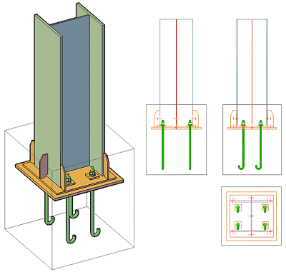
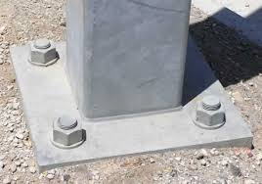
Main Menu
Job or Fabricator Options (under Setup/Utility)
Job Setup
Base/Cap Plate Schedule (this is where you will create the plates that go at the bottom of the columns…that attach the columns to the concrete slab). See sheet S3.

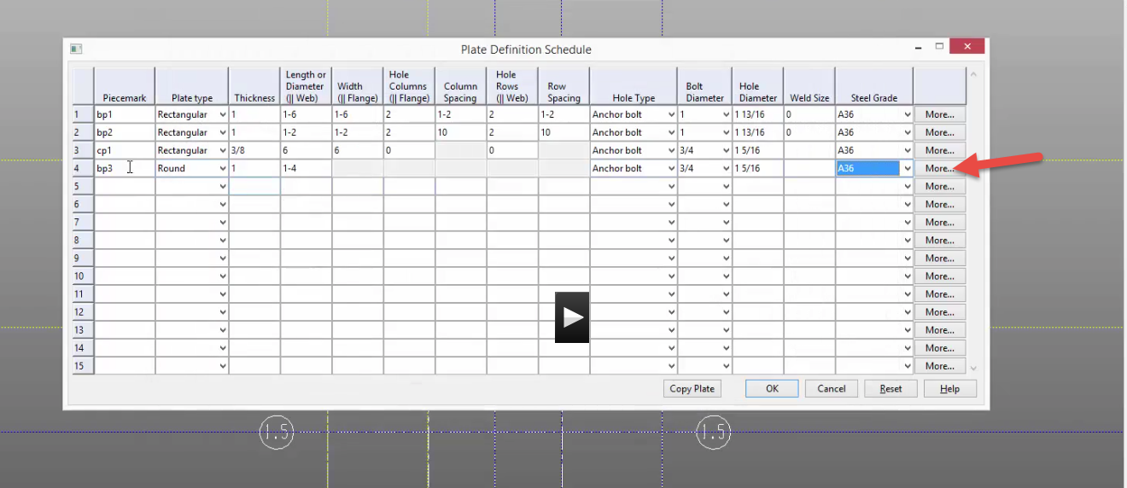
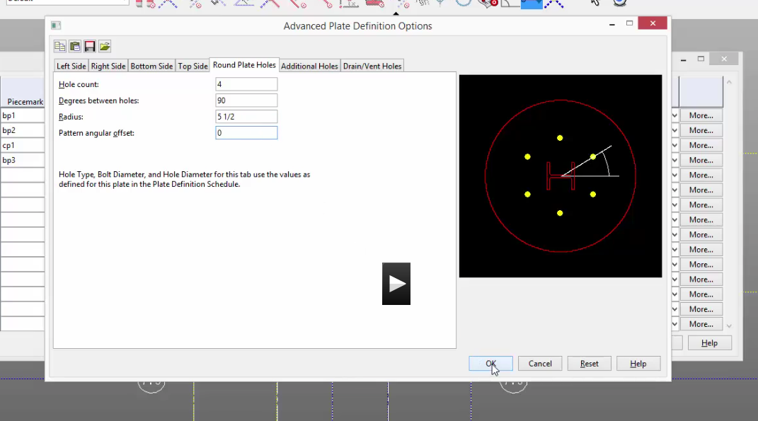

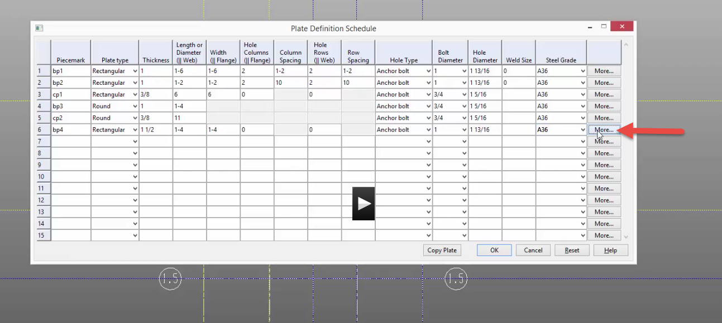

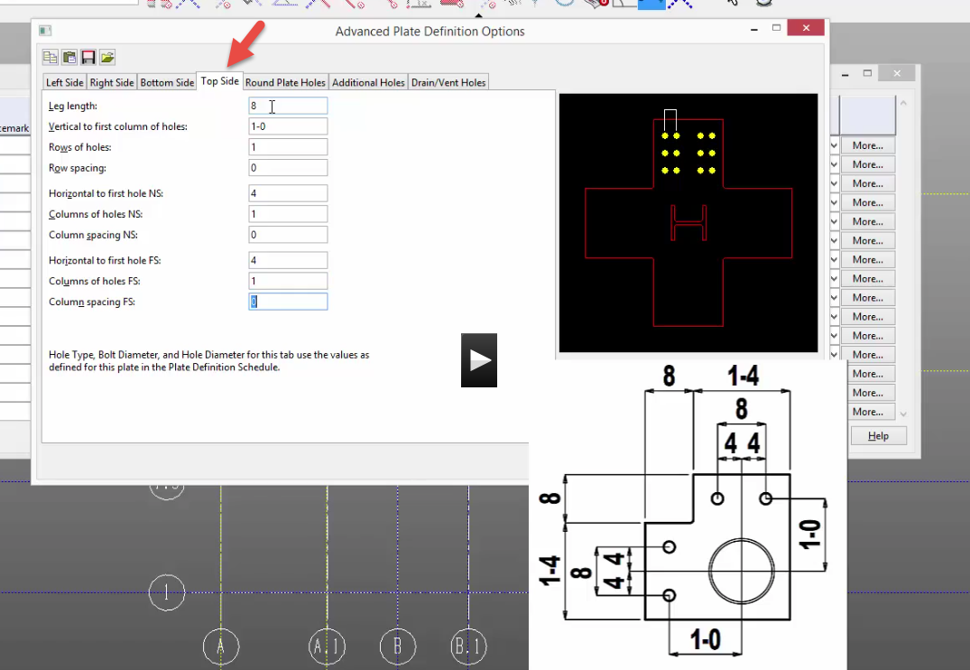

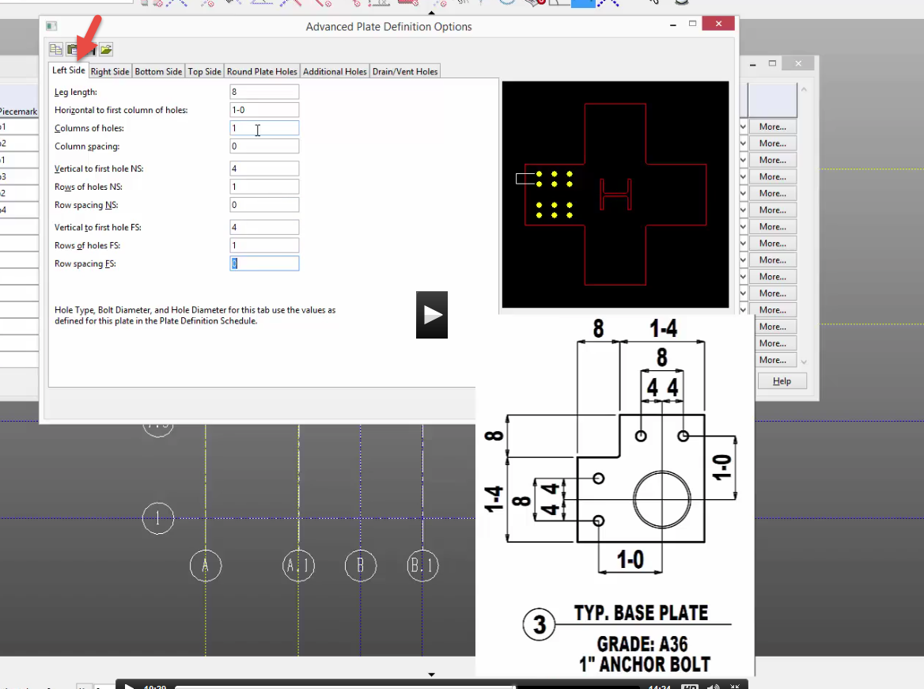

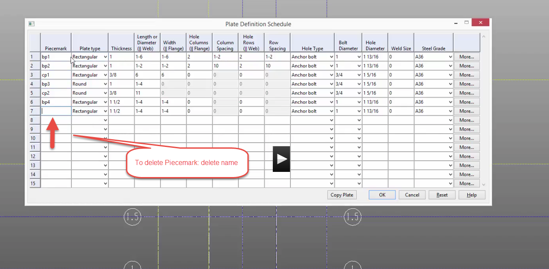

Columns
Open Columns Sheet S2 AND Plate Definition Schedule Sheet S3
H is 0 degrees
I is 90 degrees
Note Columns 90 degrees

0 degrees

At A1, place W10X49 90 degree rotation
Bottom: 107-2 Top 126-0 (remember format!!)
Input connection: user base/ cap plate
BP1
Place same column at C1 (exact)
Columns
Format:
W10x49
W 10 x 49
Shape depth weight in lbs/inch

Note Columns 90 degrees

0 degrees
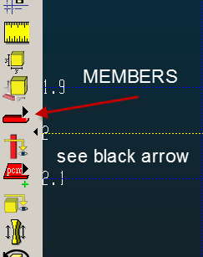
Column (icon) at left. Note: See flyout arrow to change members.
Place column using “Intersection of Construction Line”. Note: they don’t always stay selected.
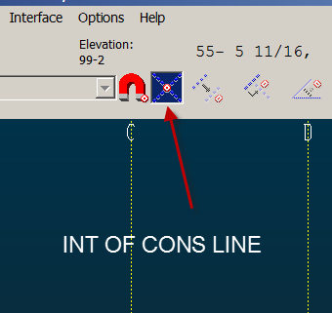

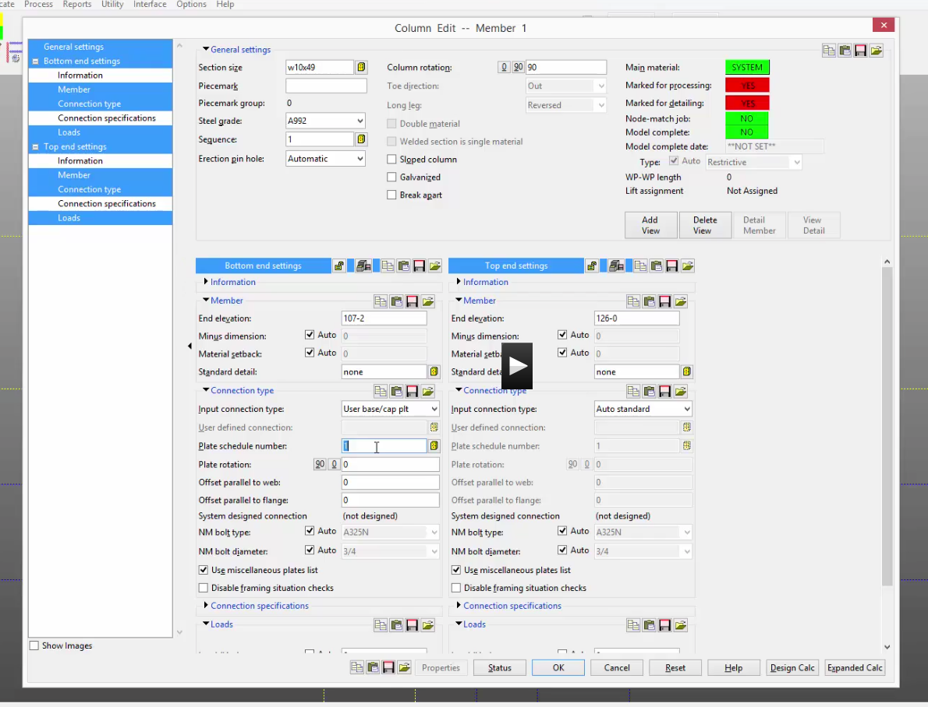

A2 changes a little…
Still W10x49 rotate 0
Same cap plate
+9 ½ ….so….126-9 ½

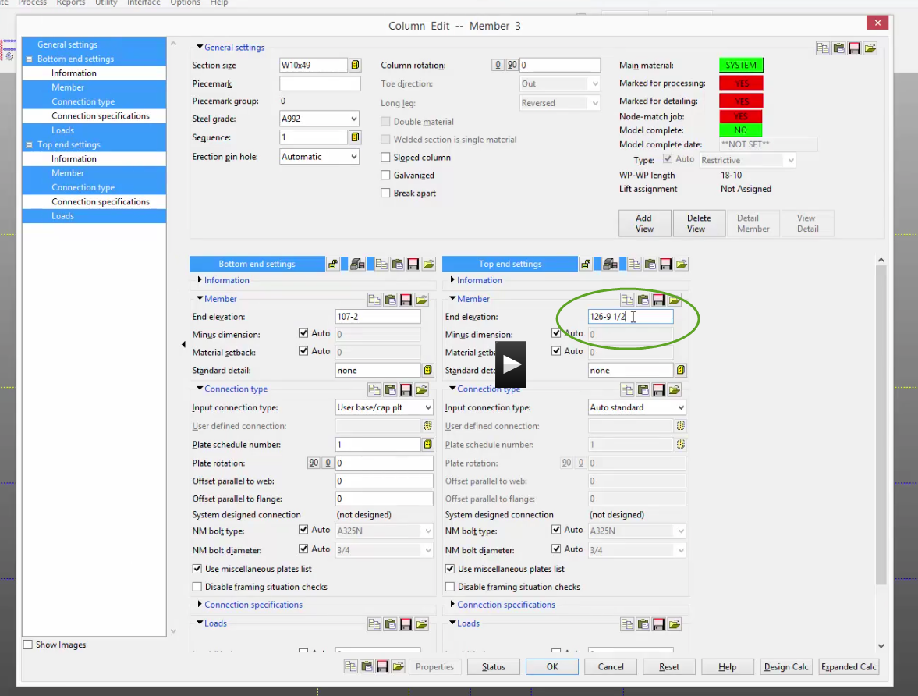

C2 is same as above (use middle click for repeat)
B2 is same as above, just rotation 90
C1.5 column rotate 0
NOTE: C1.5 Top of Column is 114-6 (stops at first floor)
(126’-0” – 11’-6” = 114’-6”) -11-6 so end is 114-6
B1 W10x30 (same as above) Note: W10x30 has BP2
B1.5 Has a splice. The first W8X40 goes from 99-2 to 107-2. BP1 for base. Splice plate for top. The second (top) has a base of splice, and a top of Auto Std. 107-2 to 114-6.

See sheet S3. HSS start at First Floor, not Anchor Plan. You don’t have to be in the First Floor to start the column there.
HSS6x6x1/2
Auto standard
114-6 126-0

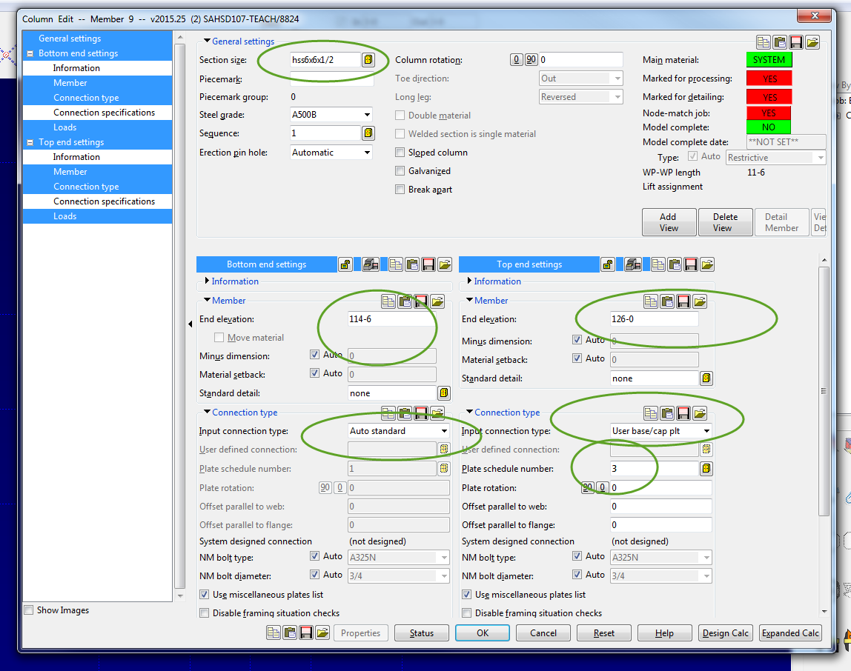

Beams
Open Sheet S4 Beams
First Floor (114-6)
Beam
W18X50 from A1 to A2 NOTE: Intersection of Construction Line!
Do middle click at C1 to repeat

A1 to B1 W18x40
Repeat at B1
Repeat at B2

A2 to B2 W18x55
B1 to B2 W14x43
A1.5 to B1.5 W12x26
MC to repeat at B1.5

Add construction lines for others…change pen colors….5-0 for filler beams
MC to repeat….remember, left side match!

Roof Plan
Open Sheet S5 Roof Plan
Roof Beams 126-0
Careful…watch elevations! 126-9 ½ Roof slopes!!

A1 (at 126-0) A2 (at 126-9 ½)
W14x43
OK

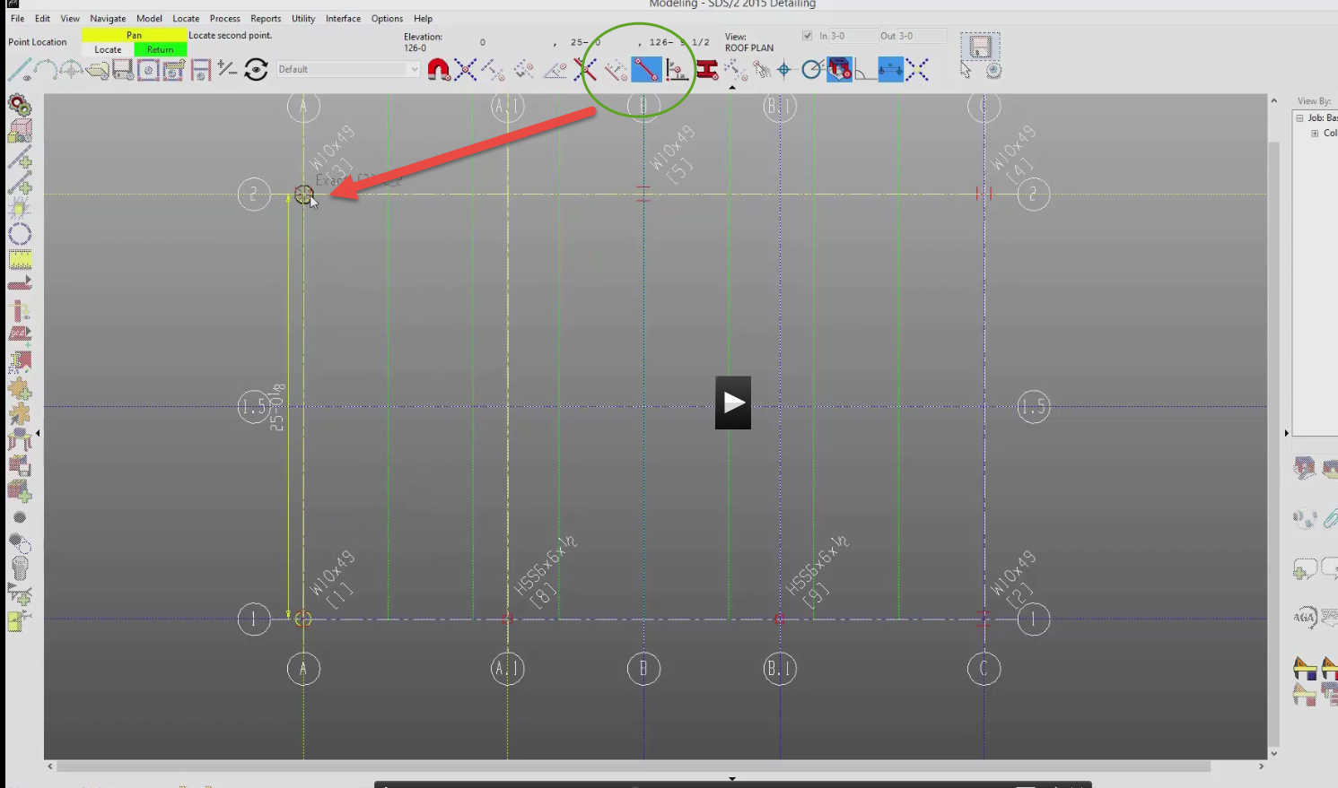
MC to repeat at C1
B1 is W12x26 (to B2)
Use “exact Point”for A2 to B2 W12x26 (not intersection construction line)

Show Member Tree
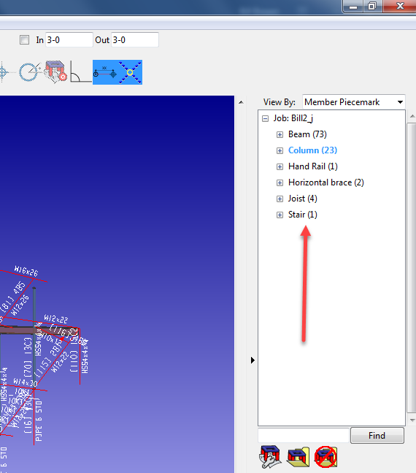

A1 to A.1 W12x26
Repeat B.1 to C

Roof Openings
Construction lines (from 2) -5-6(change color) -5-0
From A 7-6 5-0 web normal
Beam
Intersection of Cons Line/Member
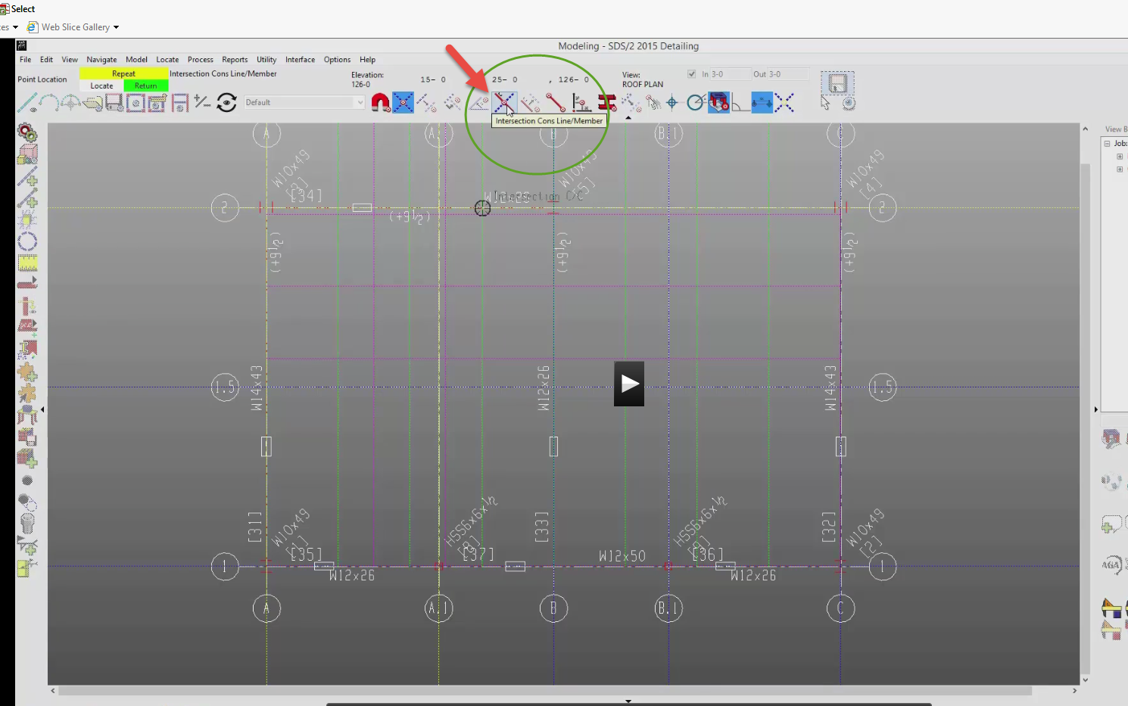
Do W12x26 (both sides of member)
Web rotation: web normal

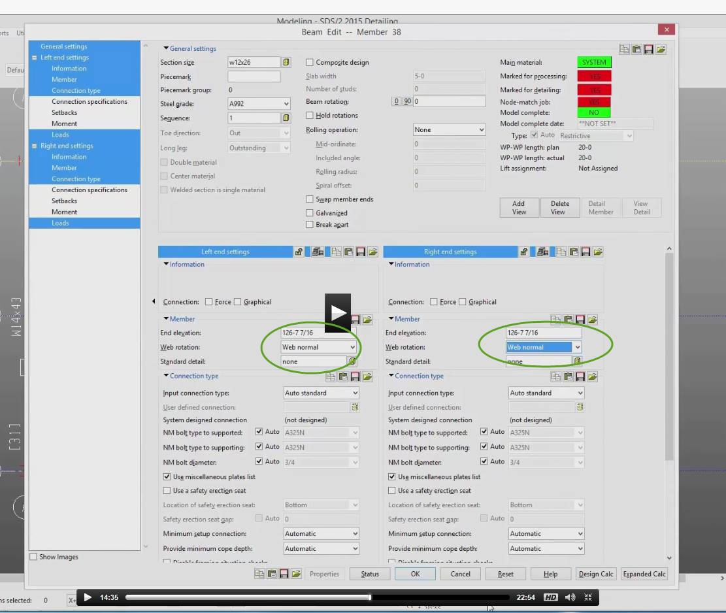
Opening C10x20 on left (keep Intersection of Cons Line/Member)

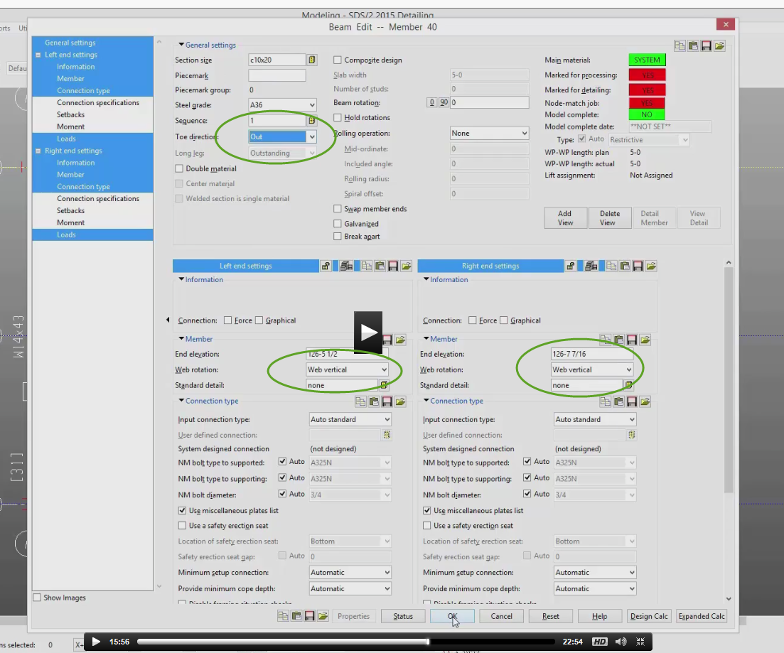
On right: Toe direction IN

Joist
Joist (in member)
Exact Point 10K1 seated input

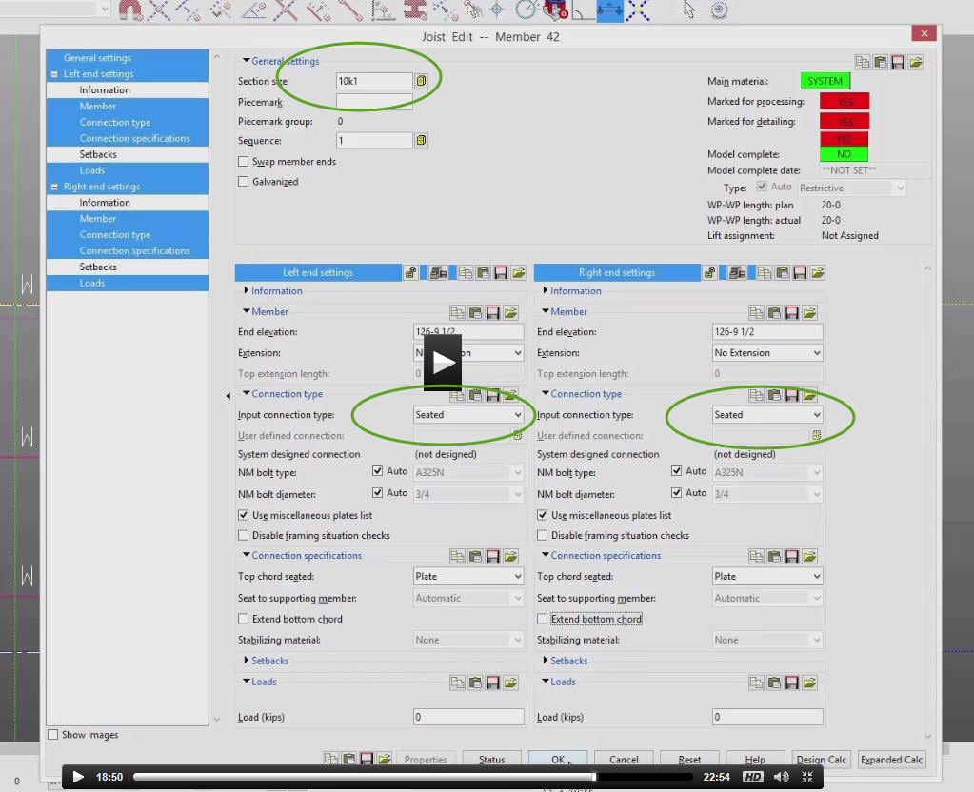
Process!
Solid
Shift/middle
Uncheck depth
View: solid types/views
Joists are just stick lines (not processed)
You can solid style selected

Interface
Shift MC to rotate
View….undo view change….”U” on keyboard…
Cnt r back to last open view
Shift LC to add to selections
Cnt LC to subtract from selections
RC on member…..select other…select all…get all of same type
Windows (same as Revit and AutoCAD)
Selection filters (top of screen)
Esc does not clear selection…LC in open space does
Model Tree-can select from there
Copy members: select member….RC…copy member
Options: single (2 pts), linear (horiz or Vert), fill (like an array)
Must say “YES” to accept
Mirror under copy
To move a member: select…move/stretch
No UNDO
F5 Process
To stretch:
Green box is “member end” (can use selection filter)
Select member end….RC…..move/stretch
If both member ends were selected, you could move (not stretch) member.

Bracing
Sheet S6
Start Horizontal bracing on First Floor
First Floor
Too many construction lines…..so…..
Model….Cons Line…Erase
Shift select enter or RC

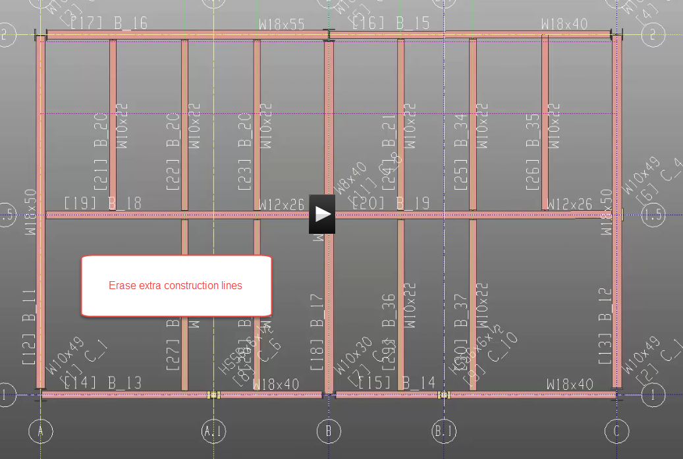
Member add…horiz brace
Int Cons Lines
L4x3x5/16
Process! Solid

See Gusset Plates? They are bolted to the top of the Flange on the beams
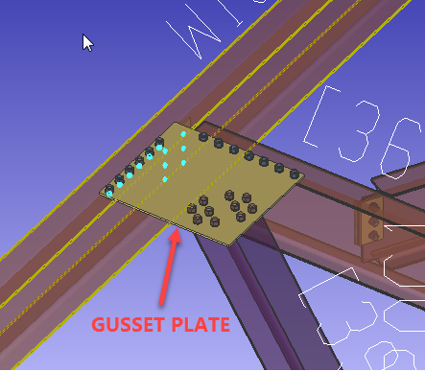
Other brace on right (-3)
Trick on -3 x,y,z filter on bottom of screen use int of cons lines
Set Z to -3
X icon to zero out filter (careful, or it will stay for the next operation)

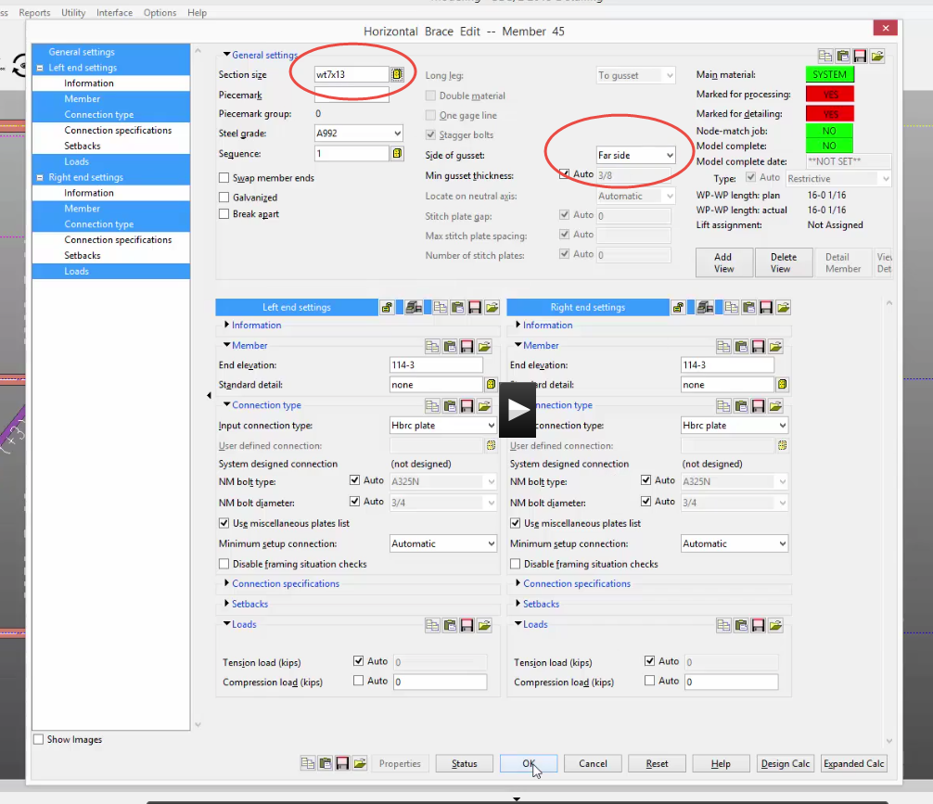

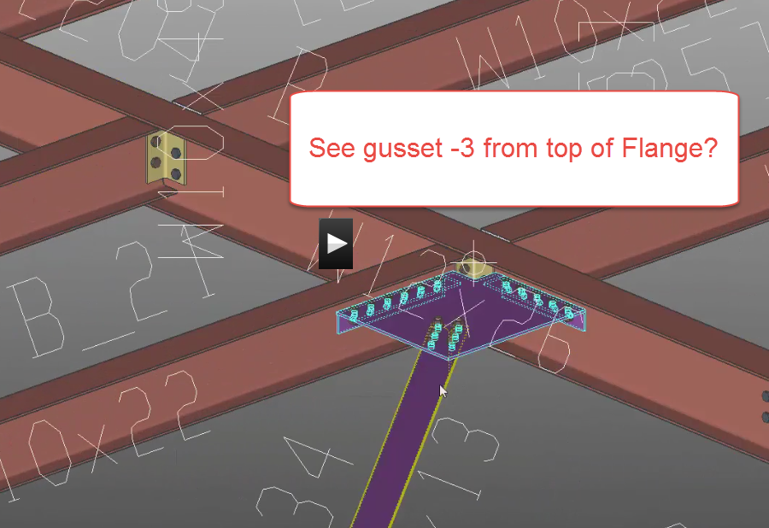

Vertical Braces
Sheet S7 Vertical Braces (at A)
View A
Set work points to ½ nominal depth of beams framing to. See 9”. Half of 18” depth
Construction line
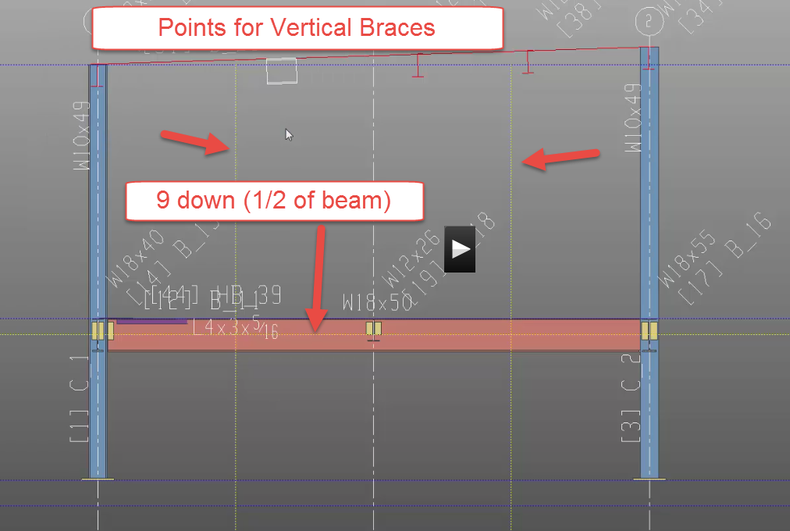
Member….add Vertical Brace
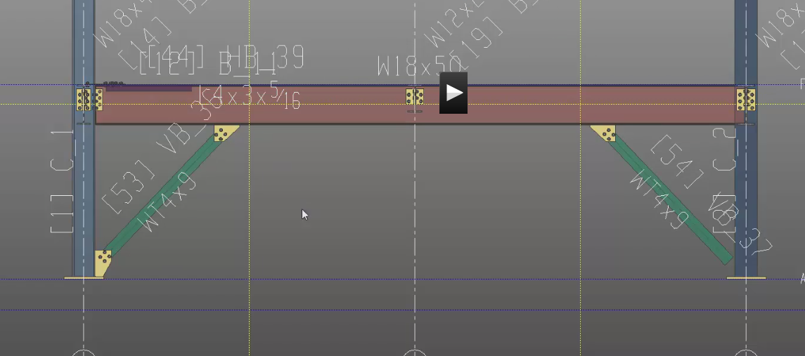
Failed connection later
Show shop welds and field bolts
C View
See same construction lines?

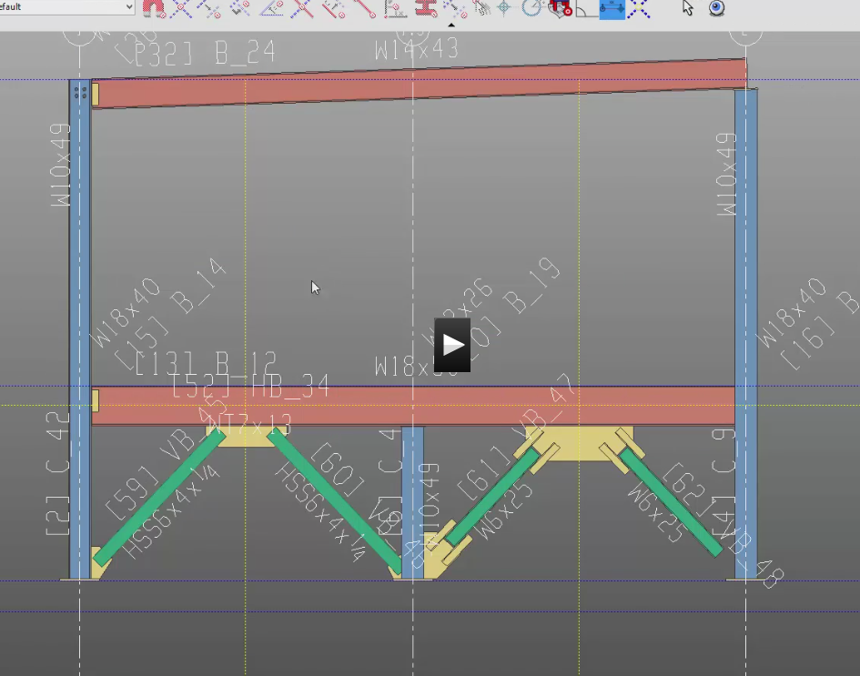
View 1
Add construction lines -6 from roof -9 from first floor
Plus blue crossing
Failed Connection:
There are many reasons a connection fails.
Check the accuracy of your modeled elements. Do you have the right base plate? Is the member facing the correct direction? Is it the right member?
Shear Load Kips could be too high. Set lower. Get out. Get back in again. See what it needs. Set it.
Main Menu….Job and Fab Options……..Job Setup…….Design Criteria….% of uniform comp load: change 50 to 25
Make it a Forced Connection
Make it a Graphical Connection
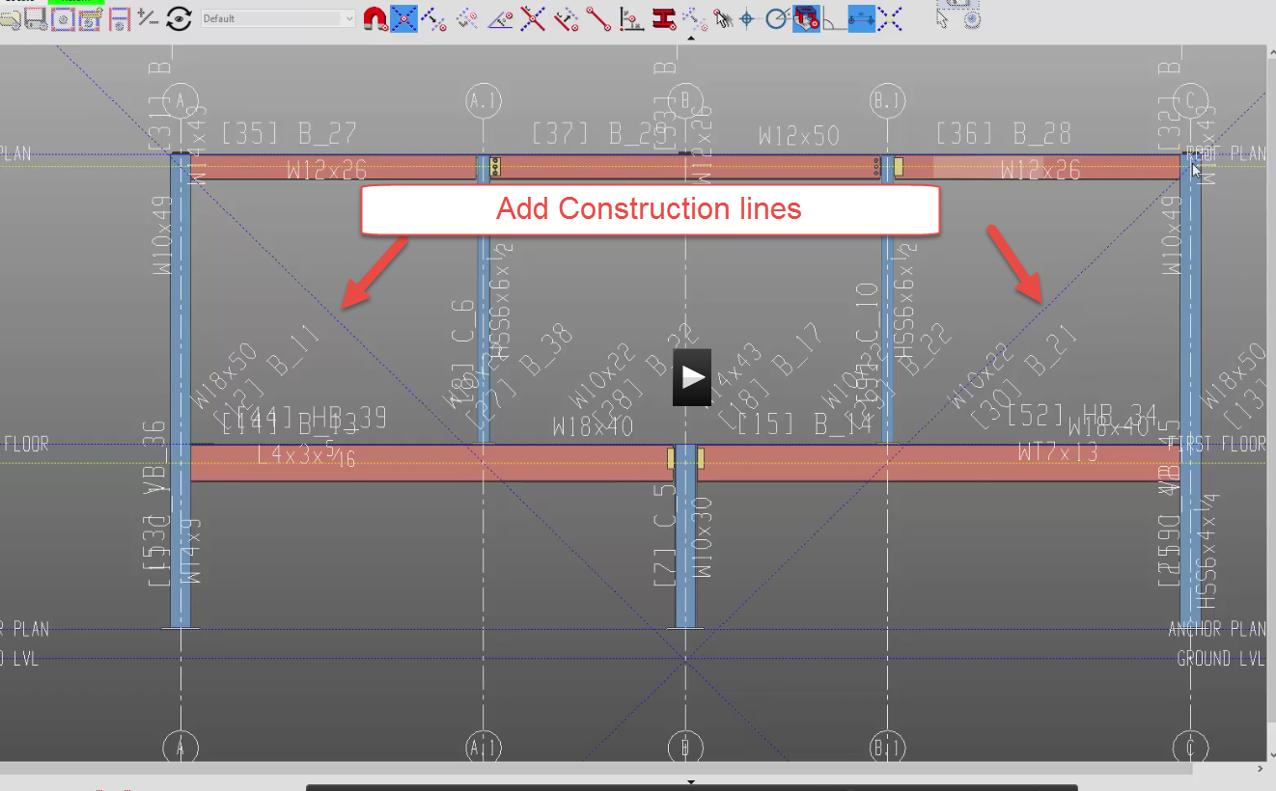
Vertical Braces (3) Pipe
2-L3x3x3/8 (the 2 is “double material”) Type it : L3X3X3/8 No “2”
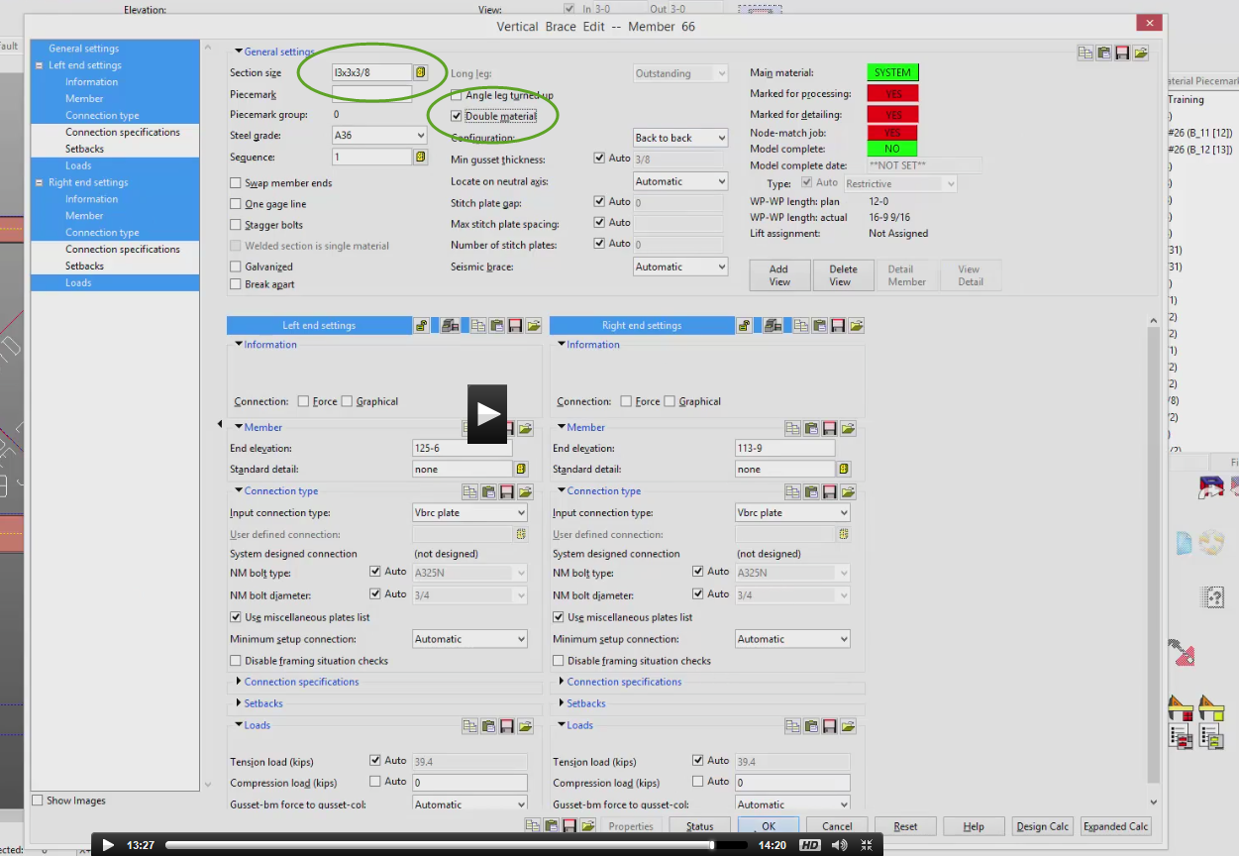

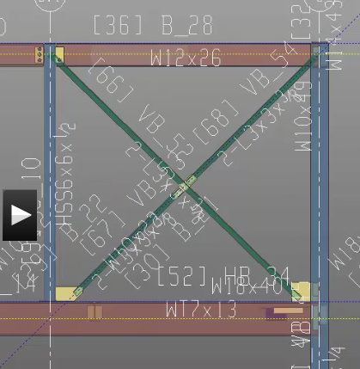
Some failed connections
See gussets attached to column base?
See connections at Bracing?
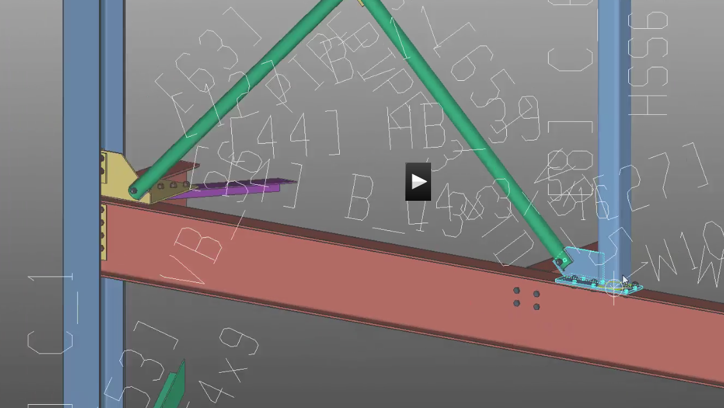

Front Deck
Sheet S8
First Floor (114-6)
Create construction lines

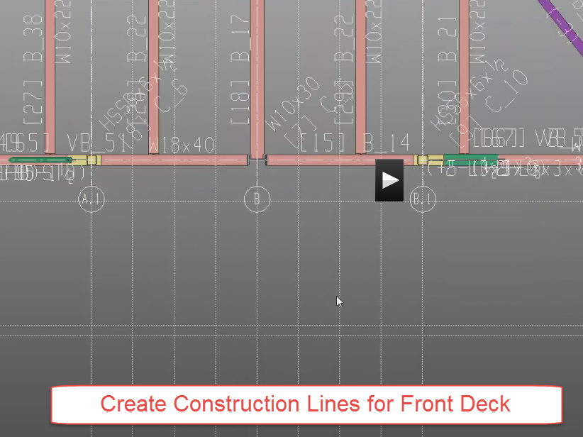
Beam W14x22 Remember….left to right!
W12x26 Use -2 1/2 in Z at bottom
X clear -2 ½
Member add joists 10K1
Connection Specification: bolted
MC to repeat joists (at left)

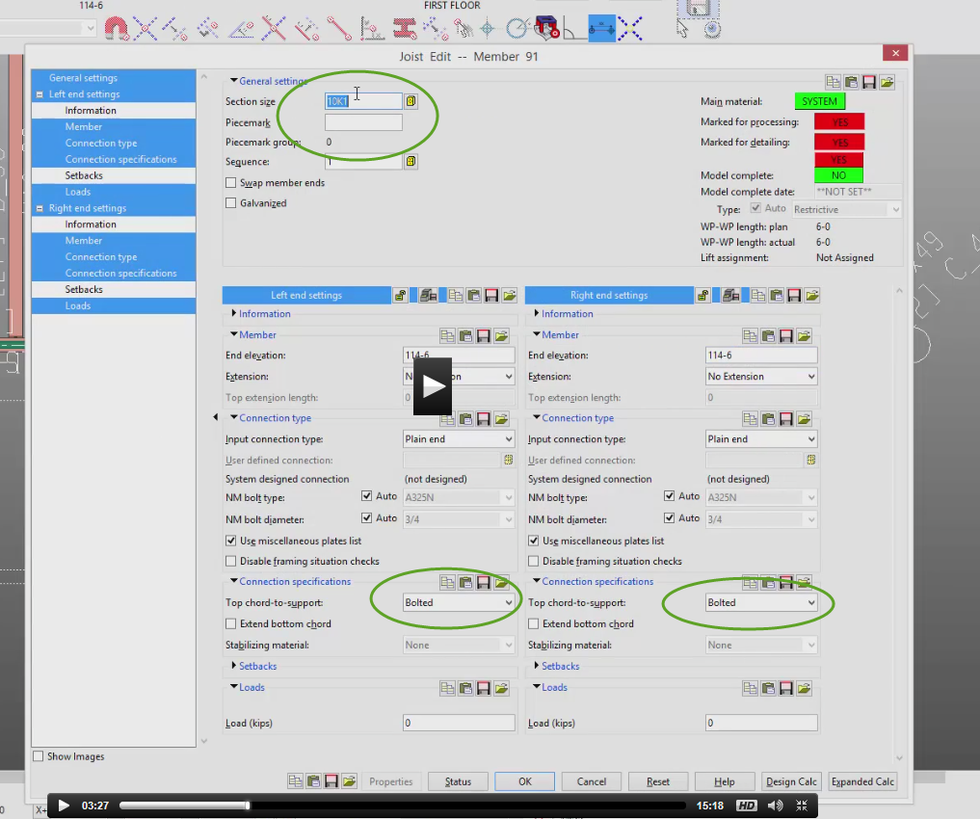
Process Solid
Plates are “dummy plates”

Columns
Roof Plan
Erase construction lines
Need new construction lines for rolled canopy
Beam W12x26 (2)
The W12x50 have a “rolling operation”
Rolling operation: strong axis
Rolling radius: 38-10

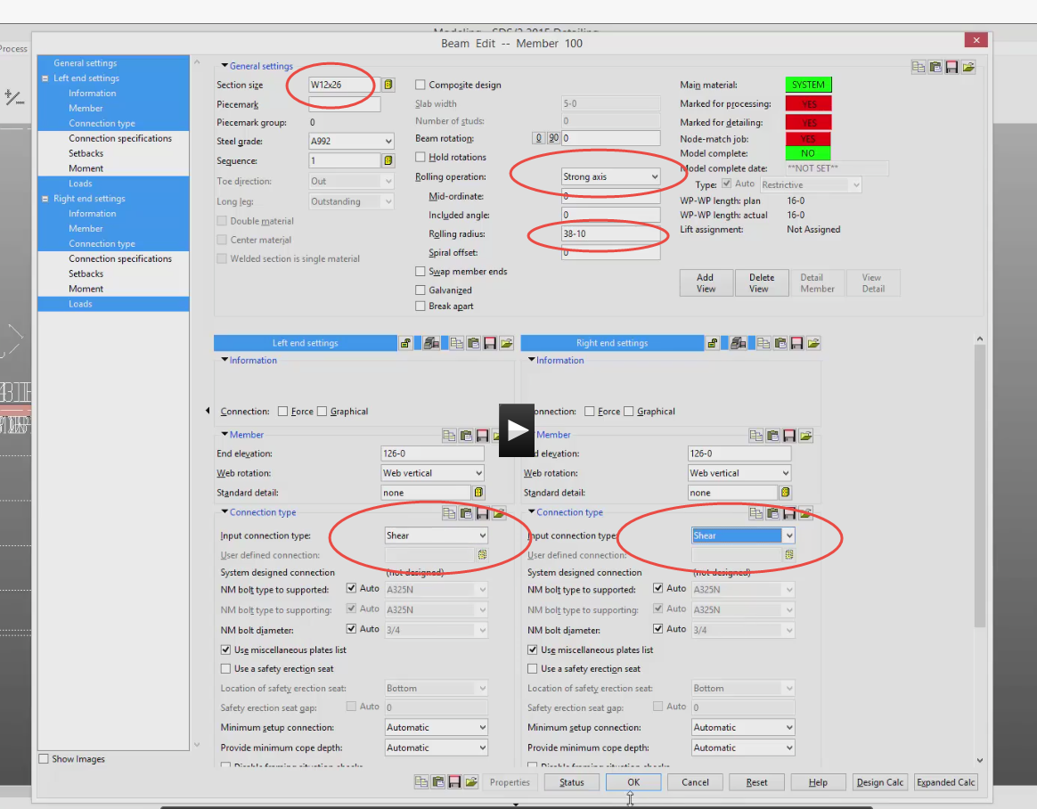
Process Solid See in 3D!
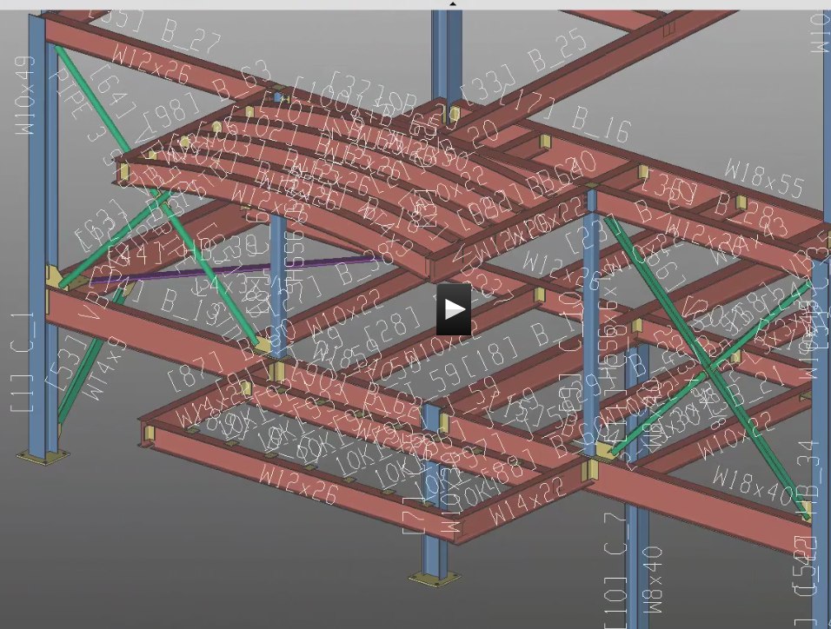
Roof Elevation
Need columns
Issue: A.1 and B.1 do not show the area we need. Go to B.1. Don’t see any members past Grid 1
When we made B.1, we only went from 1 to 3….so we don’t see any members past Grid 1 (they are sort of cropped out)
Go to Roof Plan
We are going to mofify A.1 and B.1 so we can see past grid 1
We do it by re-creating the grid (carefully) and saving as the EXACT same name.
Add Grid A.1 Say Yes to Replace

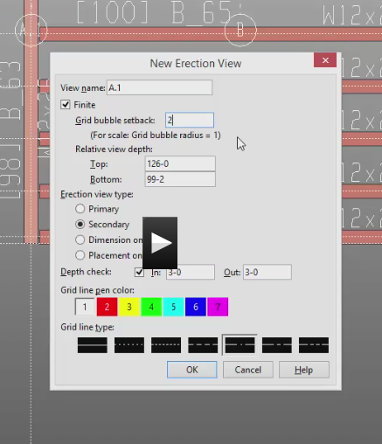

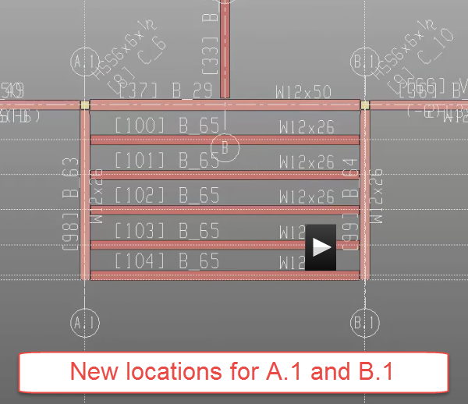

Open B.1 See canopy?
Column Pipe 5 std
Create grids @ 6-0, 2-0, 1-0

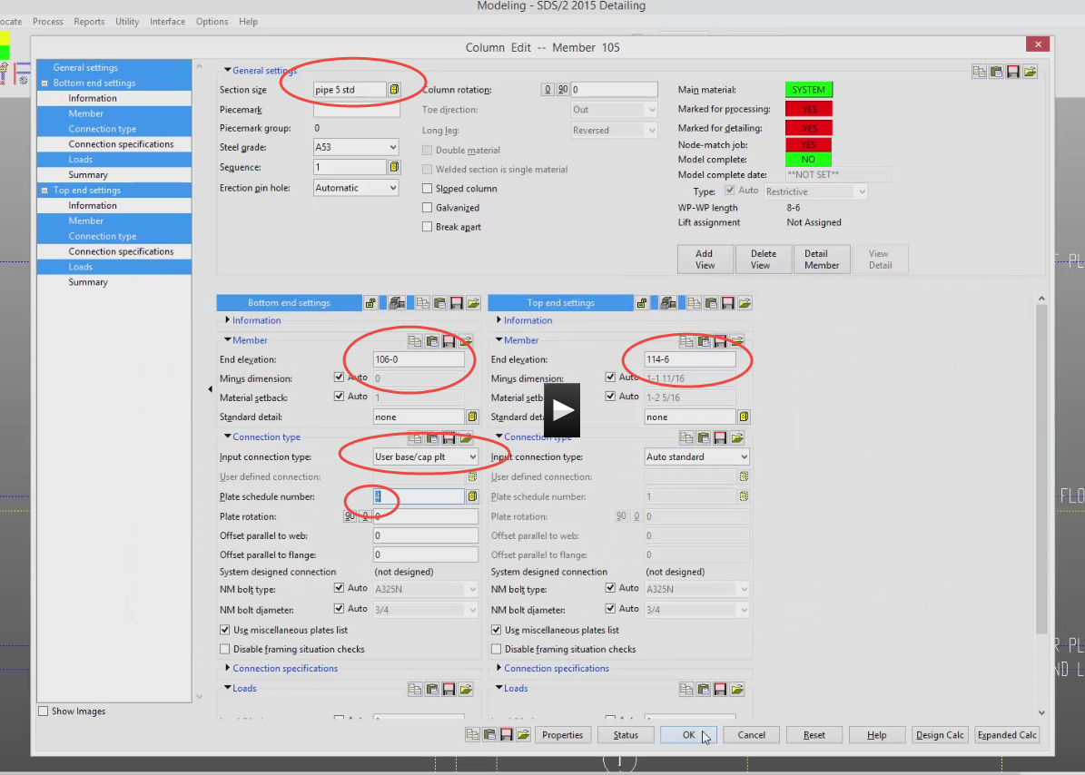

Process Solid 3D
Show pipe and base plates into beams

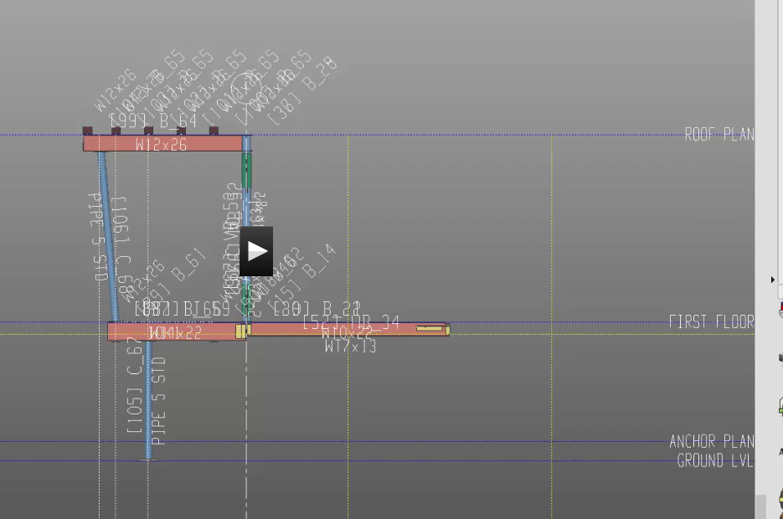
A.1 and create same columns as B.1
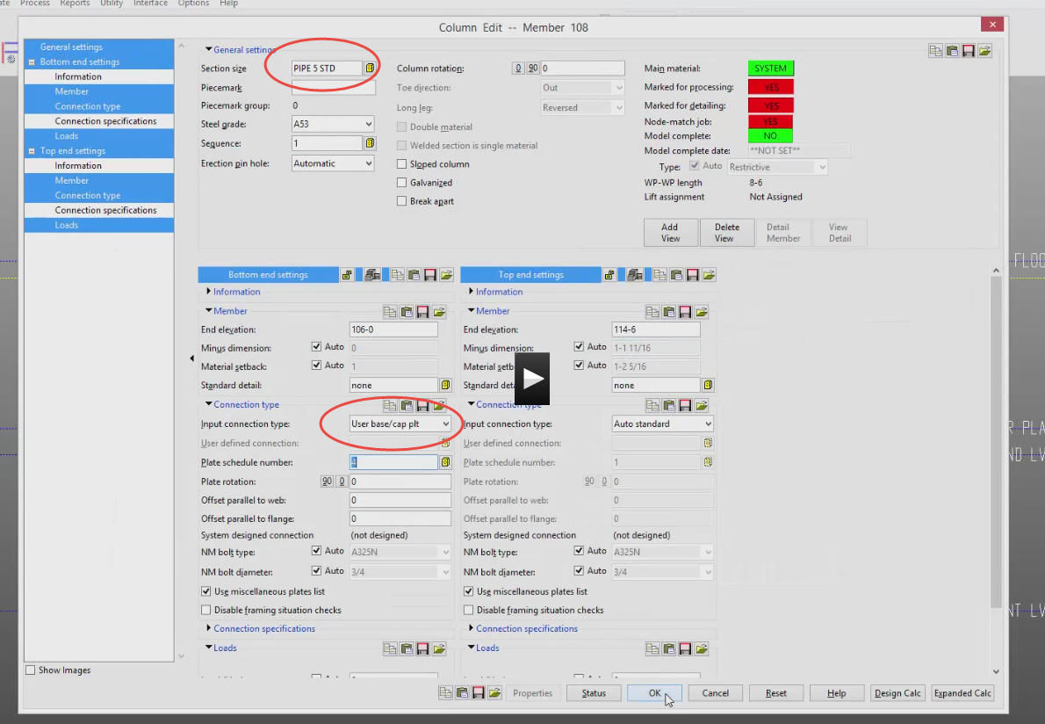
Process 3D Show all in 3D
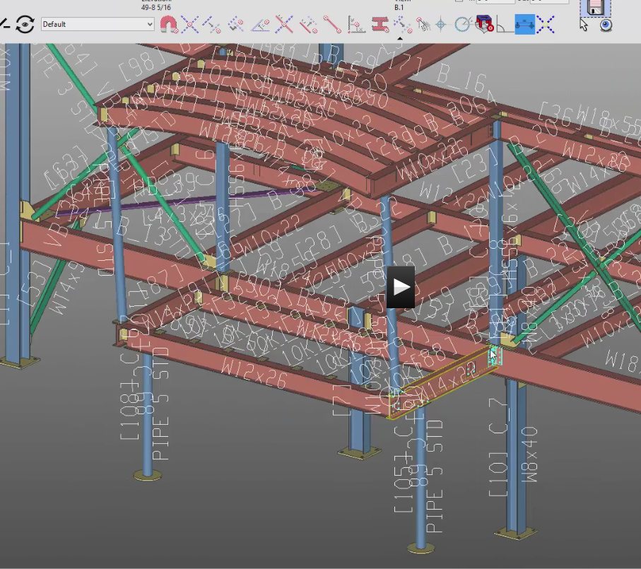
See how it is cluttered with all the annotation?
DD (display options/TV icon)
You can turn off different annotations like piecemarks and member #’s
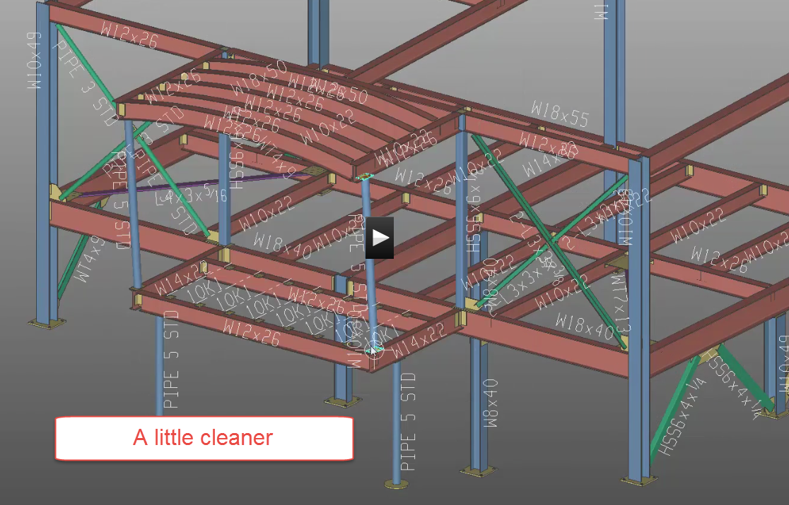
You can save and area of your plan (like the front deck)
File Save Area Crossing window
Name it “Front Deck”
Nice to work in small areas?
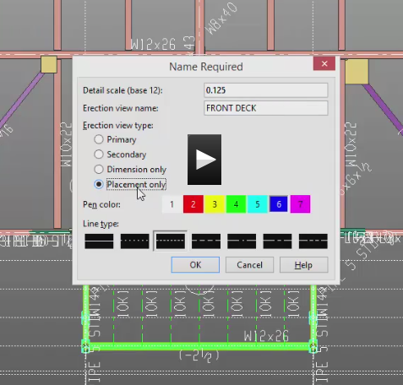

Stairs
Look at the Stair Tread Definition Schedule
We will have a bolted, grating stair
First Floor
Stair Landing above Grid 2
Setup construction lines
1-6, 3-0, 6
Left arrow 3-6 3 right arrow
Create beams W12x26
W12x19 (2)
Columns HSS3x3x3/8
BP2 User base/cap plate
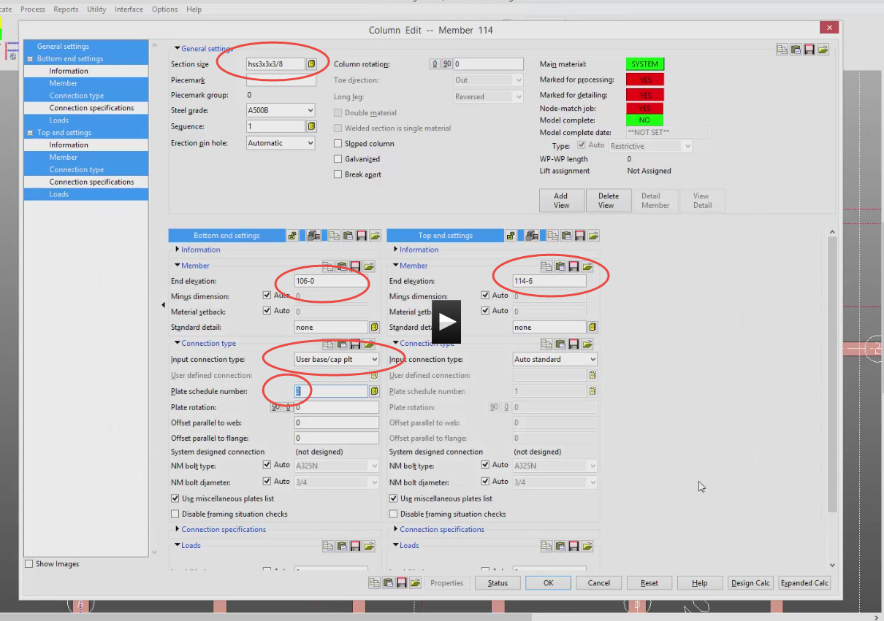
Watch out for #2 heights!
Process 3D
Some failed connections
Member….stair

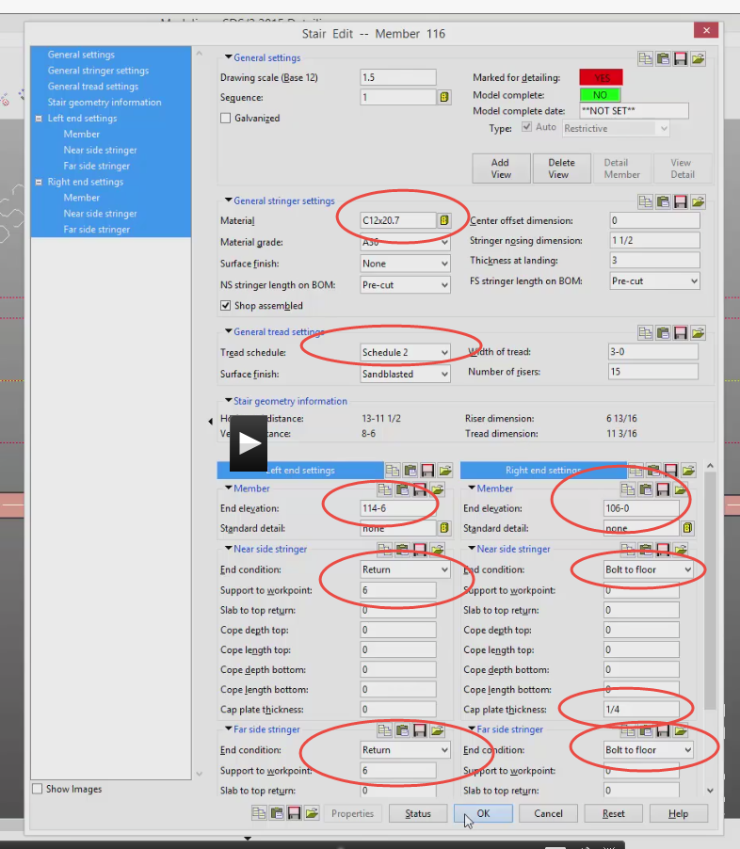
Esc to end
See issue with stairs? “Coping” is needed

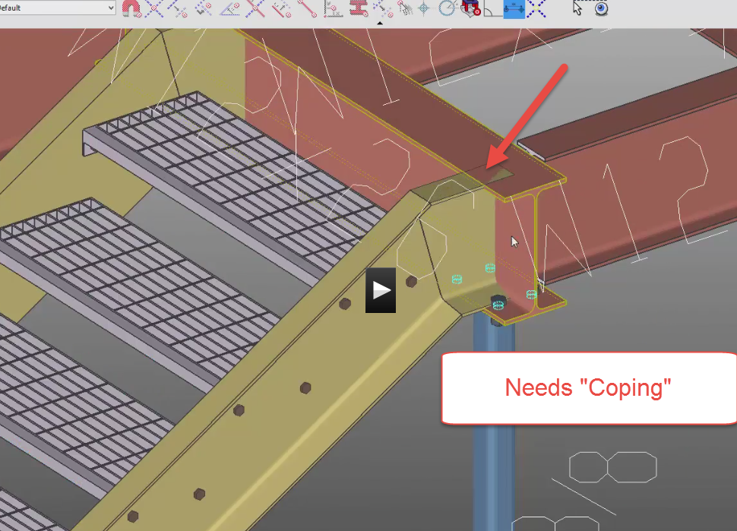
Pick Stair….edit
Note: Connections are not generated. No clash either
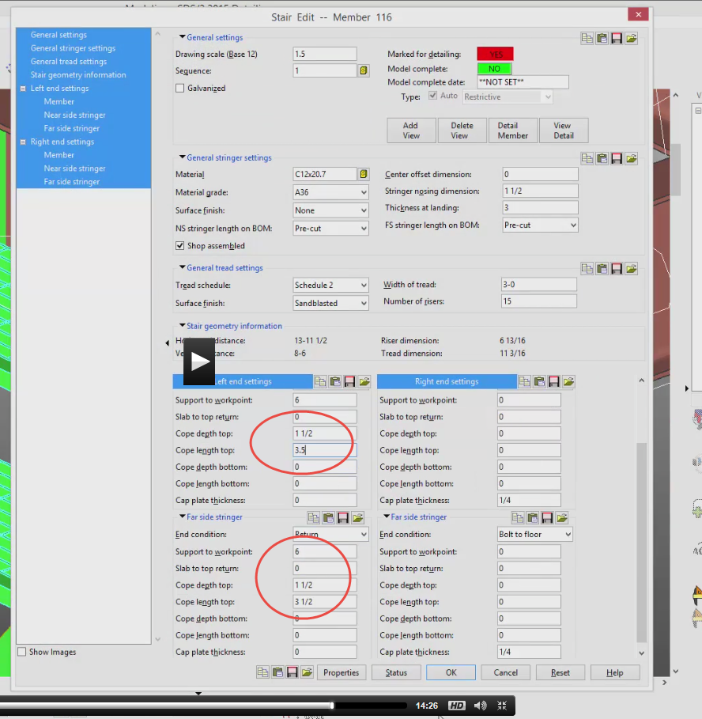
Reprocess stair
Do same for bottom

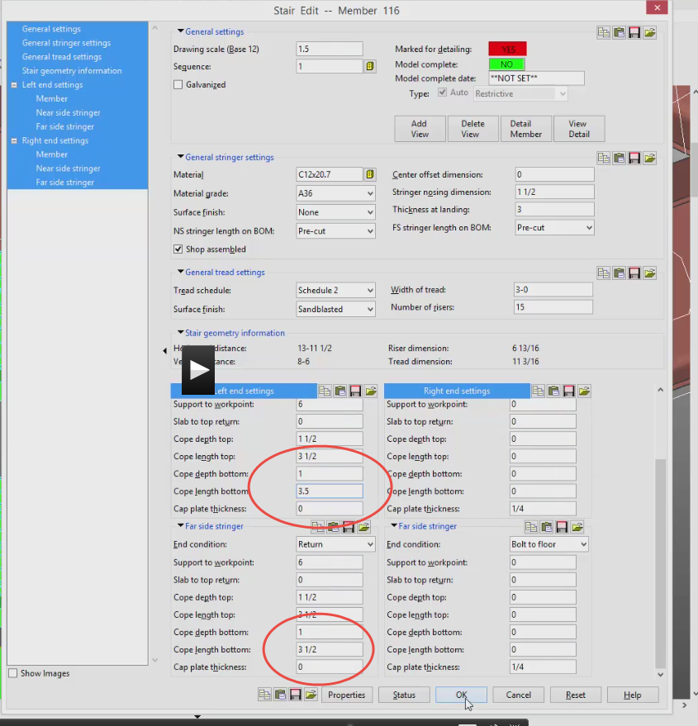

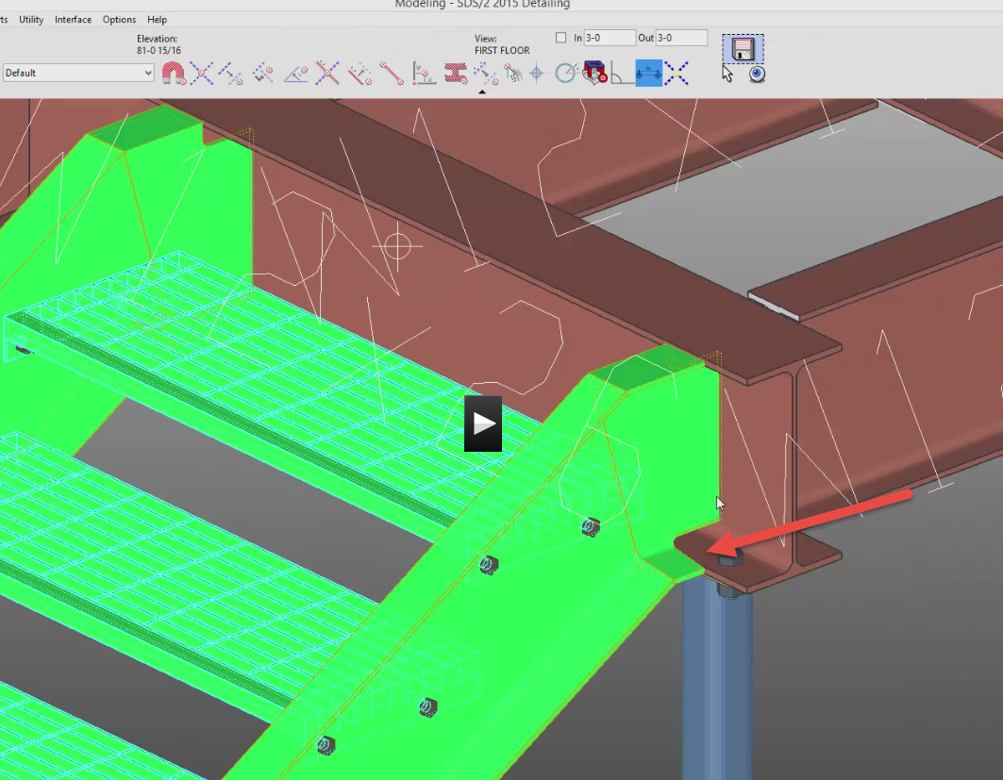
Notice stringer is going to center of beam web!
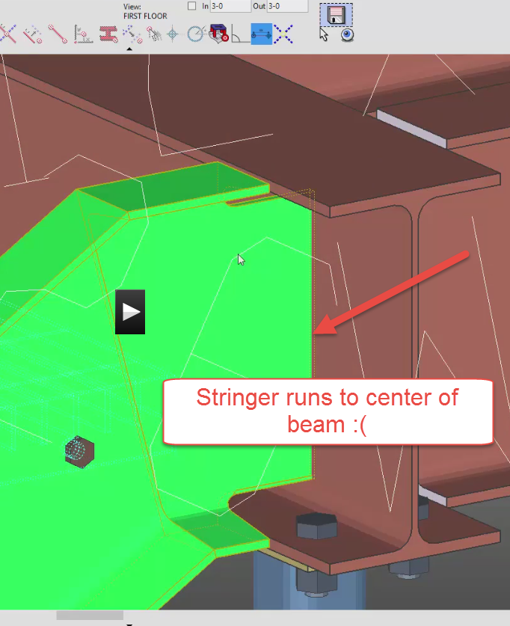
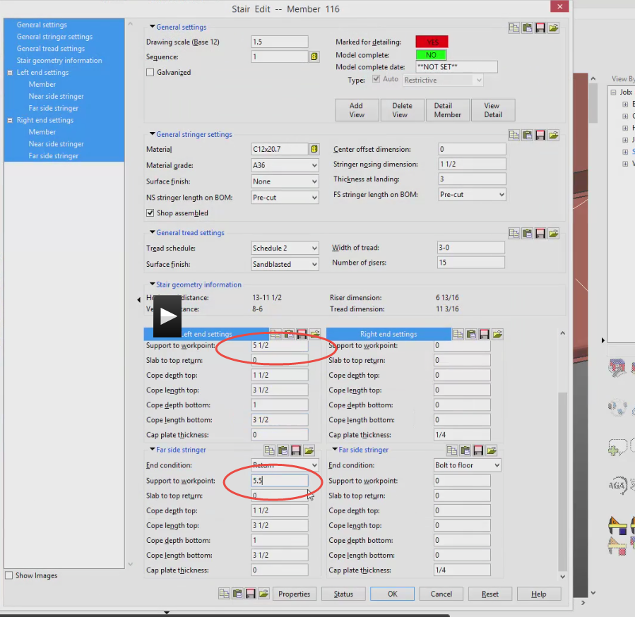
Process
Still no connections. We will build later.
To make stringer extend past first riser, (by 6” in this example)

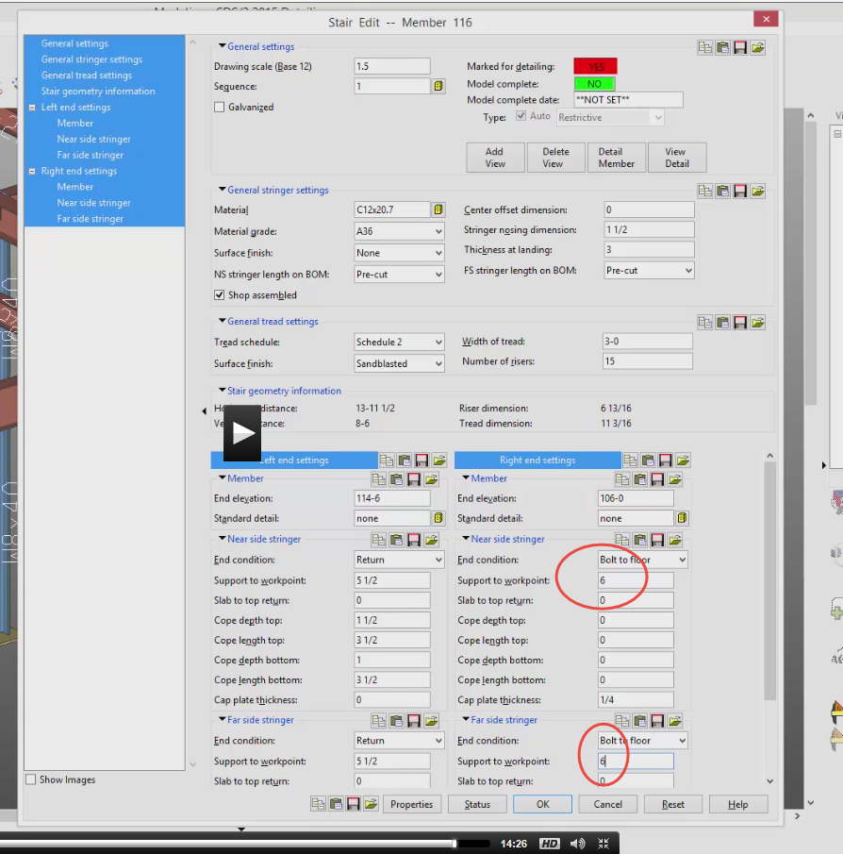

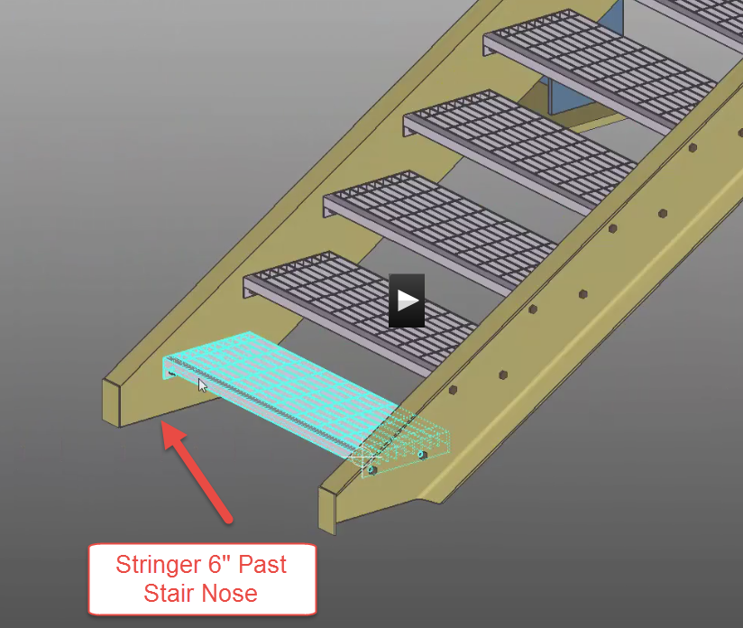

Handrail
S10
Front Deck View
Get rid of extra construction lines
Add construction lines
=/- icon is relative depth icon
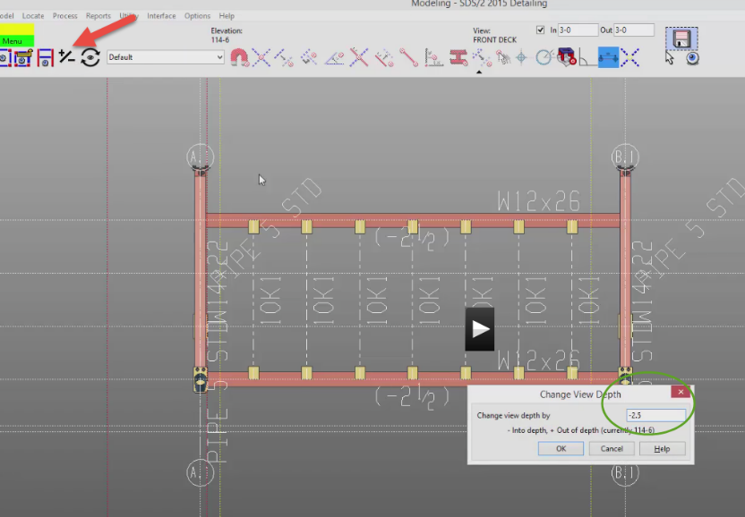
3 7/8 both
5” down (see Section A-A)
Make Rail NO
Handrail Overview
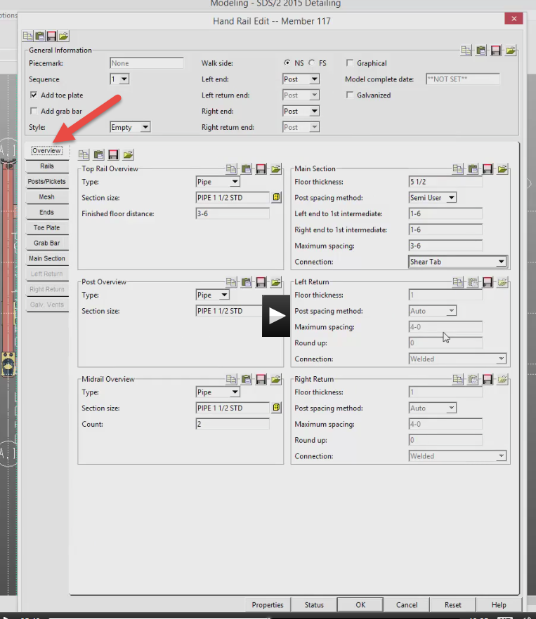
Rails
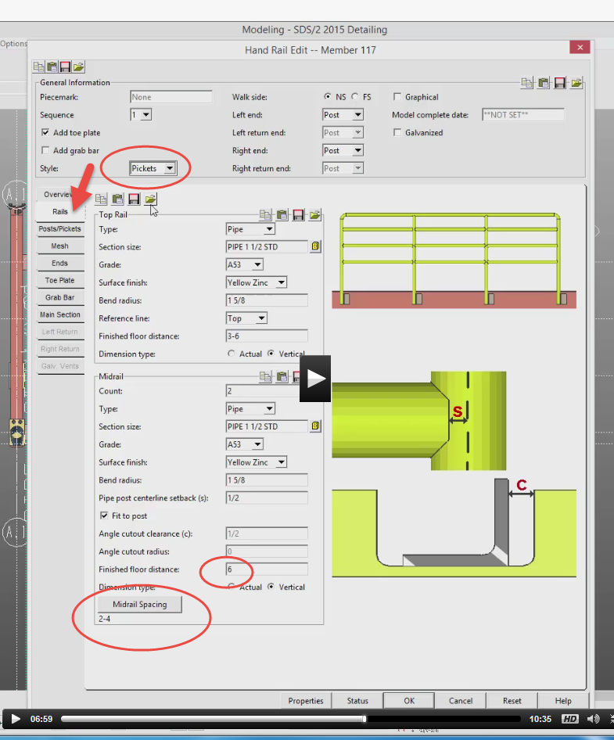
Post/Pickets default
Main Section def p-end both

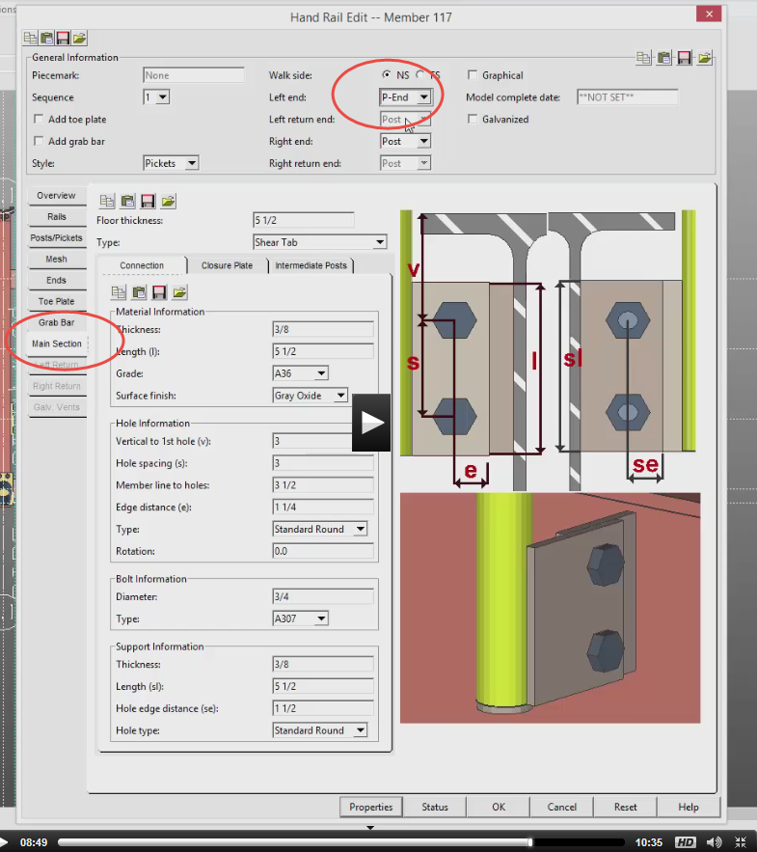
Uncheck depth before processing
Our handrail is on outside of front deck
The points picked will be top of steel
So we will go to -2 ½….on the W12x26 beam

Group Members
Purpose: To group members into 1 member (like Revit groups)
First Floor
Stair landing to group
Model….group member……create
Pick 4 members + columns (shift)
Enter
Select main member (like a base point member)
Pick beam
Should process
Now it is one member. You can edit the group, add to the group, subtract from the group…just like Revit groups….just double click….edit

Sequencing
(kind of like phasing in Revit)
Model….member….sequence by area
Roof
Members….filter
Pick purple pieces…choose 1
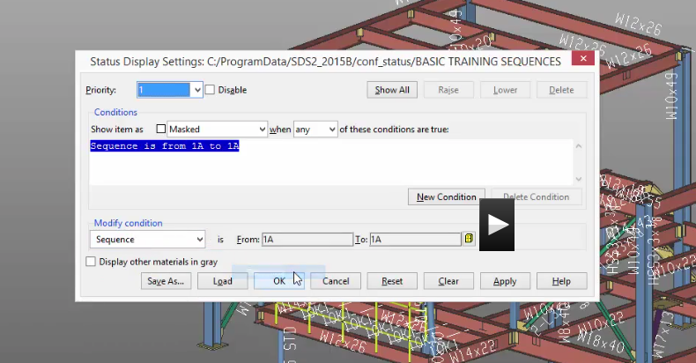
Uncheck depth…..get orange stuff
First Floor level
Get Green
Model….status display
General status….sequence (modify condition)
Show item as cyan
Priority: new 2
Change color to orange
Priority: new 3
Change color to green
Bottom of screen check status display

Hip Roof
Roof view
It will be on opposite side of canopy
Work relative depth: -1-6 (124-6)
Beams W12x22 to outside
Use exact point when going to B2 W12x14
On W8x10, use Xcons member

Column
Pipe 10 std
106-0 124-6 BP4
Top: CP2
B3 column has different base plate BP1 (instead of BP3)
See A3 column base? Uncheck depth? Rotate 180
See C3 column rotate 90
Process!

Material
Model….material….add
Note: left first, right second
First Floor
1-0 construction lines uncheck finite in cons line props
11-0 from B (right) and 1 (twice up)
Bent plate
Select beam B2 to C2 (horiz)
B2 to first 11-0
See rotate material diagog? OK

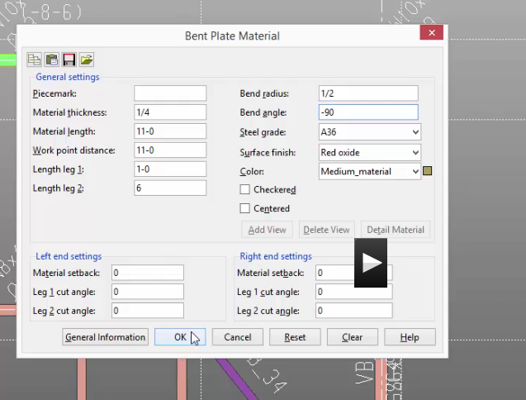
Pick lower right corner locate material dim ref point
Do next one….OK
If you keep going (on #3 it will add to horiz beam (NO!)
ESC
Pick Vertical beam
Material not smart….does not trim at column

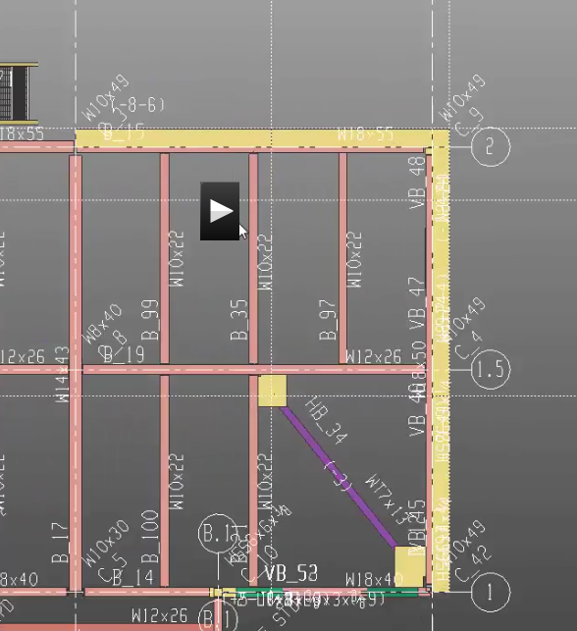

Cope plate around column at B2
Model….material…fit cope
Pick bent plate
Pick column….RC
Clearance: ½ OK
See preview? YES
Change all options OK

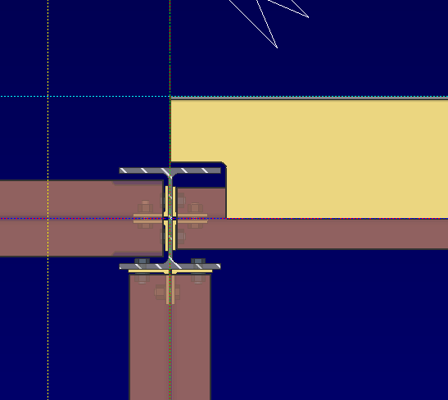
Miter
Model….material….fit miter
Pick horiz and vert (shift) both
RC….OK
Fit clearance 1/16 OK

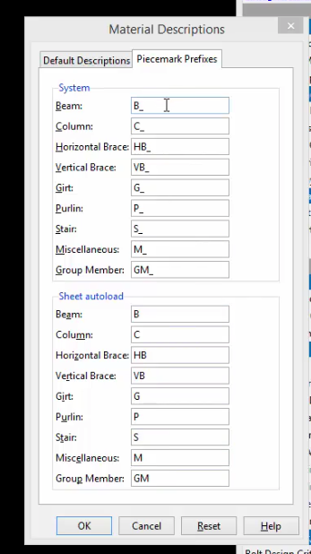

Fabricator Setup
Main Menu
Job or Fabricator Options
Dimensioning Crteria
General tab
Show Help: Dimension style for SDS2
Beam
Show Help
OK
Main Menu
Job or Fabricator Options
Drawing Cosmetics
Text Size (in MM)
Fonts (change to Arial?)
Pens
Bill of Material
Primary Dimensions
Main Menu
Job or Fabricator Options
Fabricator Setup
Member and Material Piecemarking Options
Main Member
Prefixes (show students prefixes!)

Detailing Erection Views
In Main Menu
Process/Detail….Detail Erection Views
Pick first view….Settings (box on right)
Member style: stick
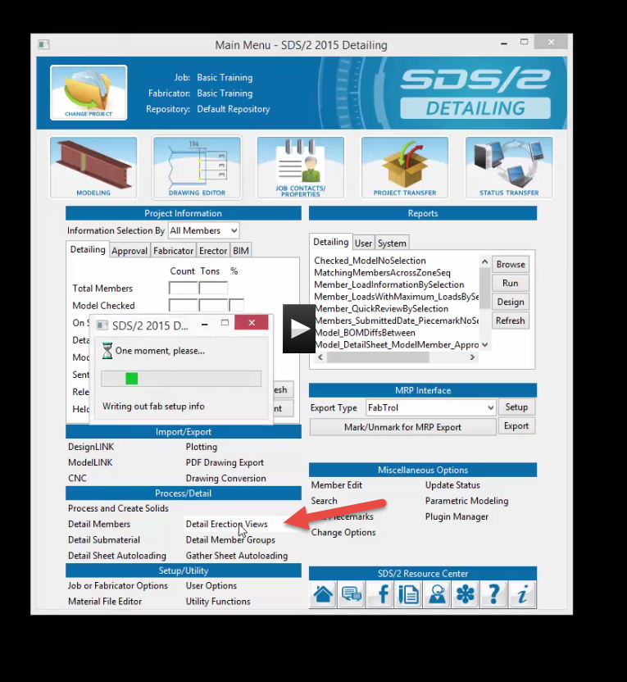
Annotations
Check Annotation Erection views on the very first time you run it
When you re-detail, make sure it is checked

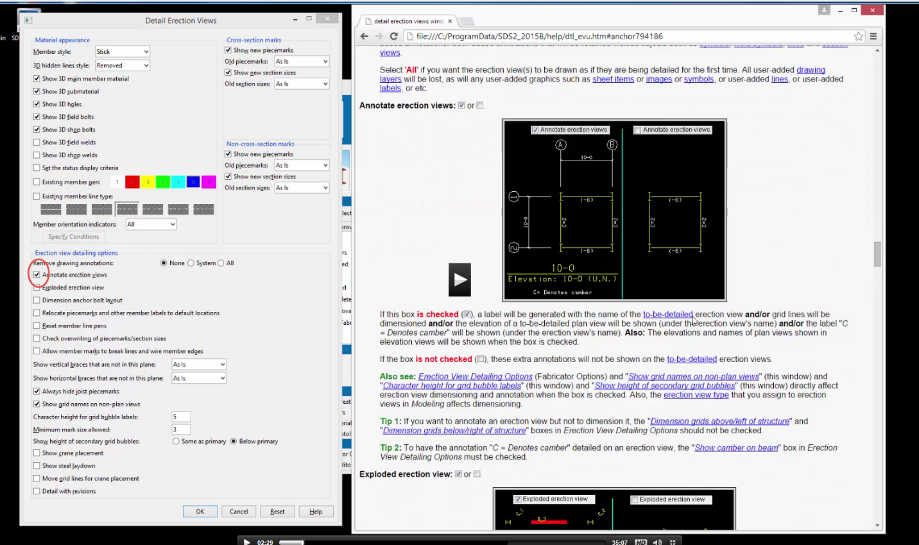
Check Anchor bolt layout (just for this view)

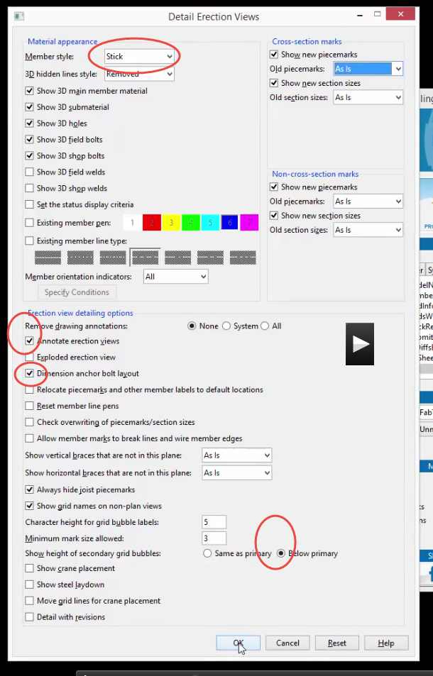
Select view to detail
Anchor Plan
OK
Now do the rest
Detail Erection views
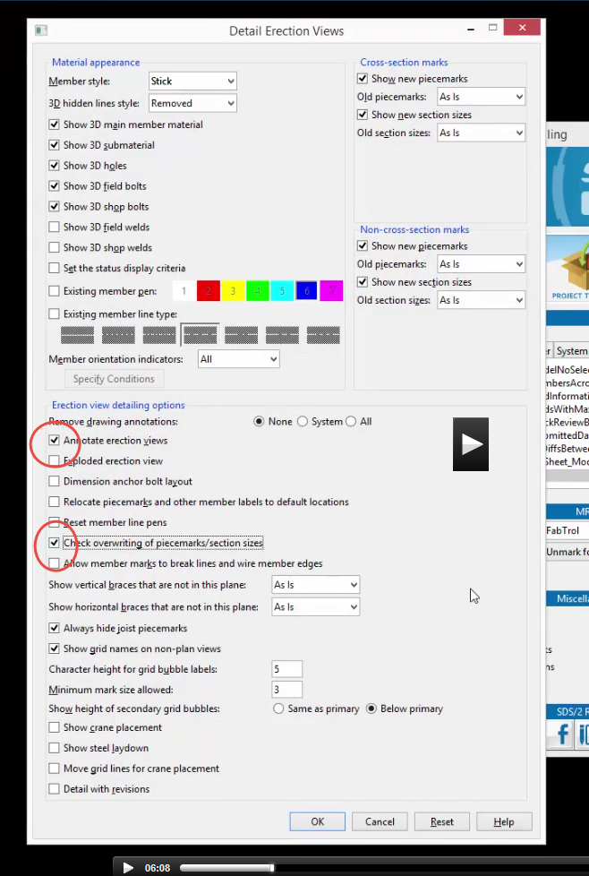
OK
Pick Views (shift)
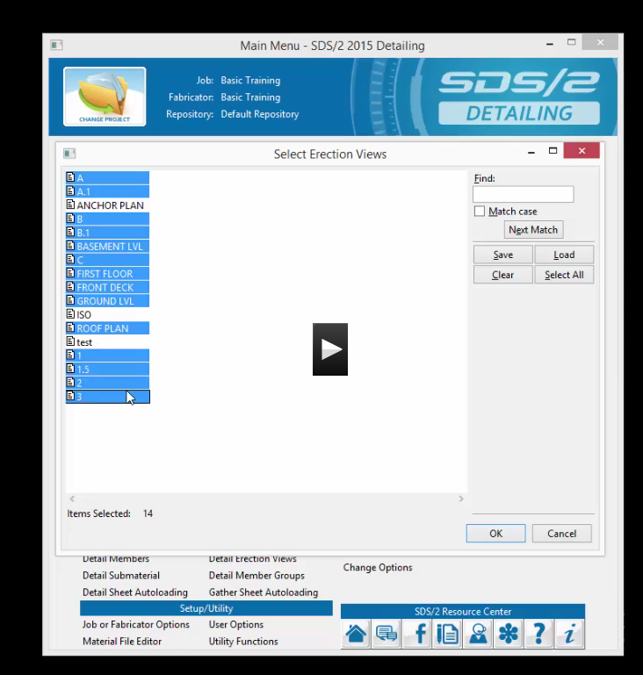
OK

You can do it from Modeling too!

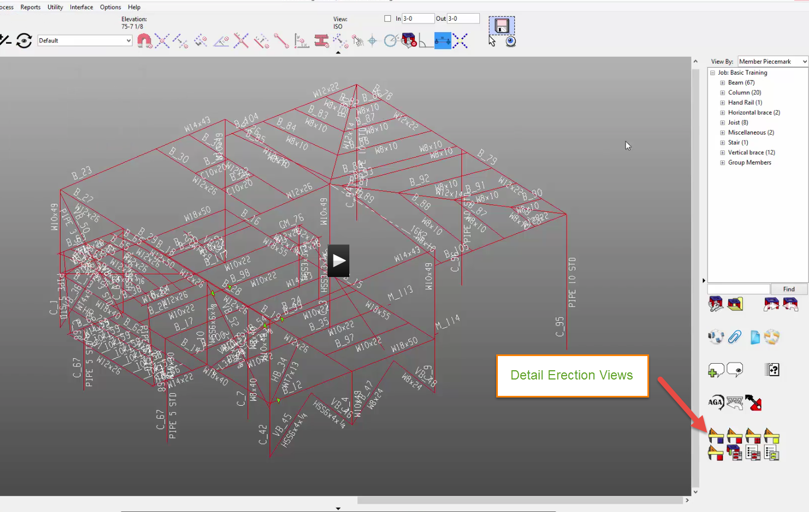
To look at views
Main Menu
Drawing Editor
“Home Screen” of drawing editor
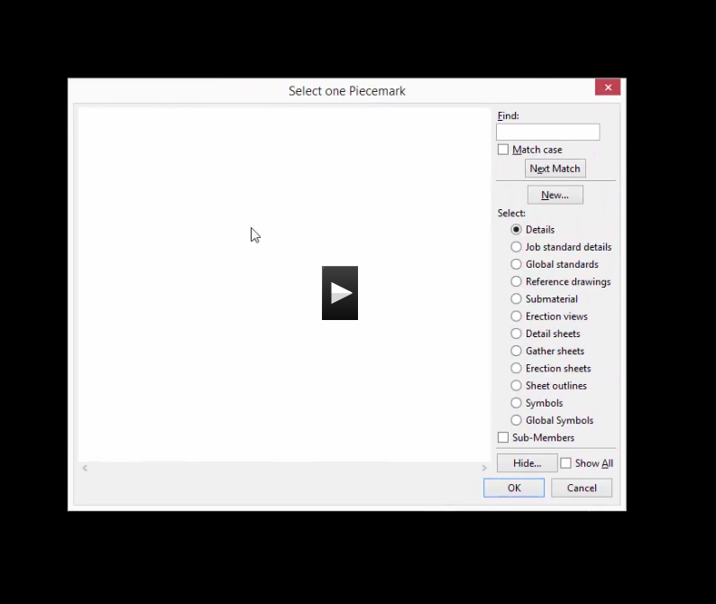
Erection Views

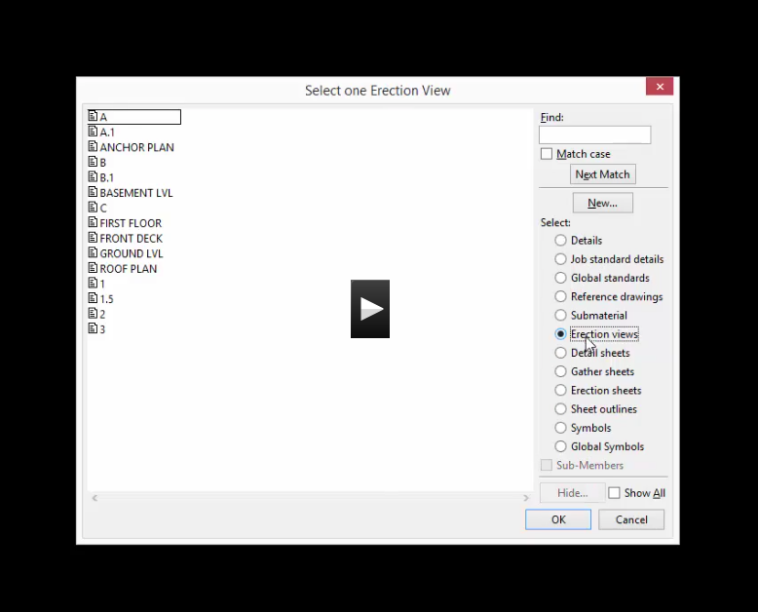
Look at Erection Views!
Pick file first….OK
Open (yellow folder)
Next/Previous

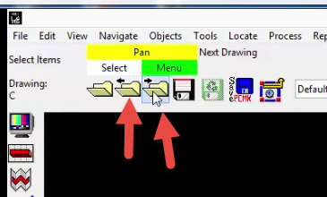
Go to Roof Plan
See overlapping details? Drag where you want to make readable.
In drawing editor, there is UNDO (YEA!)
Which means you MUST SAVE (YEA again). Use the diskette so save.

Erection Views cleanup
Roof Plan
Select and Delete (doesn’t remove from model)

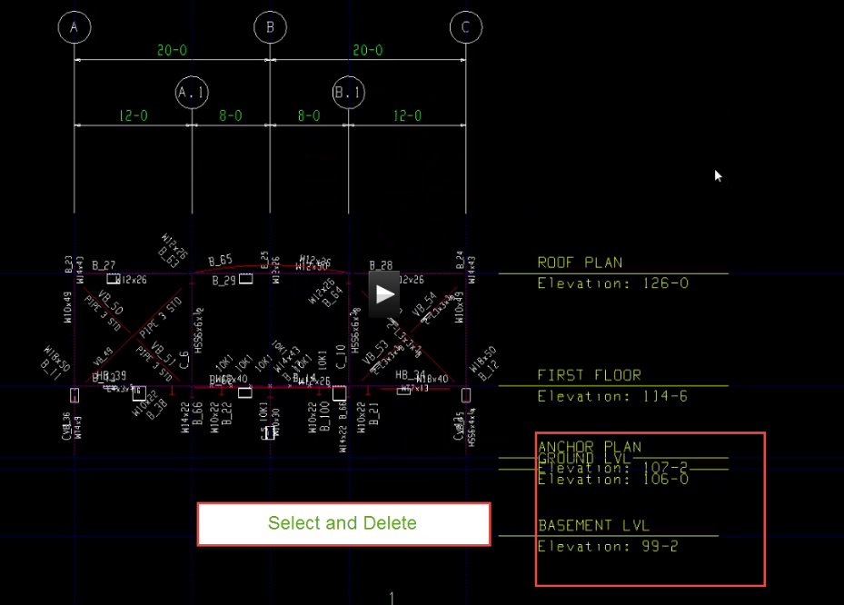
To get it back
Display Options (TV)
Show hidden members

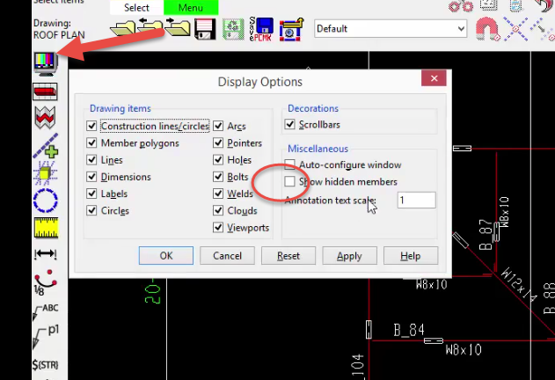
Double click on item
Check on empty box to bring back
Uncheck show hidden members

Main Menu

Detailing Members

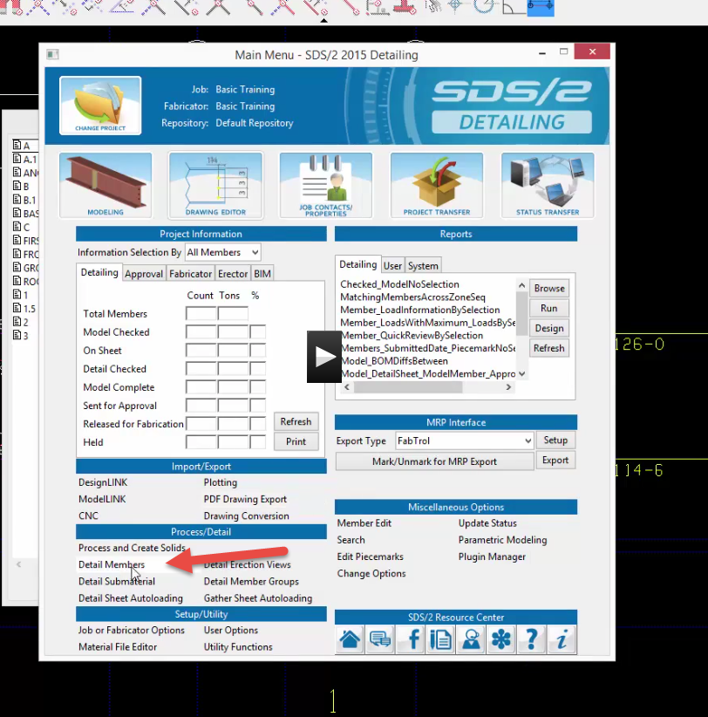

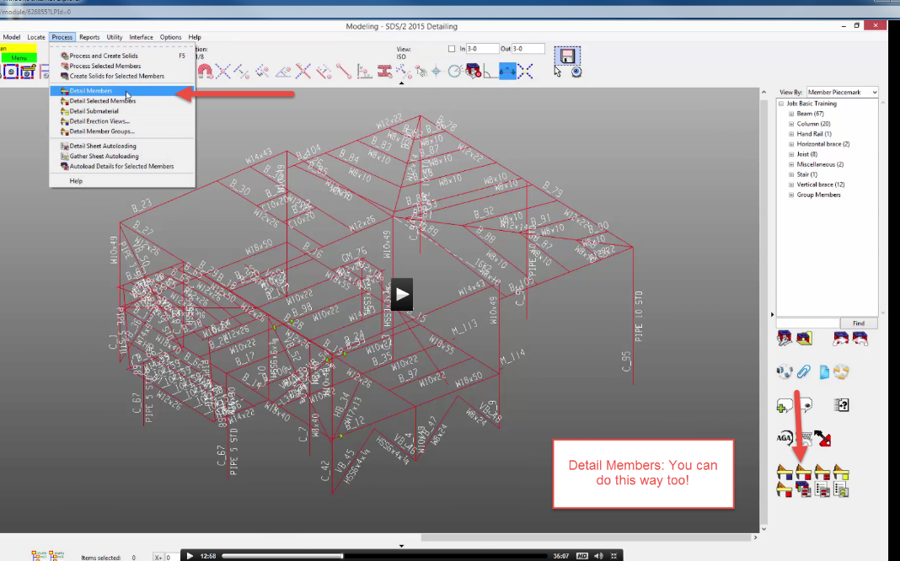
Select Piecemarks
Anything in blue needs to be detailed
OK
Settings
Member annotation box
Uncheck Detail Using Templates
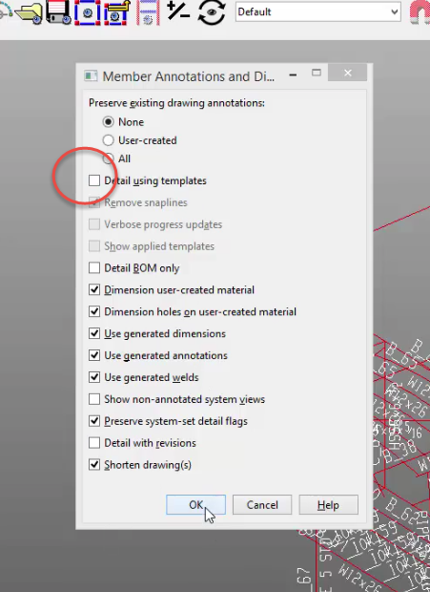
Ok….OK
Starts detailing
Warnings are fine…WOW!
OK
To view details
Drawing Editor
Check Select details (on right at top of select column)
Pick first one B_11??
OK

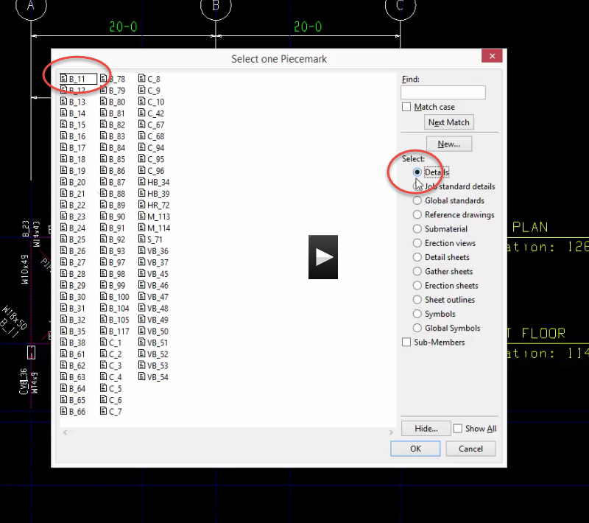
Use next folder….
Unshorten drawing if edited

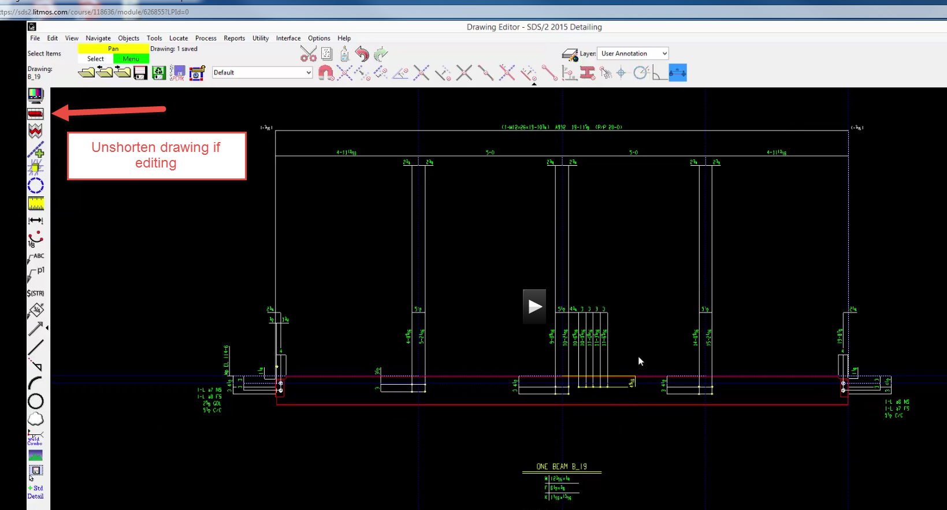
Shift select to move
To add dimensions:
Objects….dimension…..add (or use icon)

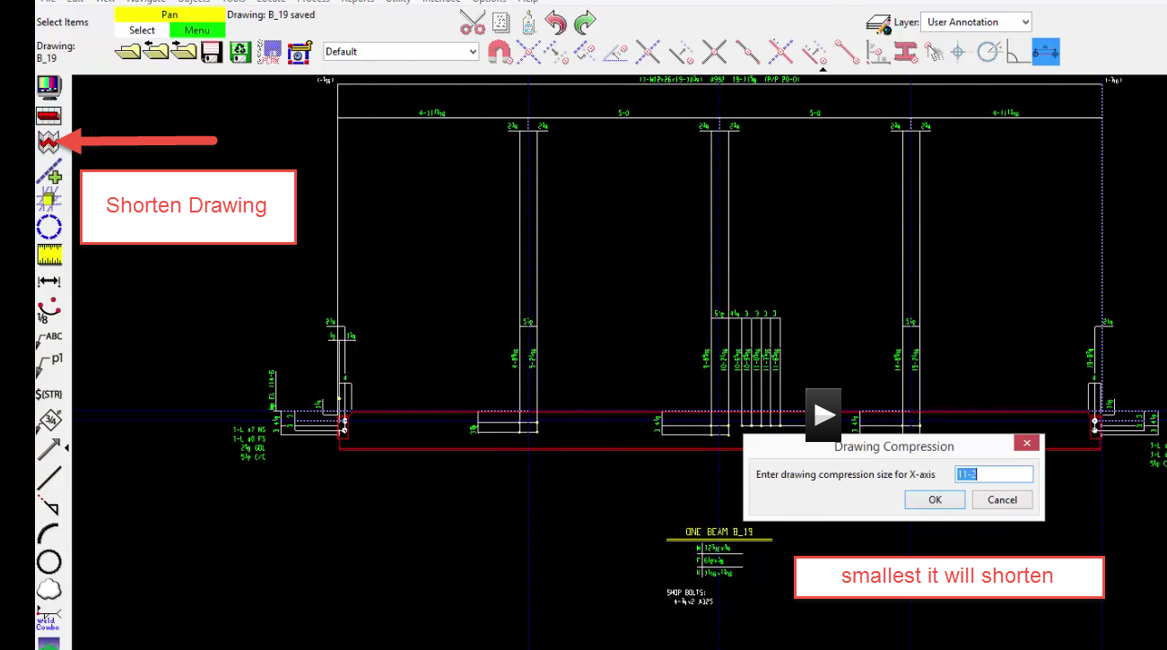
Watch LC RC area to place
Save
Shorten drawing
Save
Show tools to add labels, notes
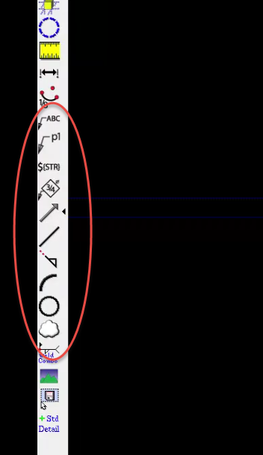

Detailing Submaterials

Main Menu
Process/Detail
Detail Submaterial

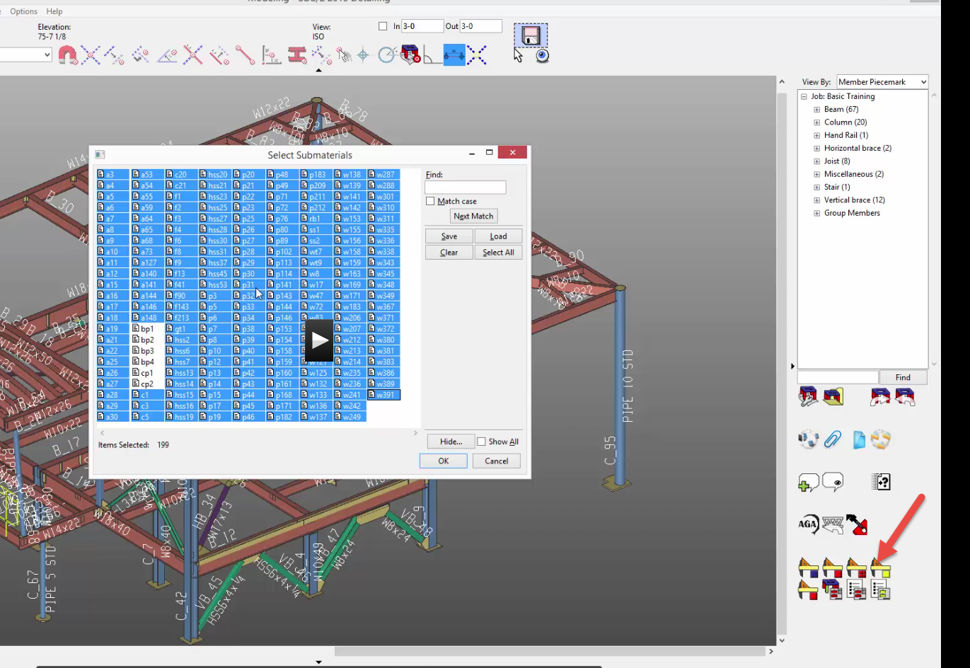
On Select Submaterial dialog box:
Hide
Category and Misc
Check main material (Main materials are not shown as submaterials)
(Total of 4 checked?)
Base plate and cap plates not in list automatically. Pick them too!
OK
Check Detail using templates
OK
It’s working!
OK to warnings
Drawing Editor
Submaterial
Pick first one (a3)

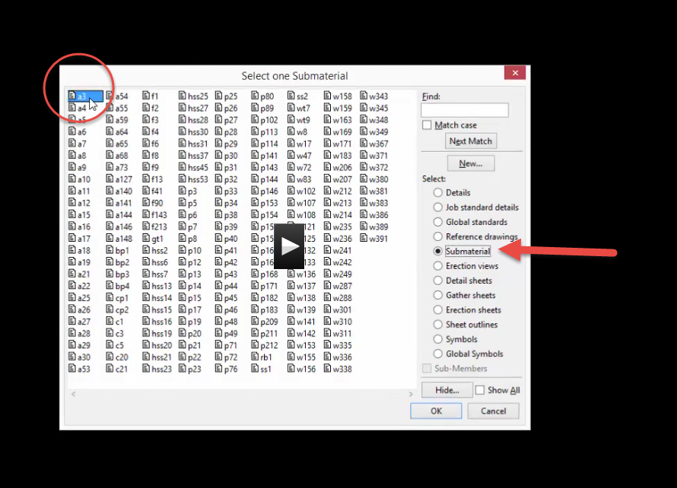
Arrow keys
See baseplates, stair stringer, shear plates, pipe, gusset plates
Not much cleanup!

Sheet Outlines
Some sheet outlines already in 2016
Need sheet outlines before adding views to sheets
Drawing editor
Sheet outlines
New

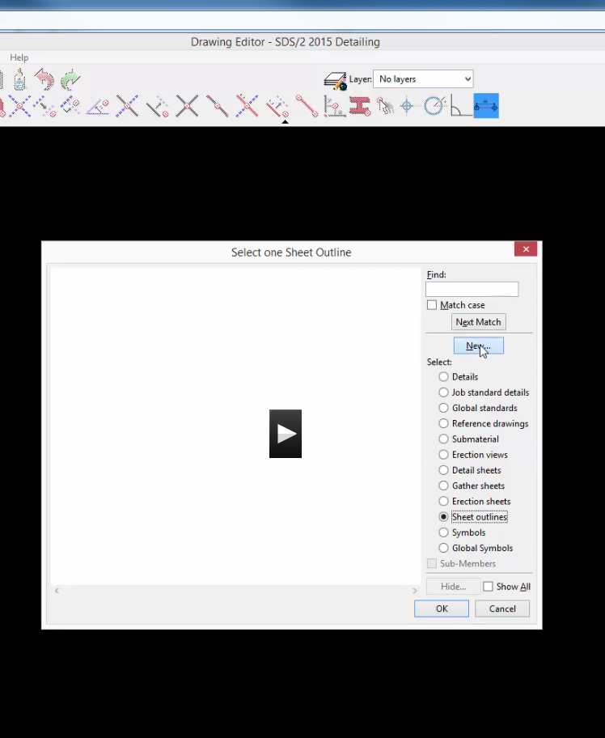
Name it: E24x36 (E for Erection Sheet)
Arch D
Check Landscape
OK
See edge. That is plotable sheet area. Note: you could import .dwg titleblock
Std detail

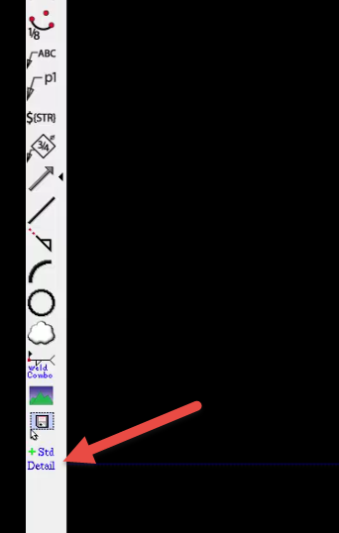
Check Global std
36x24 border
OK

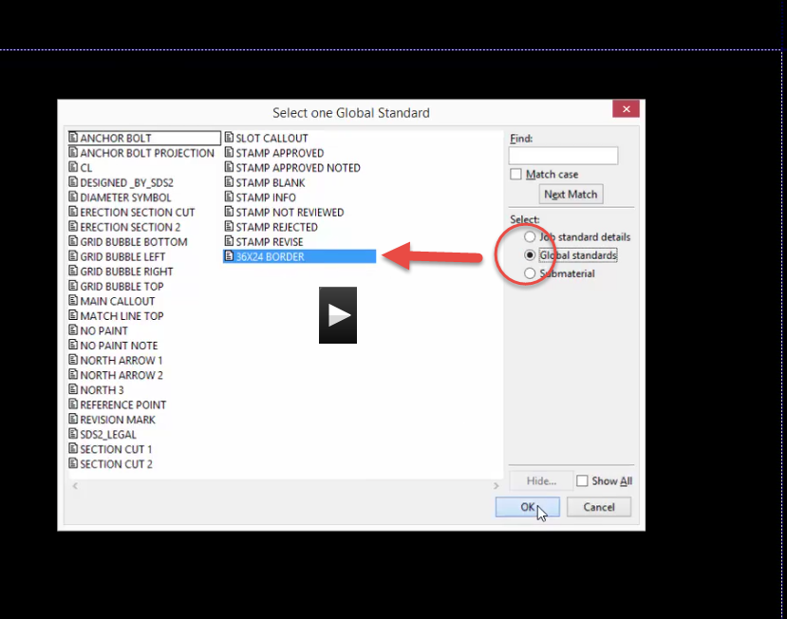
Locate it (RC done)
In title block
Bring in labels (that go on all sheets)

Labels
Help
Index
L
Labels
Labels special (link)
$NAME (all Caps …case sensitive)

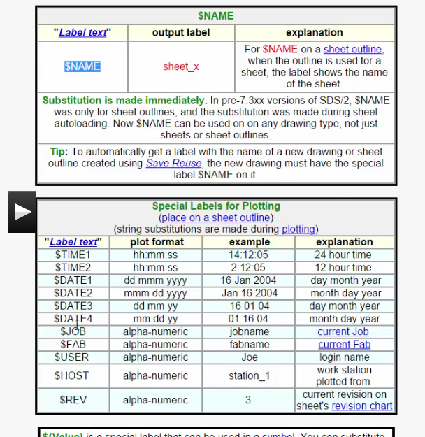
Labels only update when sheet is plotted…just like Revit labels!
Label (icon on left) $(str)
MC to activate label text
$NAME at DWG NO.
See E24X36 (that is the name of the sheet)

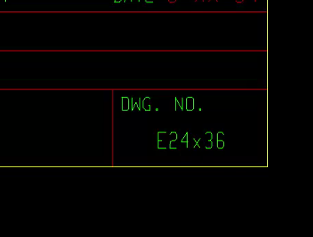
$JOB at JOB
$USER at Made by
$DATE2 at DATE
Delete the white dots
Save (diskette)
Need a new outline sheet for stuff with BOM
Green Floppy
Next drawing name: D24x36BOM
OK
See drawing name D24x36BOM?
To add BOM
Objects
Bill of Materail
Place Bill
Place on top, right corner
LC to accept….Esc
Note: you can place multiple BOM’s on a sheet
Double click on BOM
BOM layout
Appearance
Set minimum number of rows to 10 Max 65

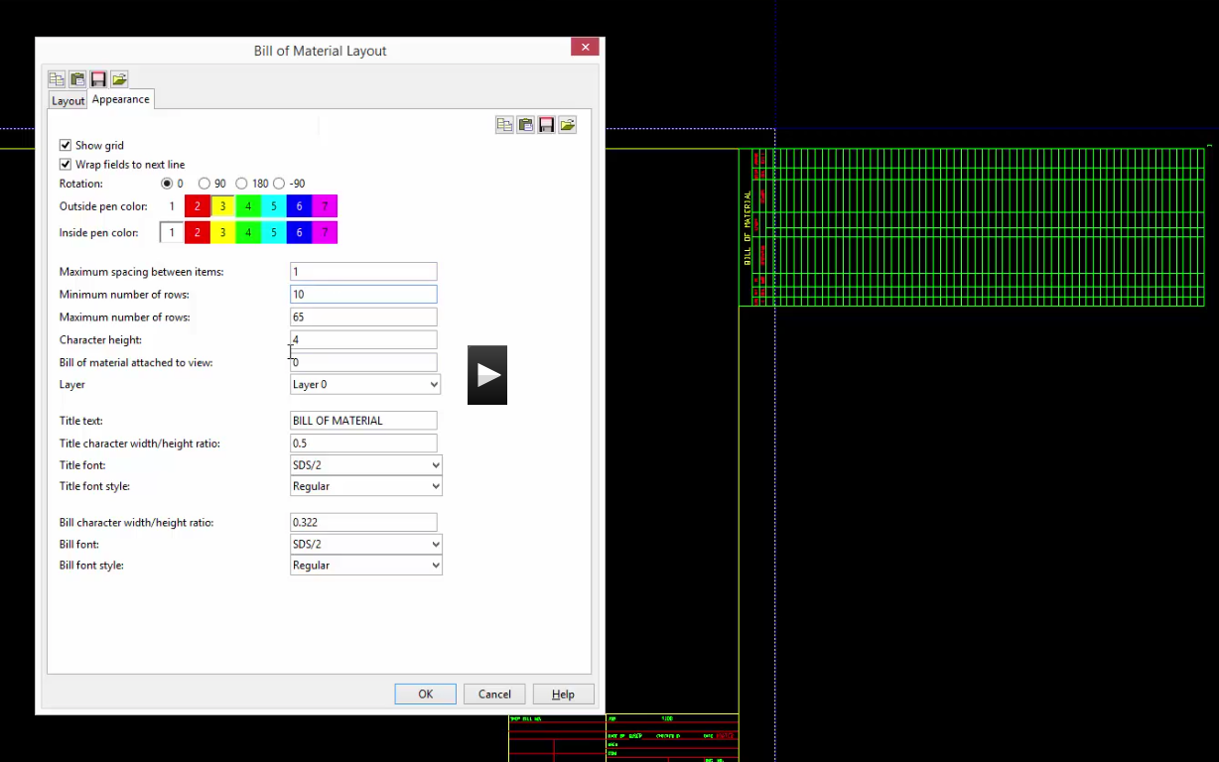
See it is shorter now. As stuff is added, it gets longer (up to 65 items….get it?)
Save

Gather Sheets
One more sheet outline…Gather sheets
These will be smaller sheets that will hold just one part.
File open (yellow folder)
Check sheet outlines
New

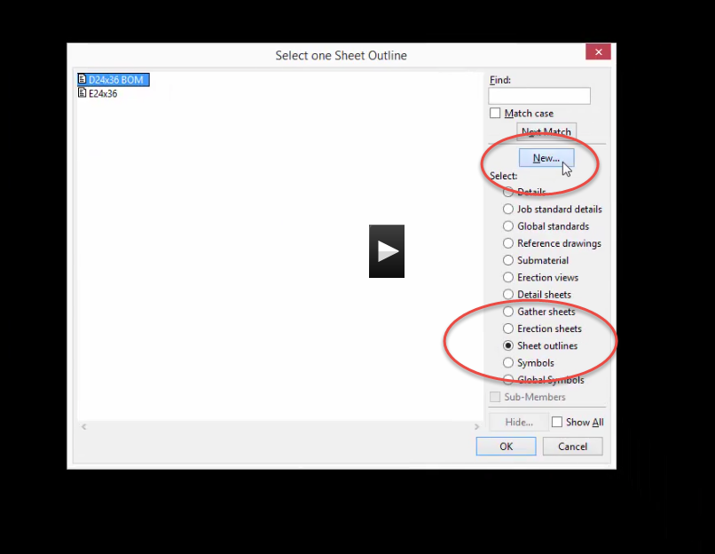
Name it G11x17
OK…..Paper size: ANSIB
Landscape OK
Draw construction lines ½” in, the 1 ½ “ up from lower construction line to form border layout
Line command over
Will start at center of screen….a little weird….MC to where you want to start
LC to place
Edit lines to solid if they are not (RC…edit)
Add label
$NAME 10 character height change font
Save
All 3 sheet outlines are now created!

Loading sheets
Drawing editor
Check Erection sheets
New
Name: E1
OK
E24x36
OK
See E1 in sheet
To add:
Objects
Sheet items
Add
Pick erection view
Anchor Plan
OK
Locate it
You can change scale….try .2
Next sheet
Save/Reuse (green disk)
Next drawing name:E2
Check Discard Sheet Items
Obj
Sheet items
Add Bring Plan views on sheet
OK
Save Reuse
E3
Add rest on sheet (lettered)
E4 Finish
These views were added MANUALLY to sheets
Save
Note: show sheet add icon at bottom of screenDetail Sheets
Open

Detail Sheets
New
Name: 1 OK
D36x24BOM (see BOM?)
Sheet Item add
Bring on beams
See BOM filling out?

Detail Sheet Autoloading
Now the good part!
Main menu
Detail Sheet Autoloading
D24x36BOM
Starting sheet 1

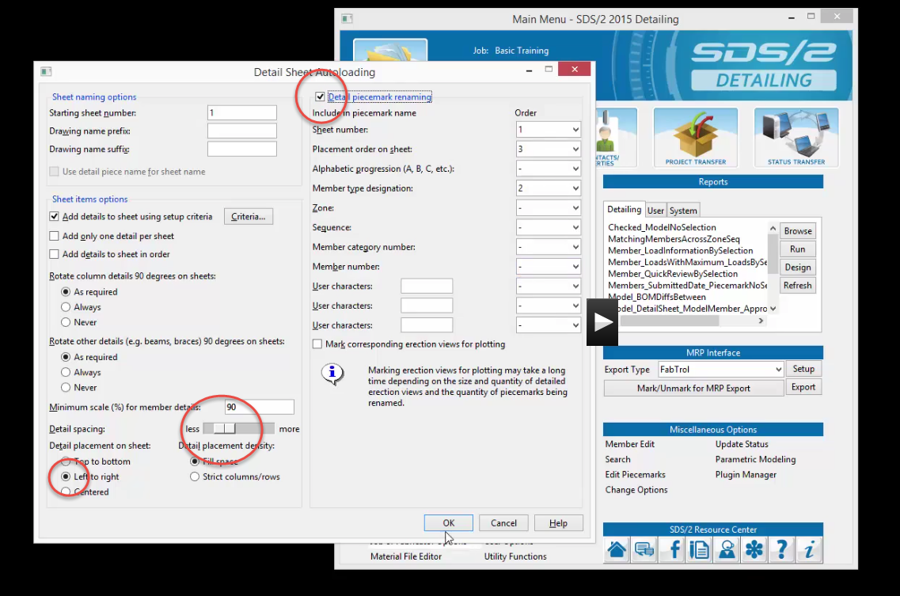
Pick all details OK (select all icon)
Starts autoloading
OK to error. You will have to load manually all drawings that did not autoload. They were too big to fit on sheet at that scale.
HINT: write down piecemarks so you know which ones you need to add to sheet manually!

Detail Sheets
Drawing Editor
Detail sheets
Pick #2
OK
Note piecemarks are all numbered! 2B6…..2B7…etc
Detail sheets
See sheets?!!!!!
For details that did not fit on sheet:
Open
Details
Pick one
Clean up dimensions
Objects
Viewports
Add
Create vport
Make another
Name it
Save
Detail sheets
New next #A
BOM
Edit
Viewport
Just puts vport in
Next #B
OK….OK
Change to other VP
Save

Gather Sheets
Open
Check Gather Sheets…..NO…NO….NO! That would be CRAZY!
Main Menu
Gather Sheet Autoloading
G11X17
Use default in box
OK
Select all
Open Gather sheets….there should be a bunch!
Open Gather sheet
See them??

Moving/Archiving the SDS2 File
Main Menu
Project Transfer
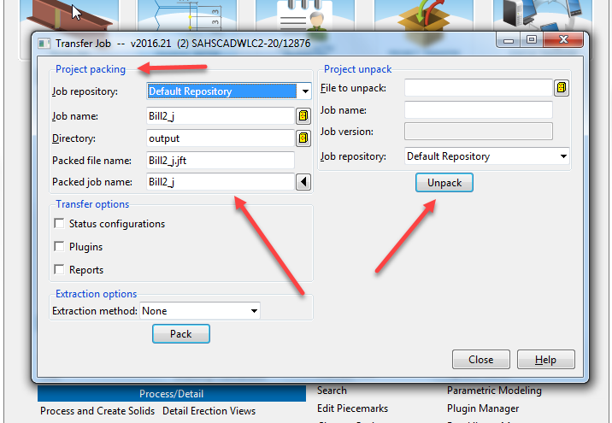

Printing and Creating PDF’s
Main Menu
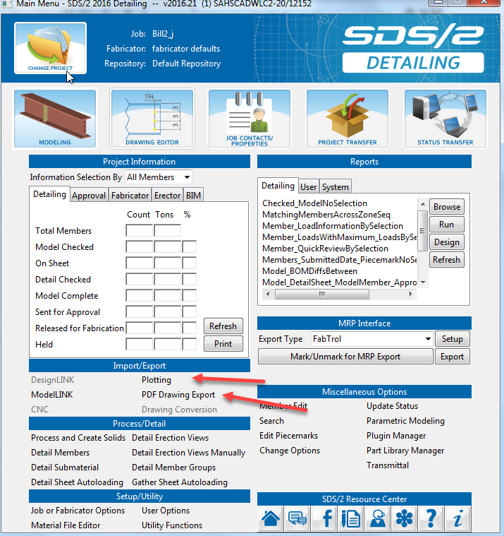
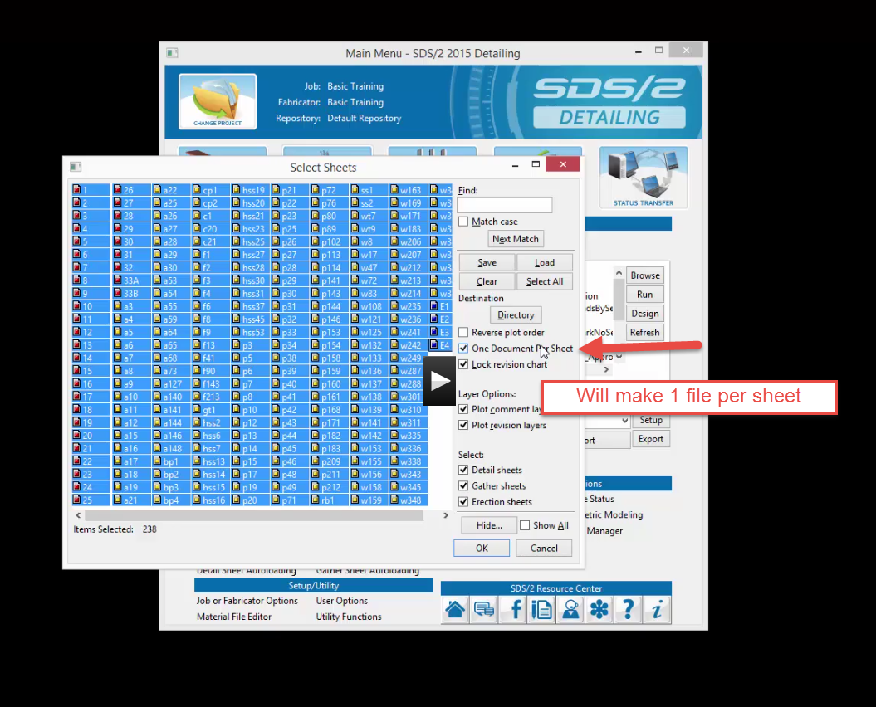
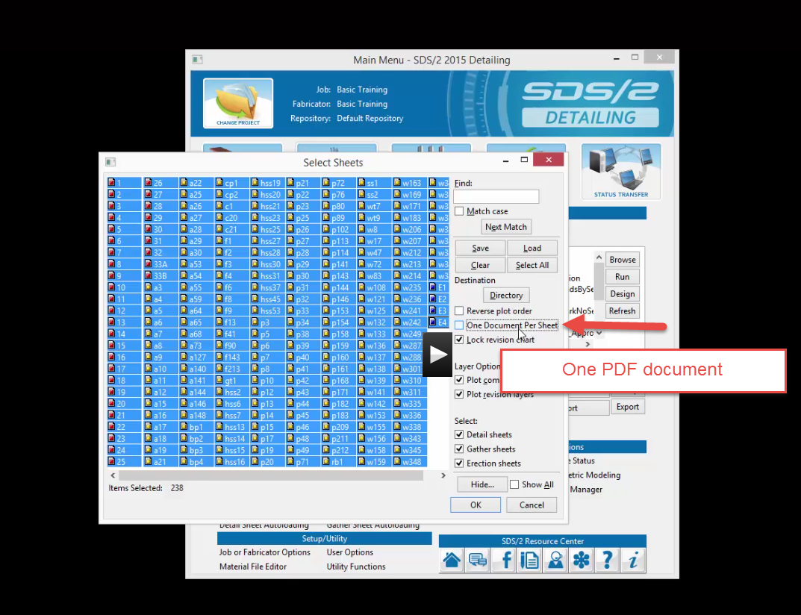
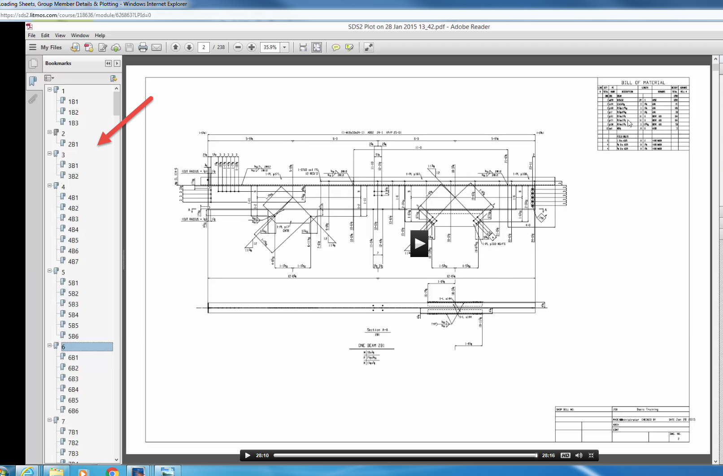
See bookmarks to go to sheets and views organized in you pdf program. Note: the company who owns Bluebeam recently bought SDS2…so pdf’s should be great!

SDS2 to Revit
There are a few ways to get your SDS2 model into Revit. None are perfect yet.
1.SDS2 in ModelLink exporting model as .xml In Revit: Import xml using SDS2 Connect
Or Model…..Revit…..export…
Good: Members come in accurately
Bad: No connections come in
Bad: No grids come in
Good: Easy to create grids leveraging accurate geometry
Bad: It’s not a linked file, so you can’t turn it off with one button. You could create a Revit structure file that could be linked with the other disciplines.
2. Open IFC
SDS2 in ModelLink exporting model as IFC (EM11IFC)
In Revit:
Open (arrow) IFC Options
Default Template for IFC Import-Proj IFC
Open (arrow) IFC
Pick file from SDS2
2. Link IFC
SDS2 in ModelLink exporting model as IFC (EM11IFC)
In Revit:
Insert
Link IFC
Pick the linked file.

