Looking for a 1-semester elective class to pair with your 9th grade, 1-semester Health class at Santiago?

Santiago High School

INTERIOR CAD DESIGN 1A

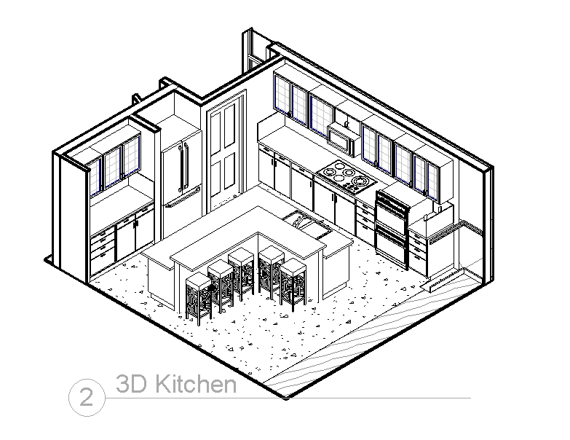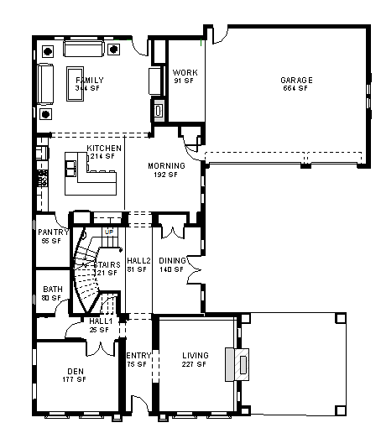

Interior Design 1A is the first class in the Architecture Pathway (along with Intro to Engineering and Architecture 1A/1B) at Santiago High. The goal will be to expose you to the type of work Interior Designers do in an architect’s office.

In this one-semester class, you will be introduced to “Revit Architecture” CAD software (retails for $6000!) that will allow you to more efficiently design building interiors. You will produce a professional-level set of drawings related to the interior elements of a home such as: Interior Elevations, Expanded Floor Plans, Floor Finish Plans, Furniture Plans, Schedules, Specification Sheets, Ceiling Plans, 3D views, and Material Boards. You will design the Kitchen, Bathrooms, Living Rooms, Bedrooms, and Dining Rooms. Furniture, flooring, wall paint, fixtures, countertops, cabinets…even a custom tub….you do it all!

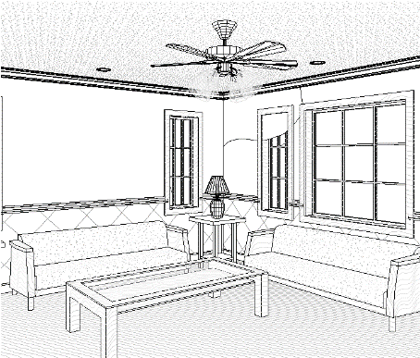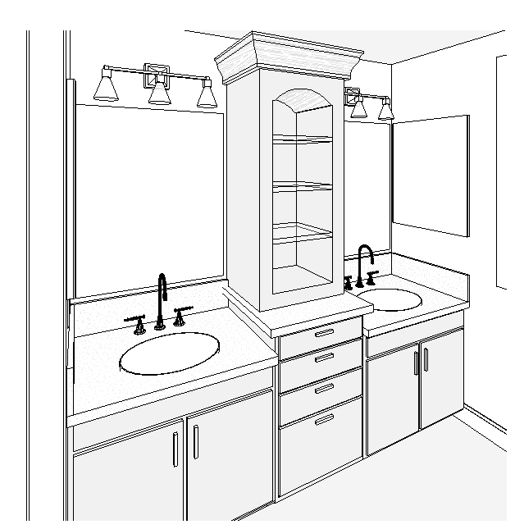
.

Interior Design 1A has no homework. It is a lab class, so all the work is done on computers in class. No computer or interior design experience is necessary! 9/13/16

