EnergyPro 7 Tutorial: From Scratch
Student Store
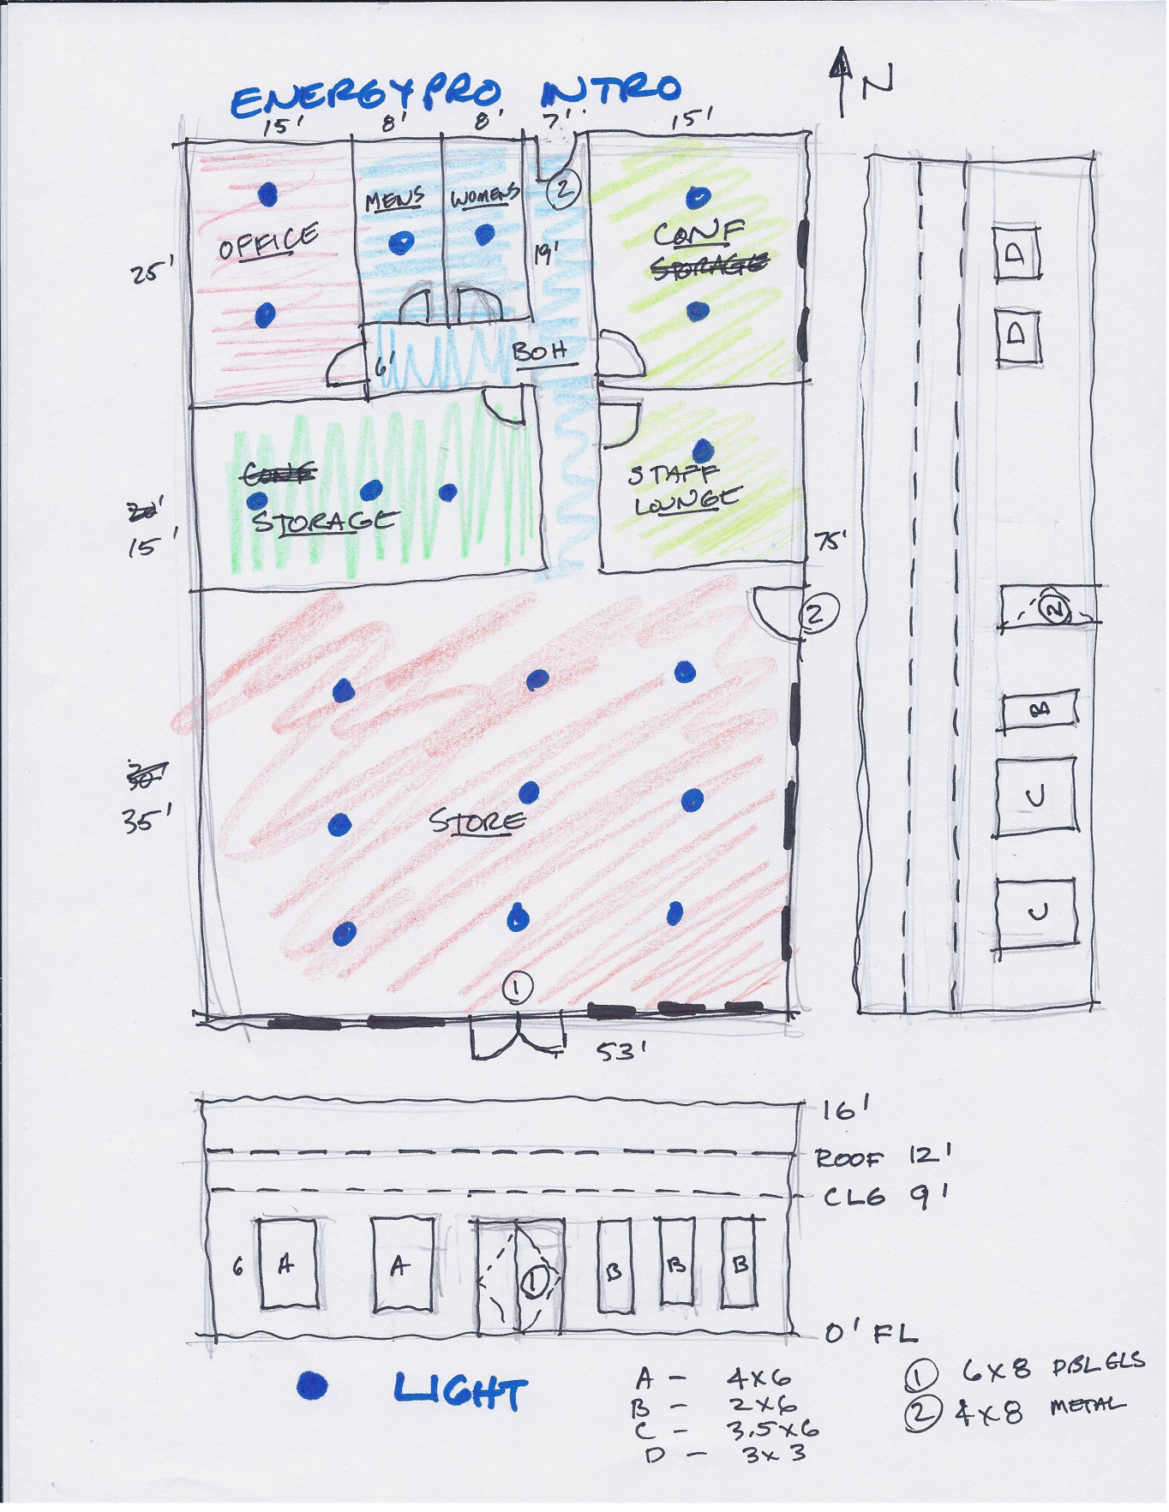
Open EnergyPro
File
New
Undefined
Rename to “STUDENT STORE”
Front orientation: South (it might say 180 deg)
Location: Corona, CA
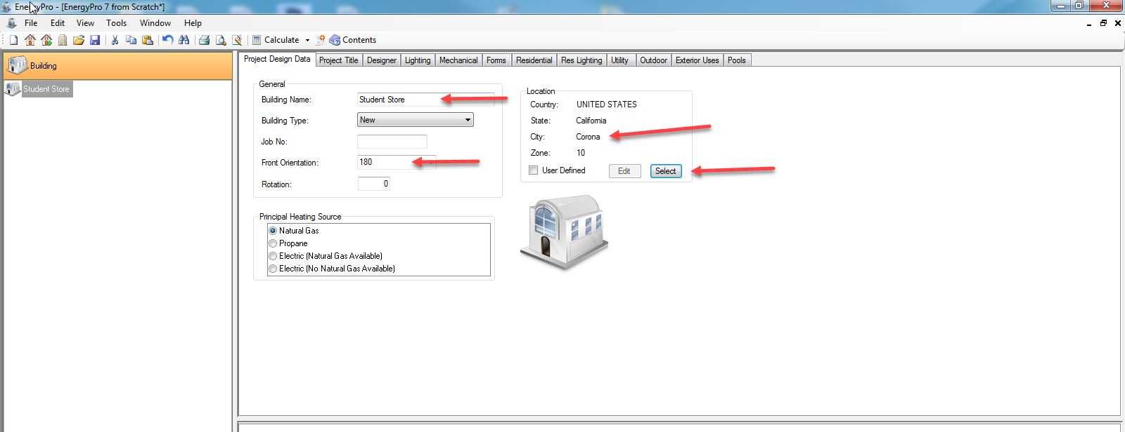
RC on STUDENT STORE
Add Plant (this is your domestic hot water)
Name it DHW
Give it Standard Gas 50 gal or less
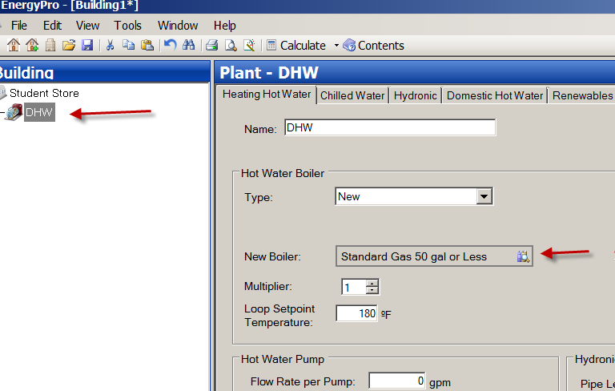
RC on DHW
Add System (this is the HVAC unit)
Rename to HVAC
RC on HVAC
Add Zone
Name it Zone 1
Note: we will need 5 Zones. Make them.
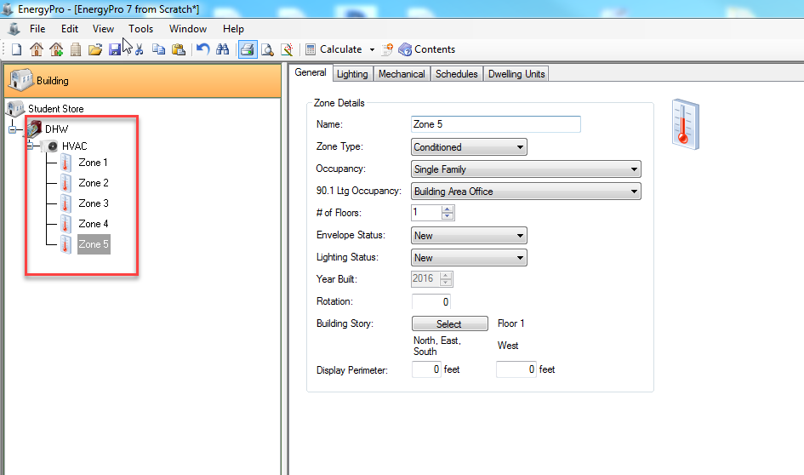
Zone 1 will hold the Store
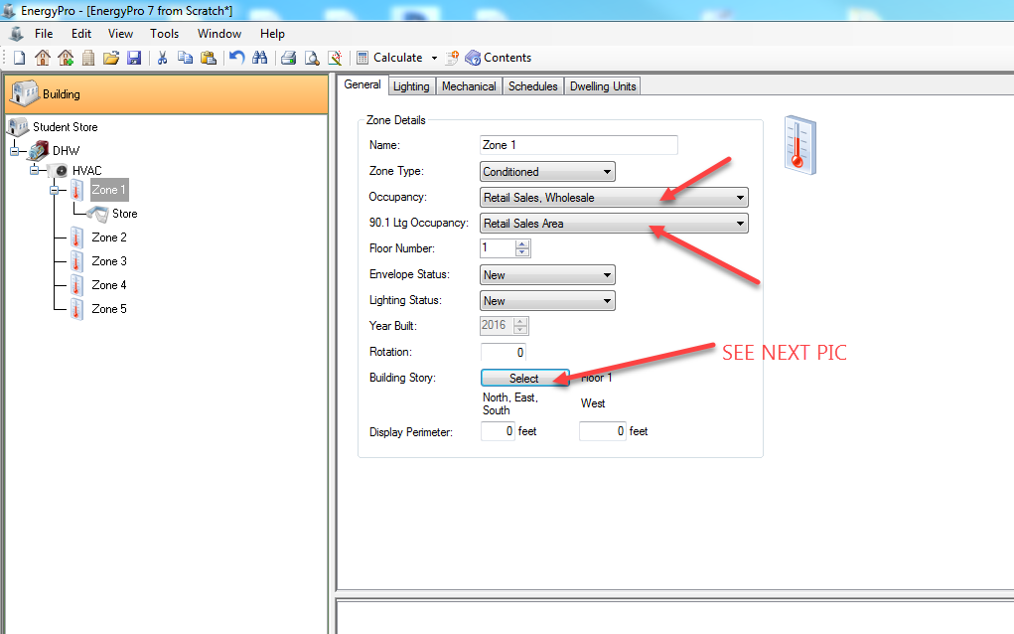
Occupancy: Retail sales: Wholesale
Zone Type: Conditioned
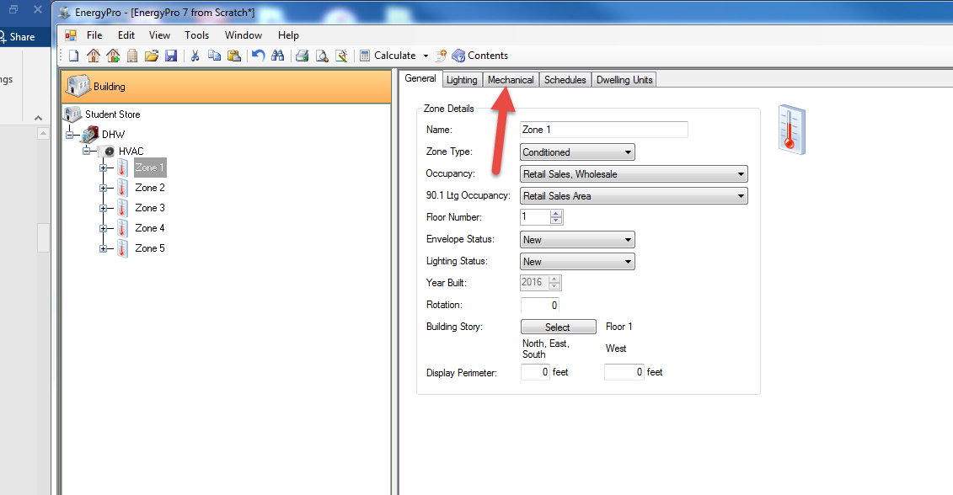
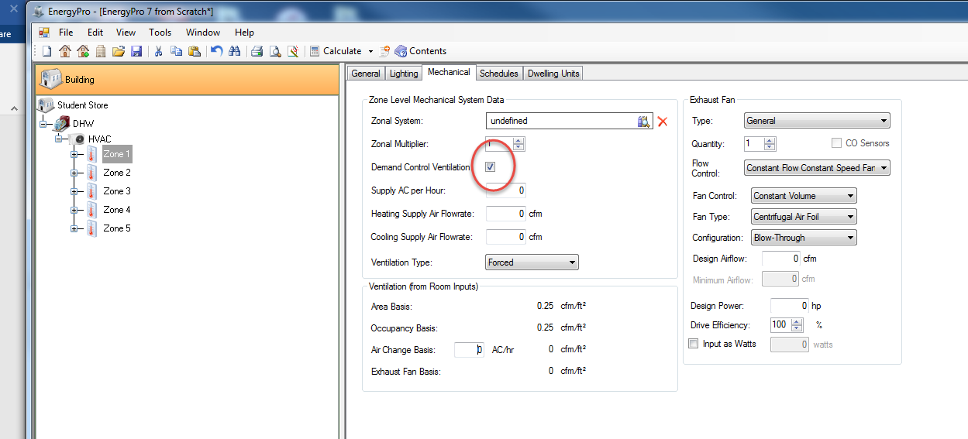

In Zone 1, pick the “Mechanical” tab. There is a checkbox for us…..Demand Control Ventilation.

The Zone will have a ceiling height of 9’0” (use average of rooms in the zone if there are multiple rooms). Same with the window head heights. Floor to Floor is 12’0”
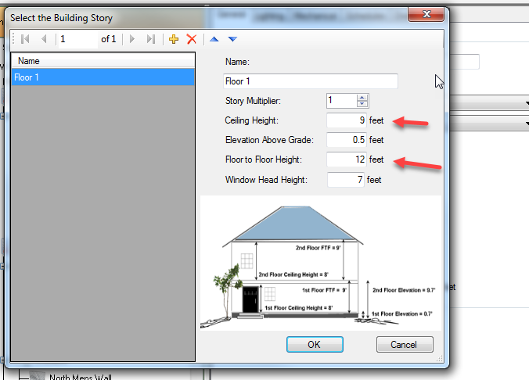

RC on Zone 1 ….Add Room
Name the room: STORE
Area: 53*35= 1855
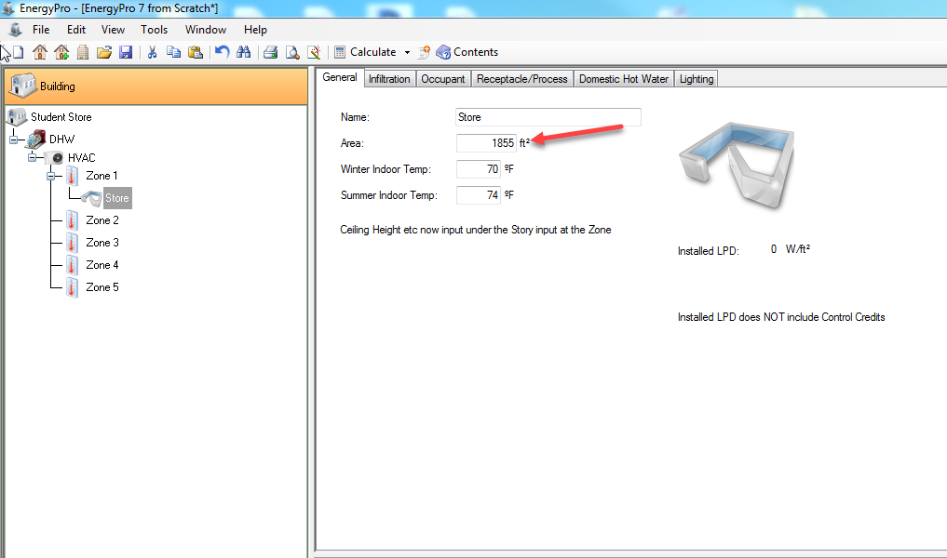
RC on STORE
Add Ext Wall
Name it “SOUTH WALL”
Area: 53*16=848
Orientation: South
New Assembly: R-19 Wall (we’ll give the wall smarts later)

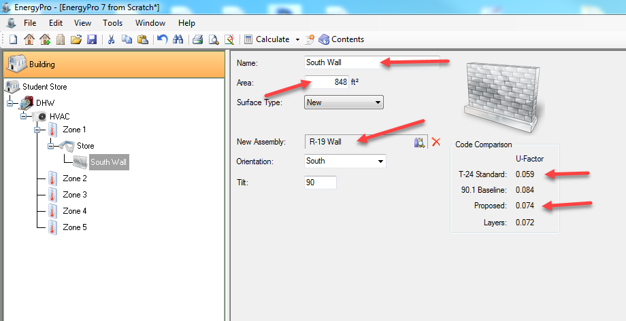

RC on STORE
Add Ext Wall
Name it: EAST STORE WALL
Area: 35*16=560
Orientation: East (may say 90…North is zero……get it?)
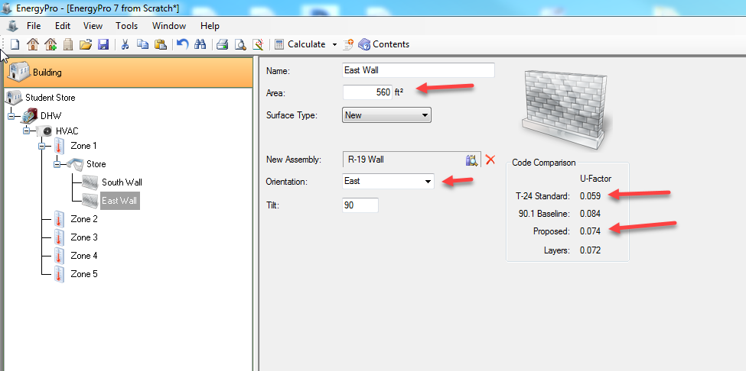
Back to SOUTH WALL
RC…Add Window
Note: We have 5 windows, but only 2 sizes….so we will create TWO windows on the south wall to start
On first window, name it “Window A”
Area: 24
Pick second window, name it “Window B”
Area: 12

Select window A….RC….Copy
SOUTH WALL….RC Paste
Select window B…..RC…..Copy
SOUTH WALL….RC…..Paste twice
Note: you can drag them in order
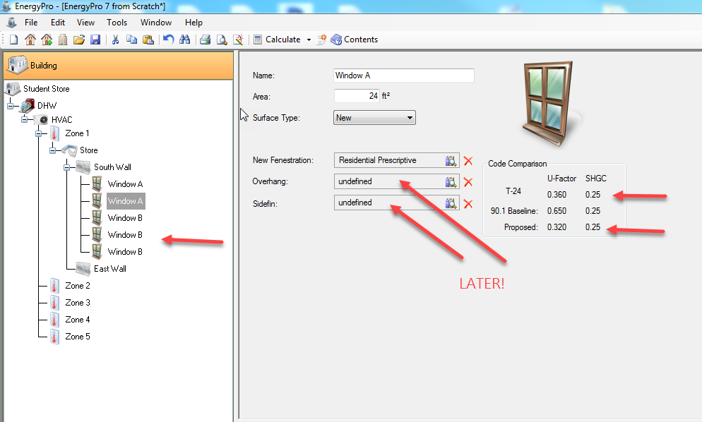
South wall….RC…Add Door
Name it STORE DOOR
Area: 48
We’ll make it smart later
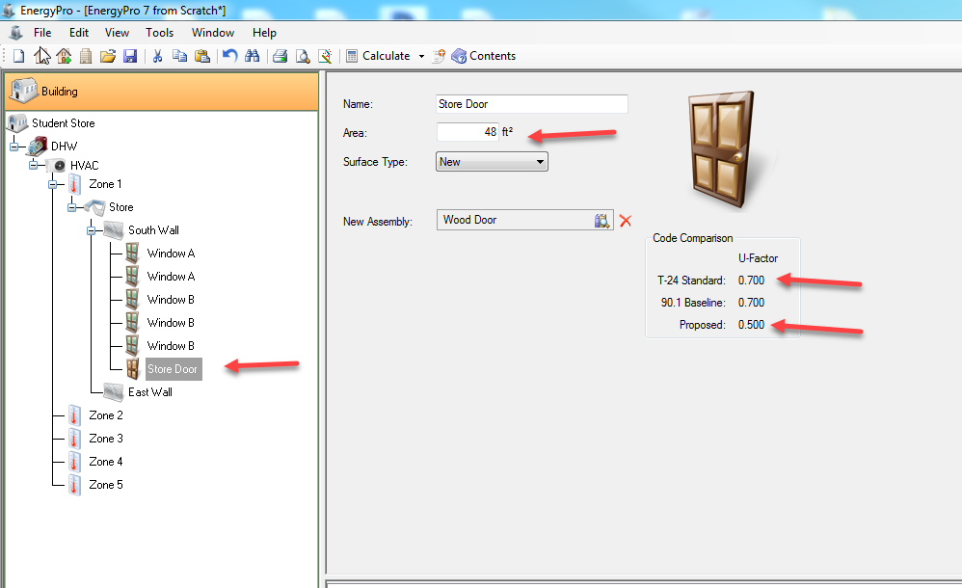

Select STORE
RC…..Add….Slab on Grade
Name it Store Slab-on-Grade
Area: 53*35=1855
Ext Per: 35+53+35=123’
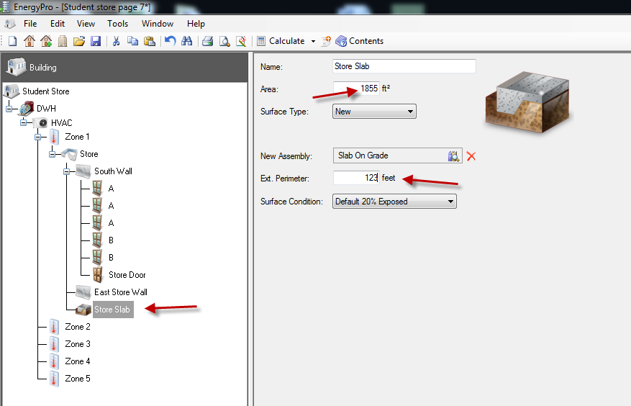

Select STORE
RC….add Roof
Name it Store Roof
Area: 1855
Choose R19 Metal Deck Roof
(no orientation since it’s flat)
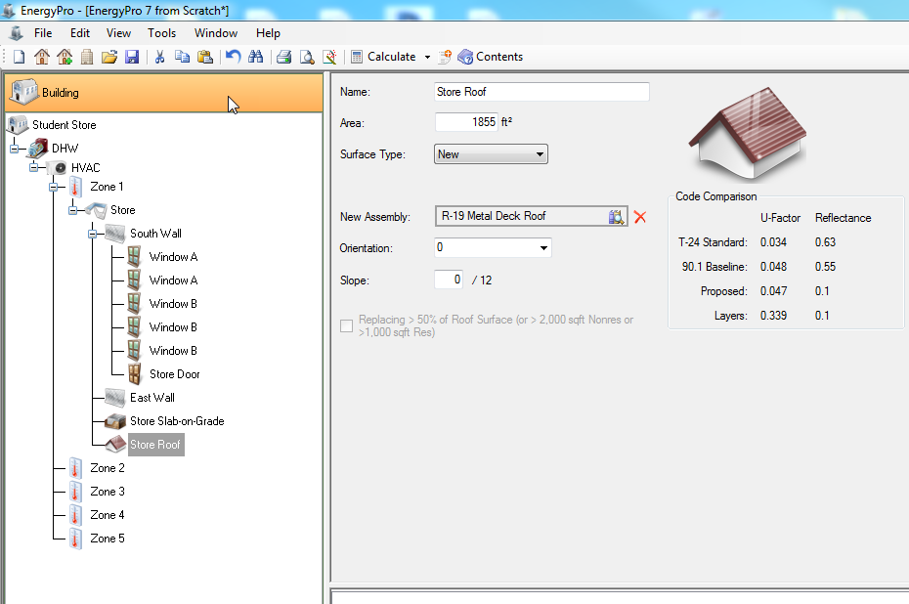
RC on STORE
Add Ext Wall
Name it: WEST STORE WALL
Area: ?? Orientation: ??
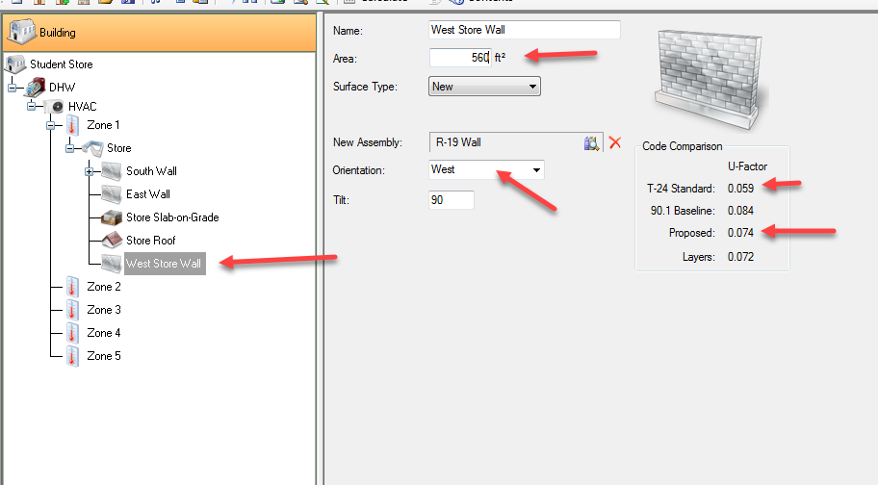
Select STORE
RC….Add Lighting
Note: all the lights are the same
Name the light CFL
Use the 2 Lamp 54W Linear T5 HO ElectD 125W Flourescent (24th on list)
Multiplier: 9
Note 125W*9= 1125W….so you do NOT need 9 lights in the tree!
Control: Demand Responsive

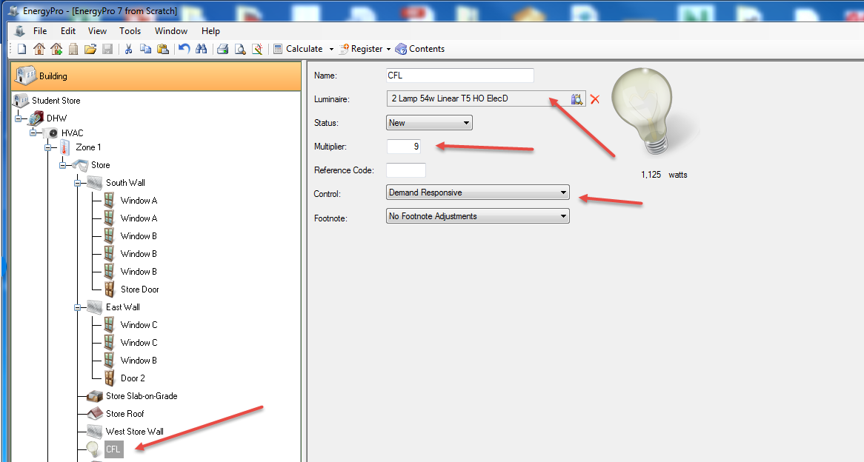
Zone 2 will be BOH, MEN’S, WOMEN’S
Zone 2
Occupancy: Bathroom
Ltg 90.1: Restrooms
Check Demand Control Vent (under Mechanical)

RC…add Room
MEN’S
RC…add Room
WOMEN’S
RC…add Room
BOH (Back of House)
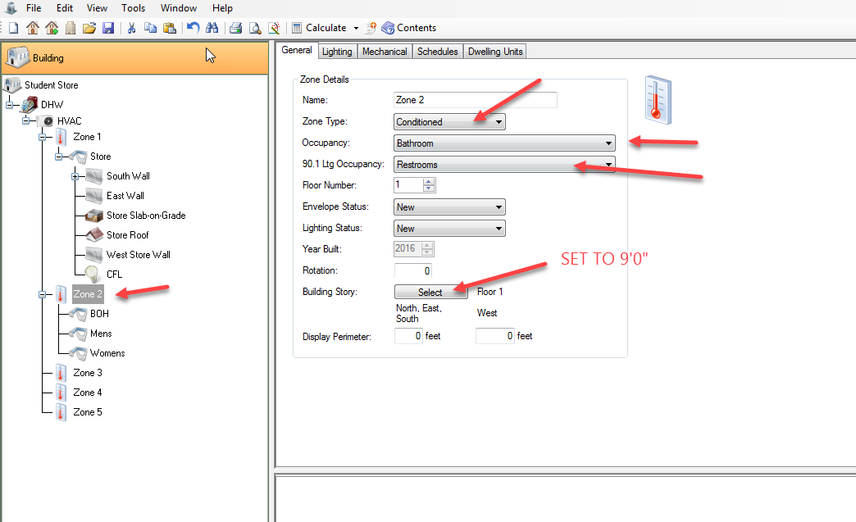

Like Zone 1, Zone 2 will have a ceiling height of 9’0” (use average of rooms in the zone if there are multiple rooms). Same with the window head heights. Floor to Floor is 12’0”

MEN’S
Area: 8*19=152
RC on MEN’S
Add…Ext Wall
Note: For now…..EnergyPro ONLY NEEDS EXT WALLS!!!
Name it NORTH MENS WALL
Area: 8*16= 128
Orientation: North
No door needed…it’s inside

RC on MEN’S
Add Lighting
Name it BA LIGHT
Mult: 2
Luminaire: 54W T5 (21st^{th} on list) (Note 62W performance)
Control: Demand Responsive
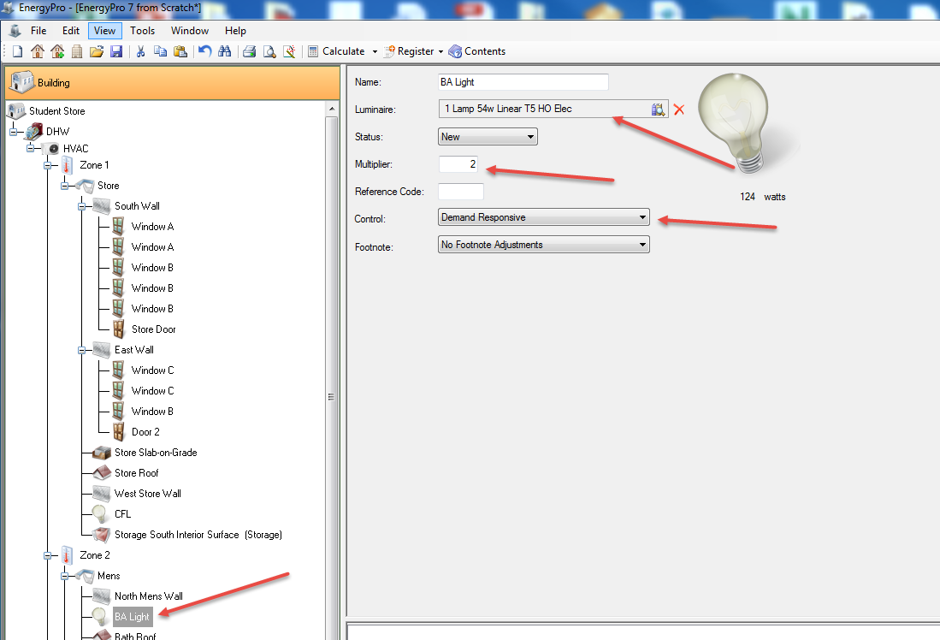
RC on MEN’S
Add Roof
Area: 152
R-19 Flat Metal Deck
Name it “Bath Roof”
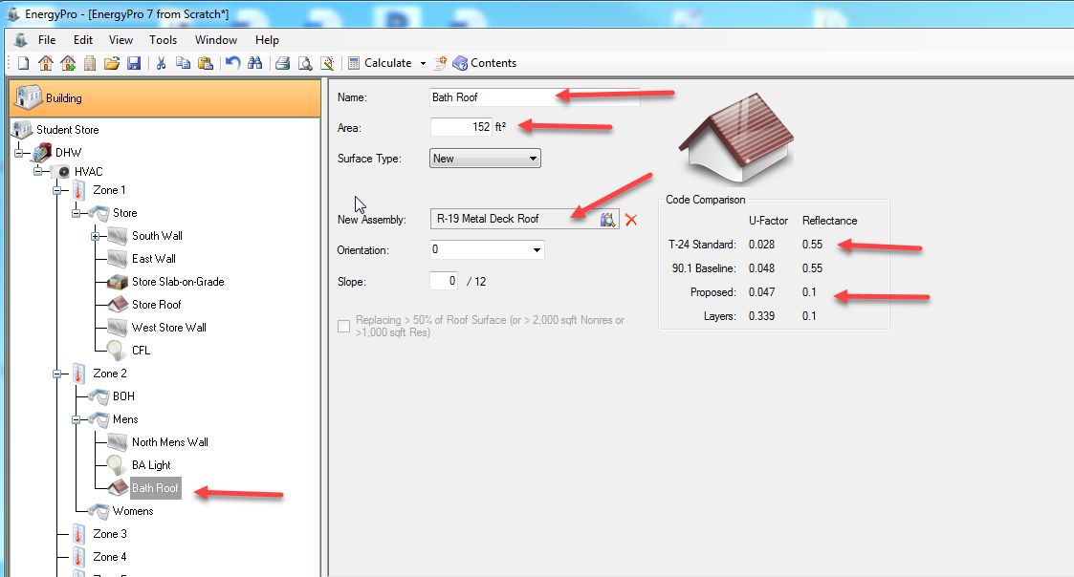
Notice MEN’S and WOMEN’S are the same???
Delete WOMEN’S
Pick MEN’S…RC….Copy
Pick ZONE 2…Paste
Rename the second Men’s room “WOMEN’S. Faster!! (don’t worry about the names, just organizational)
Note: Copy/Paste in EnergyPro is important to creating an energy model in a reasonable amount of time!
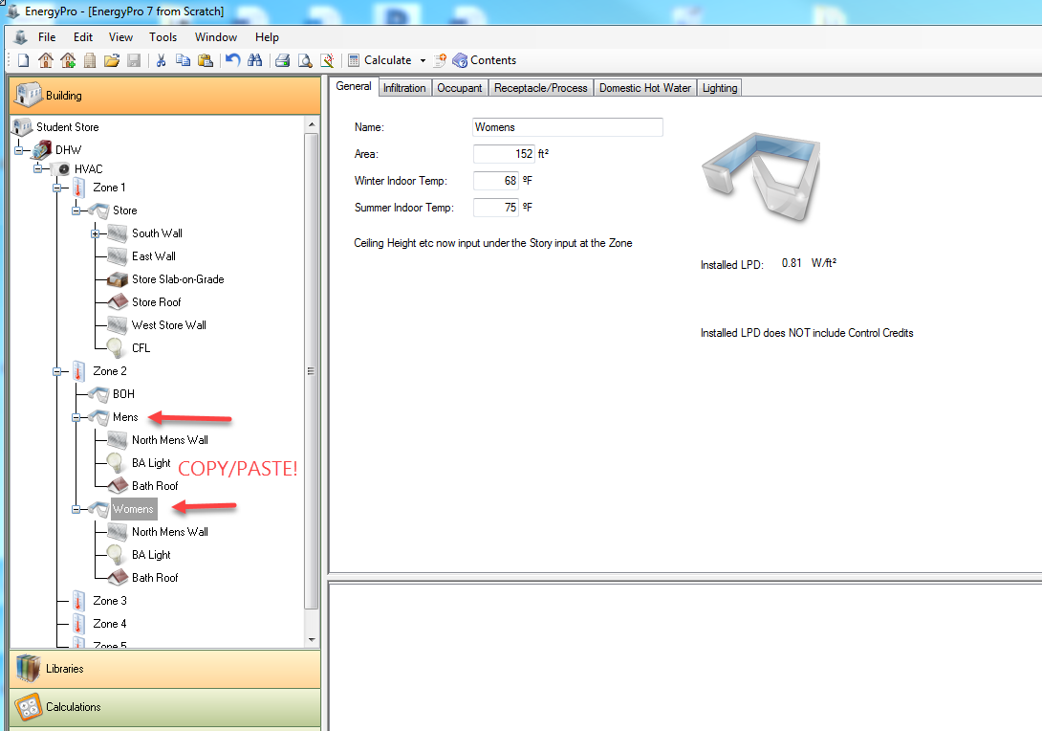
Zone 3 will be STORAGE
Zone 4 will be Office
Zone 5 will be Conf and Staff Lounge
Zone 3
Zone Type: Unconditioned
Occupancy: Comp Bldg Com & Ind Storage
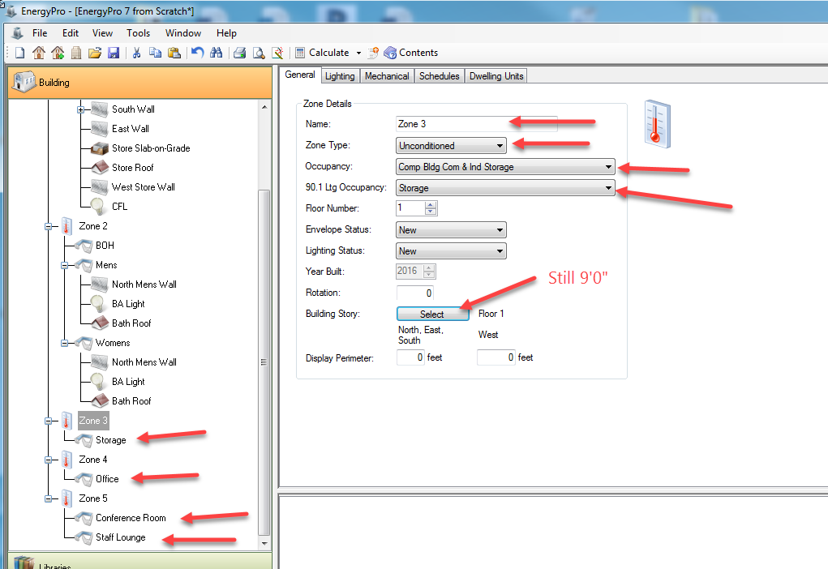
Storage
Note Storage Zone is Unconditioned. YES…you still need to create it. Lighting. Adjacent rooms and adjacent to outside.
Area: 15*31=465
Storage Lights
Choose the 4lamp 4 ft T8 Energy Saving ElecRO (60 on list) at 91 W
Mult: 3
Control: Demand Responsive
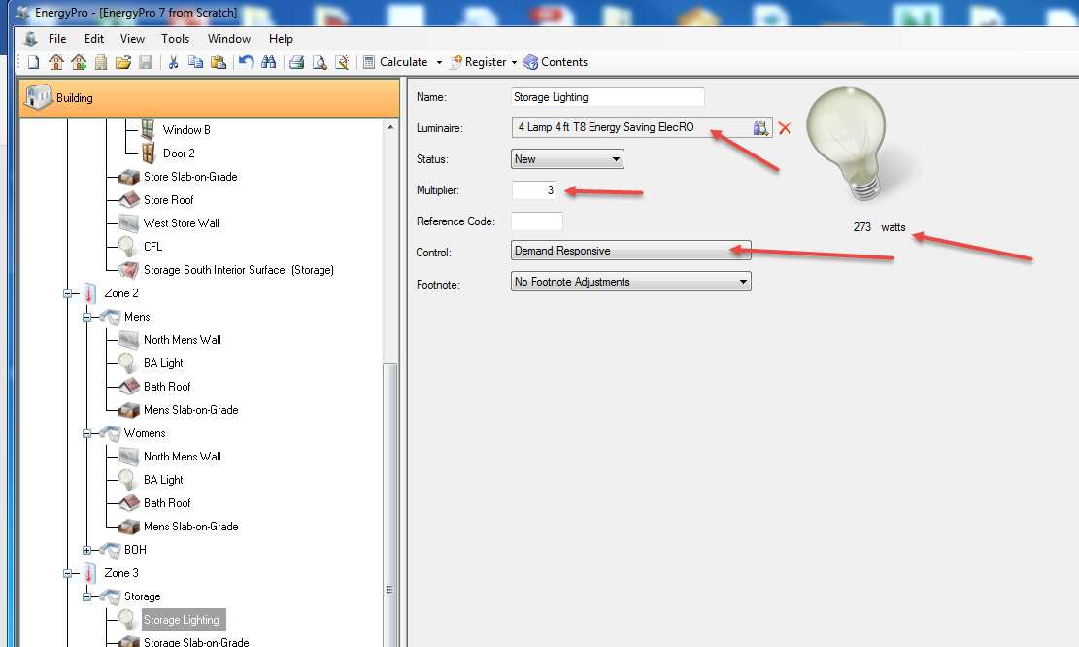
Add Slab on Grade
Name it Storage Slab-on-Grade
Area: 15*31=465
Ext Per: 15’
Storage
Add Roof
Name it Storage Roof
Area: 465
R-19 Metal Deck
Show calculations on Lights: Zone Lighting T-24 W/sq.ft to get close. So .6 times 465 = 279. If you aren’t close to the T-24 calc, you may have too much (or not enough) light for the space. We are 273….nice!
That should give you enough to finish the EnergyPro model. Ext walls, doors, windows, slabs, roofs, and lights….
Save as: STUDENT STORE 7.bld

Calculate Loads

Show warnings and fix (yes…I made a few on purpose )
Check the building tree to insure all walls, slabs, roofs, lights, windows and doors are in….and accurate properties assigned. Compare with Mr. Brown’s model…..did you forget anything???

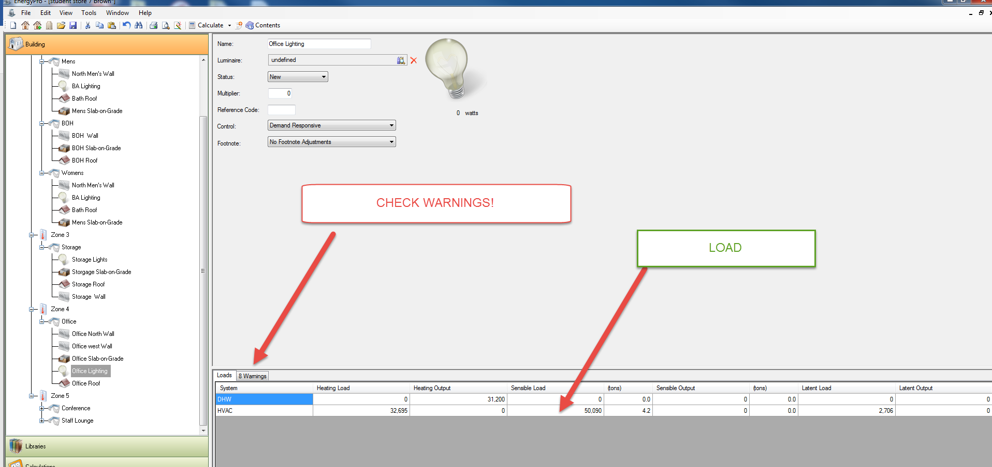
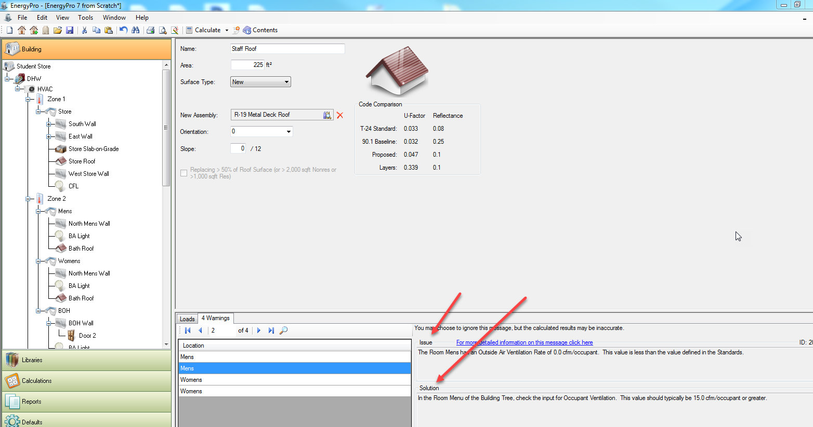
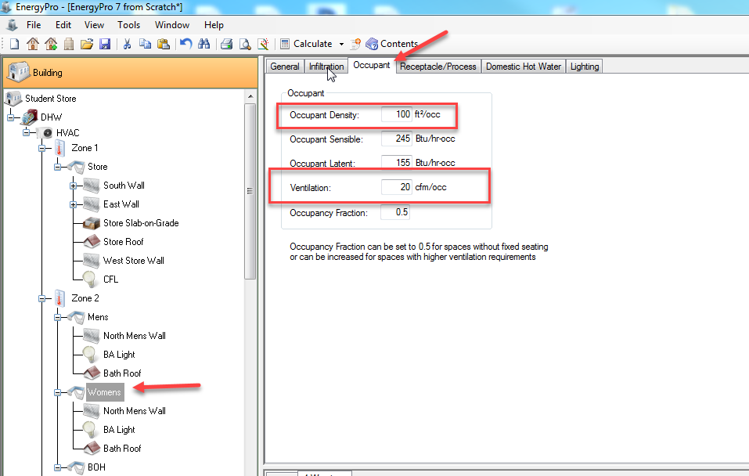

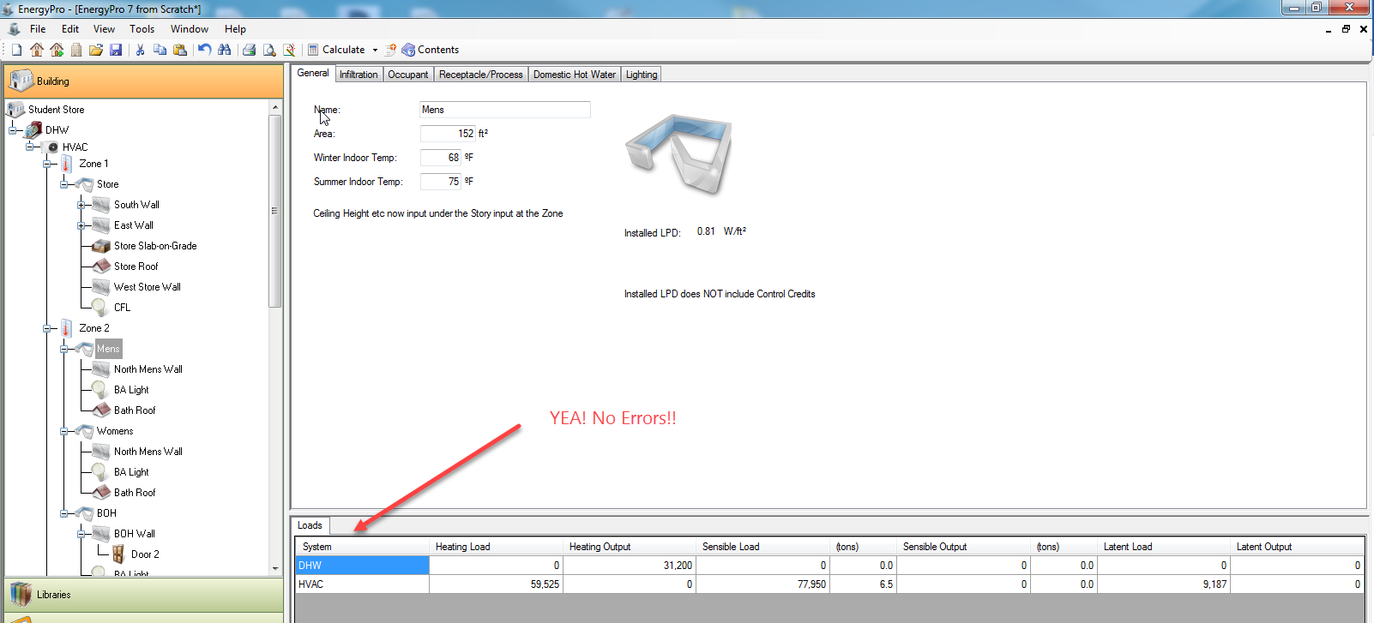

Our Sensible Load is about 144,000 BTU’s…let’s find a system that is close:
HVAC
New System
Import Air Conditioner
Show Output Filter
I put 130000 to 160000
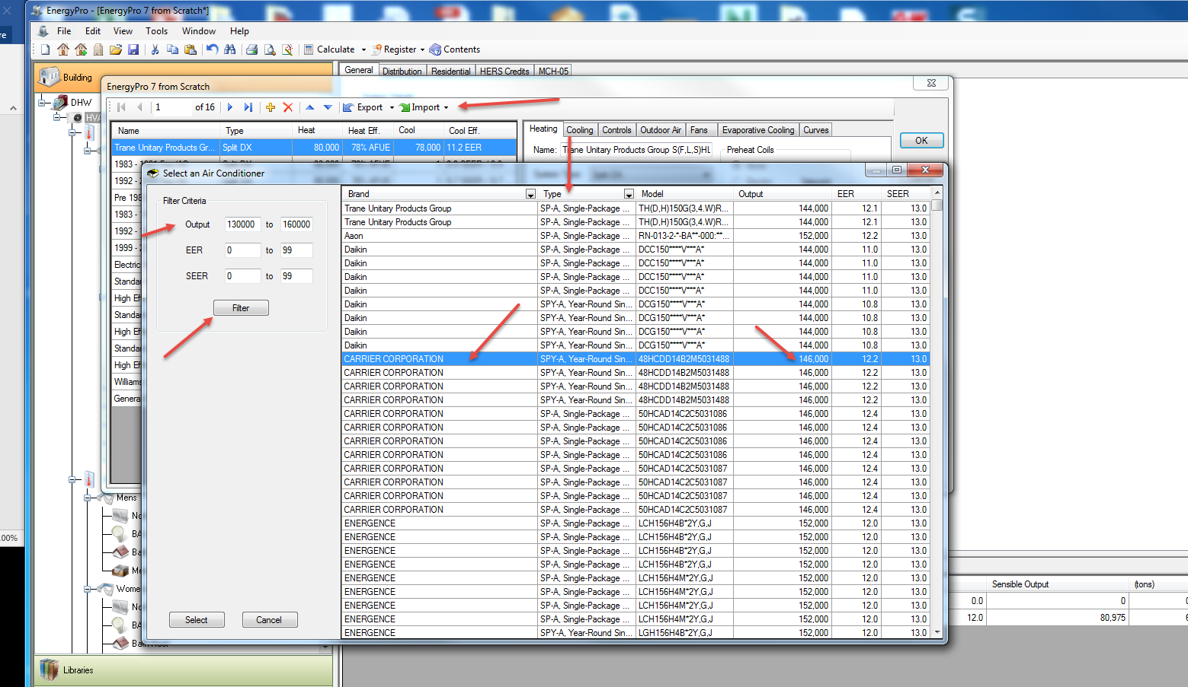
Type: Single Package:
I picked the Carrier 48HCEE14A2M5032329 (more on those long numbers later)
It has an output of 146,000 BTU. Not bad!
Select…OK
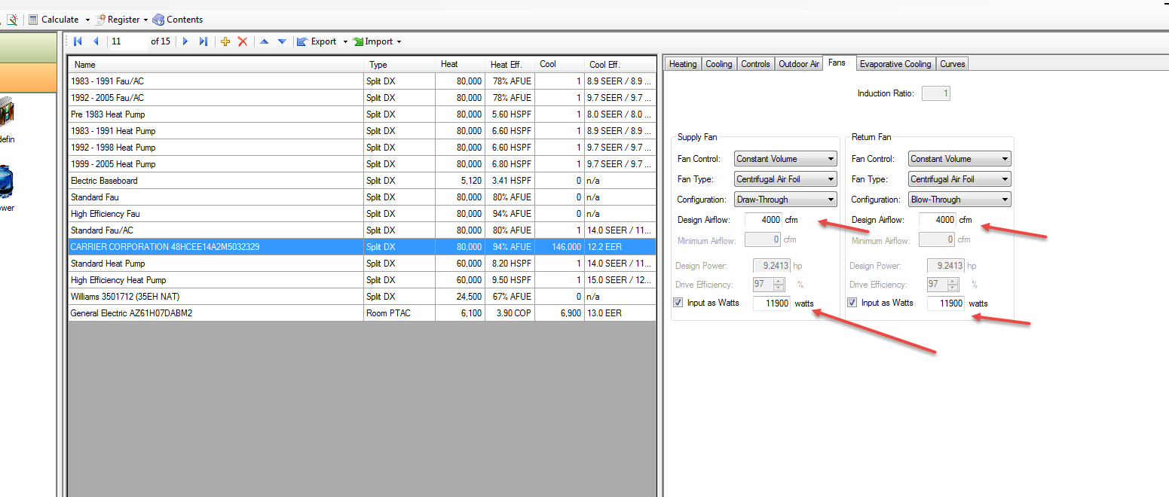
Fans
Set the Design airflow to 4000 CFM’s (was at 0)
Input as watts: 11,900 (from spec sheet page 9)

Check Title 24 Non-Residential Performance to see if the building is meeting California’s Energy Code!
Fix the errors!
I loaded the spec sheet in the X:/EnergyPro7 Tutorial Folder
Run the NR T-24
You should see “Wrapper” dialog box and it should be “Perfoming Analysis”
Wrapper not working on mine…
Note: Didn’t like my R-19 roof. Changed to R-30. Worked.
Note: In Zone 1, Mechanical, Changed Cooling Supply Air Flowrate from 2159 to 2500. Worked.
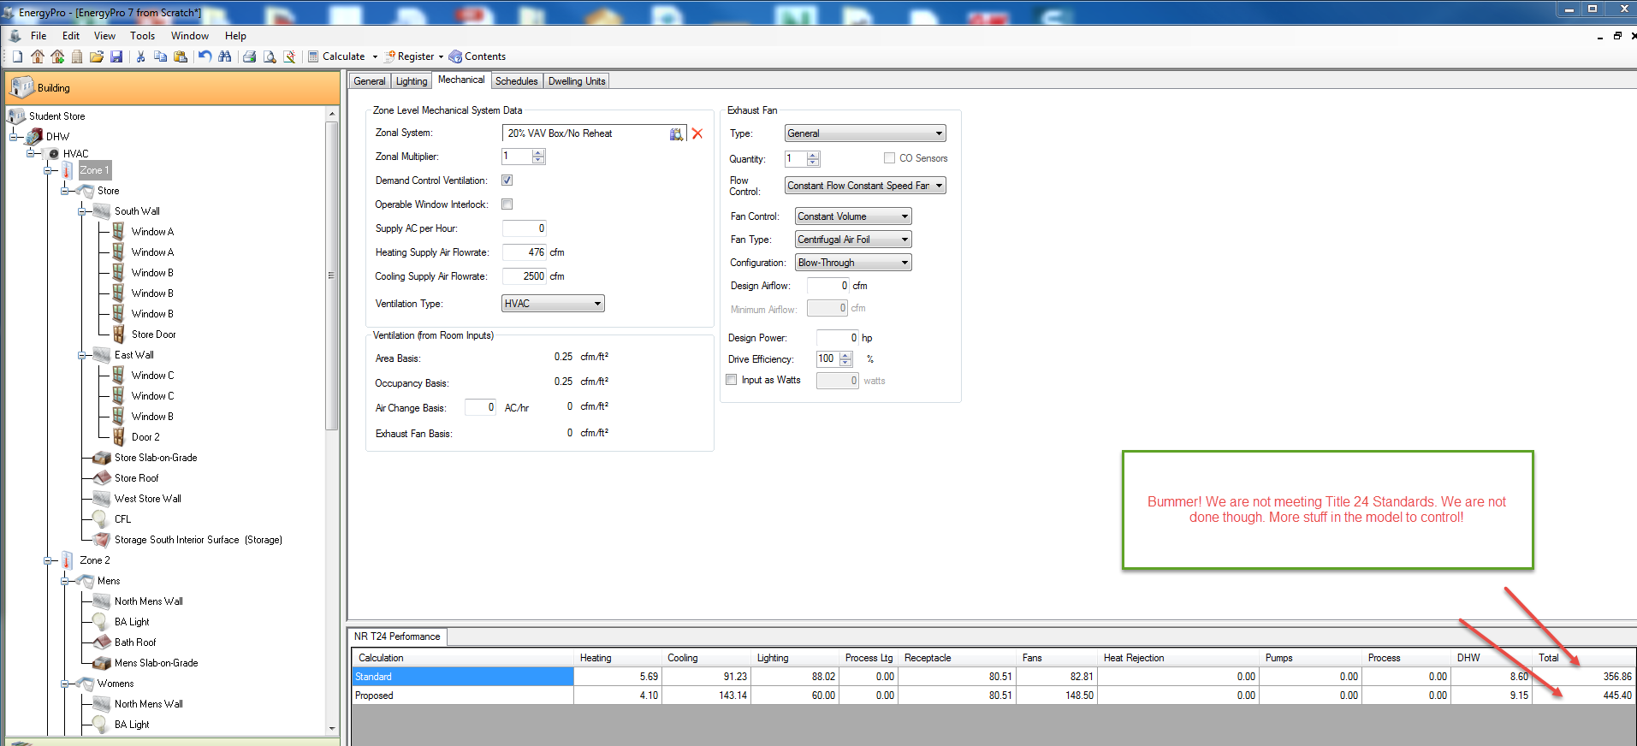
Still more to do. Cooling is high. Lighting is great. Fans are really high. We have walls, glass, roof, etc still to manipulate.

EnergyPro Interior Surfaces
So I lied earlier about Interior walls not needing to be modeled. There are some that do need to be modeled. You MUST model Interior Surfaces between zones.
Inputting Interior Surfaces between rooms that are in same zone is not necessary. EnergyPro will not look at them.
Set the Interior surface adjacent to other room. DEMO.
If you have more than one zone, it MUST have an interior surface adjacent to the other zone(s). It can be a wall, ceiling, or floor.
You need 6 surfaces in every zone.
Every zone must have a valid floor.
On multi-story buildings:
Zones on Floor 1 would have walls, floors, ceiling (maybe no roof….)
Zones on top floor would have walls, floors, roof/ceiling
http://www.energysoft.com/faqs/
Note that you do not need to model all interior surfaces, you just need at least one between the zones. You also do not need to model the surface twice (once on each side). Inputting it once will satisfy this requirement for both the zone it is in, as well as the zone it is adjacent to.
Let’s do one:
There is a wall between the Store and the Storage room. It is 31’0” long, and 9’0”
Store….RC….add Interior Surface
Name is Storage South Interior Surface
Area is 31*9=279 sq ft
Assembly: R-15 Wall
Adjacent to: see button??
Zone 3: Storage
Now the Storage Room has the same
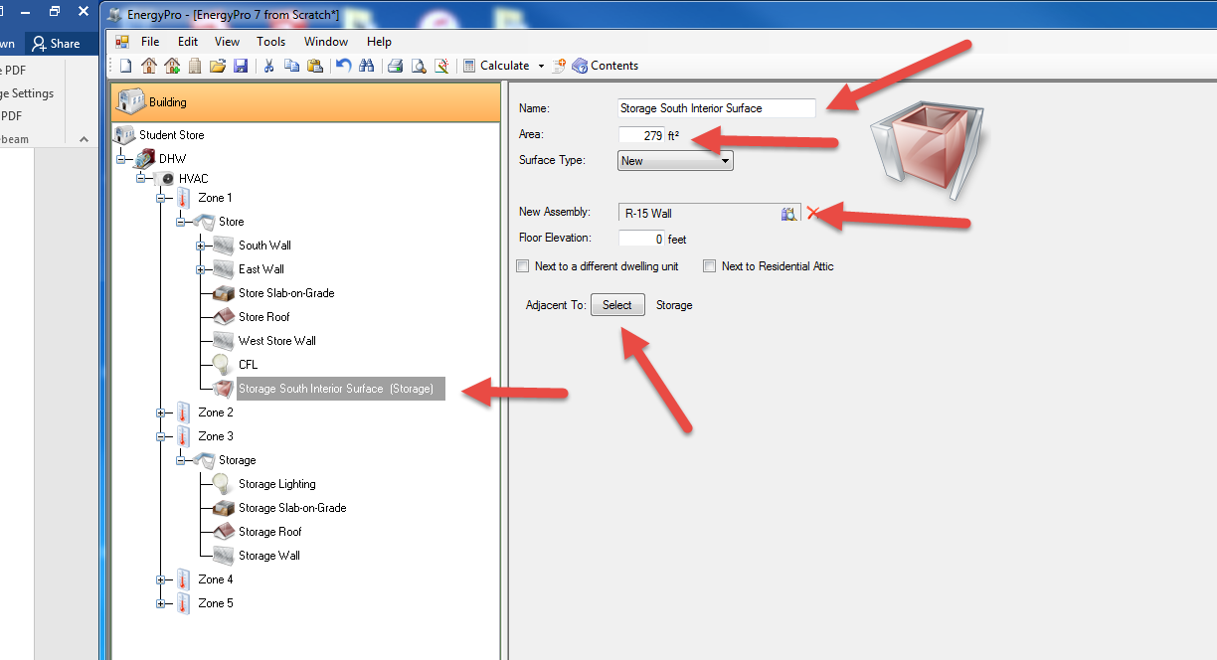
Now finish adding the Interior Surfaces!
Use “Reports” to get the load of the building for sizing HVAC.

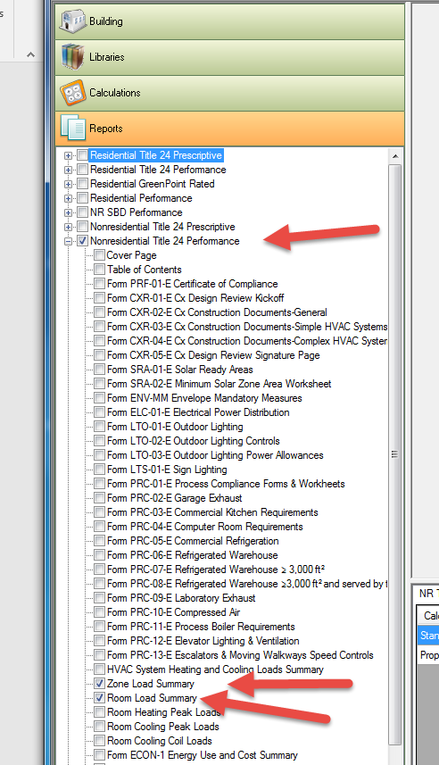
File
Print Preview
