SANTIAGO HIGH SCHOOL
ARCHITECTURE DESIGN 1A/1B

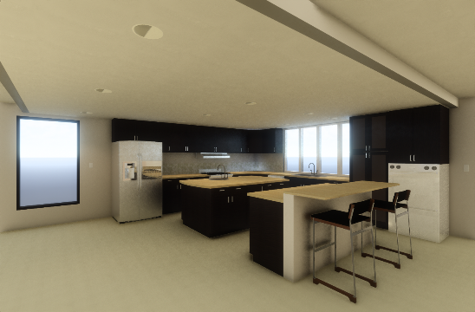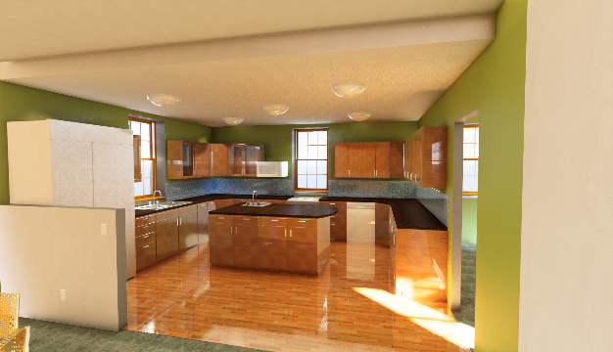

Software: REVIT 2018

Instructor:

BILL BROWN

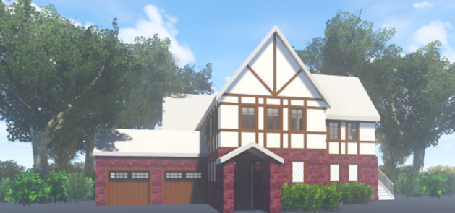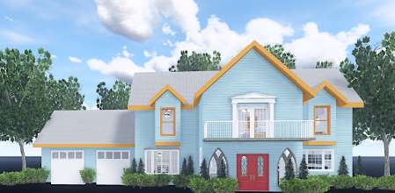

Email bbrown@cnusd.k12.ca.us

Table of Contents

Email bbrown@cnusd.k12.ca.us 1
Table of Contents 2
Revit Interface 5
Doors in Revit 16
Windows in Revit 21
Plan Regions: Clerestory Windows 31
Floors and ceilings. 34
Roofs 38
Putting your work onto paper in REVIT 45
Sheet Naming Convention 48
Section views in Revit 49
Furniture, fixtures and viewing in Revit 55
Controlling what you see 58
More Sections 60
Interior Elevations 62
Revit Schedules 75
Controlling what you see (More) 83
Smart Wall Creation 93
Details in Revit 95
Smart Wall Creation Continued 95
Smart Brick Wall 102
Rooms 104
Dimensioning in Revit 113
Creating a Site Plan in Revit 117
Basic Stairs in Revit 128
Slab Foundation Plan 137
Callouts 148
Area Plans 158
Creating Materials in Revit 2018: Basics 176
Applying Smart Material Patterns to Floors 197
Creating Fill Pattern 201
Applying Materials To Interior Elevation Surfaces: Your 2 Options 206
View Templates 216
Creating Custom Linestyles 218
Filters 220
Electrical Plan 222
Electrical Legend 231
Wall Type Legend 233
Creating a Gypsum Board Ceiling 234
Wall Sweeps 238
Wall Sweeps: Base and Crown Molding 241
Creating a “Smart” Furniture Family 252
Material as a Parameter: Family 270
Families: Steps to Creating Families 273
Title Block Family 274
Smart Window Tag 280
Drafting Views 284
Keynotes 287
Creating the Keynote Legend 296
Grouping 301
Creating Custom/Shared Parameters 306
Room Schedules 312
Room Bounding…Controlling where your Room Goes 315
Sheet List 316
Shared Coordinates Demo 317
Note Blocks 325
Phasing 329
Copy Monitor 331
Purging 343
Transfer project Standards 344
Phasing for Tenant Improvements 347
“Stealing” From Other Revit Projects 349
Creating a .PDF of your Revit Sheet 350
Key Schedule 351
Demo: Structural Components in Revit 354
Revit 2018 Path Issues Solution 370
Spanish Character Floor Plan 2017-18 371
A Home for Mr. Bond 374
Drawings Required (you will have close to 20 sheets!) 375
Residential Floor Plan Checklist 379
Bathroom Elements: Checklist 381
A HOME FOR MR. BOND: Floor Plan Design Notes 382
Cover Sheet Checklist 384
Site Plan Checklist 385
Presentation Plan Checklist 386
Interior Elevation Checklist 387
Foundation Plan Checklist 388
Exterior Elevation Checklist 389
Kitchen Plan Checklist 390
Section Checklist 391
Schedule Checklist 393
Project 2 Assignment 394
Revit Resources 402
Curtain Systems 403
New Features in Revit 2018 424

Revit Interface

Note to teachers: I have set up this tutorial so you may “get lost” during a section and not be way behind. Simply open the current drawing to get back on pace. The tutorial is also set up so you may go to a specific area to try a command without having to do the entire tutorial. If you want to go straight to creating a roof, open Revit2018demo4.rvt.

I also set this tutorial up to be presented once by me to you (the teacher), then presented to your students/employees.

I prefer that during my presentation, you do not take notes. That’s what this book is for. I prefer that you watch what I do, then do what I do. If you are frantically taking notes…..you are not watching me …making it tougher get all the details.

You may reproduce this document as much as you want for use in the classroom….

Professionals not employed by Bill Brown do not have permission to use or duplicate the information in this book.

All of the files we will use in the workshop will be made available.

I have bolded some text as reminders to me to discuss issues as they come up.

I think you will like Revit as a tool to create your architectural drawings. It’s not AutoCAD or AutoCAD Architecture, so some of your normal drawing strategies will change some….Students do not need to know AutoCAD to learn Revit, but general Architecture knowledge is important.

Let’s get started!

Revit is a database.

Give analogy to filling out a contest form with your name, address, age, income, interests, gender, occupation, etc. Companies leverage that data to target mailings to go to a group more likely to buy their product. Explain how Revit does the same with the building model.

Make a few walls. Esc to finish. Put two 24 X 48 windows in the walls. Create the Windows with their head height at 6’8” ft. RC on window….Properties…set head height. For the purposes of this exercise, make sure your two windows are facing to the front of the house. Put the South elevation on a sheet to print. RC on Sheets…New sheet…take the E size paper. Go to the elevation view. Dimension the head height. It should be 6’8” ft. tall. Go to the printing sheet. See seven foot dimension? Go back to the plan view. Change the Windows to 8 ft. head height. Now show the plotting sheets again. It's all linked in a database! What changes in one view, changes in all the views.

Show “Ribbon” Project Browser Option Bar
Architecture Views Chain
Insert Level 1 Height
Annotate Ceiling Plan
Modify
Massing & Site
Collaborate
View
Manage

The “Ribbon” in Revit 2018

Show Arrow to Change ribbon

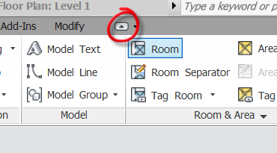

The “Option Bar” in Revit 2018

The ”Project Browser” in Revit 2018

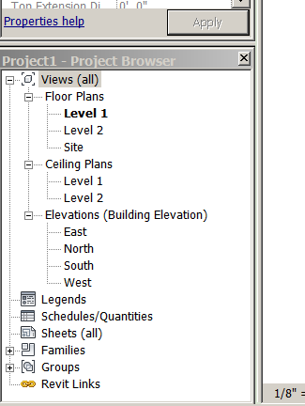
Show Properties toolbar in standard spot
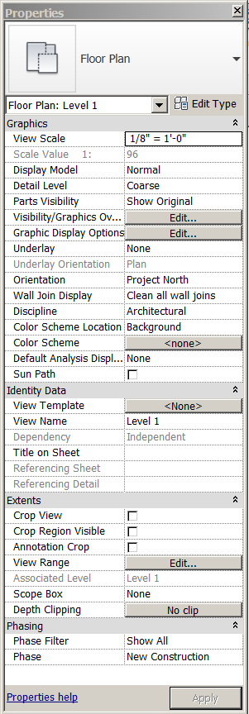

Show tear off of Properties Toolbar

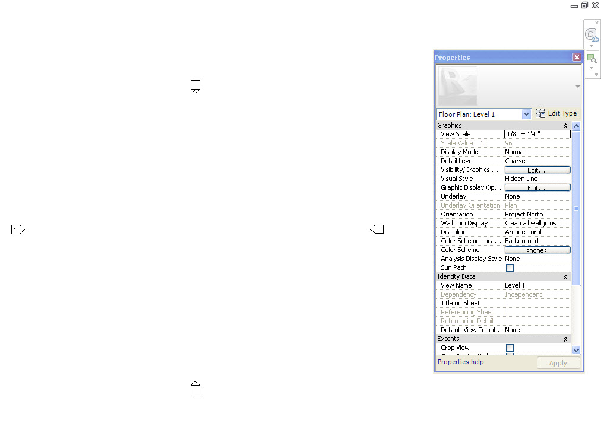

Show View display Toolbar and its commands…
Walls

Architecture….Wall Architectural….. show different types of “out of the box” walls under “Change Element Type”.

Unconnected

Move pencil icon to screen.

Make some walls in a typical cross-gable mass. Don't worry about size. Select the chain box before starting. Make them Generic 5”. Height: Level 2
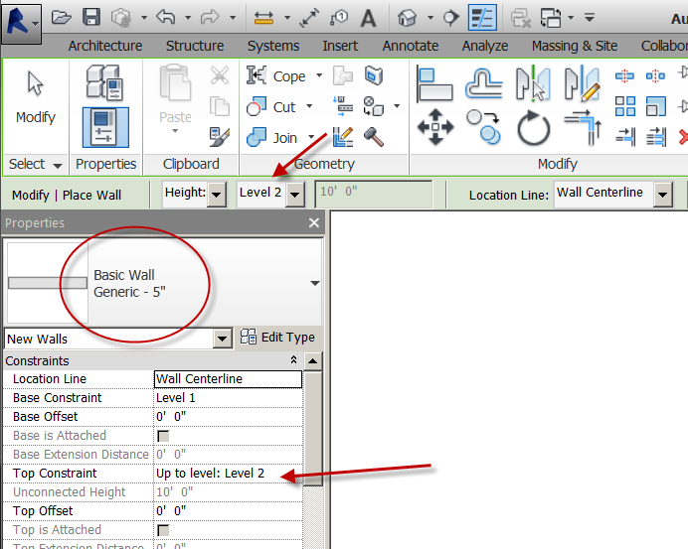

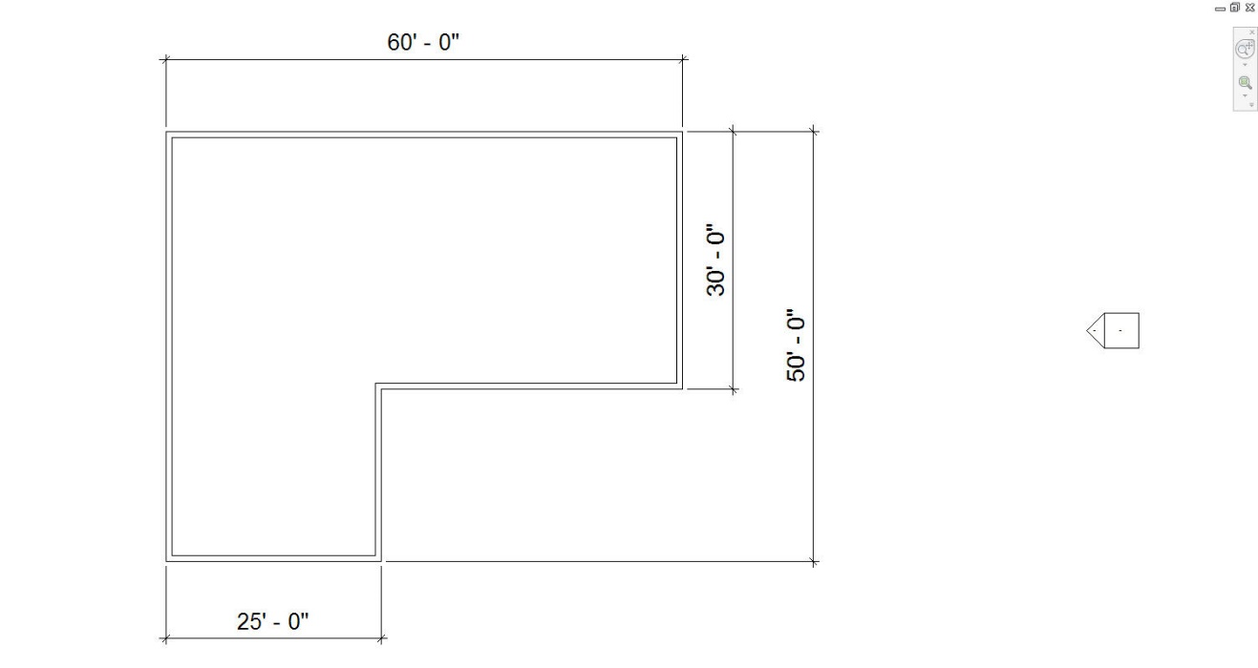

Show Wall Properties
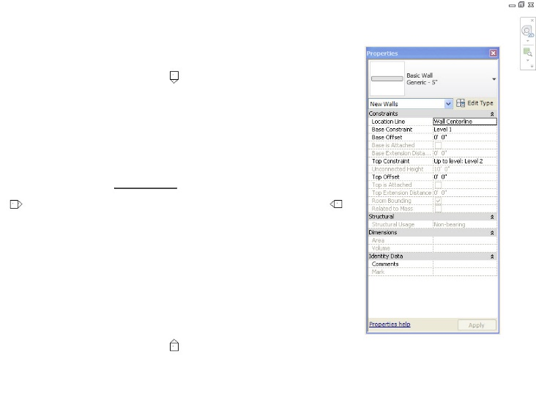

Escape to end.

Modify wall sizes.

To modify horizontal sizes, you must pick on vertical walls. Once you pick on a vertical wall, you may select the dimension and modify it. Left select another vertical surface, and modify the dimension. Pick the dimension symbol to lock your sizes. You should have just modified a horizontal size.

Temporary dimensions (the blue ones) control your model size.

The building will be 60’ long, 50’ deep, garage wall 25’ long, back right wall 30’ deep.

To modify vertical sizes, you must pick on horizontal walls. Use the same technique to modify the vertical distances. Left select outside the house to end the command.

Hint: The wall to pick, will be the wall that is moved by the temporary (blue) dimensions.

Erase the dimensions for now. LC on dim….. Delete.

Open the South elevation in the Project Browser. Notice the wall height? The walls were drawn to an “Unconnected” height. Explain

Pick all of the walls. Properties. Change the top constraint height to Level 2.

Discuss why going to Level 2 is a better strategy than Unconnected 20’ ….by making Level 2 at 12’. Then at 15’….then at 50’! Get it? That will be a big deal later in the project.

Discuss “Location Line” choices (In the Option Bar): Wall Centerline, Core Centerline, Finish Face: Exterior, Finish Face: Interior, Core Face: Exterior, Core Face: Interior. You may adjust this now, or later. It's your preference.

Note: base constraint: Level one is set at zero.

OK.

Now choose South elevation to show change in wall height. It should be 10 ft.

Show how to drag Level Line closer to building from South Elevation….from East too.

Discuss DO NOT EVER EVER EVER DELETE LEVELS!! All the objects assigned to the level get deleted…walls, doors, windows, floors, roofs, ceilings, etc….not good

Back to Floor Plan Level 1 (In Browser)

Select on the front, left wall. Properties….Wall to: exterior-brick on CMU (concrete masonry unit). Left select. Note change? Esc to exit temporary dimension.

Show your view in more detail

RC in open space. LC on View properties. Display Level: Medium. Now show wall. (Each view can have its own display level: course, medium or fine). EXPLAIN BOX

OK

3D icon (to show a 3-D view). It’s the little house icon in upper left area of screen….

The “View Cube”.
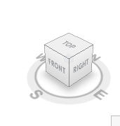

Show the “Steering Wheel”
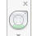
These are tools to display/view your model…..

Display bar at lower, left corner of screen
Scale
Detail Level
Shading
Explain that these tools control what we see and how we see stuff on THIS view

Note the wall is facing the wrong way. LC on wall. RC. Change wall’s orientation. Should be good now. You can use the blue arrows to flip the walls also. (show in Floor Plan Level 1 View).

Change all the walls so the blue arrows are outside….

Note: The blue arrows should be OUTSIDE to make your wall as it was designed.

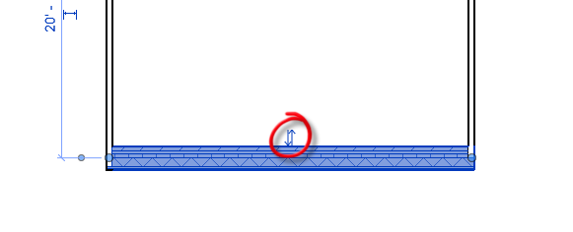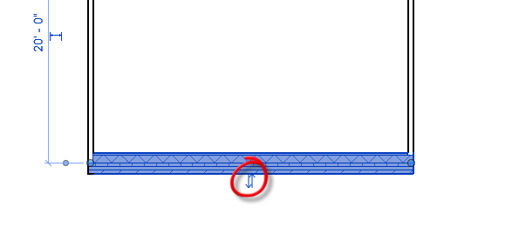
Wrong Correct

Show Properties Display Dialog
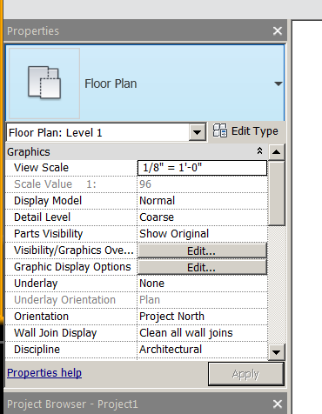

You have learned how to create and adjust the size of walls using temporary dimensions, modify the style of the walls, and control the display level of the drawing. You may have noticed that Revit keeps track of your changes in all views, not just the one you made the change in! All the information is stored in Revit's database.

Save as: revit2018demo1

Doors in Revit

Back to Floor Plan Level 1.

Architecture. Door. Notice all single flush doors with various sizes. Great, but what if you want a different type door?

Load Family.

US Imperial library folder. See all the content?

Doors folder. Residential

Let's grab a front door: Door-Exterior-Single-Entry-Half Arch Glass-Wood_Clad
Open
Pick the 32X96 and 36X96 Types
Hold down the control key and select them. Open.

Load Family….Doors….Residential

Let’s grab a garage door: Door-Garage-Embossed_Panel
Open
No choice on Types on this family. 2 came in: 96X84 and 192X84

Load Family….Doors….Residential
Let’s grab an interior Closet door:Door-Interior-Double-Sliding-2_Panel-Wood
Open
Pick the 48X80 and 72X80 Types
Hold down the control key and select them. OK

Load Family….Doors….Residential
Let’s grab a French double: Door-Exterior-Double-Full Glass-Wood_Clad
Open
Pick the 60X96 and 72X96 Types
Hold down the control key and select them. Open.

Each of these door types are called a “Family”. Each family has a set of preselected sizes attached to the door type. You can set your own sizes at any time, or modify the sizes that were preselected.

Now try the selector. Notice each family has some size choices, some you were able to pick out of the “Type catalog” and some just came in with the family. Again, you can make your own sizes at any time.

Let's start with a nice front door. Door-Exterior-Single-Entry-Half Arch Glass-Wood_Clad that is 36 in. by 96 in. Put the door into the front wall near the garage. Anywhere in that corner area. Note the dimensions above in blue (temporary)? Make it 2 ft. 6 in. from the left wall. SHOW WITNESS LINE. Enter. Now switch the swing of the door, so the door is on the left and swinging into the house. Notice options. Notice the door is tagged. Do you see the tag on placement box above? Escape twice to exit the command.

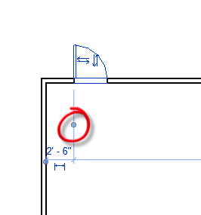Left Click (LC) on the witness line!

Add two garage doors, Door-Garage-Embossed_Panel 96X84 on the left front wall. Just get them in. We will adjust them later. Escape twice to exit. Pass your mouse over the garage doors. Do you see the yellow box with the description of the door?
Show Flipping doors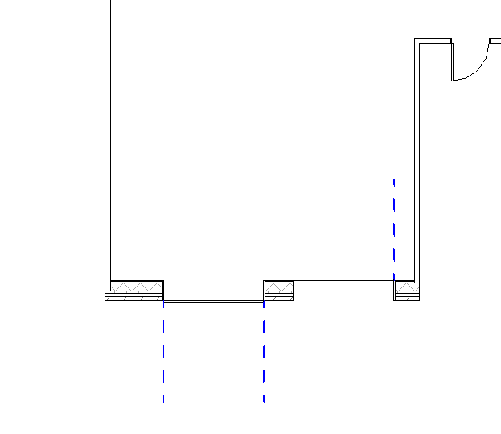

LC on the left garage door. Do you see the dimensions? Change the left one to a random size like 7 feet from left to center of door. Change the right door to the same distance from the right.

Add an interior wall.

Architectural….Wall Architectural….. Interior 5 in. partition (2-hr). Put vertically somewhere in the middle. Adjust the wall 15 ft. from the right side by selecting the blue dimension. Escape twice to exit the command.
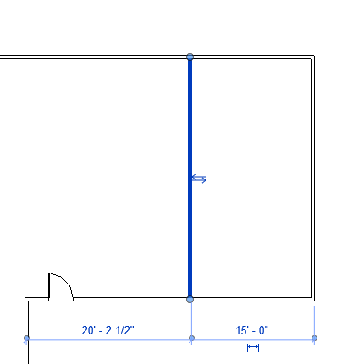

The walls Function can be changed after placement…so no worries!!!
Example: Those outside walls we created will be load bearing, exterior 6” walls:
Pick the 5” outside walls
LC (left click) on walls
RC…..select all instances…..visible in view EXPLAIN
In Properties box, Change to Exterior-EIFS on Mtl.Stud
Structural
Check Structural
Structural Usage: Bearing
Click in white space to exit
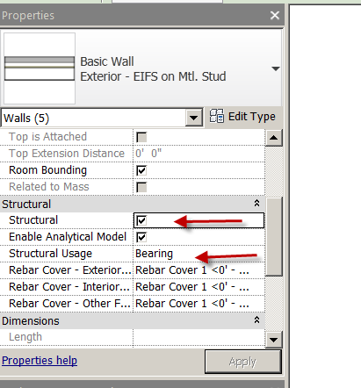
Add an Opening

Architecture
Component
Place a Component
Load Family….Openings….Passage Opening Cased….Open
Change element Type
Opening Cased 34X80
Place in wall

Show Lineweights ON/OFF
Show Detail Level: Course/Medium/Fine

Place an interior door
Architecture….Door
Single Flush 30”by 80”. Put it somewhere not in the middle of the wall.

Add a French door. Door. Door-Exterior-Double-Full Glass-Wood_Clad 60X96 (yes….I know…it’s an exterior door…just do it!). Make 16 ft. from the other door using temporary dimensions and Witness Lines. Escape to exit.

Remember….when using temporary dimensions….the object you pick is the one that moves!
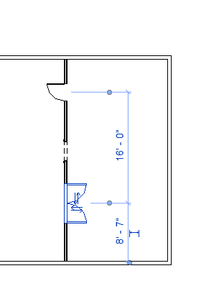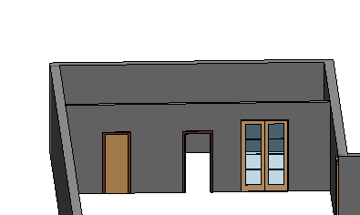

Check out the doors in 3-D view. Show moving and docking of properties box.

Check out the model by using Orbit tool on the Steering Wheel and move your mouse to spin the model!

Esc

View.
Tile. (top, right corner area)

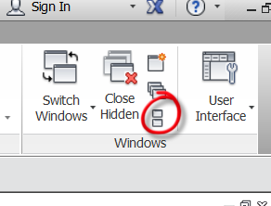
See the drawings that have been created.
Show Navigation bar with Zoom Tool (top, right corner)
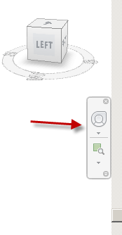
Zoom all to fit
Maximize a window

Show “Switch Windows”…allowing you to quickly cycle between open views.

Show CNTL-TAB Cycling through views technique

You have learned to load a family, control the location of an object with temporary dimensions and witness lines, and rotate the 3D model.

Save as revit2018demo2

Windows in Revit

Click on Floor Plan Level 1. Plan view.

Architecture
Window.
Notice that in the Properties box, Fixed is your only choice. Let's get a variety of windows from the library. It's the same process, we used when we got the doors.

Load Family.
Windows folder.
Get the:

Arched top with trim
Casement 3X3 with trim
Slider with trim.
Double hung with trim

Open.

Now the four additional Window families are added to your selector.

Note: Windows and Doors are “Wall-based Families”. They can only be placed in a wall. The wall “hosts” (Revit term) the doors and windows. If you delete the wall, the doors and windows go bye-bye too!

Let's put three double-hung Windows 16 in. by 48 in. equally spaced on the East wall. Check “Tag on Placement”.

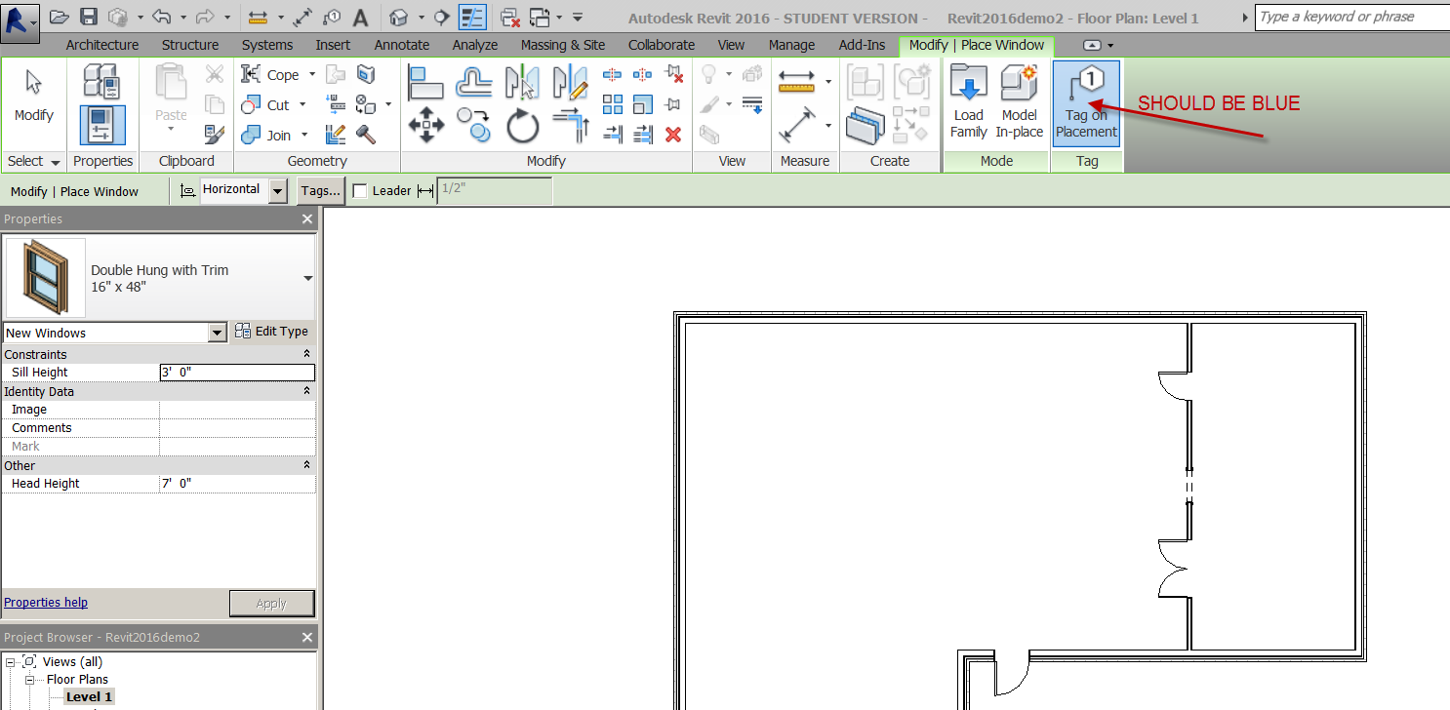

Just put them on the wall anywhere! Ignore the blue (temporary) dimensions. Escape twice to exit. Notice they include a Window tag. Also notice they are not equally spaced. The double blue arrows should be facing outside….just like the walls.
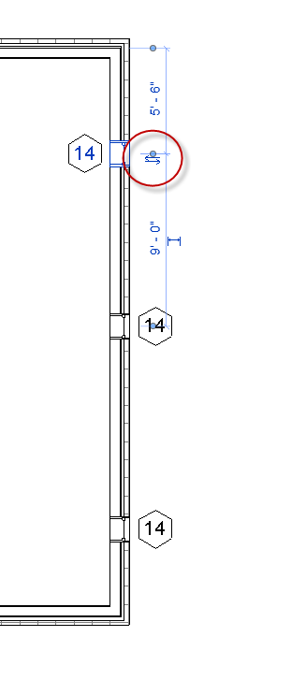
Pick on the North exterior wall.
Note the Modify Walls tab that appears on the pull-downs.
Properties.
See the Location Line: Centerline? That’s because that’s how you drew the wall……
Cancel
Esc

Annotate
Aligned
Do you see the green line in the center of the wall? Notice the box above that says prefer wall centerlines. That is the default setting. Let's change it to “wall faces”. Now back to wall. Now notice that the exterior of the wall is selected as you move your mouse over it. Left selected on the top horizontal wall. Slide mouse down to the center of the first Window, left select on the first Window. Continue sliding your mouse down and left select on the second Window. Continue sliding your mouse down and select on the third Window. Continue sliding your mouse down and select the bottom horizontal wall. Move your mouse to the right to place the dimensions.
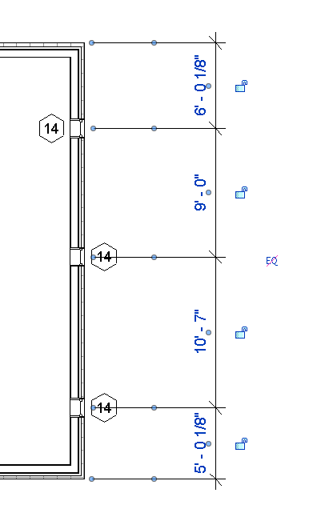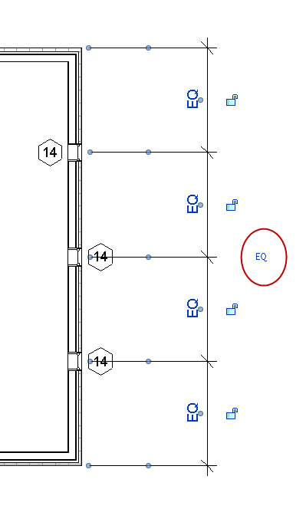

Do you see the blue dimensions? Permanent (black) dimensions can be locked an unlocked. See the uneven sizes between Windows? Click on the EQ symbol. Notice the Windows are equally spaced automatically. Now dimension, the entire wall by selecting on the top horizontal wall, then the bottom horizontal wall and slide your mouse to the right to place the dimension. Do see the overall size? Lock it. The contractors would be directed to place the Windows equally spaced on that existing wall. If that wall changed size, the Windows would remain equally spaced on it. Escape twice to quit.

Show east elevation by double-clicking on East in the Browser.

Zooming to see trim on Windows. Type SD. See the shade mode? Now type HL.

Show icons on bottom to do the same thing. Show 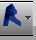 ….Options…..User Interface…keyboard shortcuts: Customize ….cancel

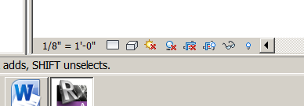

Changing a window type

Let's say you wanted the middle Window on the East wall to be a Fixed 36 in. by 48 in. instead of the Double Hung Window you already placed….

Left select the center window, you should still be an elevation view, but really doesn't matter what view you’re in.
Properties
Change the Window to a fixed 36 in. by 48 in. on the selector bar. Left select again over the Window.

Change the Head Height to 8 ft., contrasting the other two Windows.

Place two more of those windows on the North wall like this:
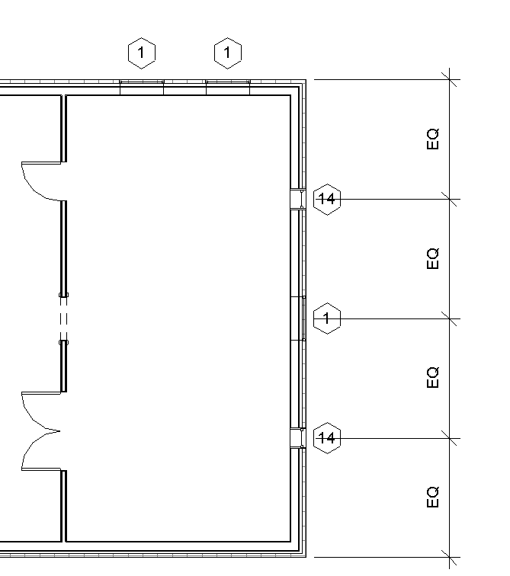

Note:
Instance Properties: just that one 36X48 window (the other 36X48 windows would not change.

Type Properties: ALL of the 36X48 windows would change

Show the Instance and Type property changes on the 16X48 windows

Let's say we want to make the window taller, but not one of the default sizes. How about 42 in. by 66 in., which is not a default size.
Left select on Window in the center of the East Wall.
Properties
Edit Type
Type Properties box comes up.
Change the Height to 66”
Change the Width to 42”
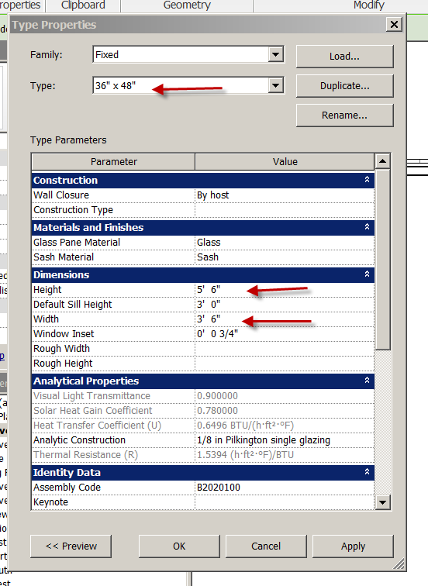

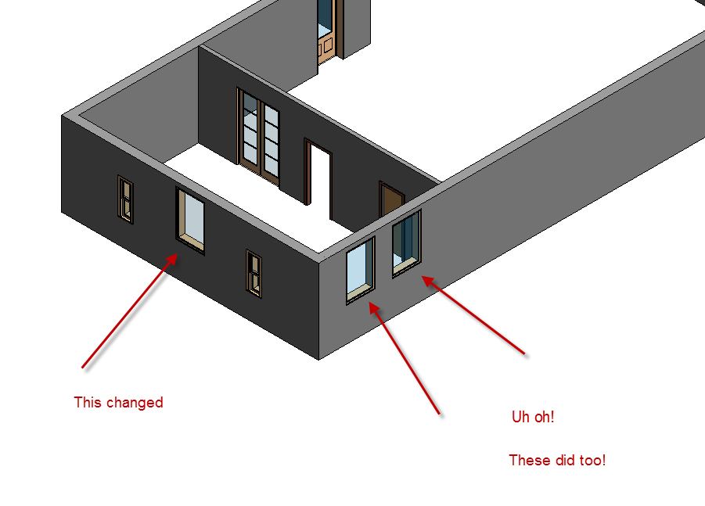

Discuss changing dimensions here….NO

Fix your mistake by going back in the type properties of the window and set it like this:

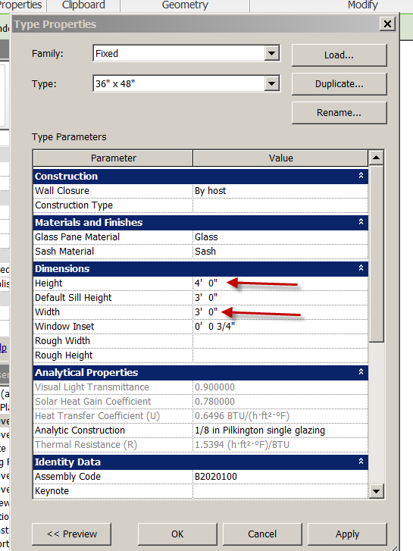

Here is the correct way:
Pick the window
Duplicate
Call it SHS4266. OK.
You'll now make your own size window in the” fixed” family. Set the width to 42” and the height to 66 in. Apply. OK. Do see the change? Set the Head Height to 8’.
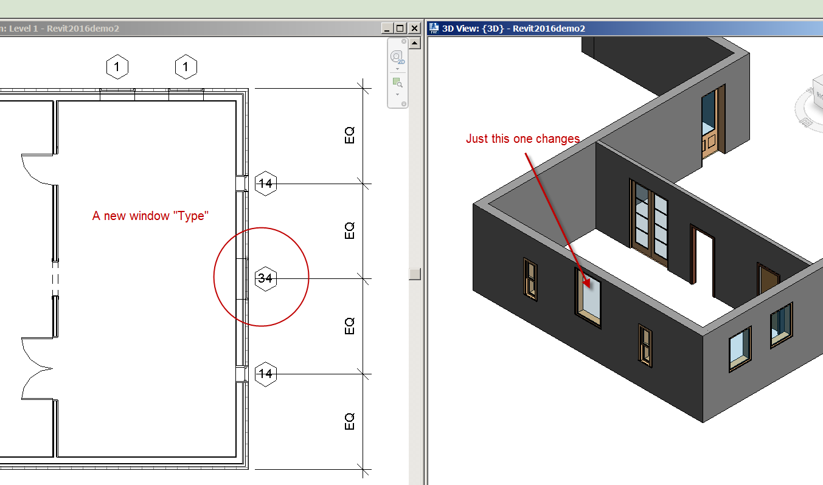

Pick on your new window
Go to the Properties….Fixed pulldown .
Do see the new Fixed:SHS4266 window you just created?

IMPORTANT: don't change the preset family sizes!... Make your own by the above technique(cloning and renaming). You don't want to mess with the default sizes. Explain consequences of not doing this correctly.

View the South elevation. Now go back to the plan view, Level 1.

Architecture
Window
Unselect: “Tag on Placement” on the Option Bar.
Now let's put an arched top 30 in. by 60 in. with trim on the front, right wall. Notice the Window is not tagged. Go to the South elevation again. Do see the Window?
Annotate.
Tag by Category.
Click on Window. Notice the tag is now on the elevation view. Occasionally, you'll want to tag your Windows on the elevation view instead of the floor plan view. Revit allows you do this!

Do see the tag number on the elevation view for the Window we just created? Go back to the level one view. Try tagging the same Window. Notice the same tag number is assigned.

Again, all the information that you're putting into Revit is in a database. It is all being stored for use later in our schedules, other views, etc.

Plan Regions: Clerestory Windows

You may run into a situation where you want to see a higher window than the cut plane will see. If you raise the cut plane, you will lose all your other windows. Here is the work-around:

Place a fixed window 16X24 on the South/Front wall. Turn Tag on Placement ON (blue)
See it….YES!
Properties.
Set the sill height at 7’0” …making the head height 9’0”.
See the window ?

Show South Elevation. See window? Yes. Show 3D view. See window? Yes. Show Floor Level 1. Can’t see the window at all now, RIGHT? Explain why.
Esc
Properties
View Range: Edit
Change Cut Plane Offset from 4’ to 8’
Change Top Offset to 9’
OK…OK
See result? Ouch!!! Discuss.
Change Cut Plane back from 8’ to 4’
Top from 9’ to 7’6”
That didn’t work!

Here is the solution….drum roll please……….a “PLAN REGION”

View
Plan Views
Plan Region
Properties
View Range (edit)
Change Cut Plane from 4’ to 8’
Top to 9’
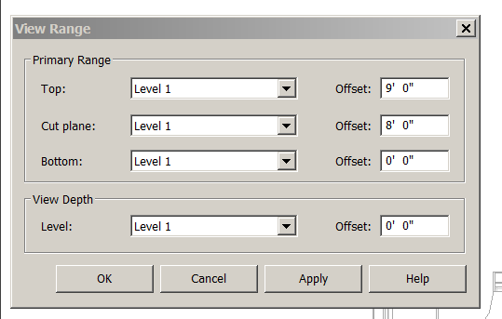
OK
Create a box (using line tools…top left corner) around the area where the window is placed. They will be magenta.
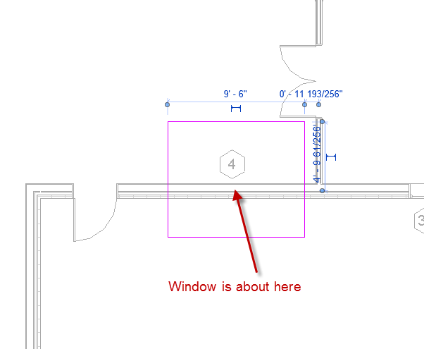
Finish Edit Mode (see the green check mark)
See it?
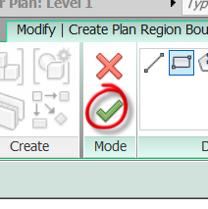
(green lines will not print)
Show how to modify the plan region and what to avoid.
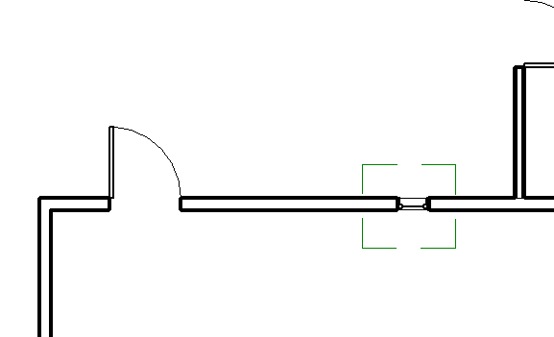

You have learned how to use temporary dimensions to control design intent (equally space), create a new size object by duplicating/cloning another, and create a plan region.

Save as revit2018demo3

Floors and ceilings.

Floors

In the view bar, click on level one.

Architecture
Floor Architectural.
Floor properties option Ribbon is displayed
Pick walls (icon in line tools area). Double lines are span direction.
You should see magenta lines.
Floor Properties. Note the different “out of the box” floors. We will leave it 12” Generic for now. Show Edit Type
Finish Edit Mode (green check)
Note: Walls are being selected to “Face of Core”
Show in 3-D.
Use View Cube to rotate.
Note: floor could be inside or outside core of wall.
The floor is not really close to being perfect….the garage floor would be lower than the house floor (water), the floor is 12” thick with no material assigned, and the edges of the floor are not correct. We will address this later.
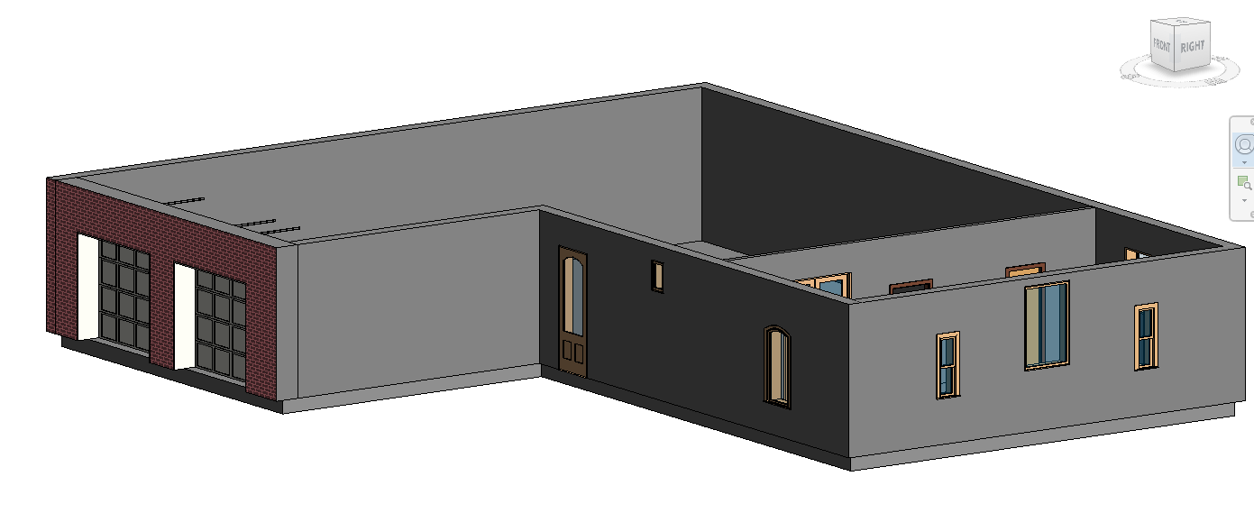

Ceilings.

I want to make a purposeful mistake on the ceiling to show you the ceiling plan dynamics.

Go to Floor Plan Level One.
Architecture
Ceiling….Automatic Ceiling
Let's cover that small 15 ft. area on the right with the ceiling. Zoom in on the area.
Properties
Let's select 2’X4’ ACT System.
Move mouse over area. See the red rectangle?
Revit anticipates the area to include the ceiling! Left select.
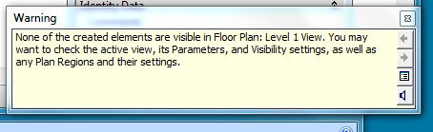

OH NO…..ERROR! “None of the elements are visible in floor plan level on...” Why?

Because the display representation for a ceiling is looking up, not looking down. Escape twice to exit.
Switch views to the Ceiling Plan Level 1. There it is! Now look at it in 3-D view. View Cube….

Show the view properties/view range for the ceiling view. Get it?
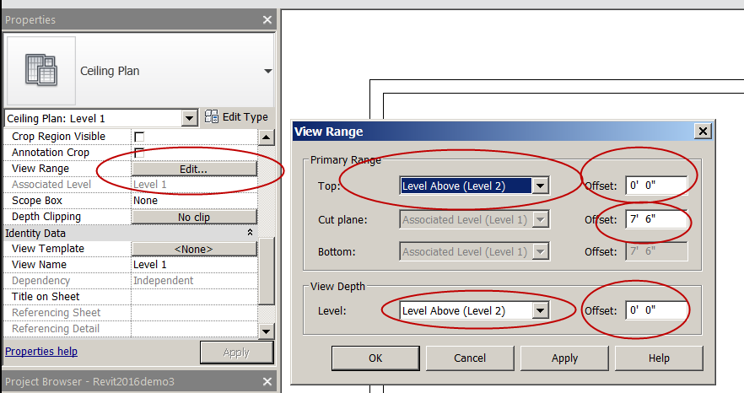

Still in Ceiling Plan level one. Let's put a ceiling over the garage area, but a Gyp board/metal stud ceiling.
Architecture
Ceiling
Compound Ceiling GWB on Mtl. Stud
Height Offset: 7’
Click Sketch Ceiling icon.
Select chain box.
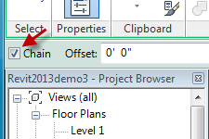

Use lines to create ceiling.

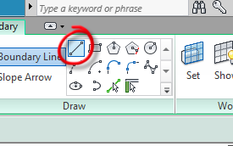

Don't worry about mistakes. You can fix it later, if necessary. Stay on the inside of walls.

RULE: magenta (sketch) lines must be “closed loops”.

Finish Ceiling.
Show in 3-D view.

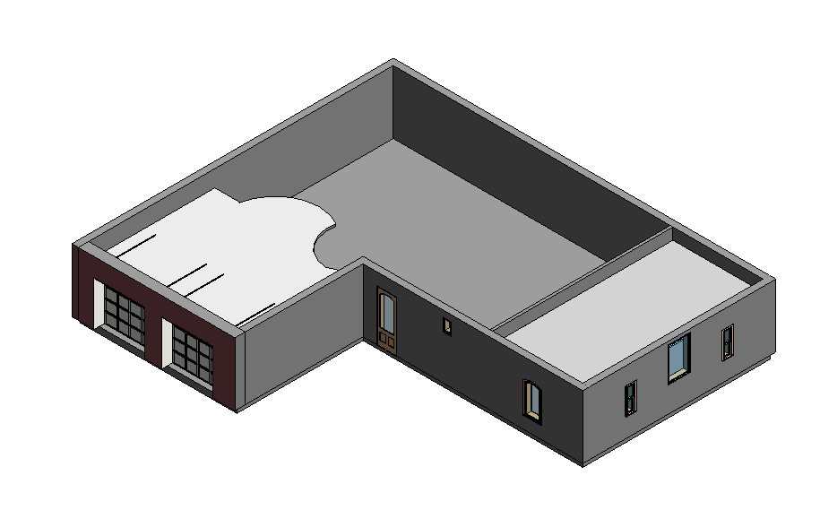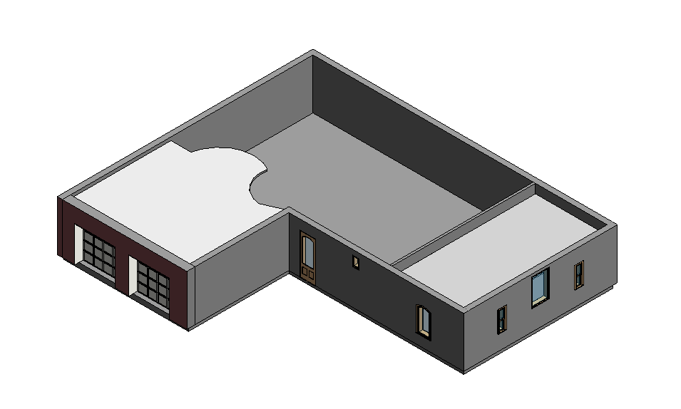

Notice the ummmmm…..design flaw with the ceiling relationship with the garage doors. Our ceiling is a little low, so let's adjust it. Select the ceiling in the garage by left selecting. It should turn blue.
Properties.
Height offset from Level. It is at 7 ft. Let's set it to 9 ft. OK.

The ceiling should be okay now. Let's change that ceiling style to a two by four compound, like the other one. Escape twice to exit. Show ceiling plan level one.
LC on ceiling.
Properties
Compound Ceiling 2X4 ACT System (some call it a “T-Bar Ceiling”).
The ceiling grids can be selected and moved and aligned to your needs. Show ceiling components and Model Pattern assigned to ceiling.

Select Ceiling
Edit Boundary button.
It should turn magenta. Select the top horizontal line. See dimensions and blue dot grips? You can adjust with dimensions or stretch/change the shape. Grab the center of the line with the left mouse click. Hold down the mouse and drag up. Easy! Green Check. Show in 3-D. Show how to change the shape using sketch lines. Show adding a hole in the ceiling.

Let’s see how many drawings have been created.
View Tile….See all the drawings? Same file!

View…Zoom (magnifying glass icon)….….All to Fit

You have learned how to create a floor and a ceiling in “sketch mode”, add a hole in a floor or ceiling, and utilize a ceiling plan.

Save as revit2018demo4

Roofs

Let’s add a simple hip roof with a 4/12 pitch on this house.

Go to Floor Plan Level 1.
Architecture.
Roof.
Roof by Footprint.
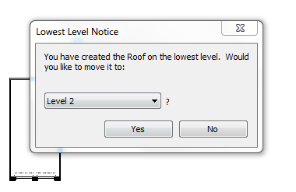
Lowest level notice box comes up. It's warning you to move the roof to level two. Good idea…otherwise, the roof would start on the ground! Click yes.
Let's set the overhang to 1’0”.
Uncheck extended into wall.
Check Defines slope

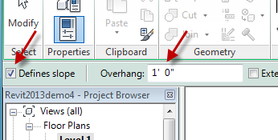

Pick Walls button.
Properties
OK. Pick the exterior walls you want to cover with roof. The green hidden lines represent the overhang. The magenta lines are the roof.
Highlight all of roof
Properties
Change the Slope to 4/12.
Edit Type
Change to Wood Rafter 8” Asphalt Shingle-Insulated. A bit smarter than the Generic 12.
Finish Roof.
No roof? Now select Level 2. Some roof, but cut off. It should look like it got sliced horizontally.
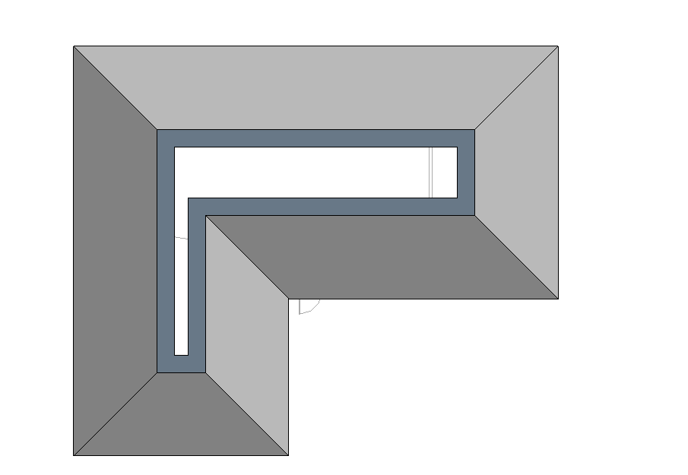 It did! Explain 4’ cut plane at Levels. Now try Site Level. Complete. That level shows the complete roof (it’s view range is 200’ up). Show in 3-D.
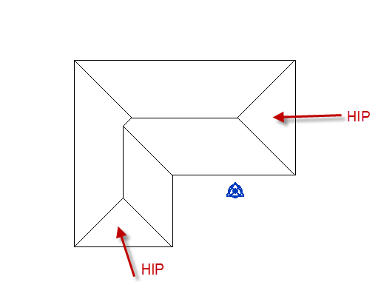

How to change our roof pitch in Revit.
Floor Plan Site
LC on Roof. It will turn blue.
Edit Footprint button.
You'll see purple lines with some triangles near them.
Window to select all of it.
Properties.
Adjust the rise to 12” and overhang to 2’.
Green Check
Finish Roof
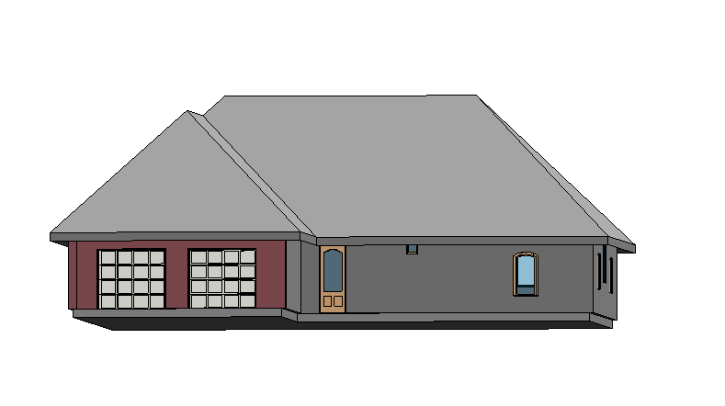

Change from hip to gable roof.
There is not a “button” to change a roof from one type to another. Maybe in the future??

LC on roof in 3-D view (you could do this on Site level too). Roof should turn blue. Let's make that right side hip where the three windows are, into a gable.
Edit Footprint.
You should see purple slope arrows and lines. Pick the LINE (not arrow)one over our wall.
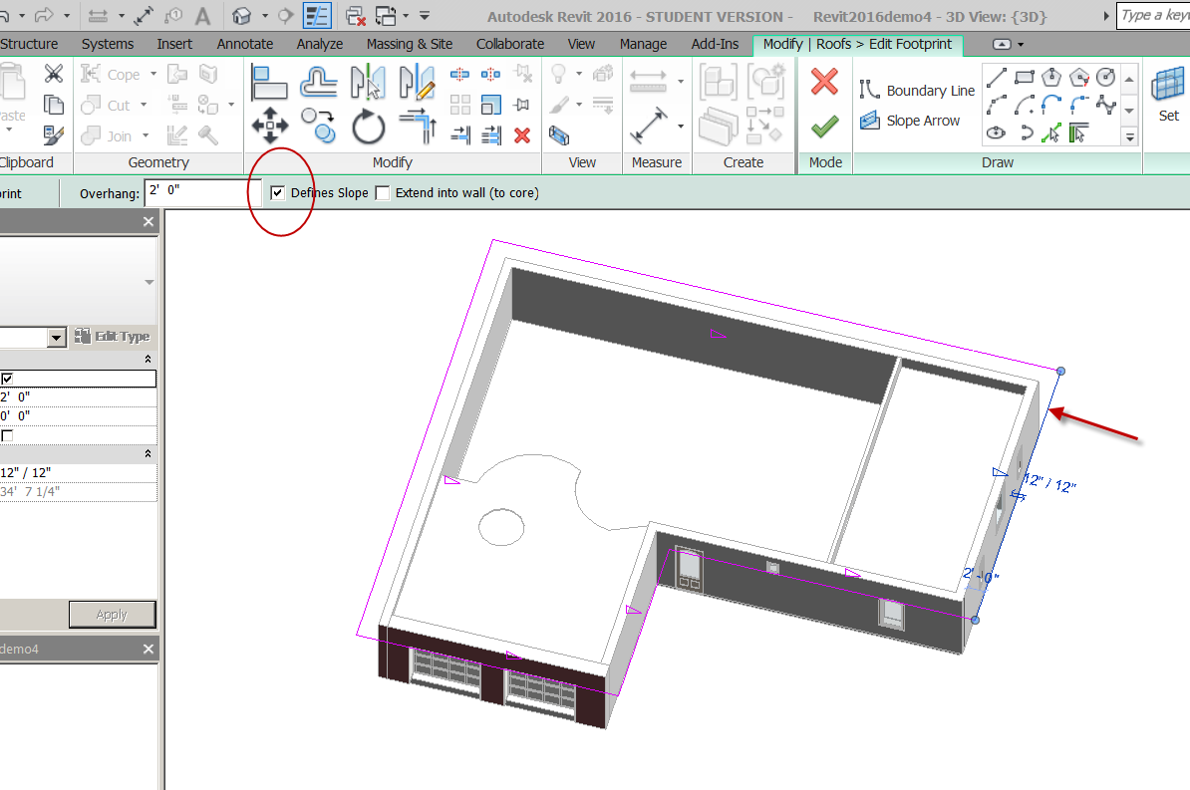
Uncheck defines slope.
Leave extend into wall off.
Green Check
Notice the air conditioning element!!!
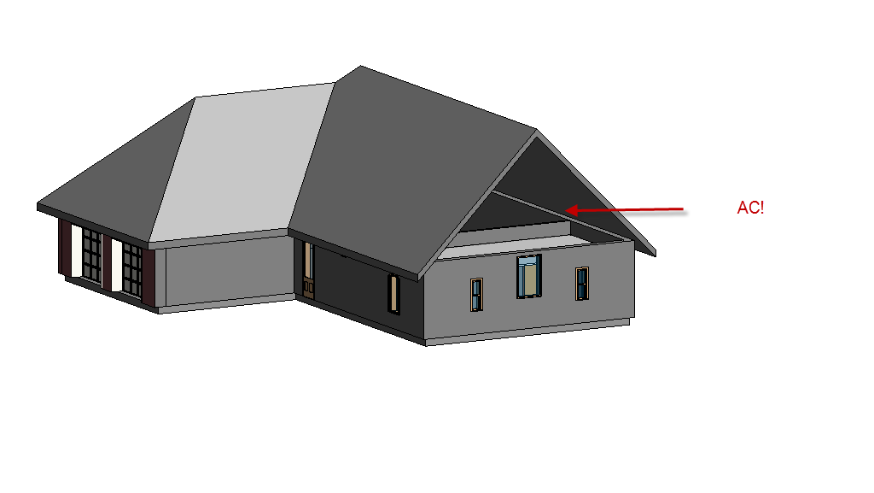
Let's do the other side, over the garage….this time in Site view
LC on roof.
Edit Footprint.
Pick line over garage doors. Uncheck both defines slope and extend into wall.
Finish roof.
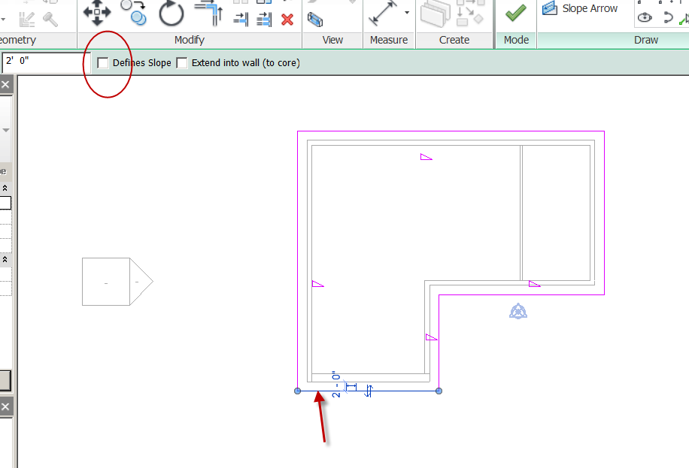
3-D rotate.
More air-conditioning!!! Let’s fix that.
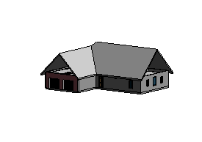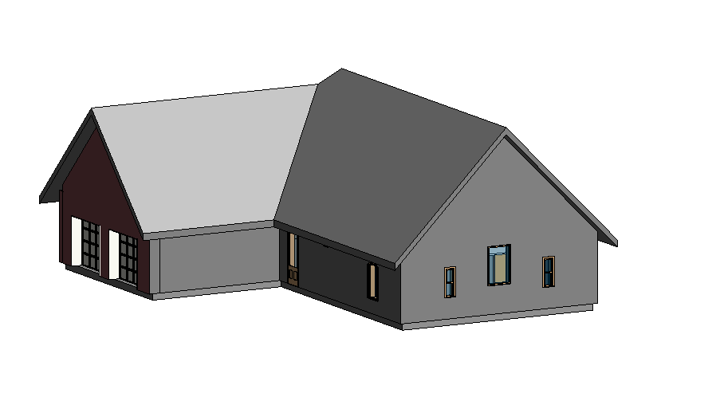

Select the garage wall.
Attach: Top/Base
Pick Roof.
Done!!

Do the same with the East wall.

Note: Windows can go in that gable wall area

Show elevation view, to demonstrate the applied roof pitch.
Change it back to 4/12 pitch and 1’ overhang.

Change from a gable to a shed

Let’s put a shed roof over the front door (off the front wall).

Floor Level 2
Put your Display settings on “Wireframe” so you can see the walls below the roof.
Architecture
Roof
Roof by Footprint
Properties
Base offset from level: -1’6”
Roof Type: Wood rafter 8” asphalt…
OK
Lines: Rectangle tool
Uncheck defines slope
Create rectangular sketch for roof
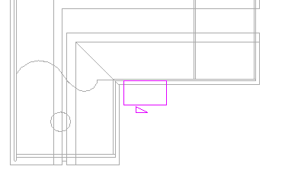
Esc…Esc
Pick front horizontal line
Check defines slope
Set pitch to 1/12
Green Check
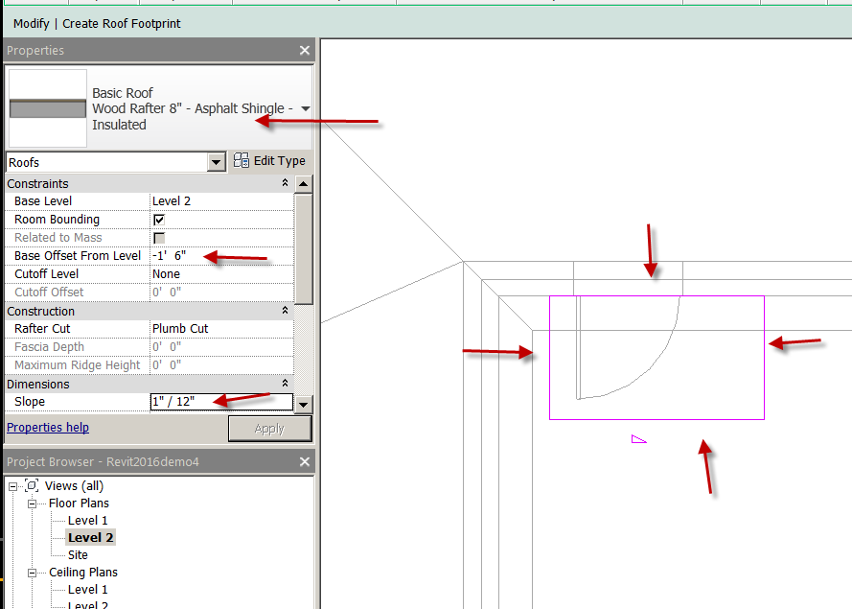
East Elevation
Notice our shed roof is a little too high? (front was base height)
LC on roof
“Bump” (Revit term) it down to desired height using the down arrow key. Bump it down to -2’0”

Roof gutters

You can add roof gutters very easily in Revit.
Site
Architecture
Roof
Roof: Gutter.
Pick the roof edges, in which you want to place roof gutters. Click into white space to exit the command. Show in 3-D. Show south elevation. You should see the gutter clearly in both views.

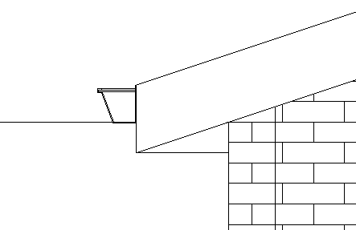

You can change/add the roof fascia in the same matter.

You have learned how to create a hip, shed, flat and gable roof, change the pitch and overhang, add gutters, and change the physical properties of the roof.

Save as Revit2018demo5

Putting your work onto paper in REVIT

The Revit title blocks are under SHEETS in the Project Browser.
Pick Sheets (all).
Right-click. New sheet.
There is a default E1 30X42 Horizontal paper size loaded.
We want a different size….. pick Load….
Imperial Library
Title blocks.
D 22X34 Horizontal.
Open.
Now you have two choices. Pick the D 22X34 Horizontal size sheet.
OK.

Let's put the four elevations on the sheet. Let's select East elevation. It should be highlighted. Drag it into the sheet by holding the left mouse button down, then releasing it in the sheet. Move the view to where you want it on the sheet. Left select. Pick outside to exit. Zoom in to see your work. Repeat the process for the other three elevations. Notice the elevation marks and the labels. All automatic! You can zoom and pan without losing your scale. It's all tied together in a database.

Try this. Go to your South elevation in the Sheet. Let's make the Level lines a little shorter (horizontally).

Show Activate View….Deactivate View

Activate the East Elevation. Drag the level lines closer to the building
Notice the West line moves too!!! They are “planes”
Continue the process until all the Level lines are closer to the building.

Show how to shorten the Title bar.

Naming Sheets

Zoom in on the lower right corner of the title block (showing the sheet name and number)
Go back to Sheets in the Project browser.
Double-click on Sheets. Pick A101-unnamed.
Right-click. Rename.
Name the sheet EXTERIOR ELEVATIONS. Give sheet number A501 OK. Notice the sheet updates automatically!
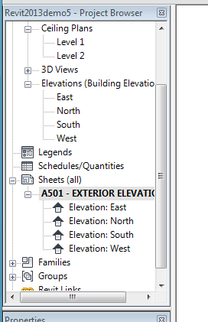

See the + sign next to A501-EXT. ELEVATIONS. Click on it. See the four elevation links? All organized, all in the database. Double-click on the little icon next to elevation east. Note that it takes you to the East elevation. Also notice the East elevation is highlighted.

Go to Floor Plan Level 1. See the elevation tags? They update as elevations are placed on a sheet. Move them a little closer to the building.

Show Blue Elevation line and issues with it being in the building
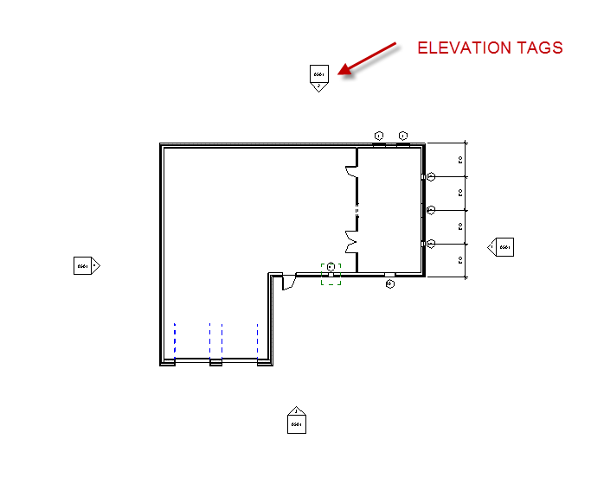

Dimension scale will not be an issue in Revit. YEA!

Let's make a sheet for floor plan one.
Click on Sheets.
RC
New sheet. Let's take a D size sheet again. OK.
Pick Level 1 in Floor Plans. Drag in. Done.
In Title Block…. Rename to A201-FIRST FLOOR
Note the project Browser updates automatically!

Select in viewport
RC….Activate View
See bar at bottom?
Change scale to 3/16”=1’0”
RC…Deactivate View
Move to center
Note Title Bar Scale!

Sheet Naming Convention

C100.00 GENERAL/ SITE
EX: COVER C101
SITE C102
SITE DETAILS
COVER SHEET
DRAWING INDEX

A100 SLAB/FOUNDATION
A200 FLOOR PLANS
ENLARGED FLOOR PLAN AREAS
TYPICAL ROOM PLANS
ELECTRICAL
A300 RCP (CEILING PLANS)
CEILING DETAILS
A400 ROOF
A500 EXTERIOR ELEVATIONS
ELEVATION DETAILS
ENLARGED ELEVATIONS
A600 BUILDING SECTIONS
WALL SECTIONS
DETAIL SECTIONS
A700 INTERIOR ELEVATIONS
FINISH SCHEDULES
MATERIAL SCHEDULES
INTERIOR DETAILS
A800 DOOR/WINDOW SCHEDULES
A900 MISC

You have learned how to place views on a sheet, activate a view within a sheet, properly name a sheet, and utilize sheet naming conventions.

Save as revit2018demo6

Section views in Revit

You can easily create section views in Revit. The views are tied to the building model, so if the model changes, the section will change along with it.

Floor Plan Level 1

First let’s put a couple of cars in the garage.
Architecture
Component
Place a Component
Load Family
Entourage
Pick the RPC Beetle ….don’t pick the semi-truck…it won’t fit in the garage
Open
Place 2 Volksvaagons in the garage.

Show how to align the VW’s with the center of the doors
Modify
Align
Target
Source

Creating a Building Section
View.
Section.
Properties
Building Section.
(Show Wall, Detail too). Use pen to place section view. Drag the section line horizontally thru garage, as if you were cutting the VW’s in half.
The blue arrows flip the viewing direction.
Click in the white area to end the command. You just created section one.
Now go to sections in the project browser. Double-click on sections. See Section 1?

Set the display level to Medium. See the structure of the roof and walls? Discuss

Change crop region so front door does not show, just the garage. (show options)
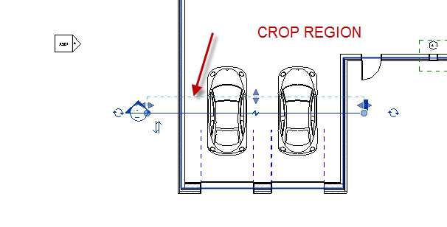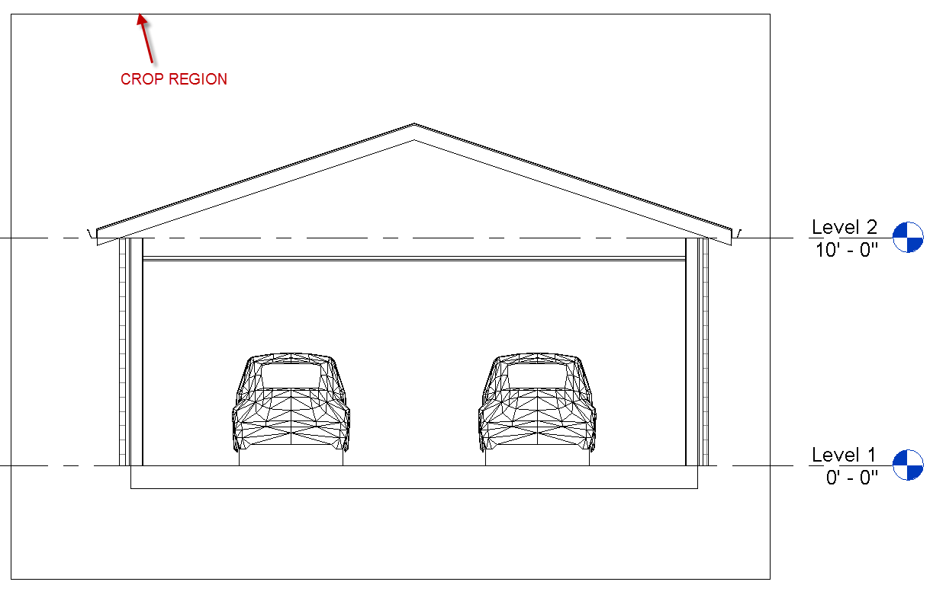

Show RC…GO TO VIEW from Section line

The following steps will keep the project browser “clean” and easy to track views:

In the Building Section View
Propeties… under Identity Data…..Title on Sheet….
Name it SECTION THRU GARAGE. This changes the title without renaming the view in the browser.

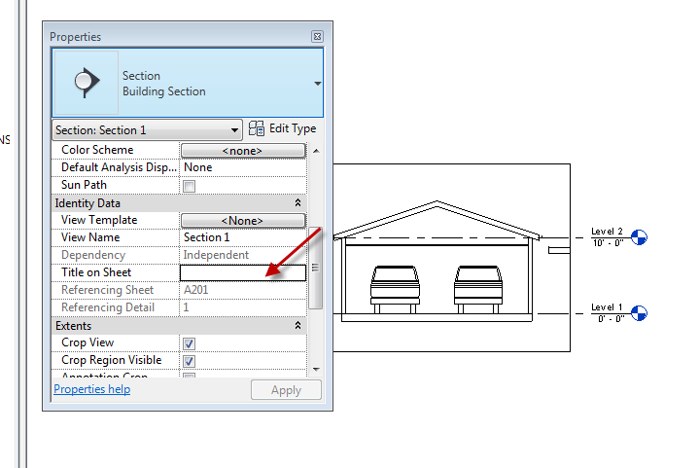

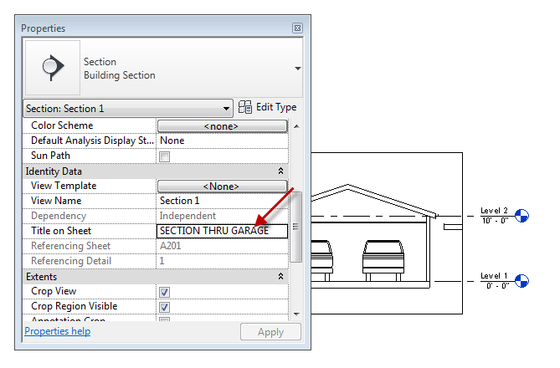
Let's make a new sheet for building sections. Sheet A600 is the proper designation for building sections.

Drag the sectional view into the building section sheet A601. Notice the section view is numbered, corresponding to the section view in the floor plan. They are linked. See the name SECTION THRU GARAGE?
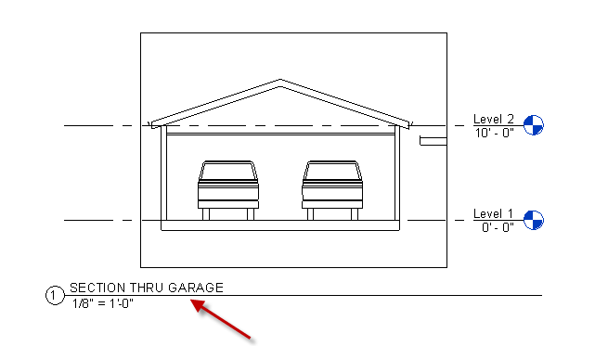

Show how to activate the view and change the scale on the sheet. Change it to: 1/4”=1’0”
Show how to turn off crop box (hide crop region icon at bottom of screen).
Deactivate view.
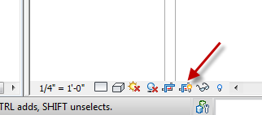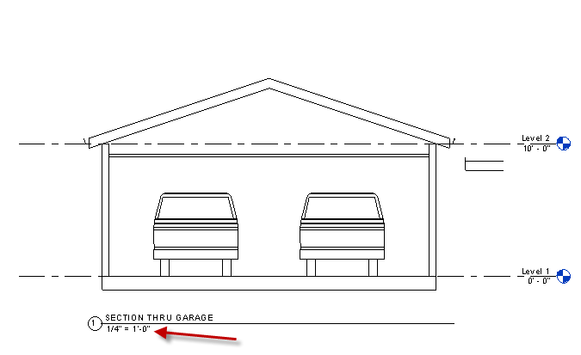

Let's make a new sheet for wall sections. A600 is the proper designation for wall sections. Name the new sheet WALL SECTIONS and give it a sheet number A602

Create a Wall Section.

Level 1 Floor Plan
View
Section
Properties
Choose “Wall Section” from bar

Go through the small window we used for the “Plan Region”
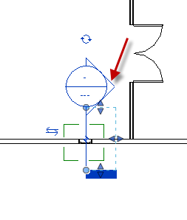.
Adjust the section region box to be about 2’0” deep
Note Project Browser now has Wall Sections!!!
Note: The Wall Section has a different arrow (unfilled) than the Building Section….
LC on the Wall Section line
RC….. Go to view.
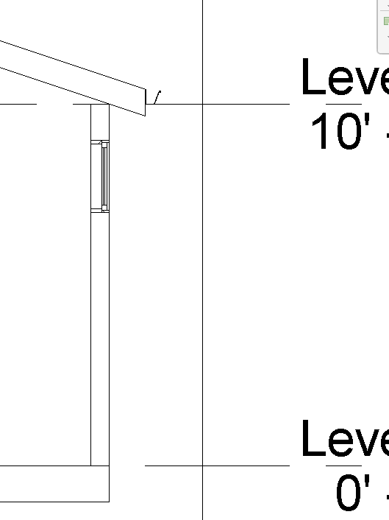
Change the Display Level to “Medium”
Change the scale to ½”=1’0”
Drag that view on Sheet A602.
Create another wall section through the garage door. It should be Section 3.
Change the scale to ½”=1’0”
Drag that view into sheet A602. The Revit scale change selector at the bottom of the screen…very easy to set on the fly!
Turn off the Crop boxes on both views.

Go back to floor plan one.
Note the Building Section tags are populated SMARTLY with data pointing to the sheet the view is on.
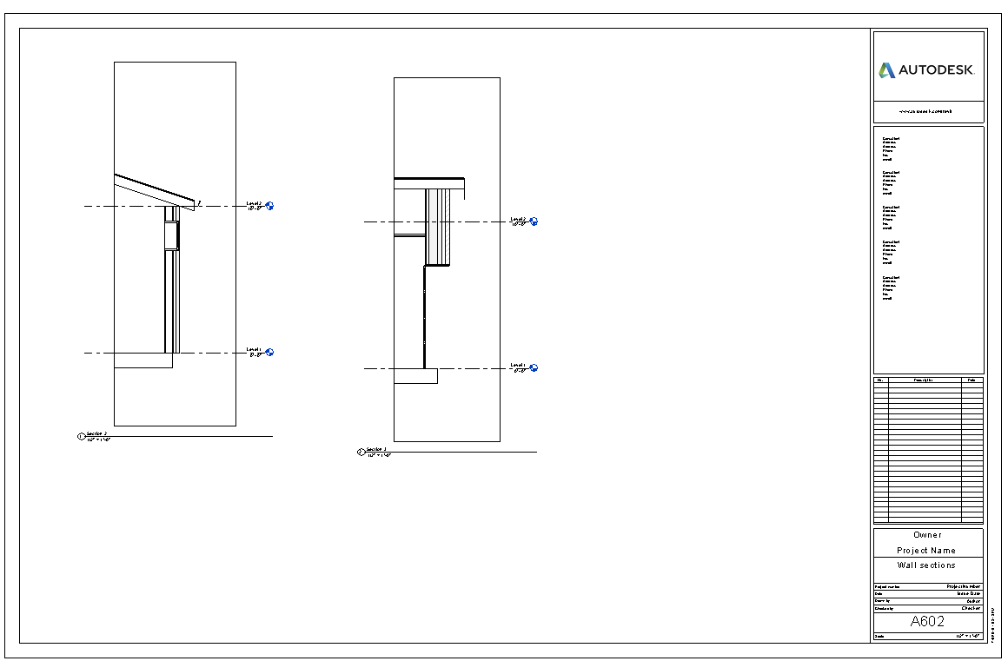

Now Erase the window that section two passed through. Now go back to sheet A600.02. Notice that the window is now gone. Once something is erased anywhere in the building model, it is completely erased in the entire database in every view. That would include door, window schedules as well. Undo the deleted window. See it back in the section view!!
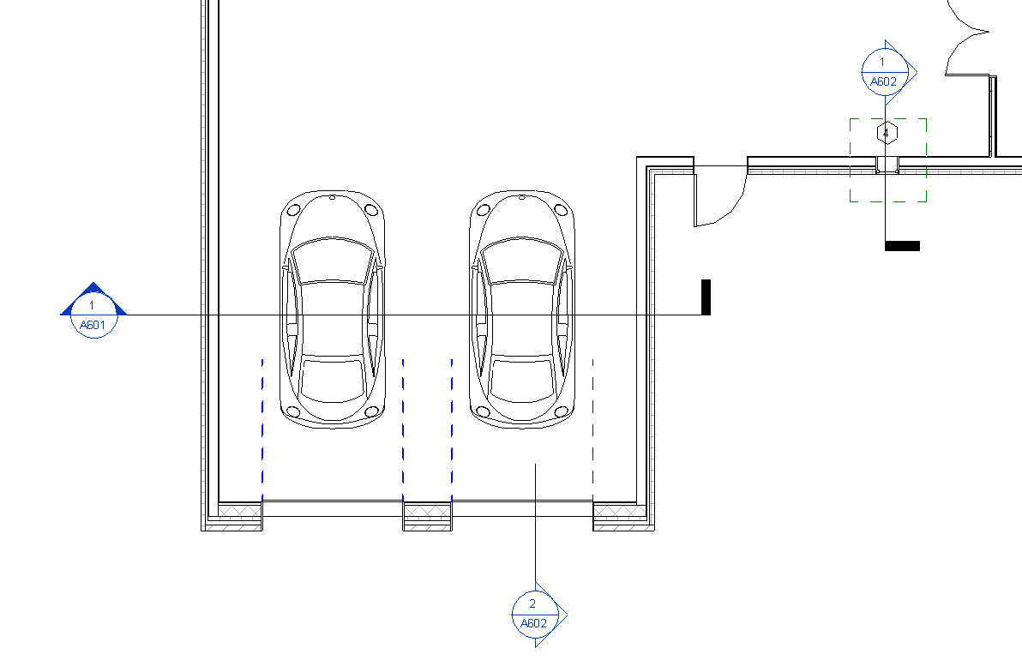
You have learned how to create building and wall sections, describe a view without changing the browser, and change the scale of a drawing in the sheet.

Save as Revit2018demo7

Furniture, fixtures and viewing in Revit

Floor Plan Level 1

Let's try furniture first.
Architecture
Component.
Place a Component
Load Family.
Furniture.
Beds
Bed-standard
Open
Properties
Notice you have 4 TYPES of beds, King, Queen, Double, and Twin. We’ll talk more about these “types” later.
For now, Let's place a king-size bed in that 15 ft. wide area, against the North wall. Notice the dimensions help you control placement, as you place the bed. Escape twice to exit. Left select on bed. Do you see the dimensions? You can adjust the distance the bed is from the walls. Show SPACE BAR will flip/rotate the objects

Show location and loading of Furniture families

Fill the room with furniture. Desk, TV, Dresser, sofa…up to you. Just populate room so all 4 walls have furniture adjacent.

Look at it in 3D
Pick Roof…VH
Pick Ceiling…VH
Use Orbit Tool to see how your furniture went in. Any luck??? Need to rotate
Pick the furniture piece…..space bar
Back to Floor Plan Level 1
Move furniture as needed
Back to 3D
VV….
Check Ceilings and Roofs
More to come very soon on the visualization stuff!
Where do I find all those cool 3D objects?

Using the same process as the furniture, here is the location(s) of some common objects:

Explain what Revit is giving (partial cabinets) and why countertops are not on casework.

Kitchen and Bath Cabinets
Component. Place a Component. Load Family. Casework.

Plumbing Fixtures (sinks, tubs, toilets, water heater, etc)
Component. Place a Component. Load Family. Plumbing, Architectural. Fixtures

Specialty Equipment (washers, dryers, oven, range, dishwasher, microwave, etc)
Component. Place a Component. Load Family. Specialty Equipment. Domestic.

Lighting Fixtures (lamps, ceiling lights, sconces, spotlights, etc
Component. Place a Component. Load Family. Lighting. Architectural.

Openings (cased, elliptical, wall openings)
Component. Place a Component. Load Family. Openings

Electrical Fixtures (panels, outlets, switches)
Component. Place a Component. Load Family. Electrical. Architectural. Electrical Power

Sustainable design (bike racks, solar panel, light shelf, recycle bin, etc)
Component. Place a Component. Load Family. Sustainable design.

Discuss 3rd party downloadable families Pro’s and Con’s:
Revit City (free…but sometimes you get what you pay for)
You must join in order to download families. To save valuable lab time, you could download families at home…then bring them to class on a USB drive. You do not need Revit at home to access Revitcity.

http://www.revitcity.com/index.php

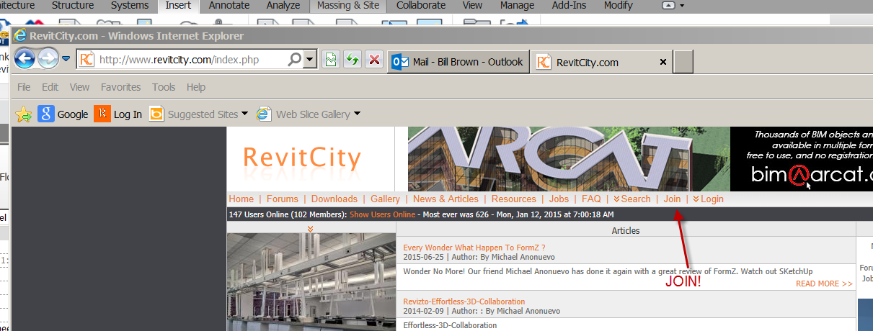

Autodesk Seek
Free content from Autodesk’s site. Good place to find families.
http://seek.autodesk.com

Insert….Load family…..
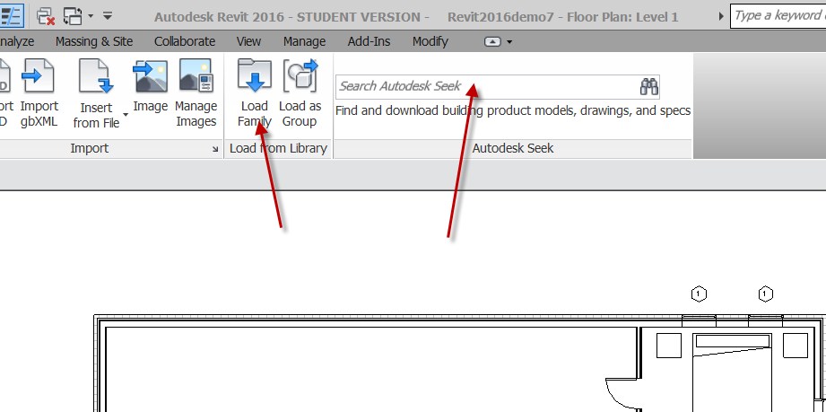

Controlling what you see

Revit allows you to hide object and categories. You can hide them so they don’t print, or just temporarily to see other things. You can hide a single object without hiding all of the same type of objects. You can make objects transparent.

Place your 3D view on a sheet.
Title: 3D Views
Sheet Number A901

Be in 3D View

Temporary hide
Let’s say you want to hide a roof portion (not all of the roofs) in the 3D view so you can see the ceilings below it….
Select the roof to hide
Sunglasses
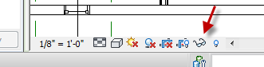
Hide element
Pick the ceiling toward East
Hide Element
Pick the left window on the East Wall
Hide Element
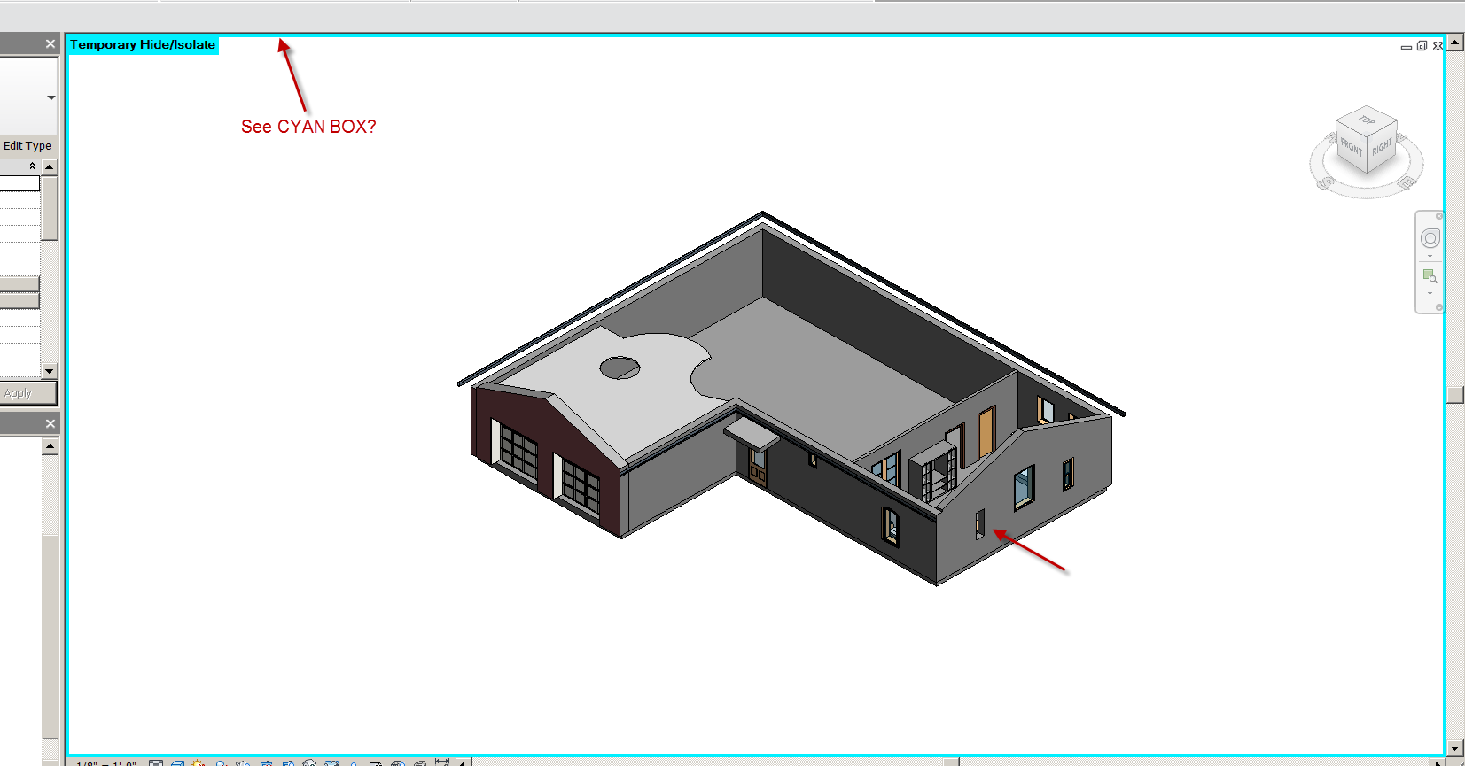

See the Cyan box??
Sunglasses
Reset Temporary Hide
They’re all back!

So the Sunglasses hide stuff temporarily…..you can pick a bunch of different objects and temporarily hide them….then turn them back on with one “Reset Temporary Hide”

Hiding an object permanently
Let’s say you want to hide the same roof section in the 3D view so you can see the ceilings below it, but not all the roofs:
Select the roof to hide
RC
Hide in view
Element
Light bulb
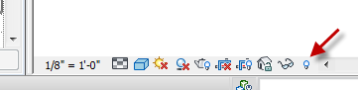
See red box? All red objects are hidden in this view. The “Analytical Nodes” you can leave them alone.
Select the red roof
Unhide Element (icon is at top, right corner)
Light bulb
Roof should be back

The light bulb allows you to turn off individual elements without turning off the whole category. You can only turn them back on with the light bulb. VV does not work.

Let's say you want to freeze the entire roof and the ceilings in the view.

Go to the 3-D view.
Properties.
Visibility Graphics Override.
Edit
Uncheck Roof and Ceiling.
OK.
Go back to floor level two, look at it. Do the same with Ceiling Level 1. Do the same with Site. Notice the roof and ceiling are ONLY frozen in the 3-D view, where we turned it off. Revit freezing is VIEW SPECIFIC!

Pick on The Building Sections sheet A600.01. Notice what's in the garage. Everything is linked in the building model!

Go back into the 3-D view, in turn the roof and ceiling back on. Use the VV (shortcut)

To hide a type of object in a view, Use the VH (shortcut)

More Sections

Flipping the section.

Floor Plan Level 1
Pick on the section Arrow. Right-click. Flip section.
See the Double-blue (FLIP) arrows? Pick them…same effect!

Breaking the section lines

Select on a Building Section line. See the little blue Z in center? Pass your mouse over it. See the “gaps in the segments”? Left click on Z. Should have broken section line into two parts. You can drag down the blue dots/grips to show the part of the section line you want. Want to join the section line into one again? Select the line…Pick Z again. See it join?

Offset section

Place a 36X48 window on the East and West wall of the Garage, not aligned horizontally.
Offset section: Pick section line. Split Segment button. Pick the part of the line you wish to move. Slide mouse up/down to change location of section. Note: You can only go as far as the crop region boundary (green lines) on the split section.
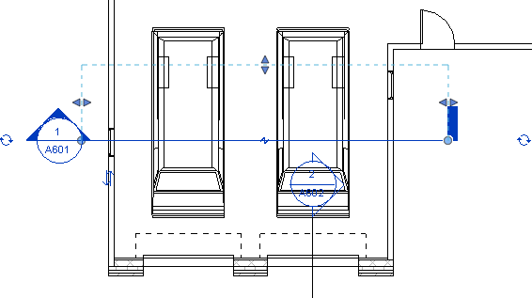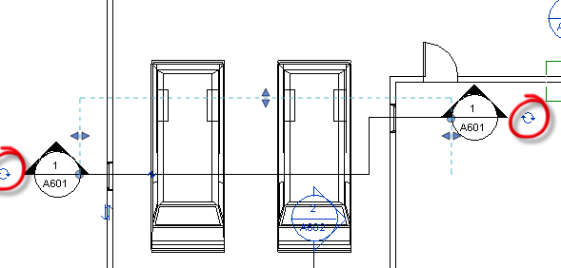

Changing the section Head/Tail

Select on section line near section marker. See the blue circle with arrows near the section marker? Pass mouse over. See “cycle section head”? Pick on it. Pick again. You are toggling between 3 appearances: no line, thick line, and arrow.

Repeat for “tail” (other end of section line).

You have learned how to find components in the program and via external websites and control the visibility of objects in the view.

Save as revit2018demo8

Interior Elevations

This is a neat one. Let’s set up some interior elevations in a room.
View (pulldown)
Elevation…Elevation
Properties
Select Interior Elevation
Place elevation marker inside room of choice.

Notice as you near a wall with the marker, the marker points to that wall. Pick a wall of choice so the marker points to it. Notice new interior elevation is created (in the project browser under elevations).
Double click on the interior elevation in the browser to see it.
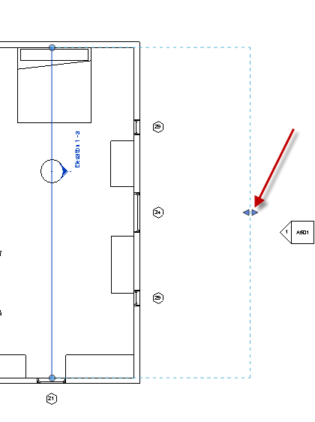

Crop the box by picking the blue arrows (see above) and dragging your mouse.
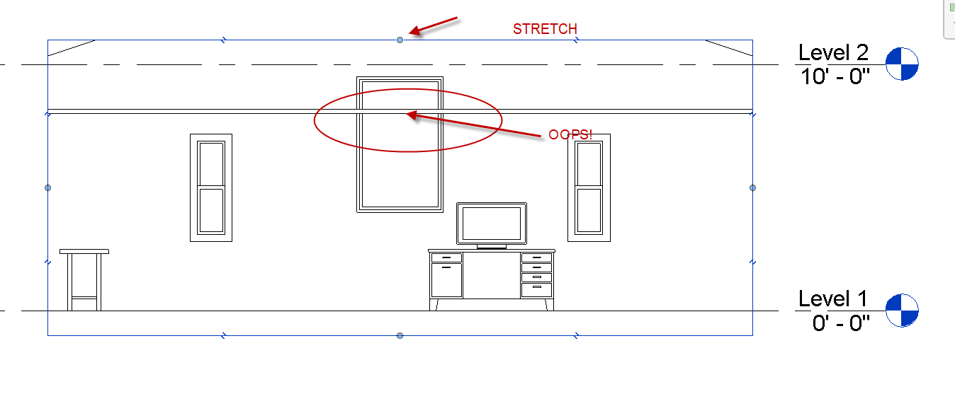
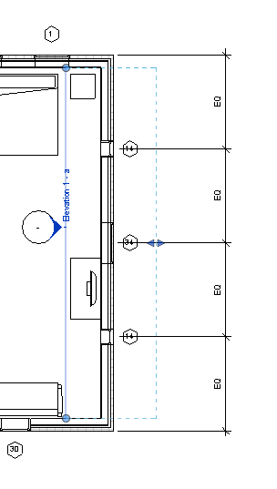
See the blue line? That is where you are standing. Just like a Section line. In fact, elevations and sections are pretty much the same (in the way they work) in Revit. Discuss

Place the Elevation on a sheet.
Name the sheet INT ELEVATIONS A701
Back to Level 1

See the information in the elevation symbol? Page number…elevation number…
Here is a neat feature. Pick on the elevation marker.
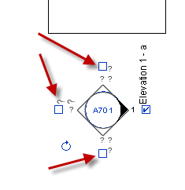

Notice it changes to a diamond. See the blue boxes? You can check them to set up more elevations! Check them all. As you are checking them, notice in the browser, under elevations, new elevations are being formed. Drag the new elevations onto a sheet.

Getting rid of the Elevation Mark text
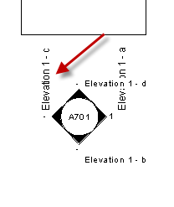

The Floor Plan is a little cluttered. A little trick….
Manage
Settings….Additional Settings
Elevation tags
½”Circle
Elevation Mark
Chose Elev Mark Body_Circle: Filled Arrow
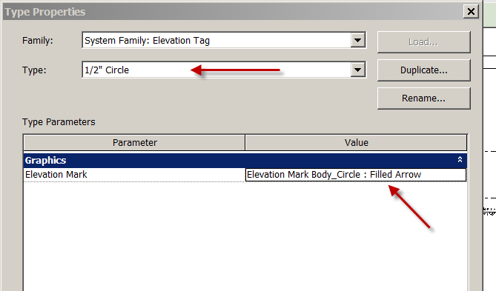
OK

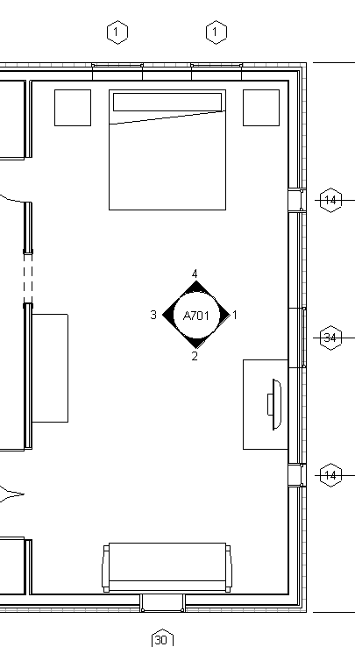
A little better?
Drag the other 3 interior elevations on sheet A701
That is Revit’s database being updated….it’s all tied together! If you add content later, EVERYTHING UPDATES…automatically!!!
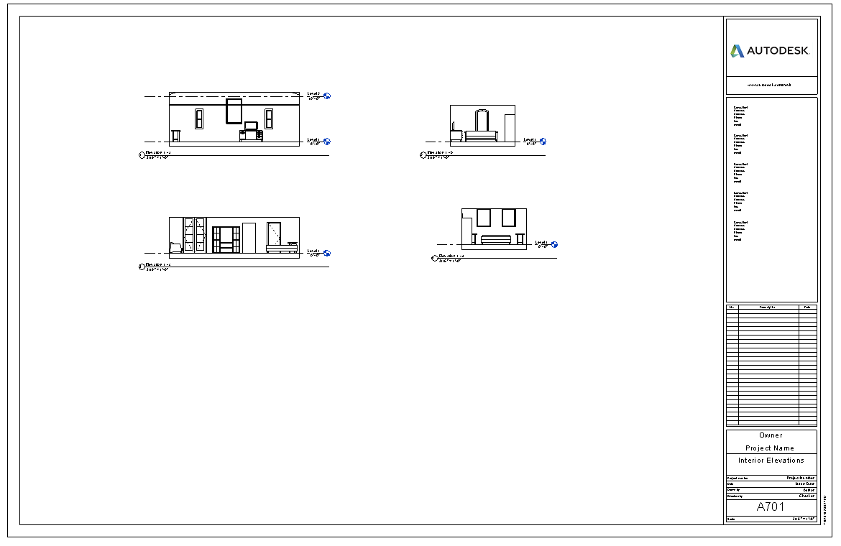

You have learned how section and elevation annotations work, going to a view from the annotation symbol, creating Interior Elevations, and how the browser updates smartly as views are created.

Save as: revit2018demo9
Adding Multiple Floors in Revit

Add some windows on the South, North, and West Elevations. Different types…Explain that we will use them for schedules later.

3D View
Delete Roofs (we will be adding floors, so the roof will be higher)

South Elevation
Architecture
Level
Check Make plan View
Create 5 more levels…10’ apart….to Level 8
Show “Offset” strategy
Turn on Level markers on left side
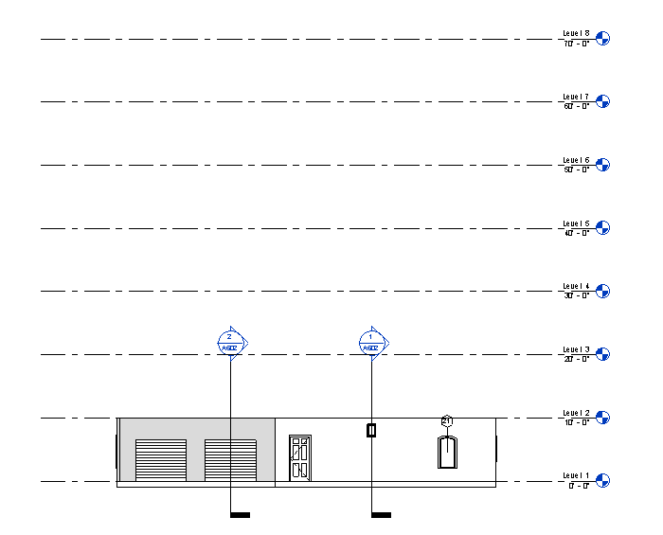

Rename Level 8 to “Roof” say YES to box asking about renaming.

3D View
Select the front wall (with entry door in it)
RC
Select all instances…in entire project (discuss)
Modify Walls (Tab)
Under clipboard: Copy
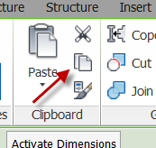
Pick in white space to exit

Modify
Paste
Aligned to selected levels
Choose 2,3,4,5,6,7
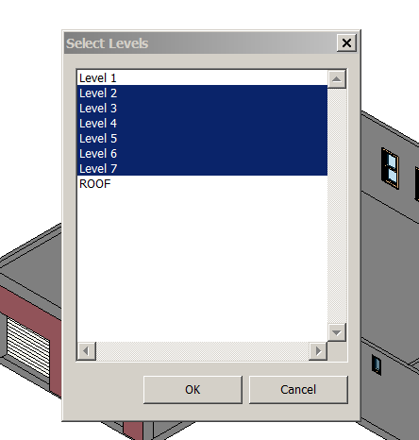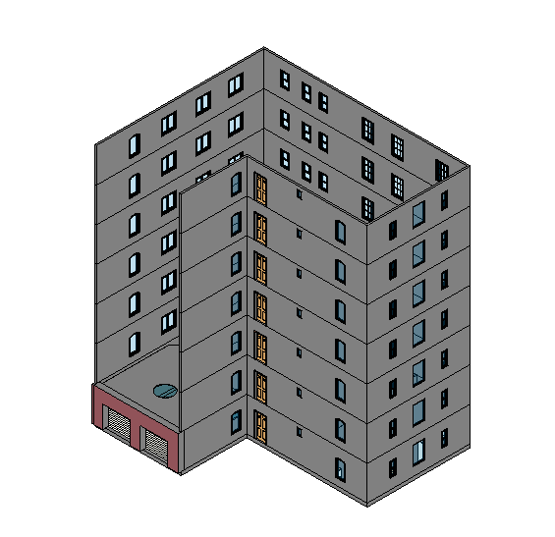
OK
Notice change?
Discuss what would happen if we copied to Level 1

Select CMU wall (the one with the garage doors)
Properties
Change top constraint to “Roof”
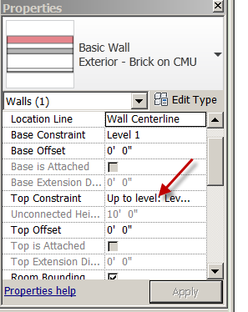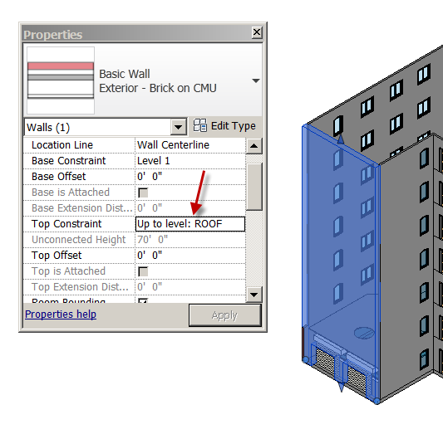

OK
Note: They don’t really build walls 70’0” tall as a single wall, but you can model it that way.

Notice the Garage doors did not copy up like the doors and windows in the last step. Prpbably not needing Garage doors at Level 6 .

Windows on this wall would be placed on Floor Plan levels
Floor Plan Level 2
Place two Archtop 30X60 windows with head height of 8’0”on the CMU wall.
South Elevation
Dimension from exterior wall to center of windows (use wall faces)
EQ
Discuss “look”
Try aligning windows with the Align tool.
Modify….Align

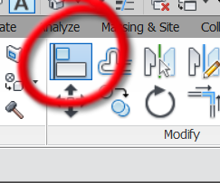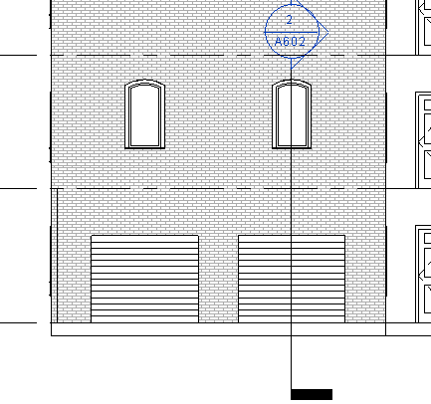

How does it look? You pick your look.
Select the two windows (use Cntl key)
Modify Windows (pulldown)
Clipboard…Copy
Paste
Aligned to pick level
Pick Level 3
See it? Paste
Aligned to selected levels
Select Levels 4-7
OK
See in 3D
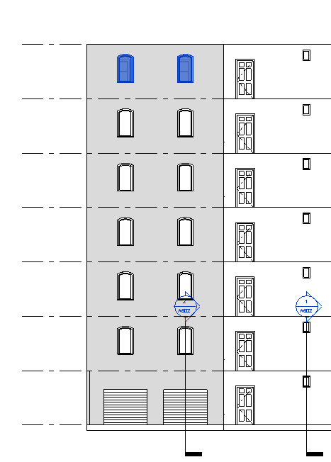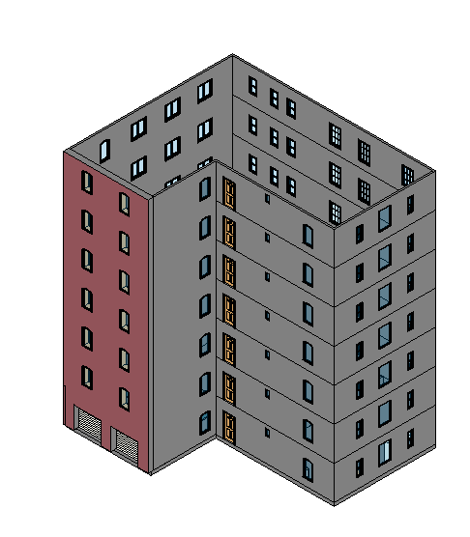

Those lines between the floors look bad!?

Modify
Geometry
Join
Join Geometry
Select Level 1 south elevation wall (w/ front door)
Select the wall directly above
Notice the line goes away
Repeat this process for the other walls. DISCUSS JOIN GEOMETRY

Again, better to plan ahead on the exterior walls if you initially know how high they will be.

One last task. Let's look back at the Exterior Elevation A501 sheet.

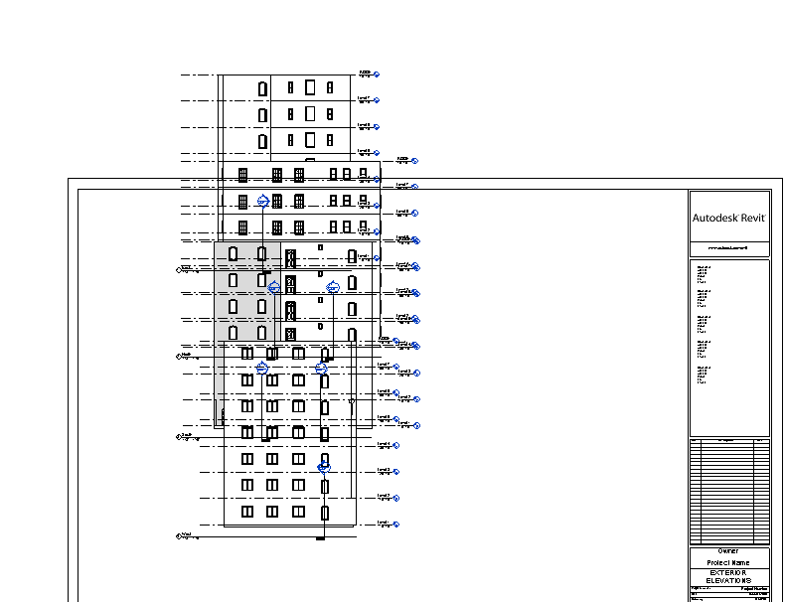

Whoa!! Discuss

We will have to make some new sheets!! Put the North and South Elevations on a sheet….and put the East and West Elevations on a different sheet.
Now look at the Building Section A601 sheet. Activate the view. Turn on the crop region box. Pull it up to expose the ENTIRE Building Section. Turn off the crop again. Deactivate the view.
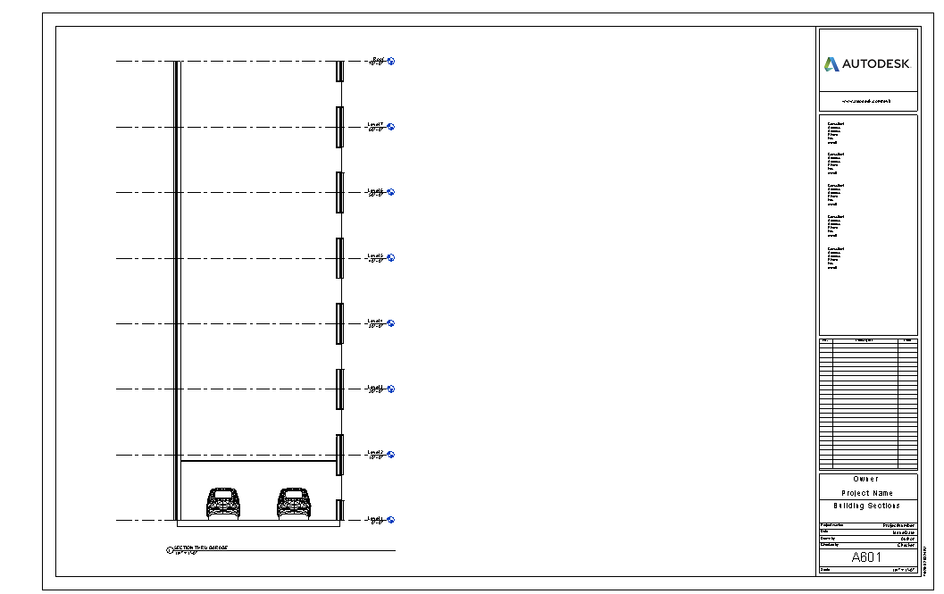

Notice how they were updating with us all along. Building information modeling (BIM) in Revit allows us to focus more on our design, and less on coordinating our construction documents.

Show how to delete views on a sheet, create a new sheet, then add view again.
Try using same sheet number….note it won’t let you!!

You have learned to create multiple levels, strategies for multi-level buildings, and leveraging information from one floor to another.

Save as revit2018demo10

This file is now about 6 Megs as we created it. You should save the file on the hard drive and back it up with a USB drive Also, Revit is set to save backup copies of your saves, very much like AutoCad’s .bak system. You may want to set the number of backup copies to 3 so your hard drive doesn’t get filled up.

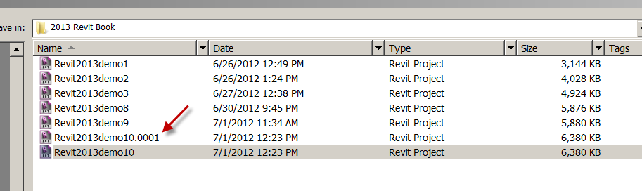

Explain the name.0001 and name.0002 back-up system in Revit
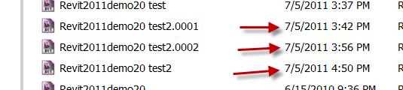

Note Revit2011demo20test2 is the most current
Note the files with the .000X are BACKUPS! If you open those, you will be getting an OLD file!
Note .0002 is more current than .0001. The bigger the .000X, the more current the file…BUT….still not the MOST CURRENT.

Controlling Number of Backups

File
Save As
Options
See Maximun backups? The default is 3.

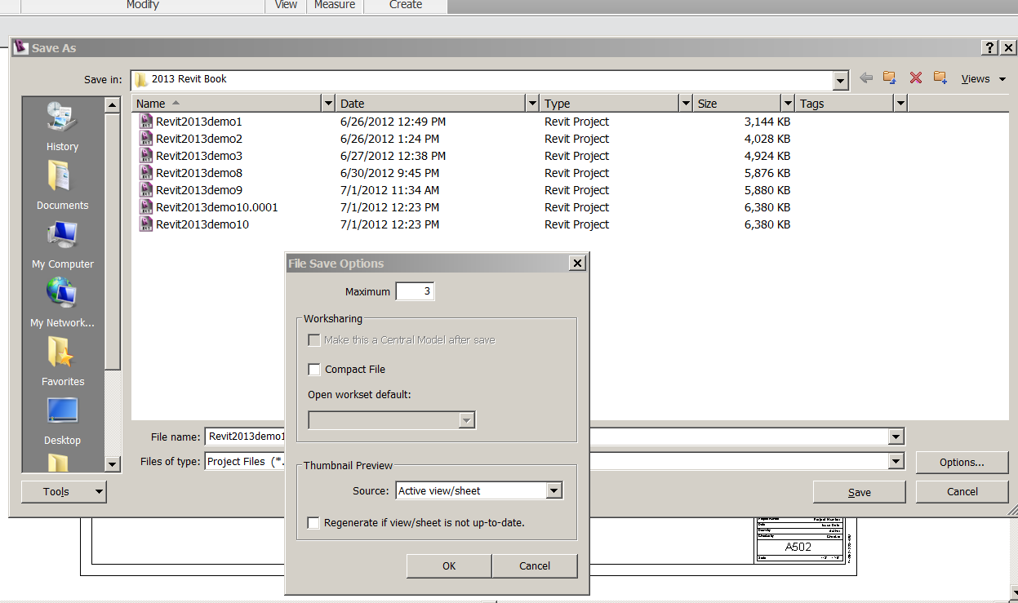

Revit Schedules
Door Schedule
You can be in any view in the Browser….
View
Schedules
Schedule/Quantities
Doors
Take defaults in New Schedule box
OK
We will set up the schedule to have the following columns:

Family…Add. If it’s on the right, the category will be in the schedule.
Mark (use Cntl key to select more than one at a time)
Finish
Frame Material
Head Height
Height
Level
Thickness
Type
Type Comments
Width
Add
OK. Note what you have.

Let’s also add a few of the Green Building Parameters
Fields
Edit
Heat Transfer Coefficient (U)
Solar Heat Gain Coefficient
OK

Discuss garbage-in/garbage-out analogy.

Add frame material to Door #1
Name it PAINTED PINE
Finish: OAK STAIN
Type comments: LOW VOC RATED

Level 1 Floor Plan
Select door 1
RC
Element properties
Instance Properties
See Materials and Finishes?
Database!!
See Identity data?
Yup….Database!!
Cancel…Cancel
So you can (carefully) modify the information an object carries in the schedule too!!

You can give custom/company standard titles to your schedule columns:

RC on Door Schedule in Browser
Properties
Formatting (tab)

Rename Fields (Formatting)
Family Door Style
Finish Finish
Frame Material Fr. Mat
Head Height Head Height
Height Height
Level Floor #
Mark Door #
Thickness THK
Type Door Type
Type Comments Notes
Width Width
Heat Transfer Coefficient (U) U-Value
Solar Heat Gain Coefficient SHGC

Change the order they show on schedule to this:

You must be in the fields tab to move the fields up and down…..

Mark Door #
Family Door Style
Type Door Type
Level Floor #
Thickness THK
Height Height
Width Width
Head Height Head Height
Finish Finish
Frame Material Fr. Mat
Type Comments Notes
Heat Transfer Coefficient (U) U-Value
Solar Heat Gain Coefficient SHGC

OK

Make a new sheet A801. Name it DOOR & WINDOW SCHEDULE
Bring into sheet
Stretch to make columns look “proper” DISCUSS
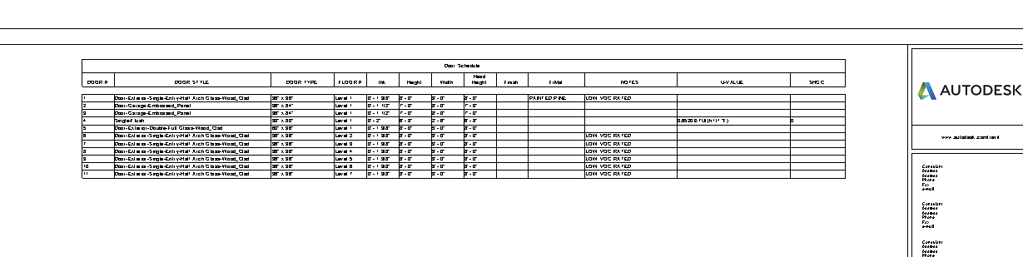
Discuss deleting, changing sizes and types in the schedule…the effect on the building model.

Windows Schedule

View
Schedules
Schedule/Quantities
Windows
OK
We will set up the schedule to have the following columns:

Count
Family
Head Height
Heat Transfer Coefficient
Height
Level
Solar Heat Gain Coefficient
Type Comments
Type Mark
Width
add
OK

Go ahead and type “Paint White” in the first Type Comment.
Say OK to the box…DISCUSS Type Properties

Drag the Window Schedule on the Door/Window Schedule sheet.

Show break to split schedule. Show how move icon puts it back.
Show schedule properties to adjust the database and appearance of the schedule.

Change the fields to the following names and put in this order:

Count QTY
Type Mark Win #
Level Floor #
Family Window Style
Height Height
Width Width
Head Height Head Height
Heat Transfer Coefficient (U) U-Value
Solar Heat Gain Coefficient SHGC
Type Comments Notes
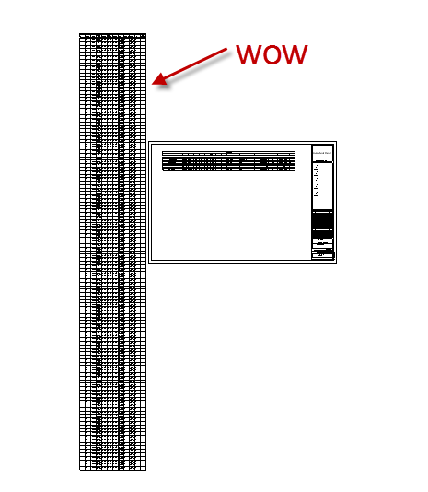
Stretch the schedule.
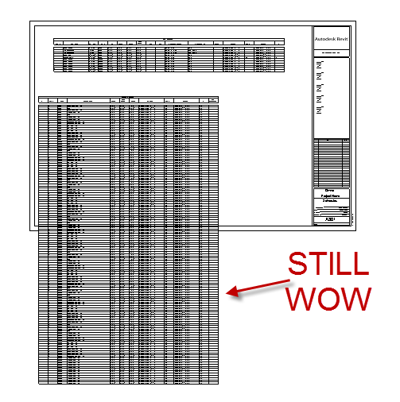
Notice the QTY is not working so well….all 1’s???
LC on schedule
Properties
Sorting and Grouping
Uncheck itemize every instance Discuss
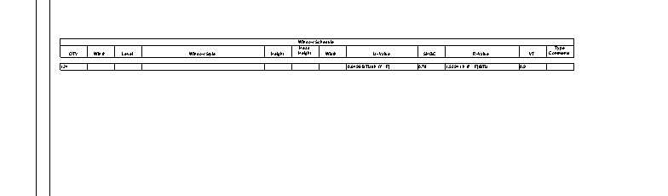
Sort by:
Type Type Mark…. then by Level
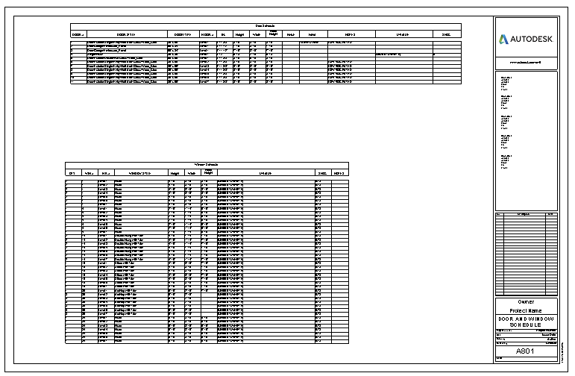Switch them
Adjust the schedule on the sheet, controlling row height and length.

Grouping Schedule Parameters

You can group Parameters within a schedule.
In the Door schedule, we will group the “Dimensions”
LC in the THK cell…on the left. You will drag your mouse to the right. If you see the cells fill in black, you are doing it right.
Group

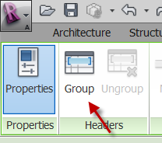

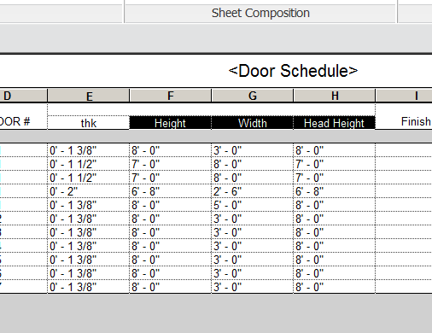

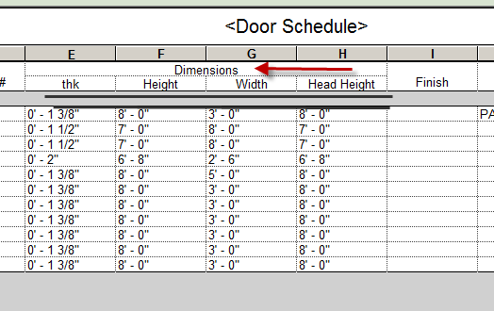

Discuss copying schedules depending on the use or development of the project and using Transfer Project Standards to reuse settings.

You have learned to create a door and window schedule, change its order, fields, filter, and sort. You learned the schedule is directly linked to the building model….if it changes in the model, it changes in the schedule….if it changes in the schedule, it changes in the model.

Save as revit2018demo11.rvt

Controlling what you see (More)
Note: The most challenging part of learning Revit is figuring out the various ways people can hide stuff from you! Really. Making walls…easy. Dimensioning…easy. Finding that missing lighting fixture….sometimes…not so easy.

The solution? Let’s talk about the ways people can hide stuff from you….and why they use what they use.

You get this, Revit gets A LOT easier!

First:
Revit does NOT have layers.
Revit has OBJECTS.
When you hide something in Revit, it is VIEW SPECIFIC (it only goes away in that view)

OK…here we go….

View Visibility (VV)

Floor Plan Level 1
VV
See Model Categories?
These are your (3D) objects. The checks mean they are ON.

See Annotation categories?
These are your 2D objects. Get it?

Pick a window (any window)
VH (View Hide)
See how the windows are gone? The hole in the wall are still there because the wilnows are still there…just hidden!
3D View
Note windows are there.
South Elevation
Note windows are there too.
Again…when we turn something off in Revit, it is only in THAT VIEW.

To turn the windows back on?
VV
Check Windows.
They are back!

VH turns off ALL of the elements of that category (in this case, all of the windows in the view)

Sunglasses

Sometimes we just want to hide a bunch of elements to see something hidden…..but want to put it back quickly.

The sunglasses are a “temporary hide”
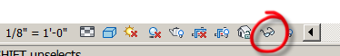

Show use of Sunglasses
Select 1st floor east wall
Sunglasses
Hide Element

Select a window on that east wall
Sunglasses
Hide Element

See the Cyan box? You know by that you have Temporarily Hidden Objects!
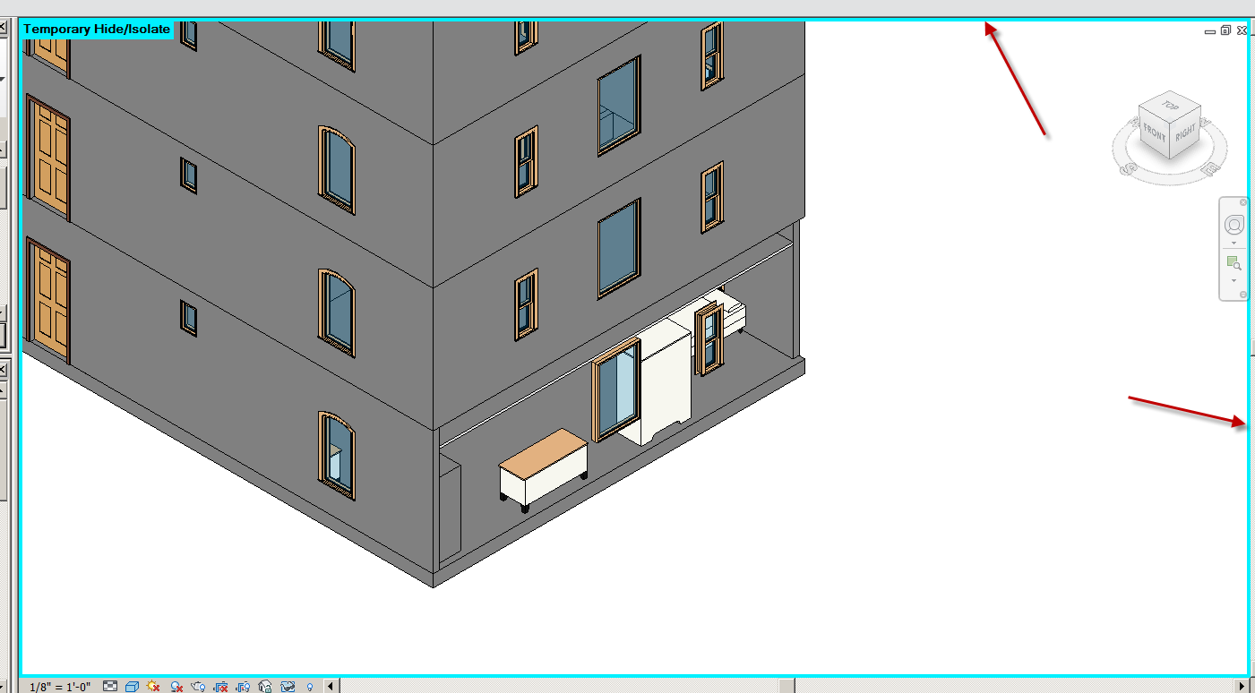

How to put it back?
Easy!!!
Sunglasses
Reset Temp Hide
Done!

You can isolate elements with the sunglasses

Pick on the CMU wall
Sunglasses
Isolate Element
Only the wall shows!
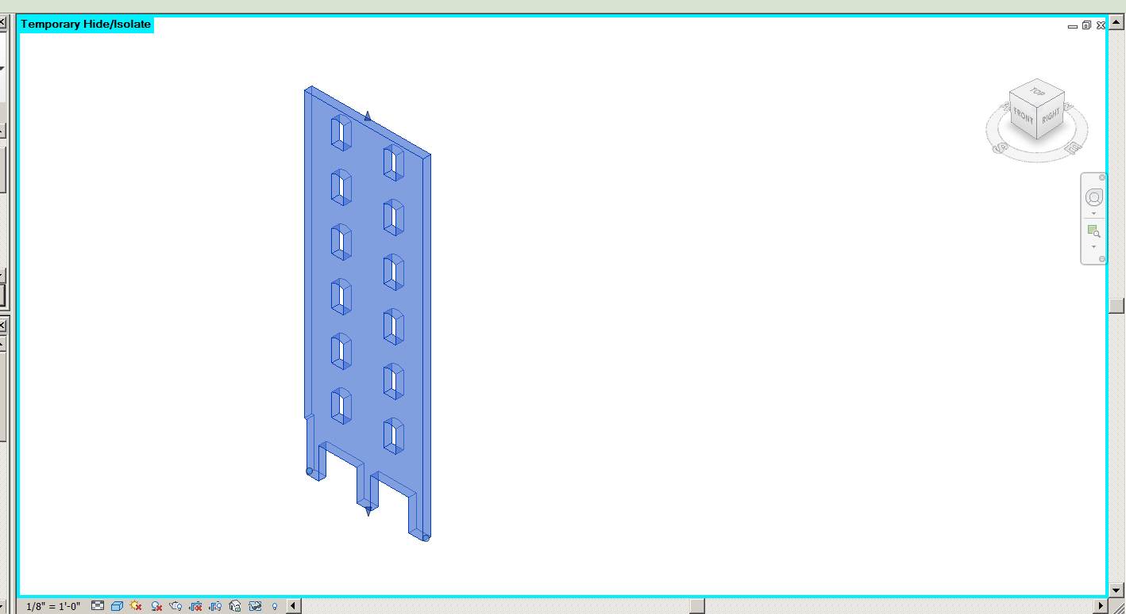

How to put it back?
Easy!!!
Sunglasses
Reset Temp Hide
Done!

Light Bulb

You can hide an individual object in a view, without hiding all of the same objects
Ex: Hide specific pieces of Furniture without hiding all of them

Floor Plan level 1
You want to see the Bed and Dresser, but not the other furniture
Select the furniture you want to hide:
RC
Hide in view
Elements
Should be gone!

Get it back?:
VV
Oh no…the furniture is still checked???? So how do we get it back????
Light bulb
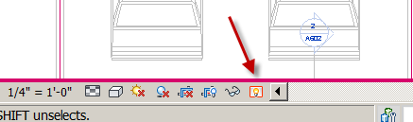

See red?
Select object(s) in red

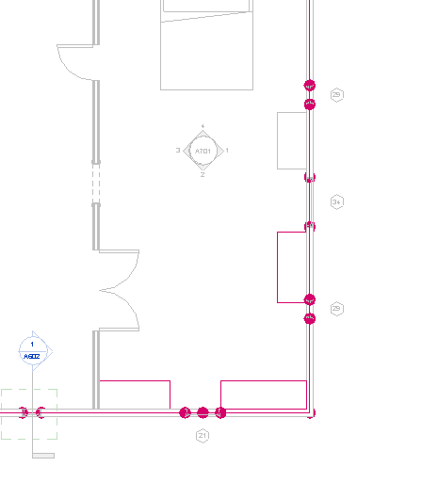
“Unhide Element”

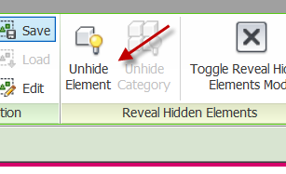

Light bulb
See it come back?

Override Visibility

Let’s say the pattern on your floor is overwhelming your floor plan….you generally do not show floor patterns on a Floor Plan…there is a different drawing for that.
3D
Pick the floor
Change the Element Type to Wood Joist 10” Wood Finish
Back to Floor Level 1
See the floor pattern? It’s gotta go!
VV
Floors
Under Projection/Surface
Patterns
Pick in white box
Override
Uncheck “visible”
OK…OK
Floor material is gone (will not print), but it is still there…will tag…will be in all other views.

Transparent

Objects can be made Transparent.
Go to a 3D view
VV
Walls
Under Projection/Surface
Transparent
Pick in white box
Override
Use slider to dial in the transparency
Try about 70%

See thru the wall?
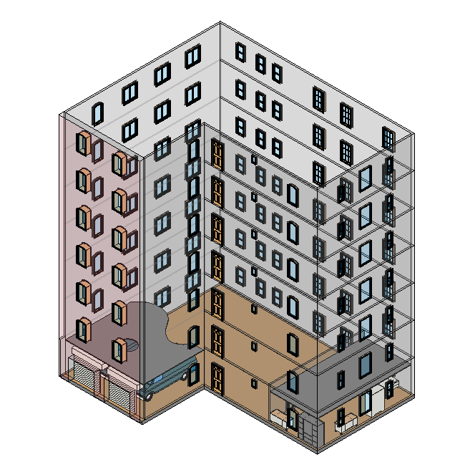
Undo that…

½ Tone
Objects can be made Lighter on a view.
Go back to the floor plan view
Turn Floor Pattern back ON
Floor pattern back on.
VV
Floors….Patterns….Override….Visible…OK….OK
The flooring pattern should be back
Scenario 2: You need to see the flooring in the view, but it overwhelms the drawing:
VV
Floors
Check “halftone”….OK
Notice the floor pattern gets lighter?
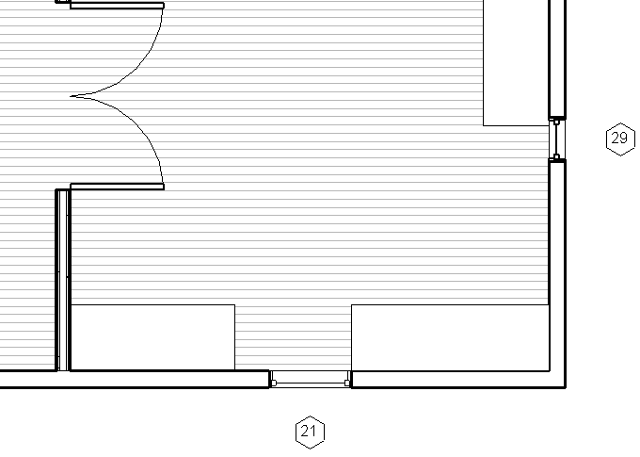

Crop Region

Go to an elevation view
Show Crop region icon (just to left of sunglasses)
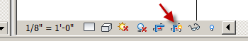

Show how to turn ON OFF
Show how to “Crop” View
Show what happens when View is Cropped and Crop box is off

See how easy it is to hide something without an obvious way of finding it???

Show Do Not Crop
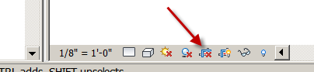
Back to Floor Plan level 1
Select the arrow on elevation marker
See blue line?
Show Crop Region
Get it?
Hide Crop Region (to left of sunglasses)

When an area or object is not showing, it may not be within the crop region!

Select the arrow on south elevation marker again
See blue line again?
Move the blue line into the garage
Go to South Elevation
Notice something is missing. This happens once in awhile….something to look for when an elevation isn’t looking right….

Put the blue line back outside the building. And yes, elevations and sections are essentially the same in Revit.

Underlay

A common visualization complain is: “why am I seeing my 1st Floor walls on my 2nd Floor?

Revit has the ability to show another level (grayed-out) on another level. It’s called an underlay.

The solution:
On the 2nd Floor
See the interior wall…ceilings….grayed out….
That is an “underlay” of Level 1 Floor Plan
LC in white space
Properties
Underlay: none (it would be set at Plan…Level 1 to show the Level 1 graphics)
OK
Underlays are a great tool to borrow locations of things and apply them to your level.

View Range

It is possible that you are not seeing your entities because the entities are out of your view range.

Example: The sill of a 2’ high window is at 16’ on a 20’ high wall. On your floor plan, the window is not showing. Why?

The View Range might not cover that high window.
On the 1st Floor
LC in white space
Properties
View Range
Edit
Discuss Primary Range, Cut Plane and View Depth (below primary range)
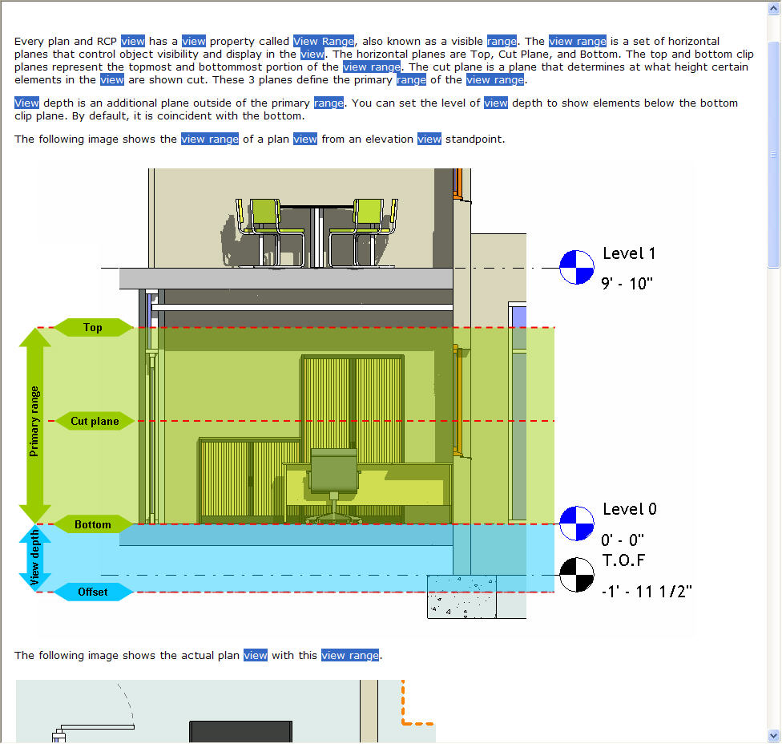
Model Categories vs. Annotation Categories

I can’t see my object! A familiar issue with Revit. Things get turned on and off…. and frequently, you have to find them. Here is a simple rule for narrowing down your search:

VV or VG (you do not hit ENTER after typing the 2 letters in Revit)

Model Categories: If the item you are looking for can be seen in a 3D view, it is in Model Categories. Walls, doors, lines, components, stairs, etc. The parts of the category are in subfolders…if you need to hide/unhide something like surface patterns and lines in the object.

Annotation Categories: 2D stuff like tags, dimensions, elevation marks, levels and section marks.

Imported Categories: Usually AutoCAD drawings that were imported into Revit. You will be able to turn layers on and off, as well as hide entire drawings.

Hiding object types quickly

VH will turn off an object type in one step. SHOW

Smart Wall Creation

We will create a simple 2X4 wall, then a plumbing wall 2X6

Select the Interior 5” partition 2-hr wall
Edit Type
Duplicate
Name it: SHS 5/8"3.5core5/8"
Structure: Edit
Make it look like this:
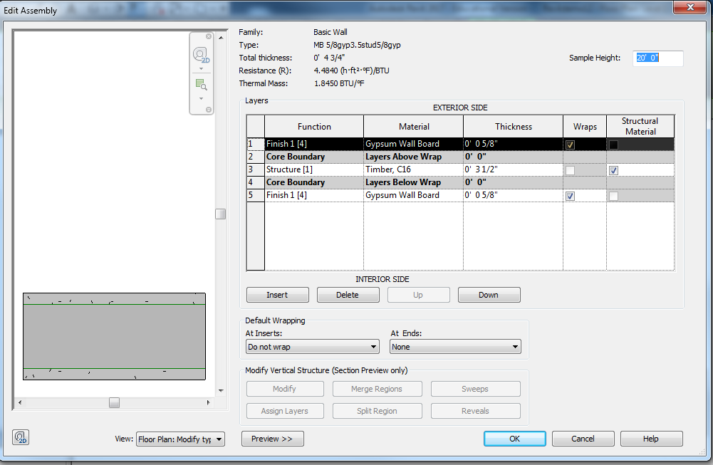

Note a 2X4 is not really 2” by 4”!! It is 1-1/2” X 3-1/2”. I put the Gyp on Fin 1 (4) to make wall joining less of a problem.
OK…OK
Now we will make a plumbing wall/wet wall Plumbing walls have to be wider because some of the pipes can be wide and must be held down. A 2X4 wall is only 3-1/2” wide, so generally the pipes will not fit!
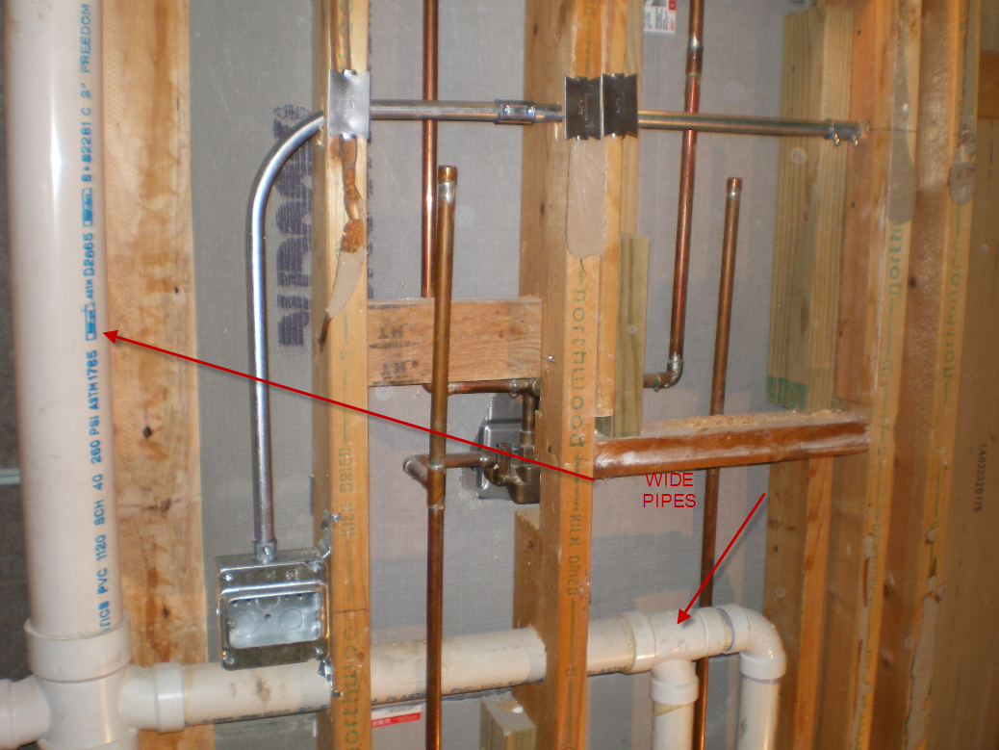
.
Select the SHS 5/8"3.5core5/8"
Edit Type
Duplicate
Name it: SHS 5/8"5.5core5/8"
Structure: Edit
Make it look like this
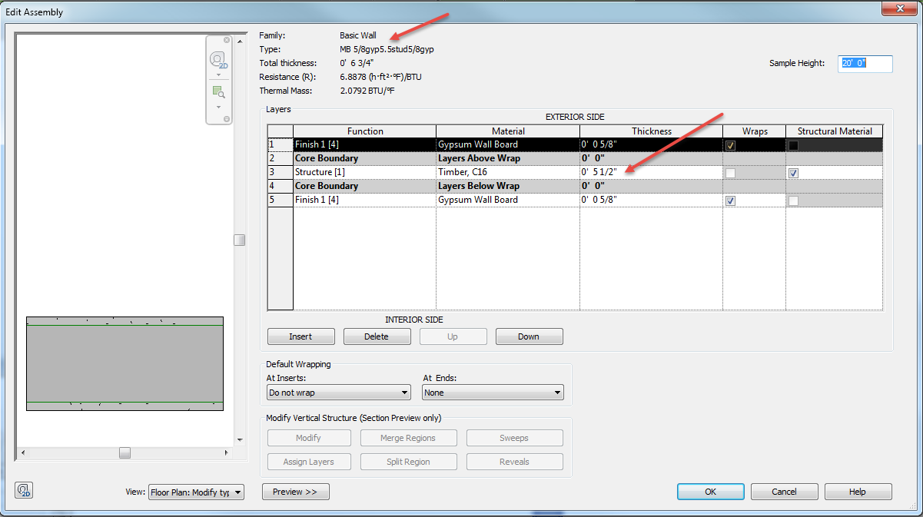

Save as revit2018demo12

Details in Revit

We will create a Building Section, followed by a Wall Section callout, then a Footing Detail from the wall section.

Floor Plan Level 1
View
Section
Building Section
Create a Building Section horizontally thru center of building. Crop about 2 feet past section line. Set the scale to ¼” = 1’0”
Should be the second Building Section in the browser.
Go to that Building Section. Call it Section 4
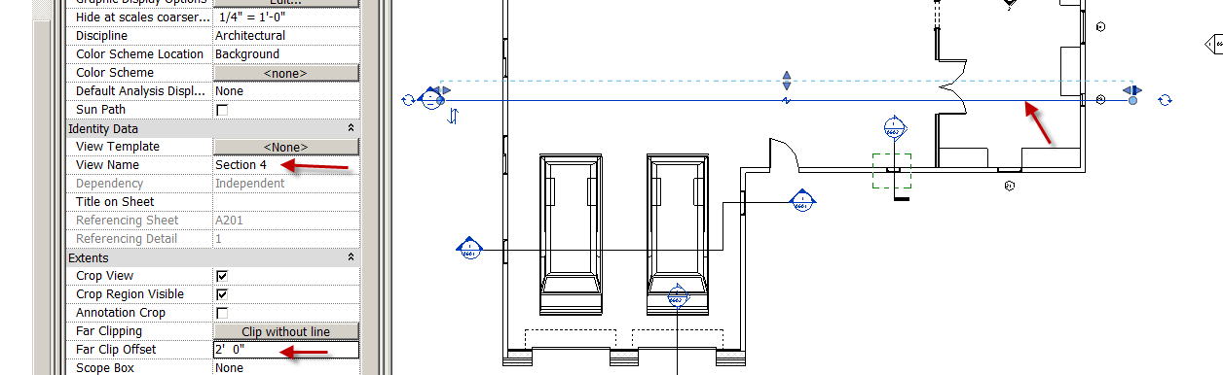

Smart Wall Creation Continued

Before we start, let’s make “smart walls” out of the East Elevation walls:

Select the lower east wall (with the three windows on it).
Properties
Edit Type
Duplicate
Name it:SHS1STUCCOVR1/2PLY5.5CORE5/8GYP
Structure: Edit
Click preview pane to see wall being formed
Build it as follows:
# Function Material Thickness
1 Finish 2 Stucco 1”
2 Membrane Vapor Retarder 0
3 Substrate 2 Wood Sheathing Plywood 1/2”
4 Core Boundary 0
5 Structure Wood Stud Layer 5.5”
6 Core Boundary 0
7 Finish 1 Gyp Wall Board 5/8”

The wall should be 8-5/8”
Stud Material
Assign: Wood…Timber C24…up arrow
Done….OK

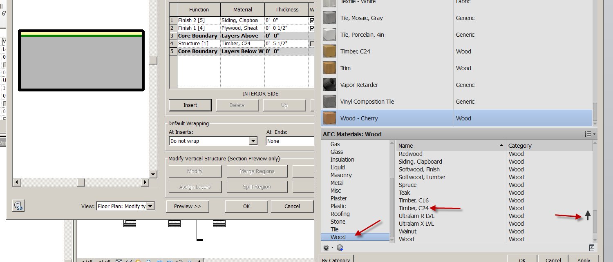

Clapboard
Assign: Wood…Siding Clapboard…up arrow
Double click on picture
Set color to purple
Set pattern to Model Pattern 4” parallel
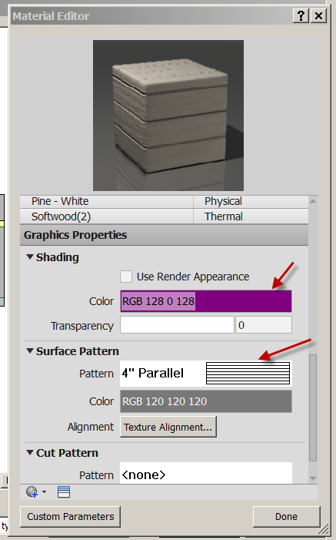
Done….OK
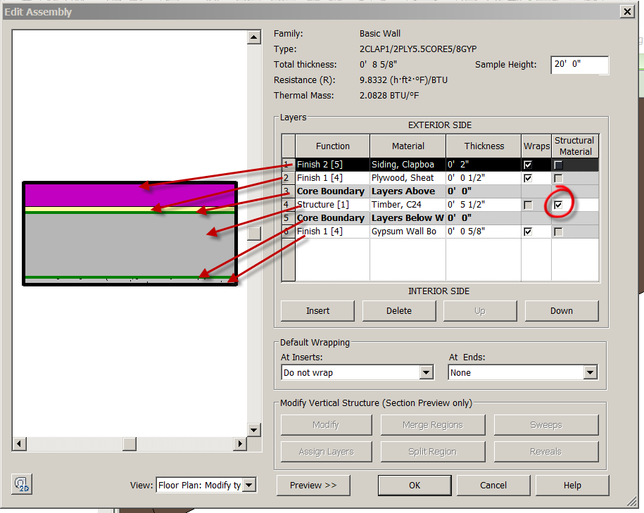

OK….OK

Set Detail Level to Medium
Change wall orientation if necessary.
View
Thin Lines
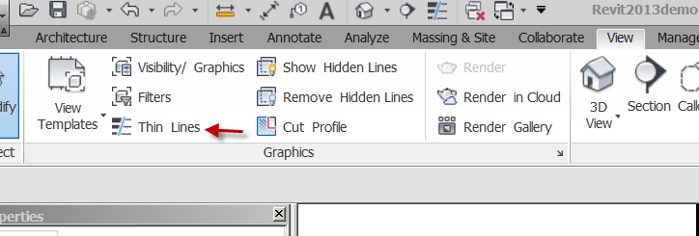
See the components of the wall clearly now. Some people line to work this way when detailing.

Change the 2nd floor wall to 5/8GYP5.5ST5/8PLY2CLAP
3D
Show Match Type (paint brush) icon to do other walls above
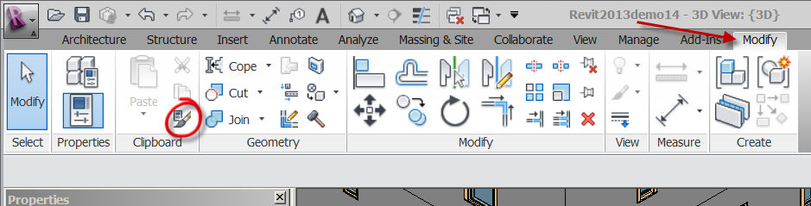
Modify
Match Type
Pick Source wall
Pick target wall(s)
You may still have to change walls orientation….
Cool!!
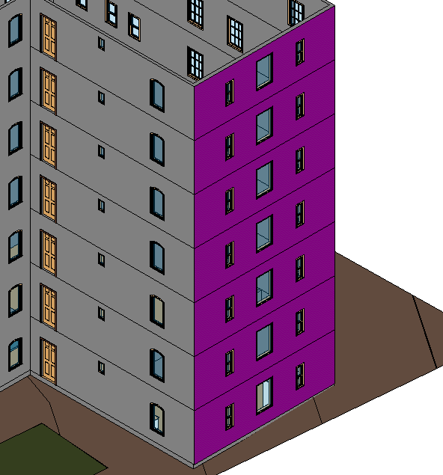

Next, let’s put a floor on the 2nd Floor:
Floor Plan Level 2
Notice we can see the Level 1 stuff on the Level 2 floor. Here’s why….
UNDERLAY Explain
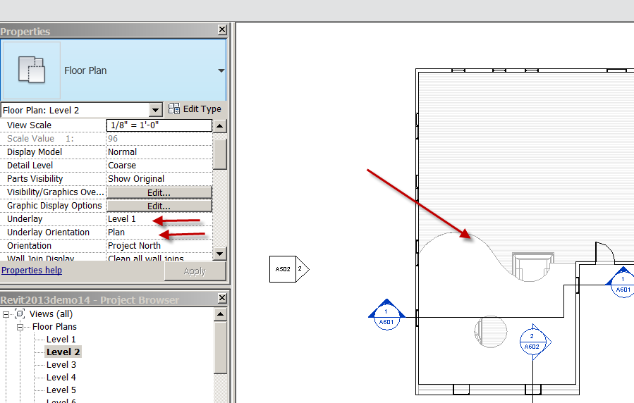

Set Underlay: None

Architecture
Floor
Floor Architectural
Properties
Choose 10” Wood Finish
Lines
Make floor inside walls (miss on purpose)
Use align command to make accurate
Finish Floor
Say No to message connecting walls to Floor Pick Detach Target(s) DISCUSS
See pattern?
You may have to set scale of Level 2 to ¼”=1’0” to see Section 4.
Back to Building Section
See the floor?
See the interior wall not stopping at the floor? Drag the wall down to the floor.

TURN OFF FURNITURE AND FIXTURES IN SECTION VIEWS
You can VH them.

Explain 2D overlay of the 3D geometry. Relate file size.
Hint #1: The more you create in 3D, the less “overlay” you have to create in 2D.
Hint #2: You will have to make decisions on what to create in 3D and when creating in 3D is just too time consuming and not cost effective.
Note: Your 2D overlay geometry will not show in other views (ie:the 3D model)

Save as revit2018demo13

Smart Brick Wall

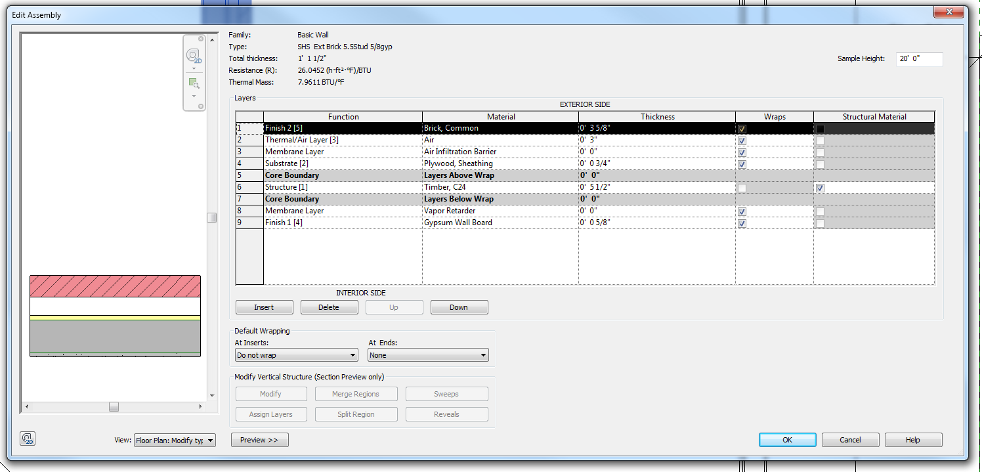

Smart Stone Wall
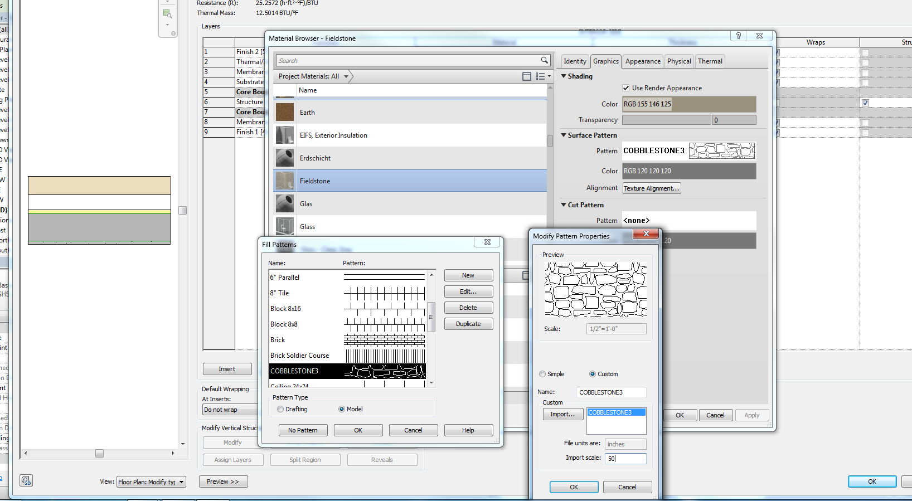
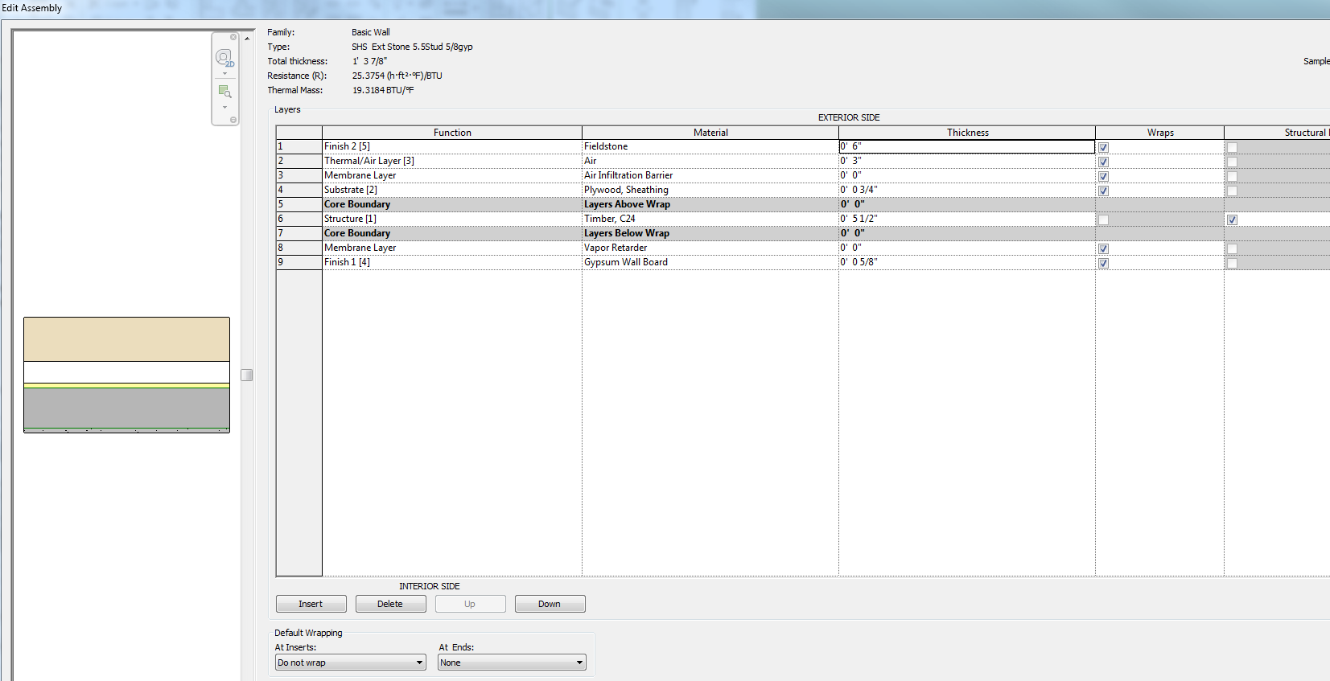

Rooms

Floor Plan Level 1
We need to create some rooms in the plan:
Don’t worry about size….
Those words are just text in this example…..don’t add those yet…..
We need a 3 Bedrooms, 1 Bathroom, Living, Family, Foyer, Kitchen, Dining, Garage, and Hall
Leave some open plan rooms
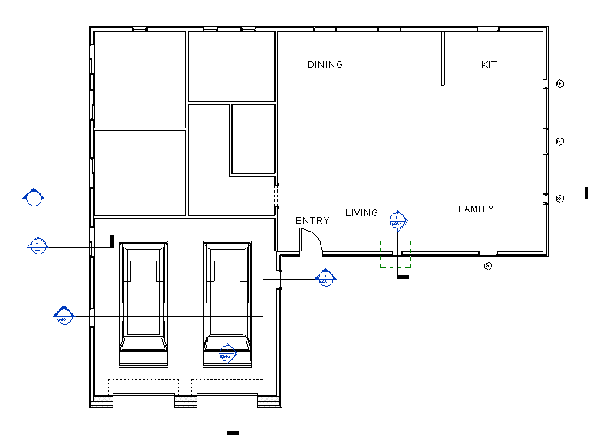

Architecture
Room
Room Tag with Area (in Properties)
Pick inside each enclosed area
You should have rooms with a random number and the Area.
Name the rooms by double clicking on the name “room” and renaming it something logical.
Nice???
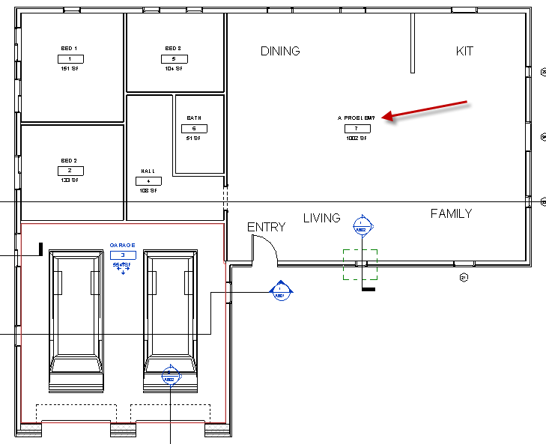
What about the area not bound by walls??
You will subdivide the space with a “Room Separator”
Architecture
Room Separator

Room separation: show

Create new Rooms in the new spaces
Pick inside rooms w/ room separation
Name the Rooms
You can VH the room separation lines.
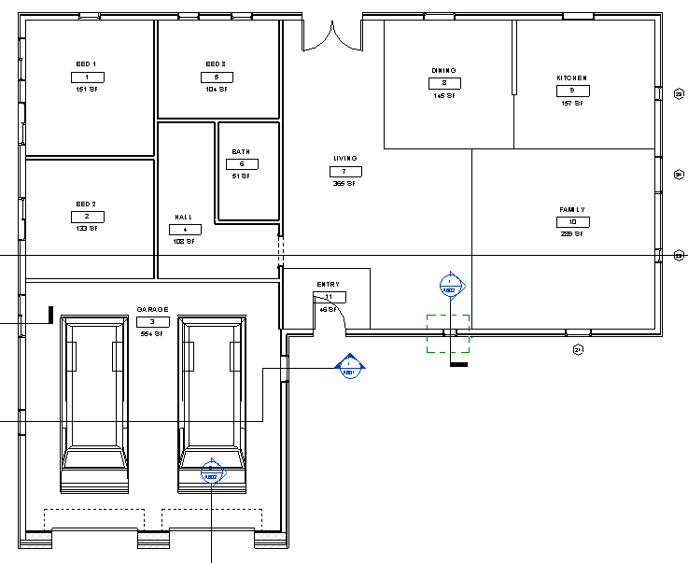

Save as revit2018demo14.rvt

Color Fills/Schemes

Have Floor 1 ready with rooms.

Pick first room…..a Bedroom (not the room tag) move mouse until the X shows
Properties
Notice the room name is there
Note: We will use the “Department” parameter to organize our room types
Department: SLEEPING OK

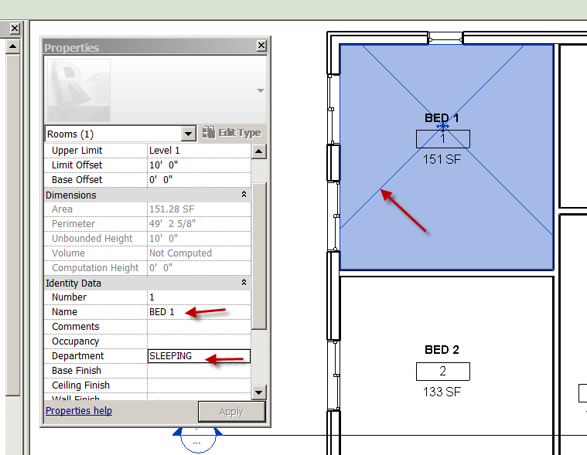

Pick a Bathroom
Properties….Identity Data
Department: SERVICE OK

Pick a Living
Properties
Department: LIVING OK

Pick Family
Properties
Department: LIVING (pick arrow so you don’t have to type it again) OK

Pick a Bedroom 2
Properties
Department: SLEEPING OK
Pick a Bedroom 3
Properties
Department: SLEEPING OK

Pick the Hall
Properties
Department: CORRIDOR

Pick the Foyer
Properties
Name the room FOYER
Department: CORRIDOR
OK

Pick the Garage area
Properties
Name the room GARAGE
Department: NON-LIVING SPACE
OK
ESC twice to exit

Before we create the color scheme, we will DUPLICATE WITH DETAILING the Floor Plan Level 1.
DISCUSS STRATEGY ON DUPLICATING

RC over Level 1 in Browser
Duplicate View
Duplicate
Rename the Plan: Level 1 Presentation
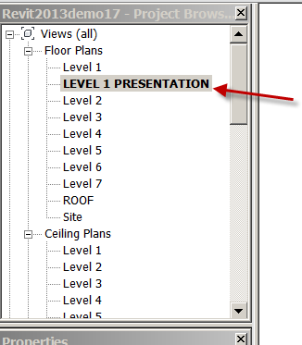

Color Fill Presentation

In Level 1 Presentation
VH any annotation
Leave the Furniture and Fixtures in (if it is still there)
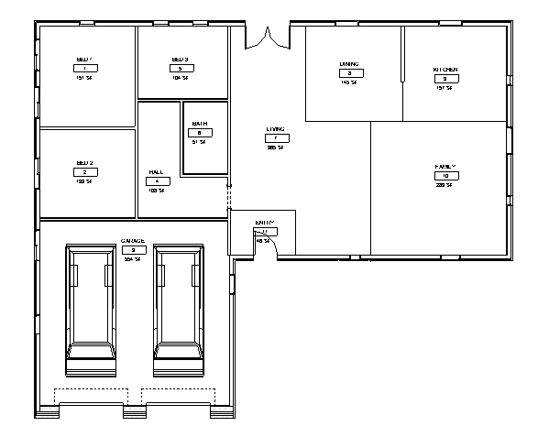

Annotate
Color Fill Legend
LC in screen
Space Type: Rooms
Color Scheme: Dept OK
NEAT?!

Shade Walls

VV
Walls
Cut Patterns
Override
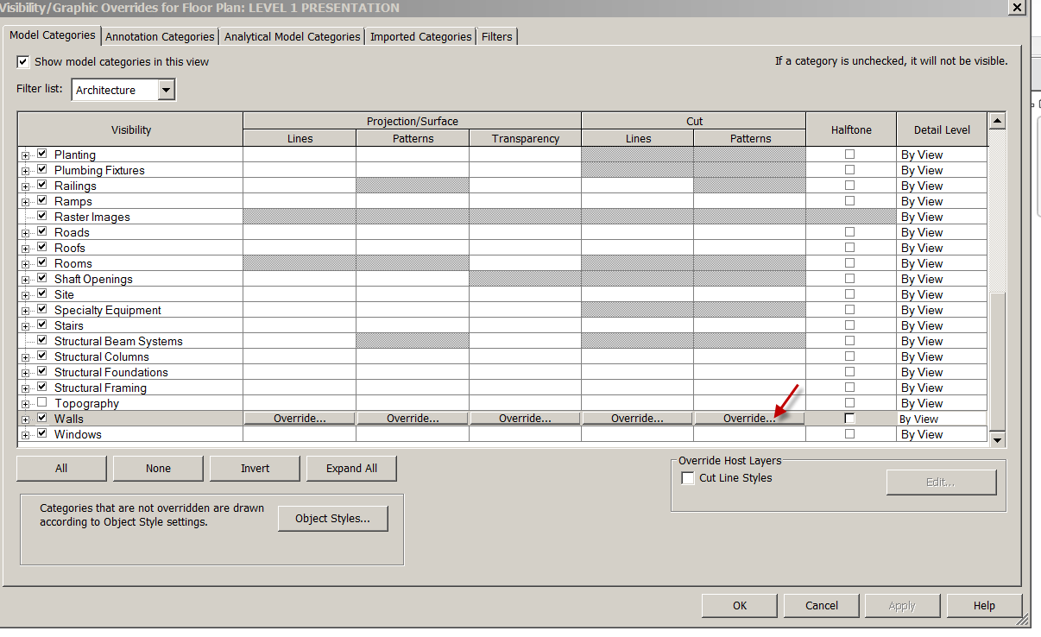
Pattern: Solid Fill
OK….OK

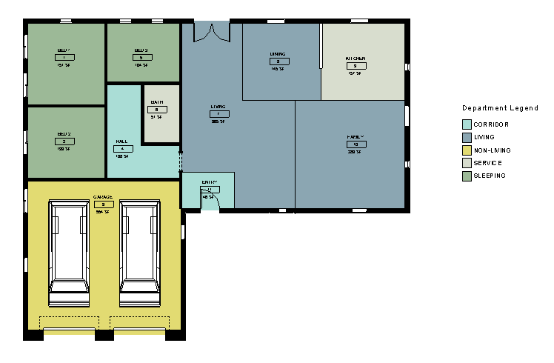
Changing the Color Scheme

LC on the Legend
Edit scheme
Discuss Duplicating the scheme

Duplicate the scheme
Name it “Shell Color Scheme”
Create new colors for the scheme….keep them light please….inkburners….
OK
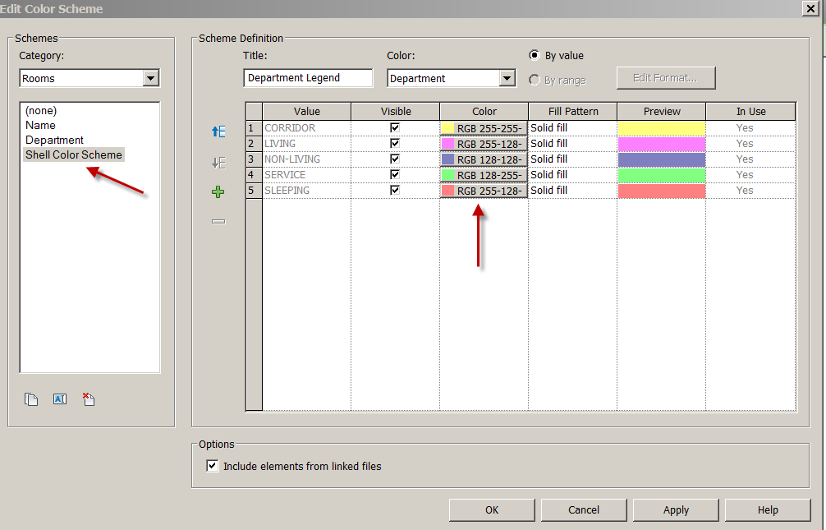
Swap between schemes

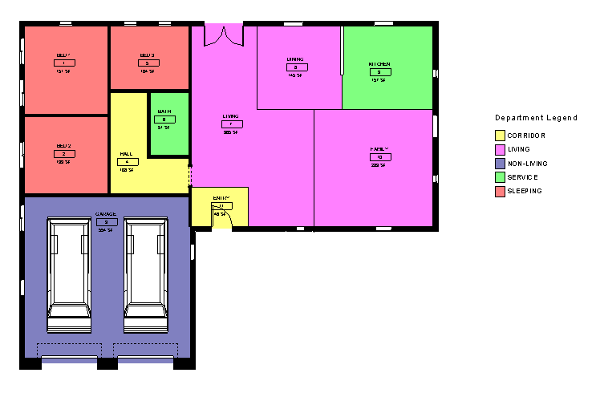You can change/create schemes by: Area
Base Finish
Ceiling Finish
Department
Floor Finish
Name
Number
Occupancy
Occupant
Perimeter
Wall Finish

Try erasing room separation line: See error? Explain
Delete room. See?? Undo the deleted room.

You have learned to create rooms, separations, apply properties to rooms, and create a color fill.

Save as revit2018demo15.rvt

Dimensioning in Revit

Floor Plan Level 1
Annotate
Dimension (arrow)
See Types:
Linear Dimension Types
Angular Dimension Types
Radial Dimension Types
Diameter Dimension Types (new to Revit 2018)
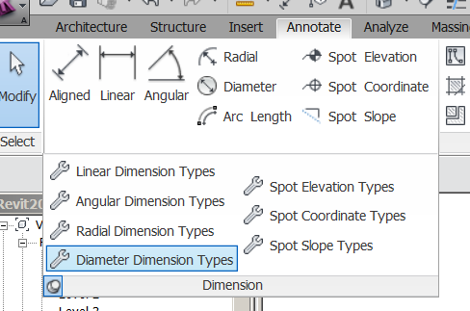
SHOW PUSH PIN

See buttons:
Aligned
Linear
Angular
Radial
Diameter
Arc length

We will customize a Linear Dimension Type
Properties
See loaded types

DO NOT CHANGE EXISTING STYLE!!!!

Edit Type
Duplicate
Name it “Bills 3/32 Arial
OK
We are now working on the “clone”
Units Format (pick shaded box)
Uncheck “use project settings”
Rounding: To nearest 1/4” (rounding can cause errors….use temporary dimensions to make sure components are placed to ¼”).
Check suppress 0 feet
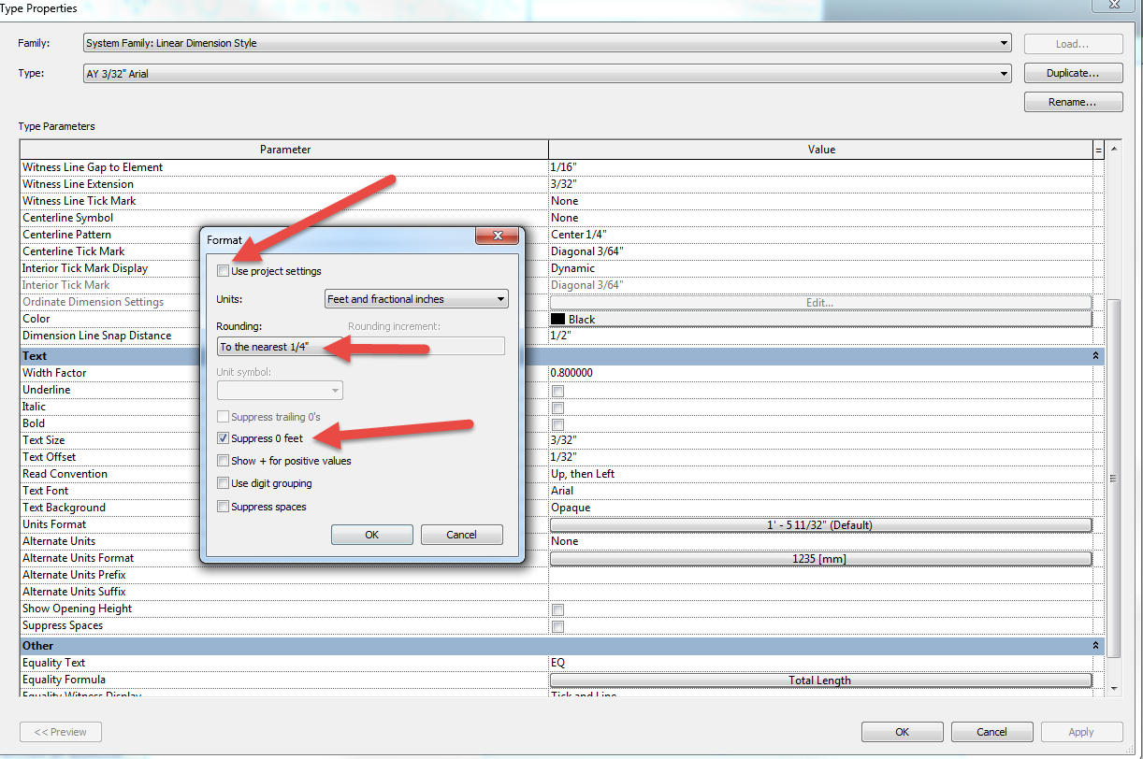
OK
Centerline Pattern: Center ¼”
Centerline Tick mark: Diag 3/64
Tick Mark: Diag 3/64
Dim line snap distance: 1/2"
Tick Mark line weight: 7
Lineweight: 1
Text Offset:1/32”
Width factor: .8
Notice text size is 3/32. We’ll take that
Notice text font is Arial. We’ll take that too.
Apply
OK
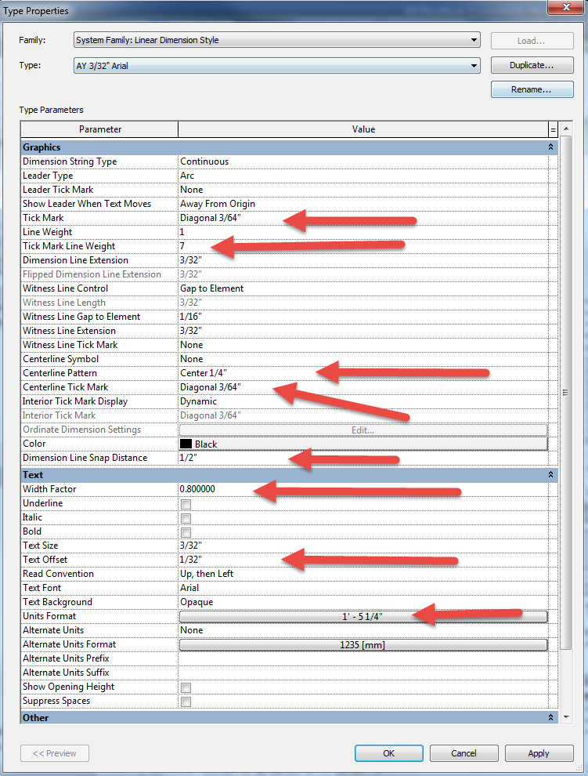
NOTE: If the Type Properties dialog box is being “uncooperative”, drag the top of the box (between Parameter and Value)to the left to make it stop flipping!

Dimension
Aligned
Change element Type
Select Bills 3/32 Arial
Individual References

Discuss Wall faces, wall centerlines, center of core, faces of core

Face of Core
Dimension the front wall.
How does it look?
Note: You can change dimension styles on the fly. (Show)
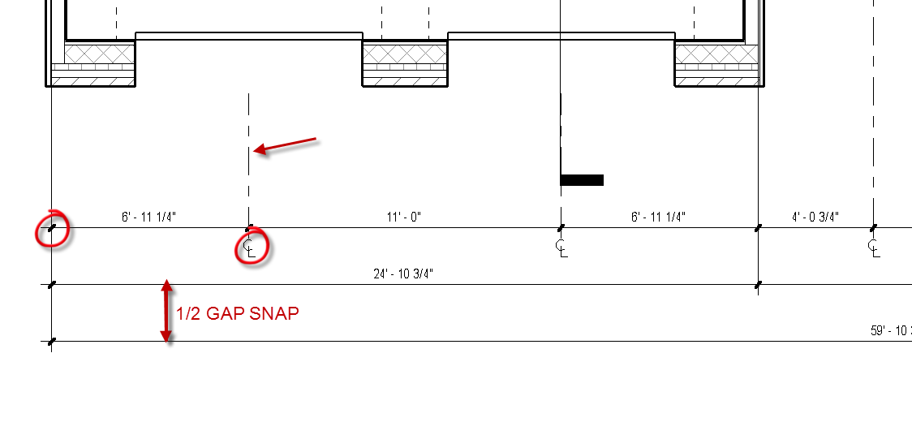

You learned to create a new dimension style, not to mess with existing/default styles, and control the way your dimensions appear on the drawing.

Save as revit2018demo16.rvt

Creating a Site Plan in Revit

Creating the property lines when given lengths:
Massing and Site (in Browser)
VH the Elevation annotations
Massing and Site (in Ribbon)
Property Line
Create by Entering Distances and Bearings
75’6 S60W Insert
110’0” S30E Insert
63’0” N60E
Add line to close (and pray site data given to you is accurate )
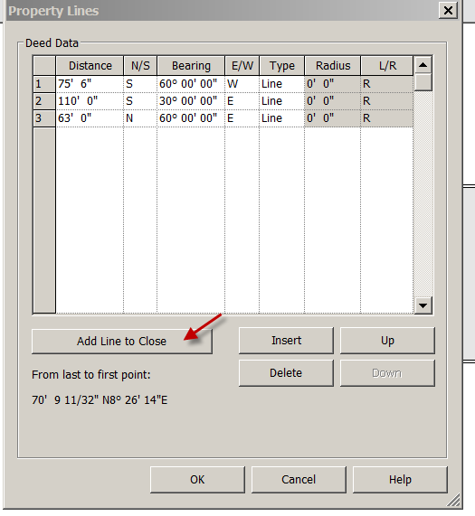
That last line should be about 110’ N23-31-01W
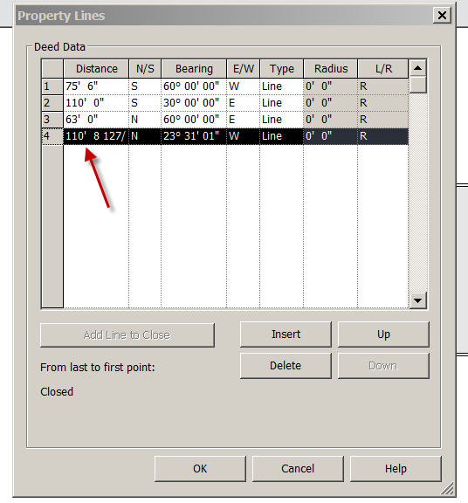
OK
Place on drawing
Click on white to Exit
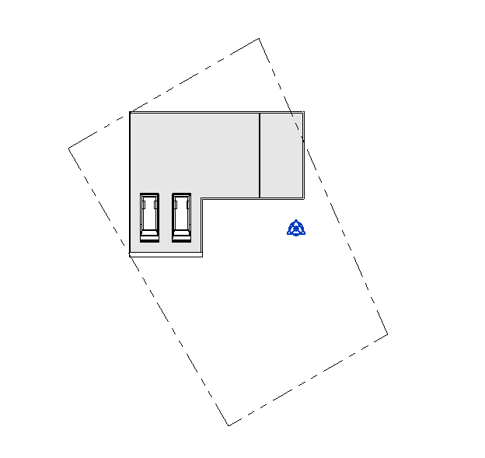

Discuss dilemma of site not aligning with Floor Plan/Building Model

Rotating project to true north:

Select the Site Plan in the Project Browser
Notice the house is not lined up the way we want to fit effectively on the lot. If we rotate the house, ALL the views will adjust and our views will be majorly messed up!! Save work then show effects on floor plan and elevations when rotating. Undo that mess.

Here’s a solution:
Select the Site Plan in the Project Browser
Properties
Orientation: Set to True North
Nothing happens (yet)

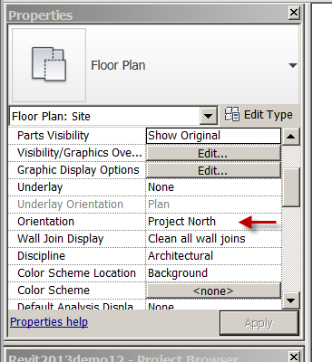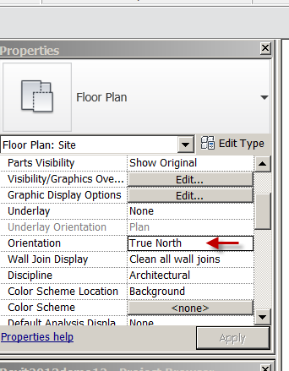

Manage
Project Location
Position
Rotate True North
Rotate it 30 degrees (counterclockwise)
Only the floor plan/roof moves!
Move the property line to a good spot
Now look at the floor plan level 1. Has not moved.
Now look at elevations. All good
Discuss Project North (Floor Plan) vs True North (Site Plan)
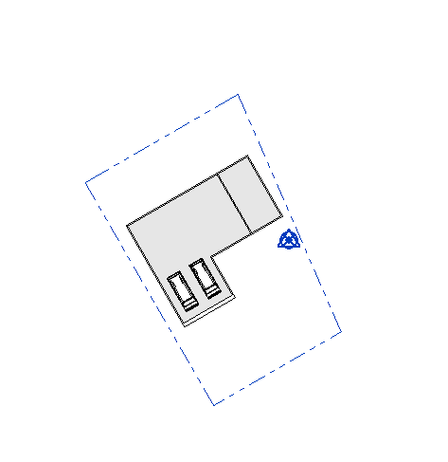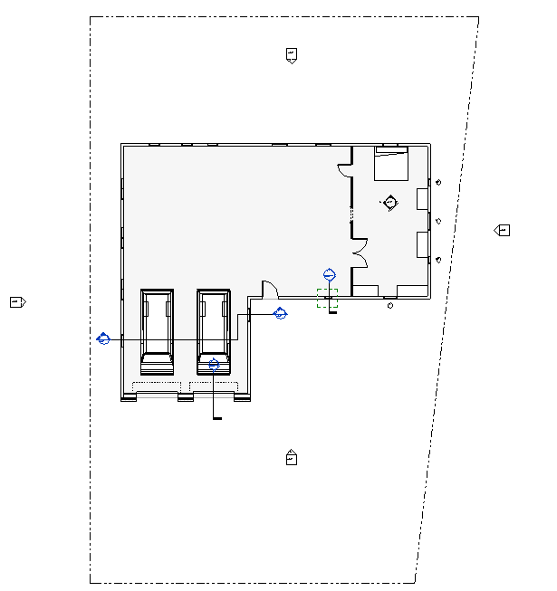
North Arrow

Site Plan
Annotate
Symbol
North Arrow 2
Place it

Pick North Arrow
Clipboard Copy
Floor Plan Level 1
Paste Aligned to same place
Accurate North arrow!!!!
Note: ALL PLAN VIEWS SHOULD SHOW A NORTH ARROW
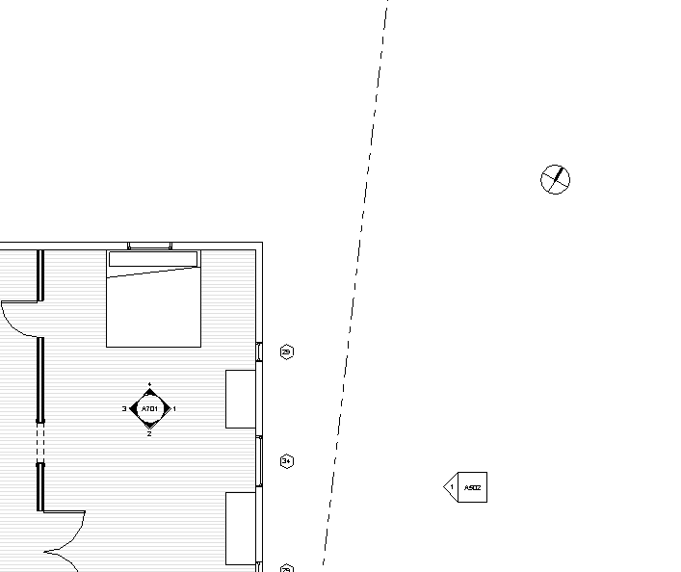

Create the topography:

Site (in Browser)
Massing & Site
Toposurface
Place Point icon
Set elevation to -10”…pick top-left corner

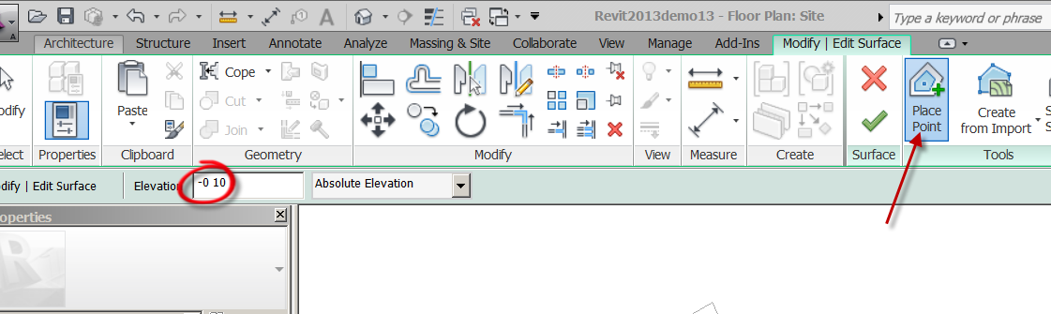

Set elevation to 3”…pick top-right corner
Set elevation to -2’3”…pick bottom right corner
(a surface needs at least 3 points)
Set elevation to -2’6”pick bottom-left corner
Green Check
SD…HL
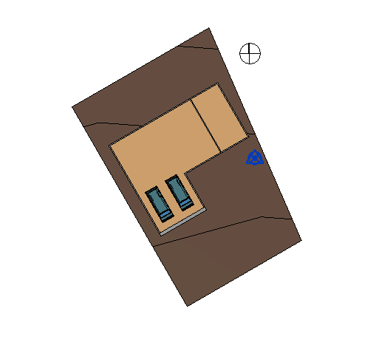

Add property line annotation (bearings and lengths):

Annotate
Tag by Category
By Category
Touch property line
(not loaded) Yes
Annotations
Civil
Property line Tag (open)
Uncheck leader
Place tags
Should give you bearings and lengths you put into table!!
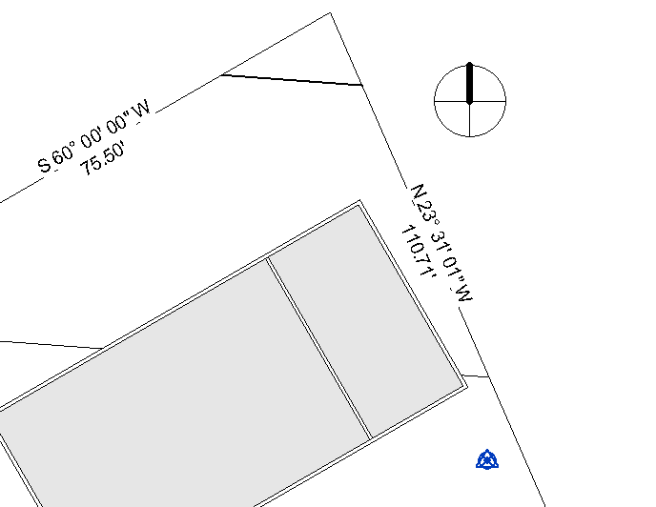

Edit family to explain what tag is doing: looking for something

Show door tag family (looks for “mark”)

Show Window tag family (looks for “type mark”)

Later, you can create annotation tags (families) that will look for what YOU want!

Discuss what would happen to annotation had you ROTATED site to make it work.

Label contour lines:
Site in Browser
Massing and Site
Label contours
Make a line that passes through all contours
You should see contours labeled in 1 ft increments

Let’s say you wanted 6” increments:
Massing & Site
Model Site (see that little arrow off to the right…select it)
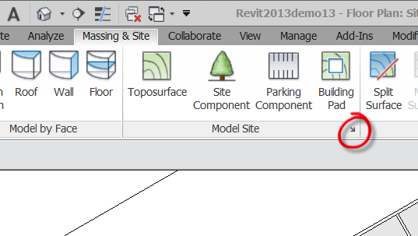
There is your Site Settings control box.
Set Start to -5’0” (we went below 0’)
Set increment to 6”
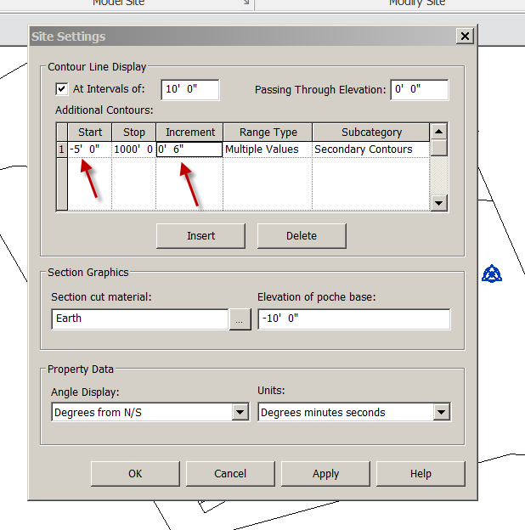
OK
Label the new contour lines

Place Elevation marks:

Annotate
Spot Elevation
Properties
Target (project)
Uncheck leader
Place on drawing
You should see annotation for the corner elevations you created earlier.
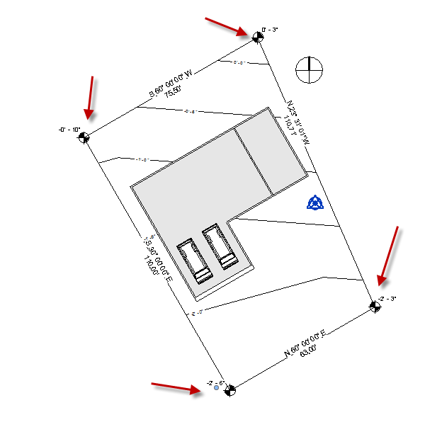
Move spot elevation over topo to show effect….see what the tag is looking for??

Dividing up a toposurface

You may need to create a driveway, patio, or other entity that breaks up the toposurface or changes the material of the toposurface:

Discuss SUBREGIONS (spray-paint) vs Split Surface (change physical topography)

Site (in Browser)
SD See the brown dirt?
Massing & Site
Split surface
Select toposurface (anywhere)
It kind of grays-out
Use lines, arcs, etc to create the shape (closed loop).
Finish Split Surface
You can delete that small surface and create your own, with different topography) in its place or simply change the material of the area.
Select surface
Edit Surface
Change each corner point to -1’6”.
Delete any other points….careful, they are tough to see/find.
Material: (in Properties)
Change material to Grass
Notice it is not loaded. Revit 2018 has a new-look material library.
Misc…..Grass….up arrow (to right)….add material to document
Pick Grass
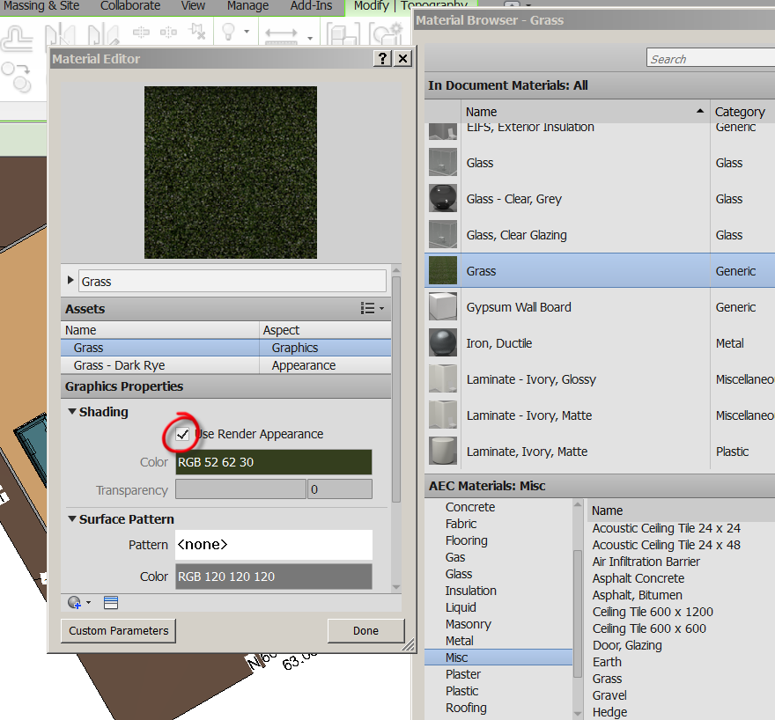

Double click on Grass (to get Material Editor)
Check Use Render Appearance Discuss Shading vs Render
Done
OK
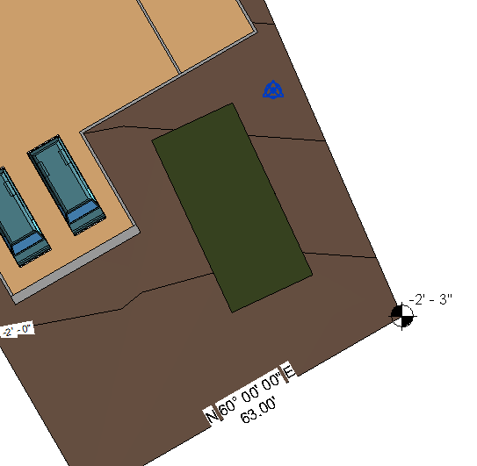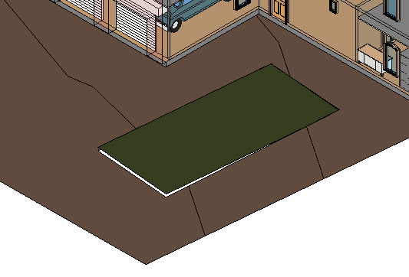
See in 3D

Subregion

Subregions are a little simpler. They simply change the surface material of the topo…..without physically changing it. Like spray-painting the surface

Floor Plan Site
Massing & Site
Subregion
Material:
Change Material to Concrete Exposed Aggregate
OK
Draw the shape
Finish Subregion
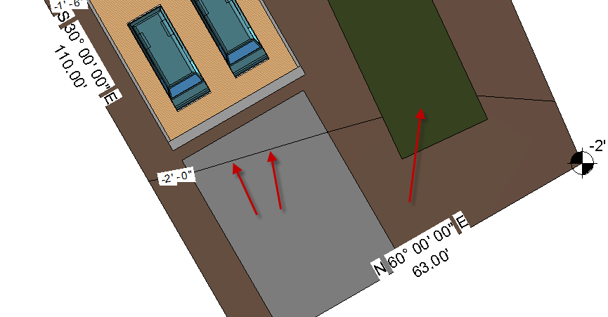
Now….let’s discuss what happened here. We have FLAT grass and WAVY concrete!
What surfaces should be subregions?
What surfaces should be split surface?
DISCUSS

You have learned to create a site plan with property line, topography, annotation, and materials. You learned that the site can’t be rotated to position it to the building, but a view setting to True North solves the problem.

Save as revit2018demo17.rvt

Basic Stairs in Revit

Floor Plan Level 1
VH the property Line
VH the Floor
Architecture
Stair
Stair by Sketch
Stair Properties (review how to change width, tread size, risers…show change if risers = 20..resulting in riser height of 6” at 10’
Now try 10 risers.: See error? Because riser height breaks rule set in the program.
Back to 18 risers….
Show Stair Rules
Edit Type
Calculation Rules: Edit
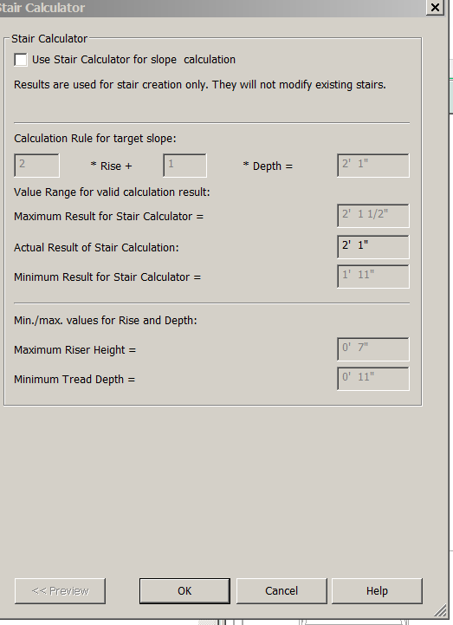
Get out of that box

Straight Stairs

Create a straight stair in the front of the building. Note riser count as you move your mouse. Notice “Center justification”. Notice Stairs created, Stairs Remaining.
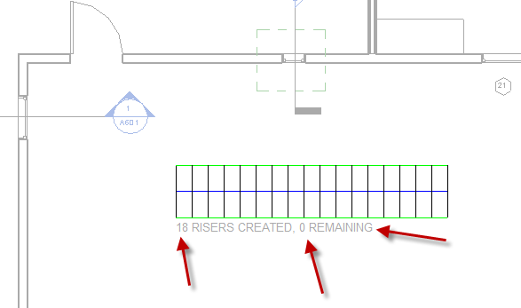
Finish Stairs
Click in white space
3D View
South Elevation
Note the stair is going from Level 1 to Level 2
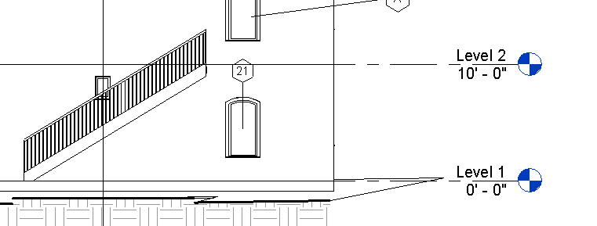
Delete the stairs
Back to Level 1

U-shaped Stairs
Stairs
Stair Properties
Set width to 4’0”
OK
LC in front of the building, starting in front of the far-right edge…Slide mouse across and to the left (notice 11” change in temporary dimensions and remaining risers)
Create 11 risers as you slide across.
LC.
Slide mouse straight down…using the green line to align with the last riser. Don’t worry about how far now. LC. Slide mouse across and to the right well past the last riser location.
LC.
Notice landing is created between!
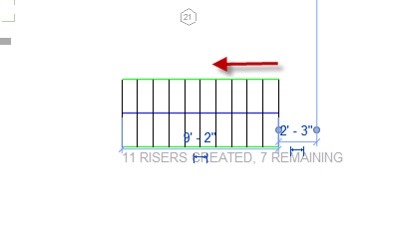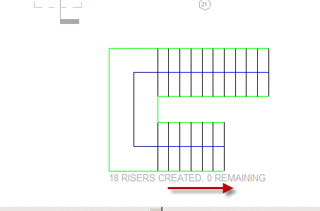
Finish Stairs
See in South Elevation
See in East Elevation
See in 3D
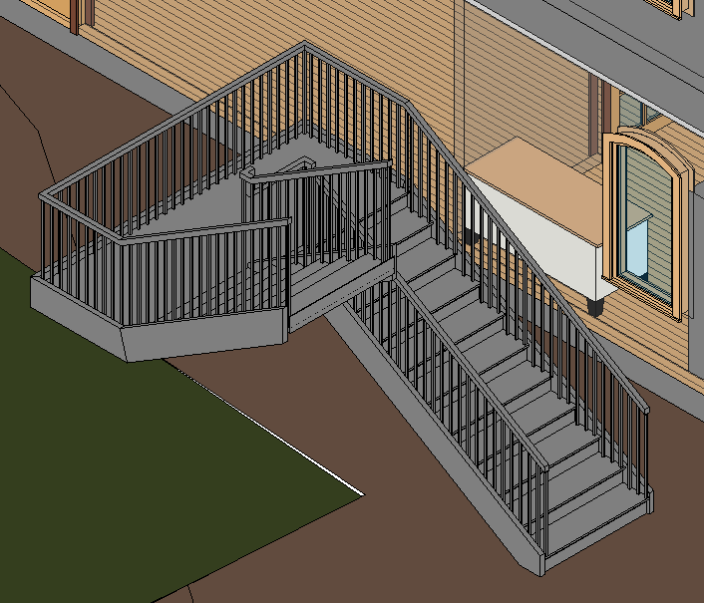
Back to Floor Plan Level 1

Adjusting the gap between the U-Shaped Stairs

Select Stairs (not railing)
Modify Stairs (pull-down at top)
Edit Sketch…You are now in “Sketch Mode”
Pick blue line on bottom
Drag up and down
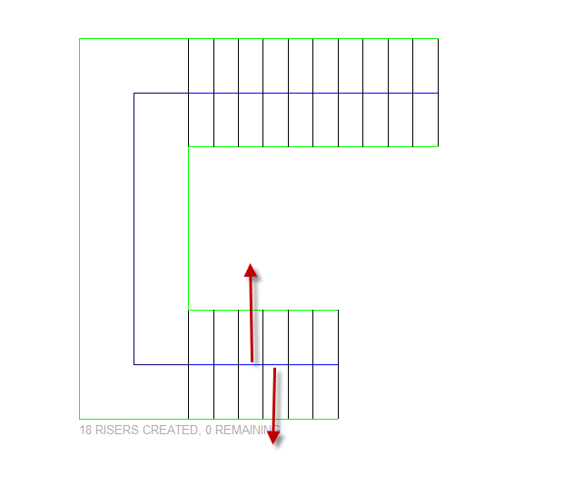
Finish Stairs.
Show in 3D. Notice railing is attached automatically.
Back to Level 1.

Edit your stair’s footprint

Select stairs (not railing)
Modify Stairs
Edit Sketch

Delete the 2 higher horizontal green lines on upper stair
We will now create a new path for the stairs:
Boundary
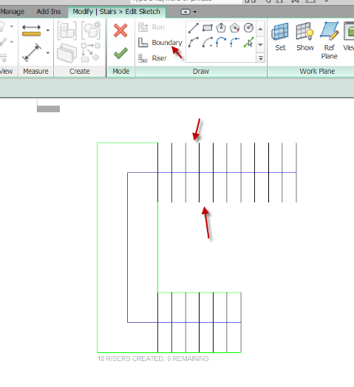
Make green lines taper, so beginning of stairs is wider. Use mirror….
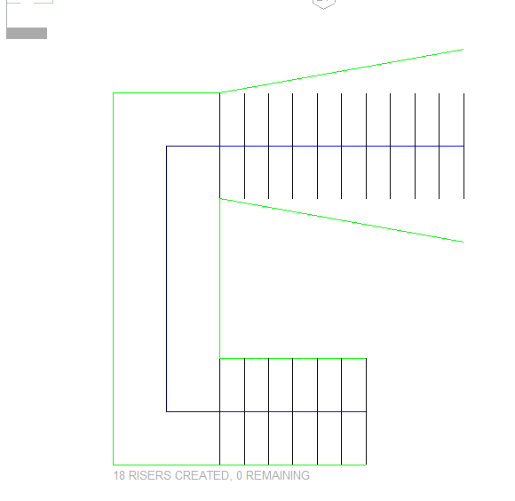
Finish
Show in 3D. Easy??
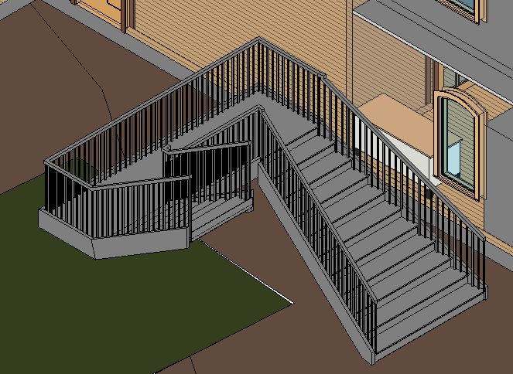

Level 1
Pick stairs
Modify stairs
Edit Sketch
Delete upper, green line
Let’s curve the left edge:
Boundary
Pick Start-End-Radius from the option bar
Create the arc
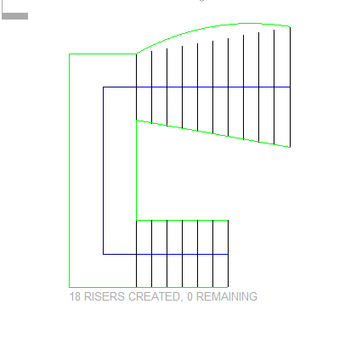
Finish Stairs
3D
Notice railing attaches correctly!

Adjusting Riser Shape
Pick stairs
Modify stairs
Edit Sketch
Pick the first riser on the lower stair
Delete it
Riser
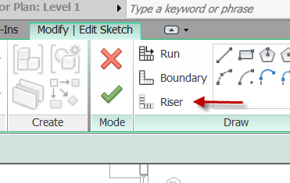
Pick Start-End-Radius from the option bar
Pick end of boundary line
Pick other end of boundary line
Slide mouse to right a bit to create arc…set it to 2’6”
LC
Finish Stairs
See in 3D
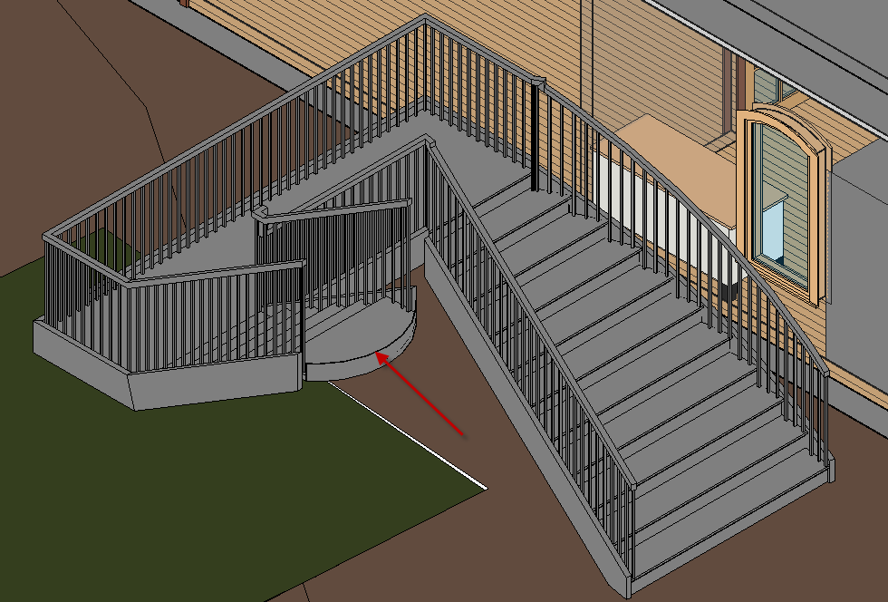

Railings
Note: The railing can be changed or deleted by section.

3D View
Select a Railing
Change Element Type
Guardrail-Pipe
Handrail-Pipe
These are just the “out-of-the-box” Railings. You can make your own or get them pre-made.

Floor Plan Level 1
Select the edge of the stair to find the railing
LC on railing
Edit Path
Delete a railing sketch line
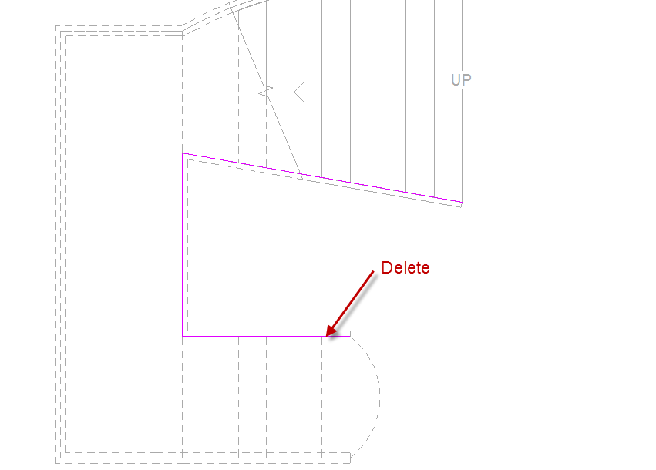
Finish Railing
See in 3D
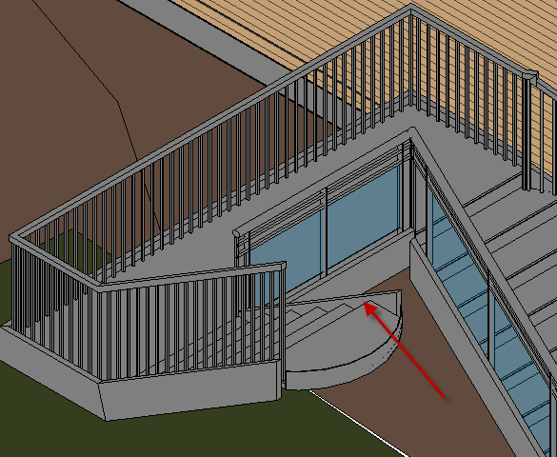

Floor Plan Level 1
Let’s put the railing back in the same place:
Architecture
Railing
Sketch Path
Place magenta sketch line in the same place you erased the other one
Finish Railing
3D
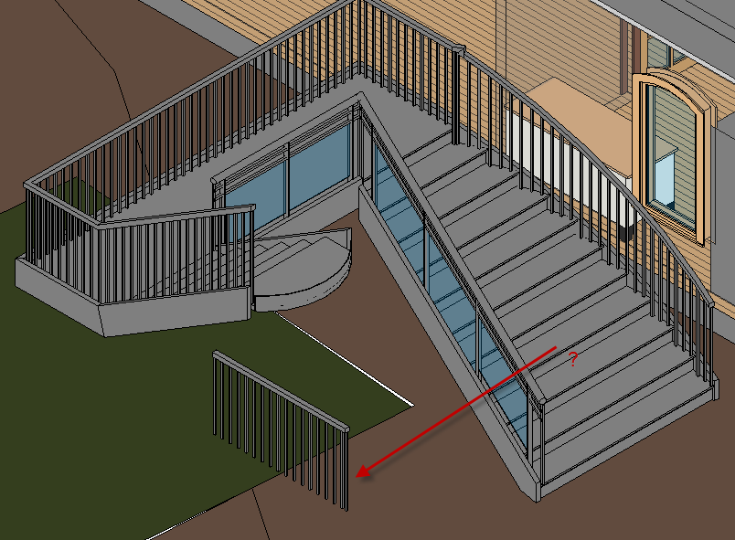
Oops!! The railing is on the ground??
Why? Because you told it too …it didn’t know you wanted to put it on the stair.
Select the railing
Edit Path
SET RAILING HOST
Pick the stair (the stair hosts the railing)
Finish Railing.
Better?!
View
Building Section thru it. Adjust as needed.
You can delete the stairs.

You learned to create straight and U-Shaped Stairs, change the shape of the stairs, recognize stairs have rules (that can be changed), edit railing, and place railing on a flat surface.

Save as revit2018demo18.rvt

Slab Foundation Plan

Make all of the 1st Floor walls 5/8GYP5.5ST5/8PLY2CLAP (except the Garage wall)
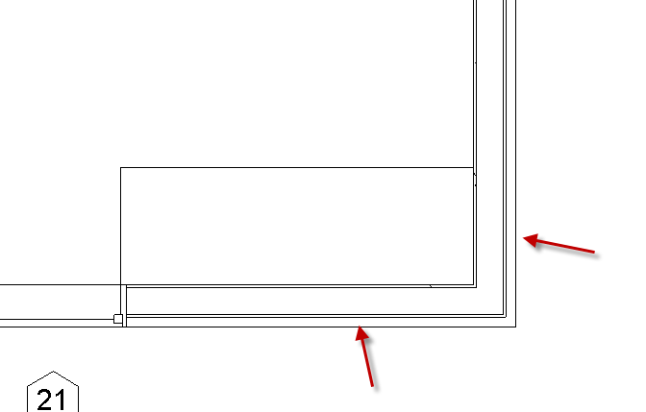

In Section 4
Pick First floor
Edit type
Change to Generic 12
Pick Generic 12
Properties
Edit Type
Duplicate
Name it: 5” CONC SLAB….OK
Structure: Edit
Thickness: 5”
Material: Concrete Cast In Place Grey
OK
Function: Exterior
Notice the floor is thinner!
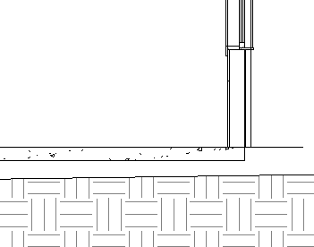
Footing as a Sweep

Floor Plan Level 1
Note: To prepare for this “sweep” process, we need a section at the first line of the path.
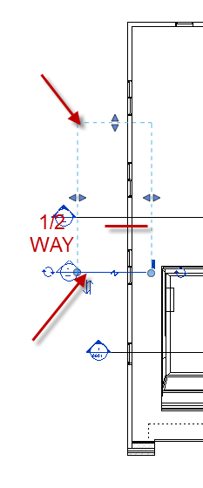
Architecture
Component
Model In Place
Family: Structural Foundations OK
Name it: EXT FTG OK
Sweep
Sketch path
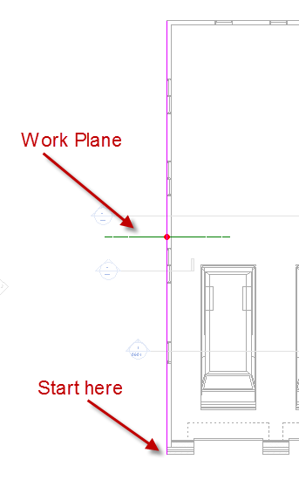
Create magenta line around building.
There is a problem….
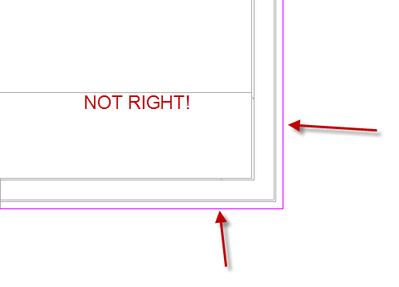
The concrete footing does not go to the face of the wall! It goes to the face of the core!
Move the magenta “sketch” lines to the right place.
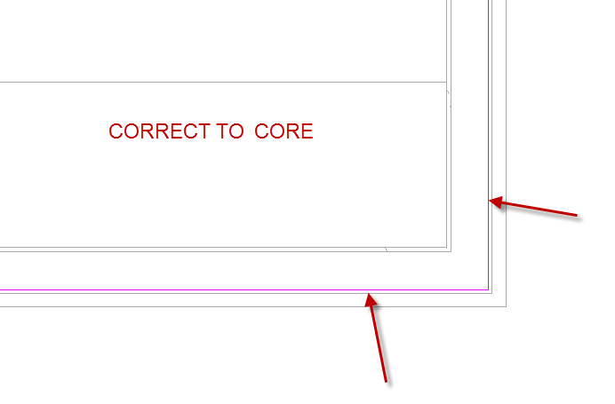

Note: The Garage is all wrong….it drops. We will deal with that later.
Set the material to Concrete Cast In Place Grey (same as slab)

Finish. The path is done. A sweep is a path AND a shape…so we are not done!
Edit Profile
Section 5 (get it?)
Open View
Set display to medium
Sketch the footing shape
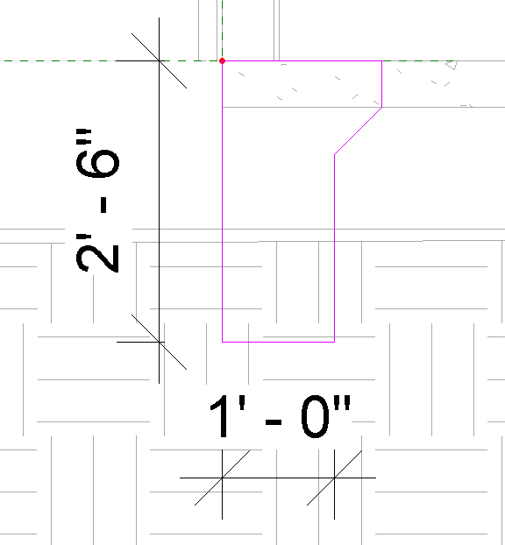
Make sure the material is: Concrete Cast In Place Grey
Finish…Finish…Finish Model
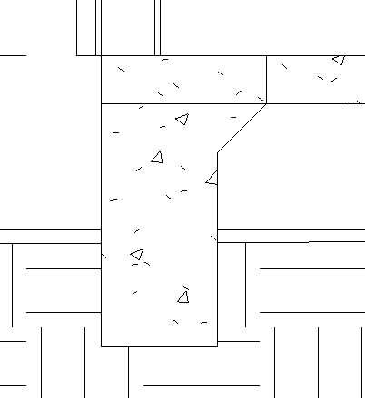
Modify
Join
Join geometry
Pick footing….pick slab
JOINED! EXPLAIN

See in 3D from bottom
Turn off topo….VH it
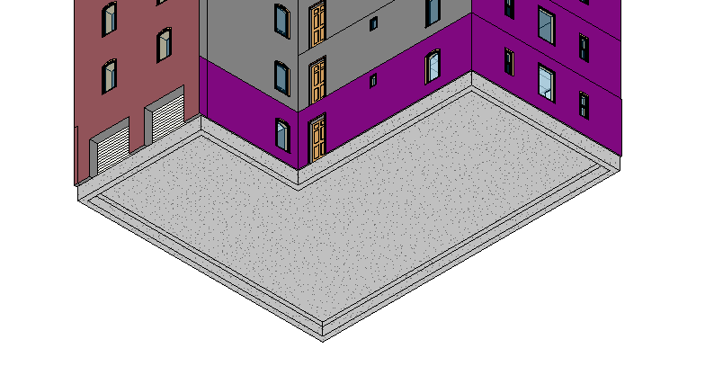

Cut a section anywhere….you will see the slab foundation correctly!!!!

Save as revit2018demo15.rvt

Foundation Plan
Duplicate w detailing
Rename to “FOUNDATION PLAN”
Properties
View Range
Top:0
Cut: -1’4”
Bottom: -2’6”
View Depth Level: -2’6”
Show section and goal of cut
Manage
Additional Settings
Line Styles
New
Name it “FOUND EXT”
Weight: 8
Line: Solid
OK
Annotate
Detail Line
FOUND EXT
Use pick arrow or line
Tricky part: Garage to house
Solid line is where wall is on garage side
Make reference planes where drop is.
View Range
Top: 1’0”
Cut: 1’0”
See where wall is?

View Range
Top: 0
Cut: -1’4”
Annotate
Detail Lines
<hidden>
Place hidden lines where footings underground are.

VH Structural Foundations to see hidden lines

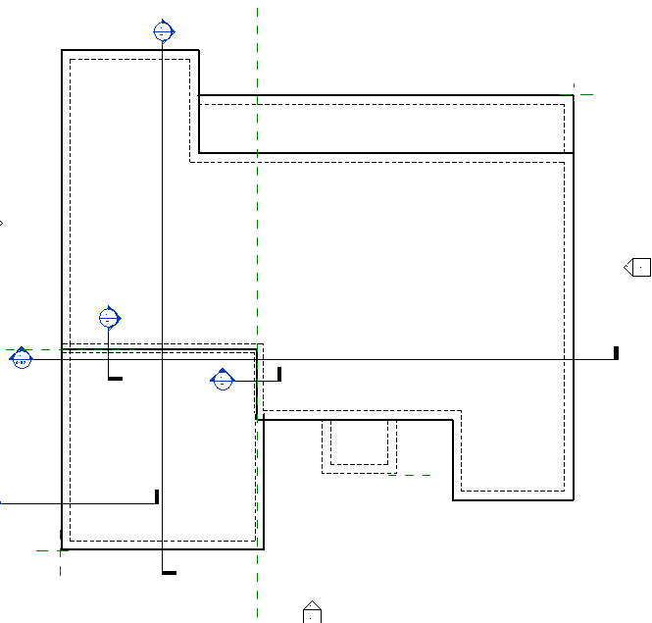

CURBS
Turn Structural Foundations back on.
Now the curbs.
View Range
Top: 0
Cut: -2”
See the curb lines and cuts?
Make solid lines at the curbs
VH the structural foundation again
Set the cut back to -1’4 (otherwise you would be cutting thru 5” concrete floor)

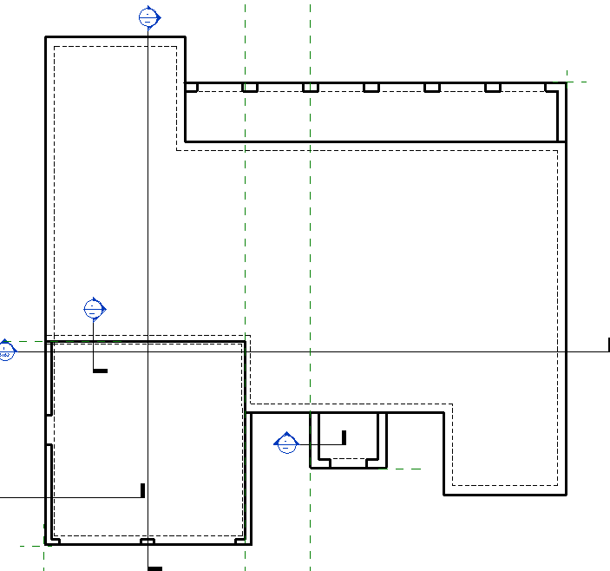

Dimension the Foundation Plan with class dimstyle (see page 112)

Add Foundation Notes (see page 388)
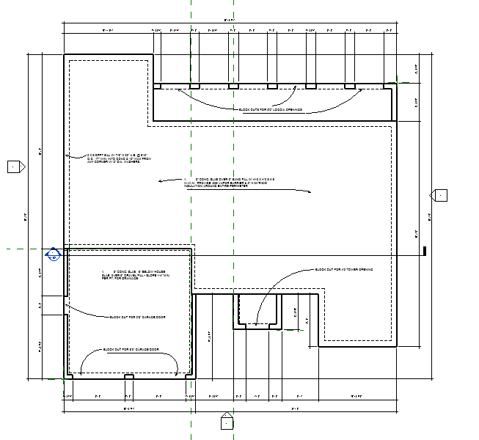

Callouts
In Section 4
View
Callout
Properties
Wall section
Create the Callout to cover the footing area up to a bit above level 2
Notice you have a “Callout of Section 4” in your Wall Section Browser
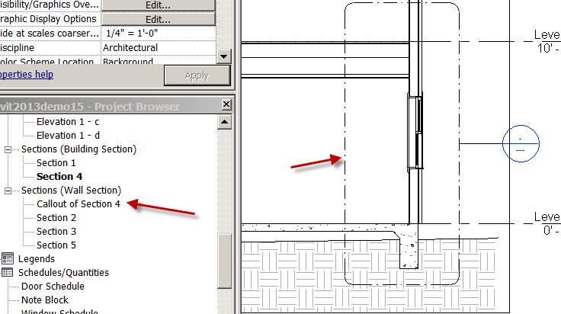
Select the Callout…..RC…Go to view
Change detail level to medium
Set the scale at ½”=1’0”
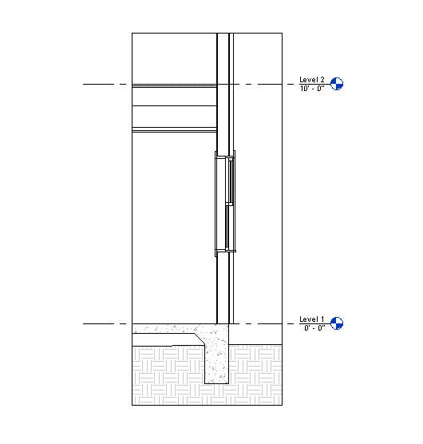

We now have a shell of the area we need to detail, with some nice information already there.
What we do now will be 2D and not show in the other views.
Let’s place a “2X6 TREATED SILL PLATE” at the base of the wall, on top of the slab.

Annotate
Component
Detail Component
Load Family
Detail Items
Div 6-Wood and Plastic (tons of stuff in these libraries)
Wood Framing
Nominal Cut Lumber-Section
Select 2x4, 2x6, 2X8,2X10,2X12,4X4,4X6,4X8 (note true sizes)
OK
Select the 2x6 from Change Element Type
Hint: Use the space bar to flip the 2x6’s.
Hint: Use the arrow keys to “bump” the 2x6’s into place. You can also use the Align command to get them perfect. They should fit PERFECT!

Place the sill plate.

Place the 2X6’ below the window

Annotate
Insulation
Width 5-1/2”
Place the insulation and drag your mouse. This is called a repeating detail (cool eh?).
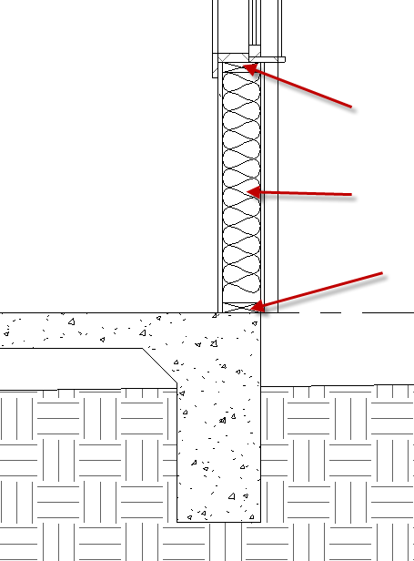

The next step is to create a detail section from our wall section

View
Callout
Detail View
Detail
Place it at the wall-slab area to create a “Footing Detail”
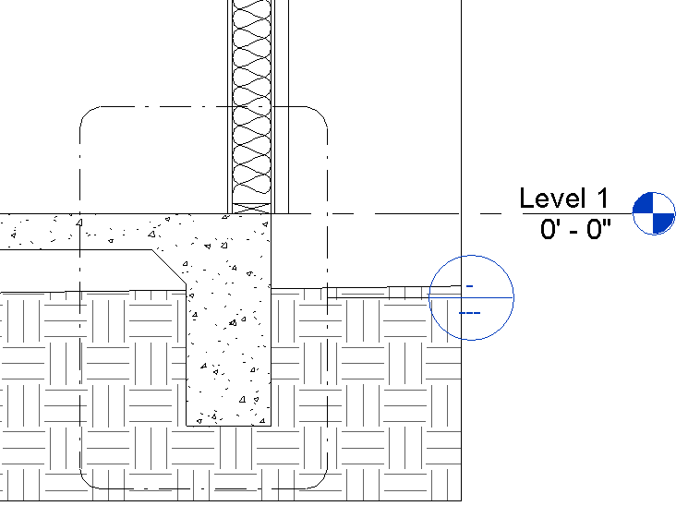
Pick Callout…..RC…Go to view
Set the scale to 1”=1’0”
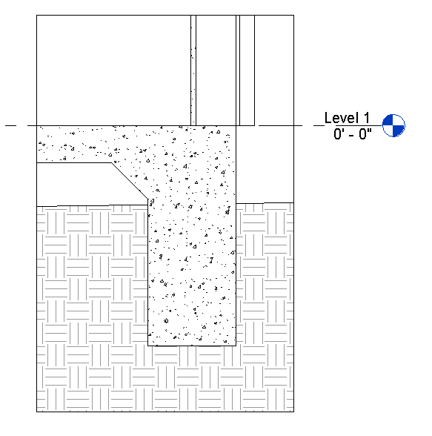

Show leader adjustment using grips

Notice the Detail Components did NOT come over! DISCUSS

2D details are VIEW SPECIFIC

There is a little trick to bringing them over without re-creating….
Back to Wall Section Callout
Select the 2D elements you want (hold Cntl key)
Edit
Clipboard Copy
Back to the Detail View
Paste Aligned
Aligned to Same Place
COOL? Note the scales of the drawings were different….but it still worked. The Revit “Detail Components” are not completely dumb!

Note: you have another folder entry in the Project Browser called “Detail Views”
Go to the Detail View
LC in white space
Propeties
Identity Data
Title on Sheet
EXT FTG @ EAST WALL. This changes the title without renaming the view (helpful for drawing coordination)
OK
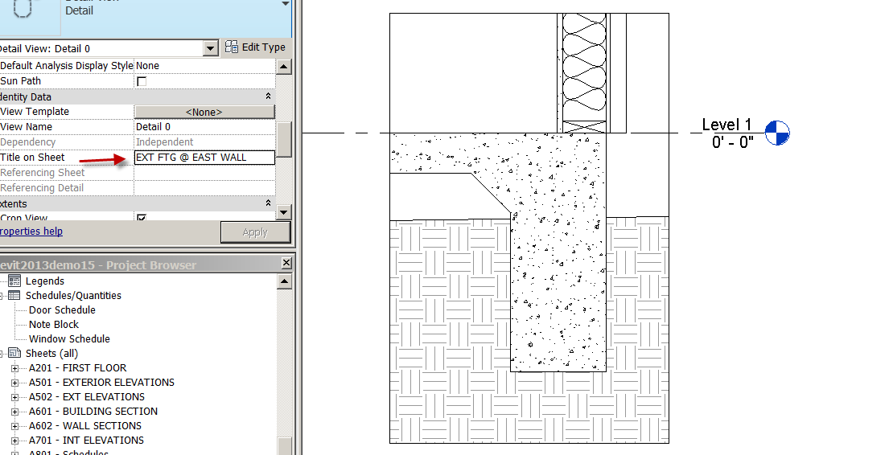

Anchor Bolt
Let’s bring in an anchor bolt to attach the foundation to the wall:
Annotate
Component
Detail Component (they are a little hard to find)
Load Family
Detail Items
Metals
Common Work Results for Metals
Metal Fastenings
Anchor Bolts Hook-Side
Open
Choose 5/8” size from Change Element Type…..Place it.
Make it 10” long…..I know it seems short. We just made our footing deep….
Show stretching vertically down. Show element properties control. Show mirror.

Rebar
Annotate
Component
Detail component
Load family
Detail Items
Concrete
Reinforcing Steel
Reinforced Bar Section
Open
Change Element Type
try Reinf Bar #6 in Browser
Use green lines to align! Place 2
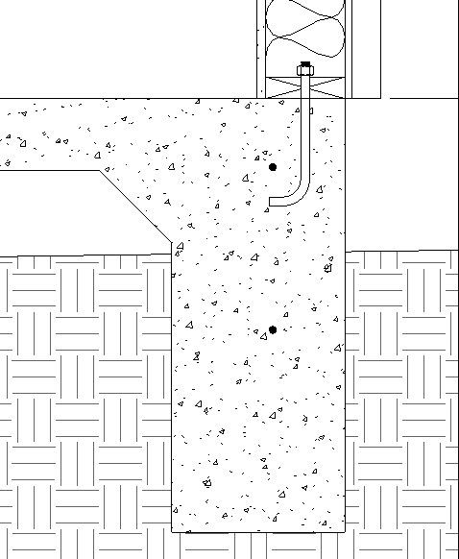

Editing a Sweep

The architect made a mistake telling you to go down 2’6”….it should have been 1’6”.
Wall Section 5 (remember?)
Pick footing
Edit in place
OK to message
Pick footing again
Edit Sweep
Pick Footing again
Edit profile
See the magenta lines? That’s your sketch!
Change the depth to 1’6”
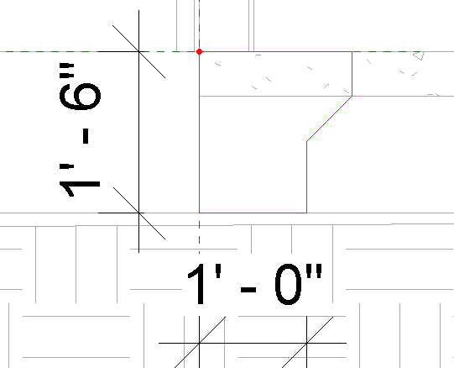
Green Check
Green Check
Green Check
Done!

Check your detail view….GOOD!
Check all of your sections…..everything updates!

Break Line
Annotate
Component
Detail component
Load family
Detail Items
Div 01-General
Break line
Open…..(Space bar to rotate) select break line to grip and change
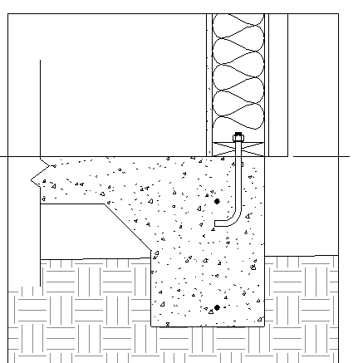

Show the Detail Components folders that users need to make themselves familiar with….

Let’s put some ground in: (we won’t use the existing topo here)
VH the topo
Turn Linewights ON

Filled Regions
Annotate
Region
Filled Region
Line Style
<Invisible lines> So you won’t see the outside lines…..
Properties
Edit Type
Duplicate
Call it “Bills Earth”
OK
Fill Pattern (pick)
Pattern type: Drafting
Earth
OK….OK
Create the region that you want the earth to be in (it must be a closed shape)
Finish Region
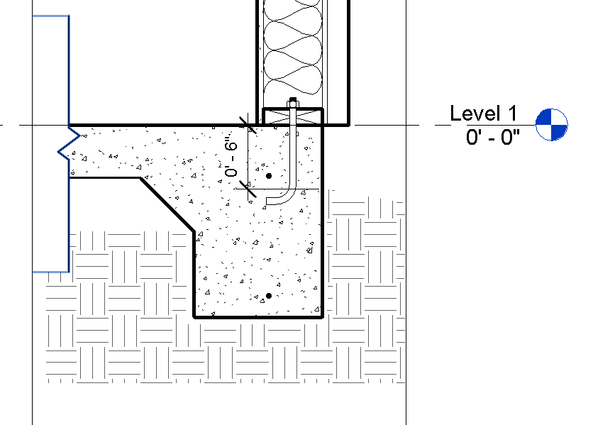

Let’s add some notation:

Annotate
Text
Properties
Choose 3/32 Arial
Pick Two Segments for leader
Pick where the arrow will point to…..stretch it out to where you want the text to go. TYPE text to identify wall components
You may have to adjust the annotation crop region out a bit to see the text (you will eventually uncheck the crop region visible box before putting this view on a sheet)
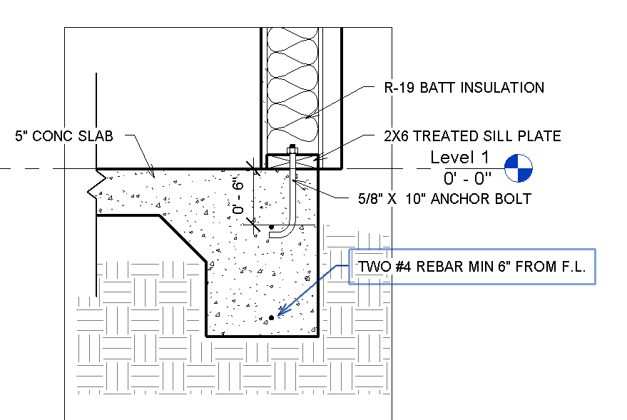

Show Crop Region and Annotation Crop Region. Show how Text can disappear even if it is there

Place the wall section callout and the detail view on sheet A600.02
Note annotation symbols get smart on the Wall Section and the Floor Plan!
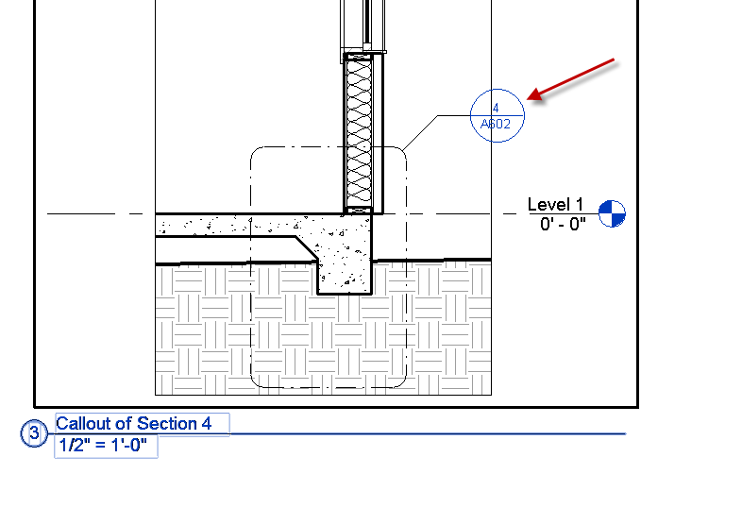
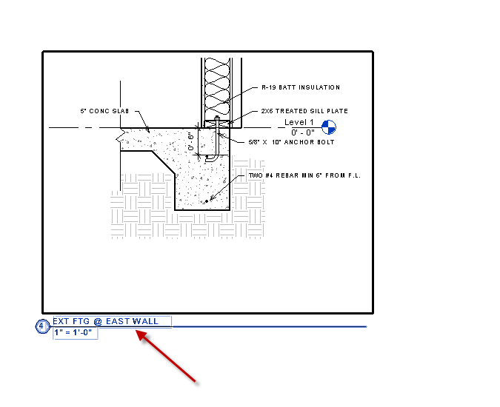

Let’s see all the drawings you have created:

Ctrl Tab will cycle you through the drawings you have created.

Window Tile will display all the drawings on the screen. Remember, each of those drawings is all part of the same file…..all tied together as a database of information!

You have learned to create detail views, apply 2D detail components to Section and Detail views, create filled regions, and add (dumb) text annotation.

Save as revit2018demo16.rvt

Area Plans

Revit has an Area Analysis Tool to define and label spatial relationships. These are different than “Rooms” in Revit Architecture and “Spaces” In Revit MEP. In fact, Areas and Rooms can occupy the same place (on top of each other). Areas have different parameters than rooms….keep track of different information.

Open Area Plan 2018.rvt

Room and Area
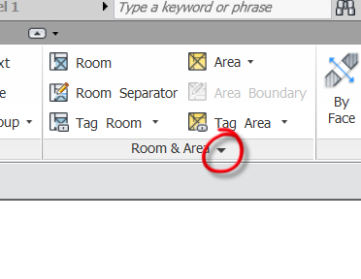
Area and Volume Computation
Area Schemes
Out of the box, there are 2 schemes. Gross Building and Rentable
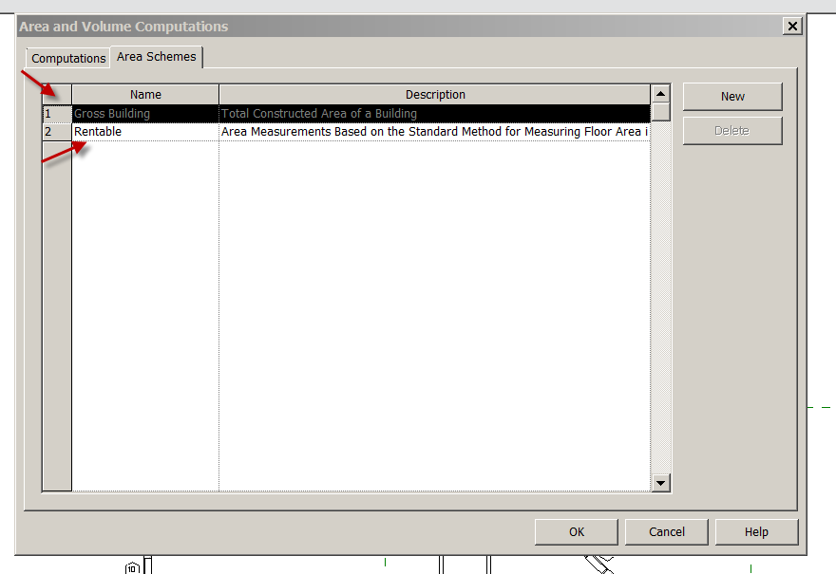
OK
Gross Building: Total Constructed Area of Building
Rentable: Area measurements based on the standard method of measuring floor area in Office Buildings.
Gross Building Area
Frequently it is necessary to find the total area of a floor plan. The “Gross Building Area Plan” is perfect for this and is really fast!
See Browser…No Gross Area Plan. We are not going to duplicate the Floor Plan Level 1.

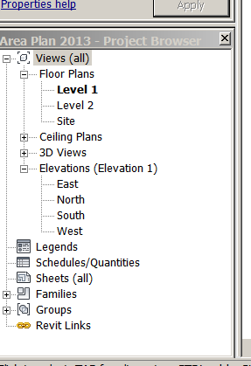

Room
Area
Area Plan
Gross Building
Level 1
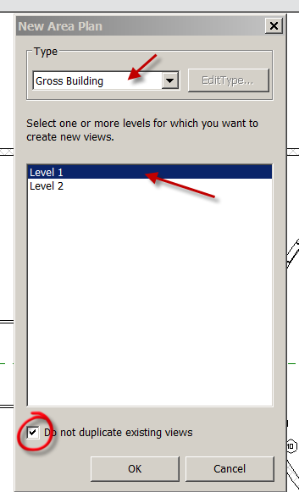
Check Do not duplicate existing views
OK
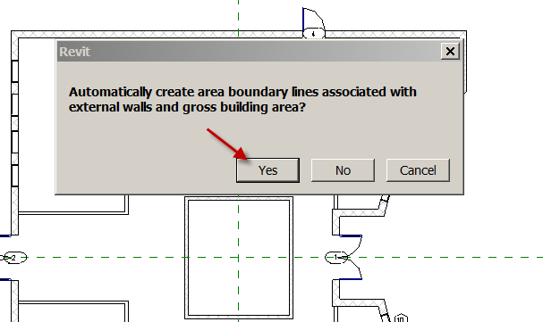
Say YES to the box. Discuss NO…..would create our own boundary lines…
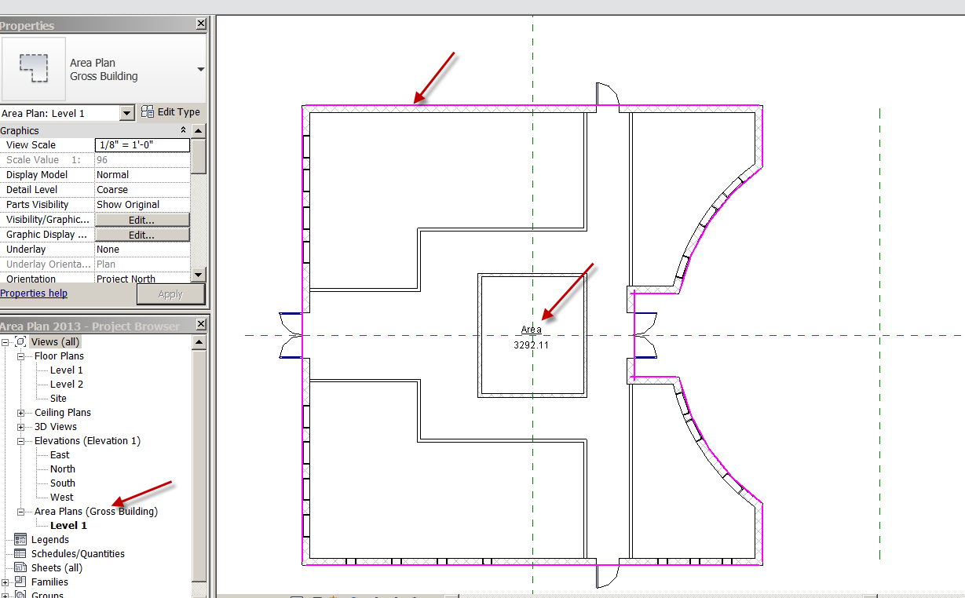

Notice the new “Area plans” in the Browser. Automatic!
The Magenta lines are “Boundary Lines. They could be moved, new ones created….but those are good.
Notice the Area Tag is there showing the Area of the Floor Plan. Nice!
On a multi-story building, it is really fast to get the area of each floor…..

Rentable Area

Architecture
Area
Area Plan
Rentable
Level 1
Do not Duplicate
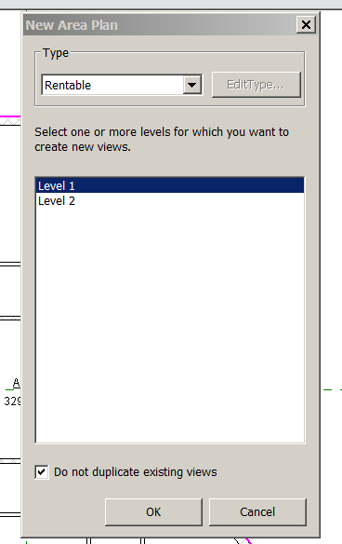

OK
Yes
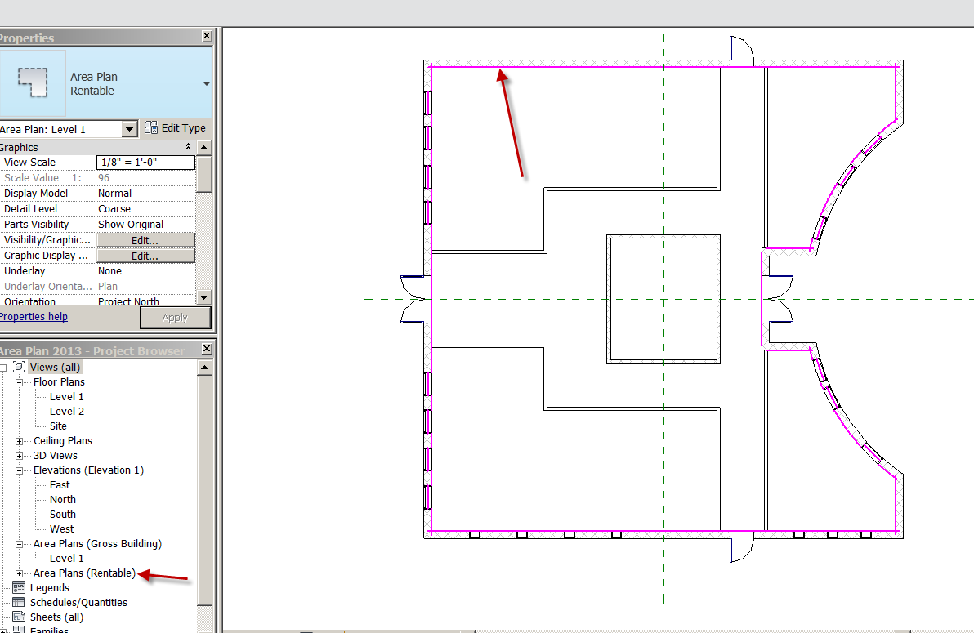

Notice the new entry in the Browser….Automatic!
Notice the magenta lines are in a different place.
Architecture
Area Boundary

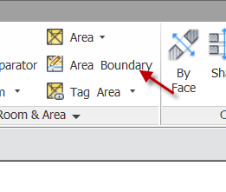
You will pick each wall (no window, sorry) so magenta lines are on each wall
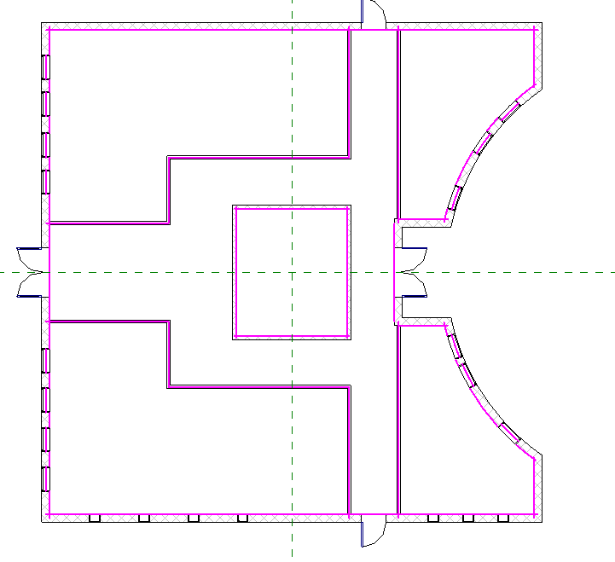
Architecture
Area
Area
Pick in lower, left corner
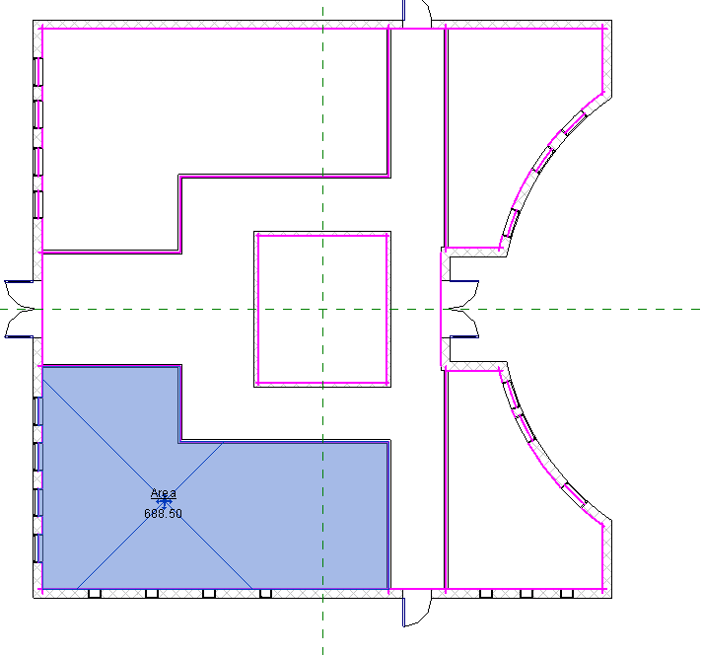
Name it Tenant 1. It should be 688.50 sq ft
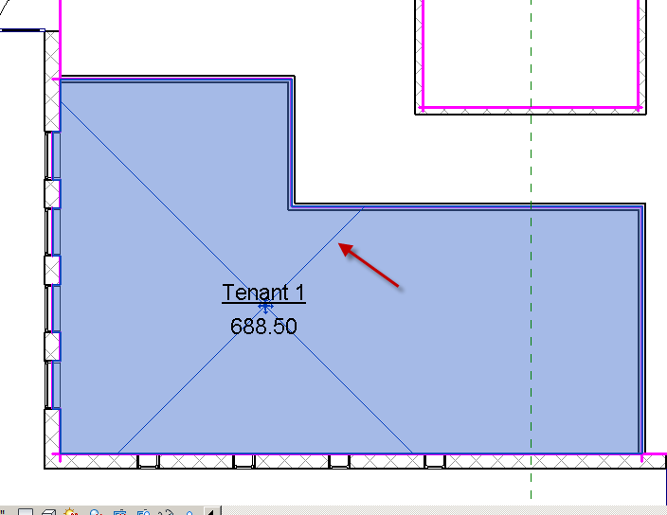

Pick on Area (see the X)

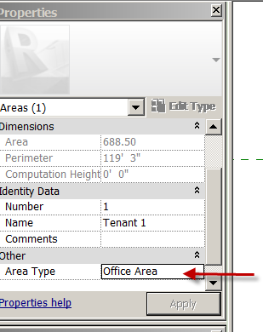

Area Type: Office Area
Done

Let’s do the same for the top, left space:
Area….Area
Pick top left space
Name it Tenant 2
Area Type: Office
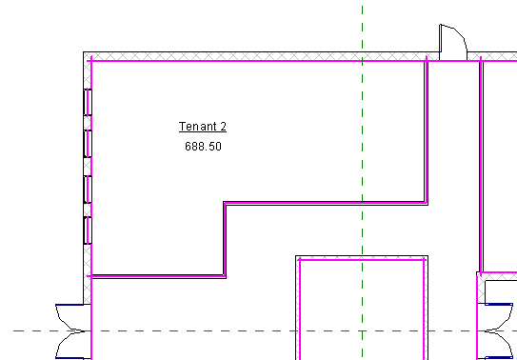

Now the Corridor
Area…Area
Name it: Corridor
Area Type: Building Common Area

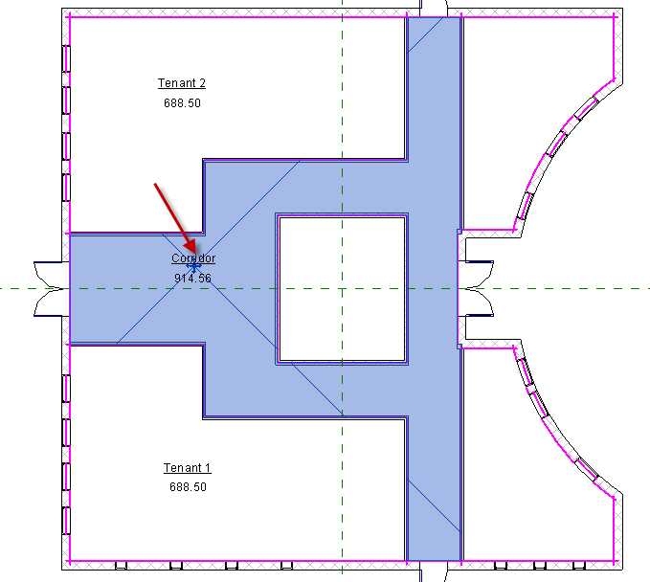

Now the Bottom Right “Store 1”
Area….Area
Name it Store 1
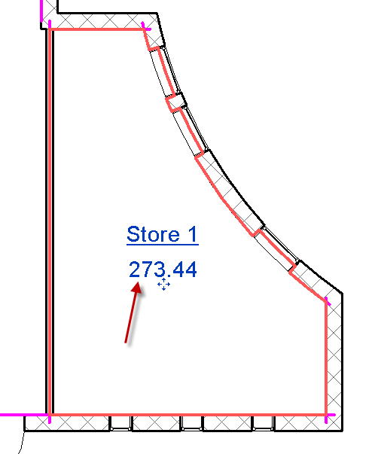
Notice the area is 273.44
Notice where the boundary lines are…….
Now change the area Type…
Area Type: Store Area
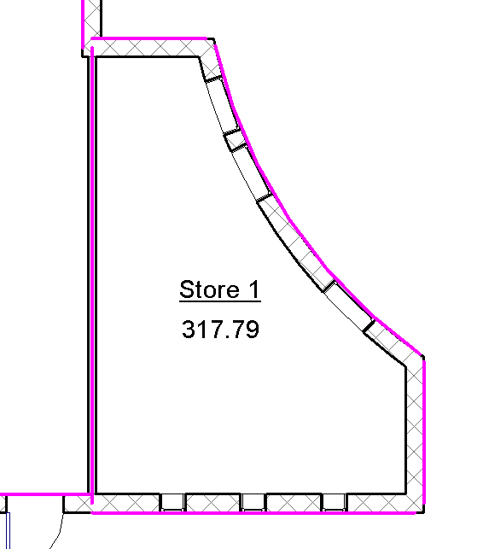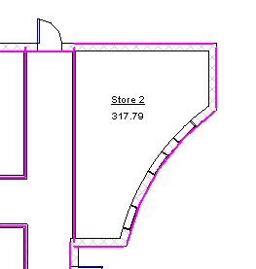
Check out the Area change! 317.79! Why? When you have Store area, you have to pay for all of the area! There are industry rules for how spaces are measured. Let’s say Store 1 was rented at $1000/sq ft. Which number would you want to use???
Repeat process for Store 2 in top, right corner.

Now the building “Core”. This is where stairs, escalator or an elevator would go. Notice where the magenta lines are….
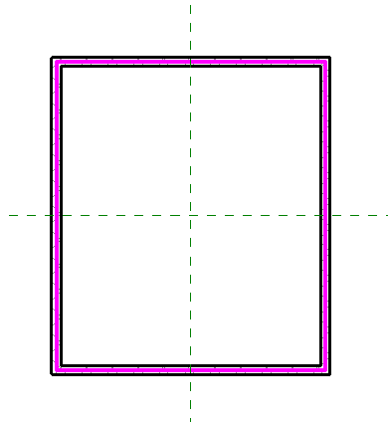
Area….area
Name it “CORE”
Area Type: Major Vertical Penetration
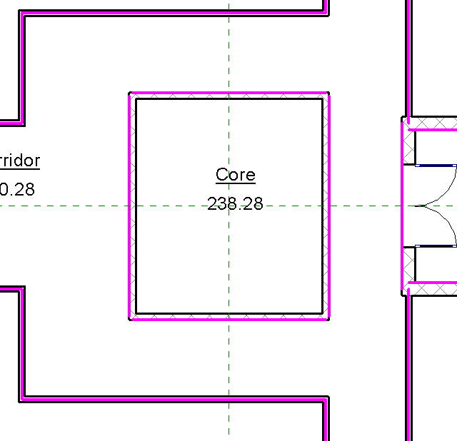
Notice changes in boundaries! This is Revit applying the industry rules for areas when they are adjacent.

Area Color Fill Plan
We can add color to the Areas based on their Area Type
Annotate
Color Fill Legend
Place on drawing to the right of the floor plan
Space Type: Area Rentable
Scheme 1
Ok
Done!
Show how to 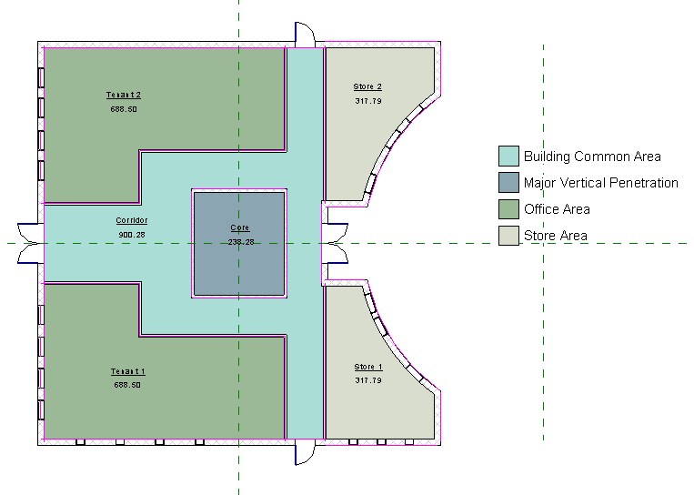

Show how to change colors:
Architecture
Room and Area
Color Schemes
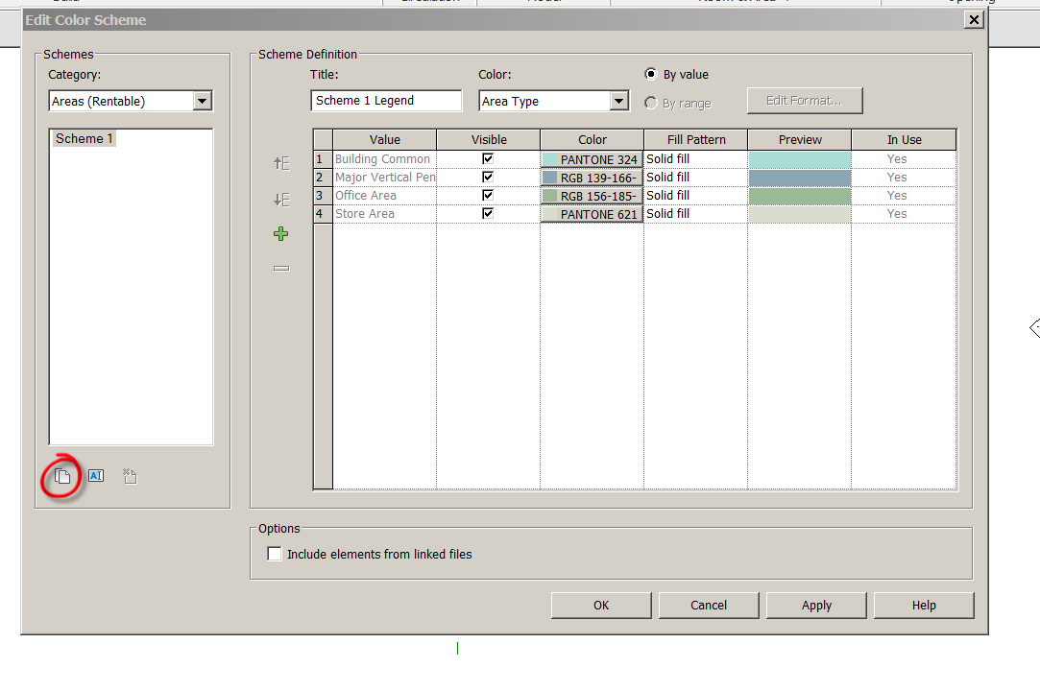

New scheme
Name it SHS Scheme
Apply new colors

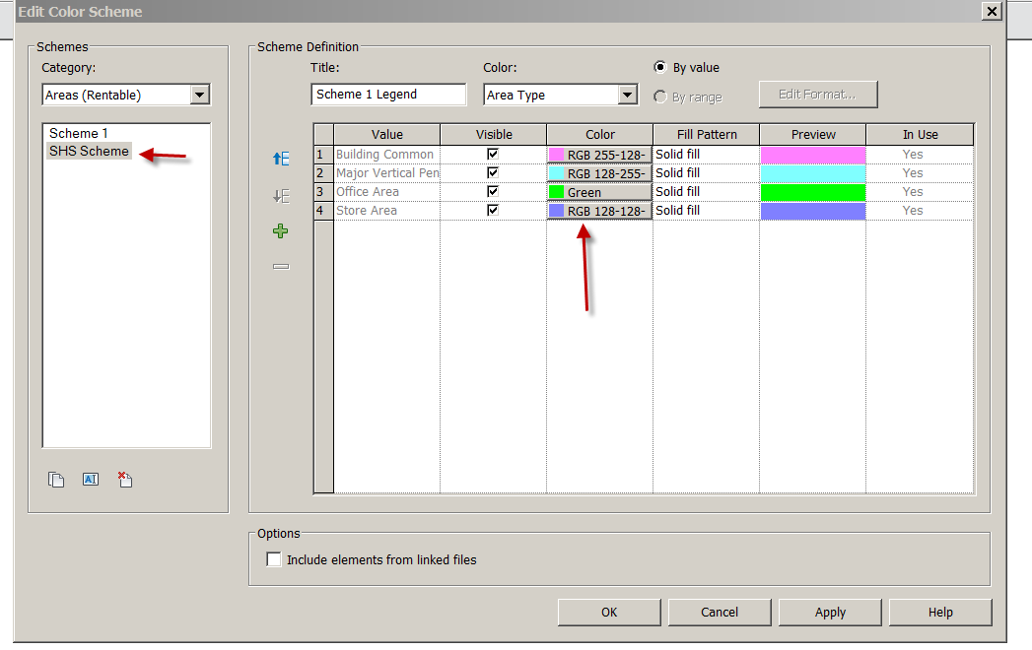

Ok
Pick on Legend
Edit Scheme

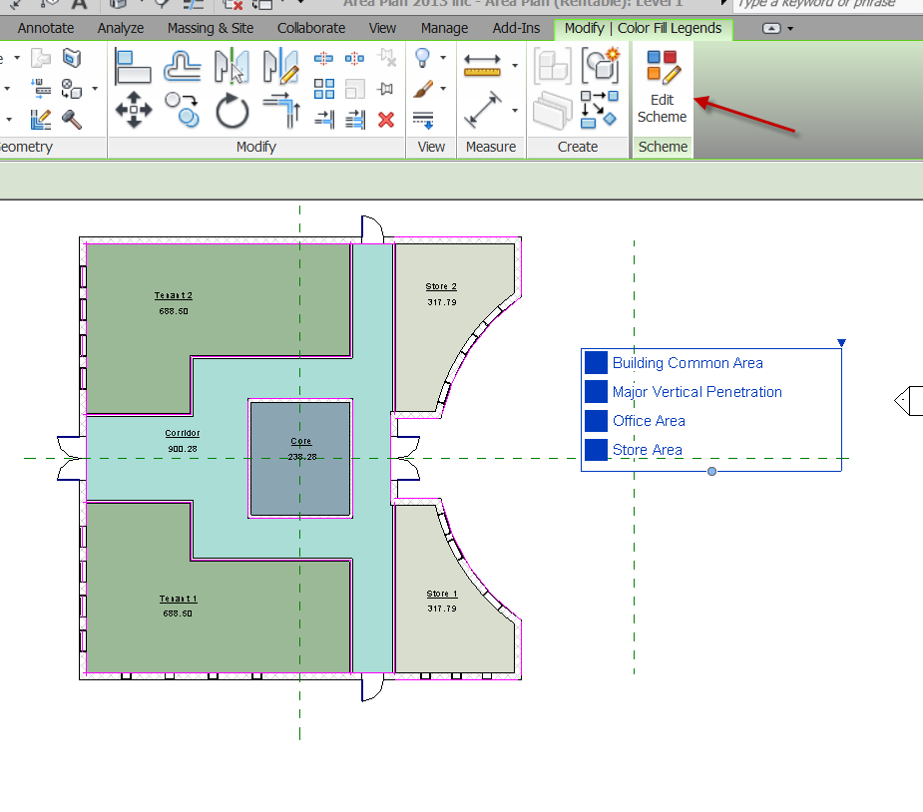
Pick SHS Scheme
OK
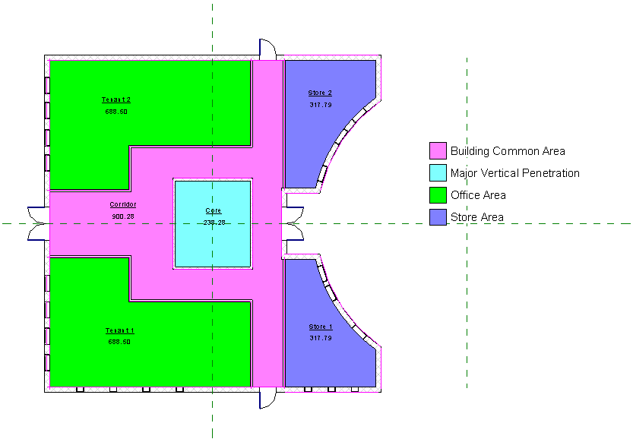
You can make as many schemes as you want!

Area Schedules
You can quickly create a schedule of the Areas
View Schedules Schedules/ Quantities
Areas Rentable
OK
Choose:
Name
Area
Area Type
Perimeter
Add
OK
Good!

Let’s total the Area Types….
Sorting and Grouping
Area Type
Check Footer
Title count totals
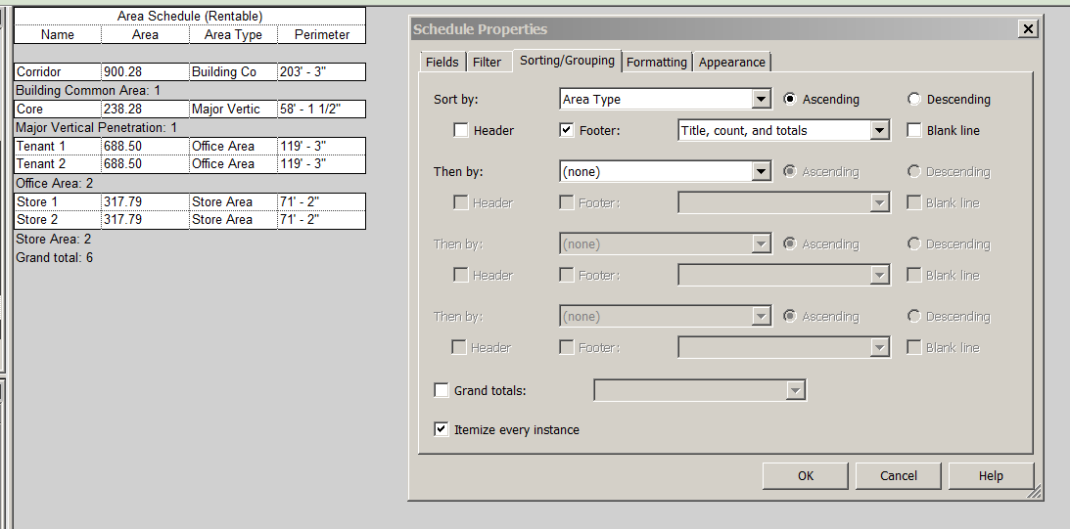
Formatting
Area Check Calc Totals
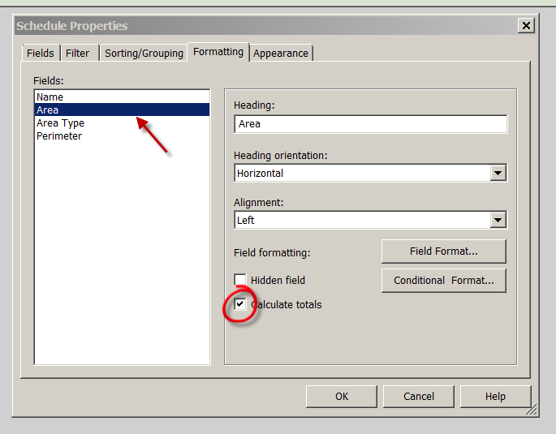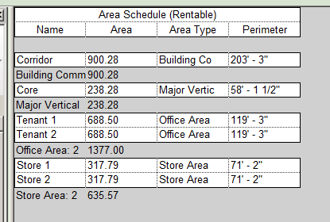

Place the Area plan and Schedule on a B- sized sheet.
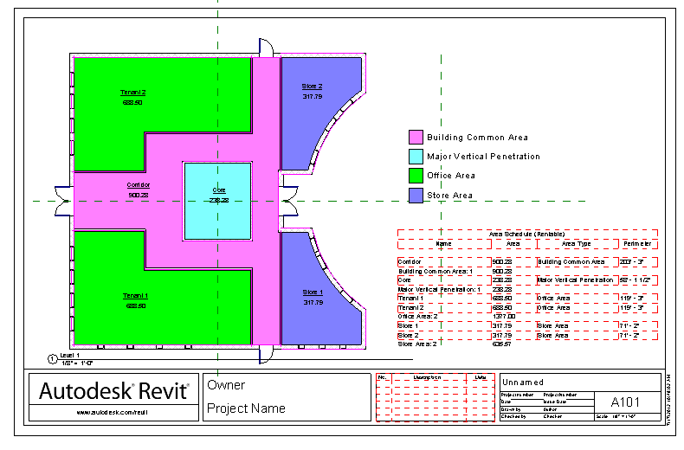

So we learned how to quickly organize areas to give us information based on industry standards.

Creating Materials in Revit 2018: Basics
Manage
Materials (icon)
Note the existing “out of the box) materials
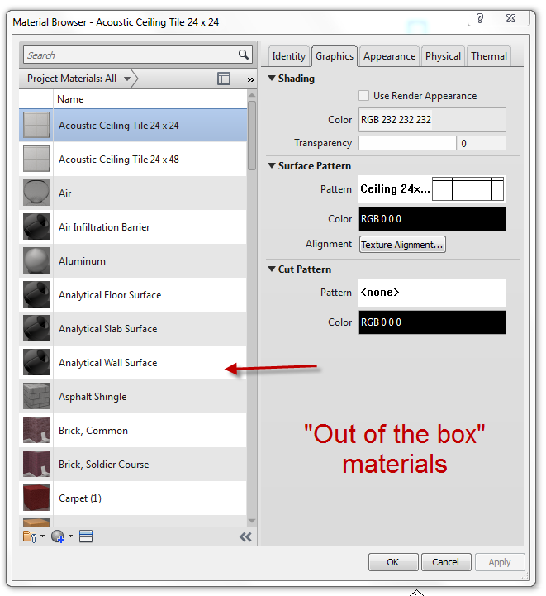

We will make a few custom materials in this demo…

Hit the circle with the + sign at the bottom of the palette
Creat new material
“Default New Material” is created. It has no color, surface pattern, render appearance or filled in parameters. Perfect to start from scratch with!
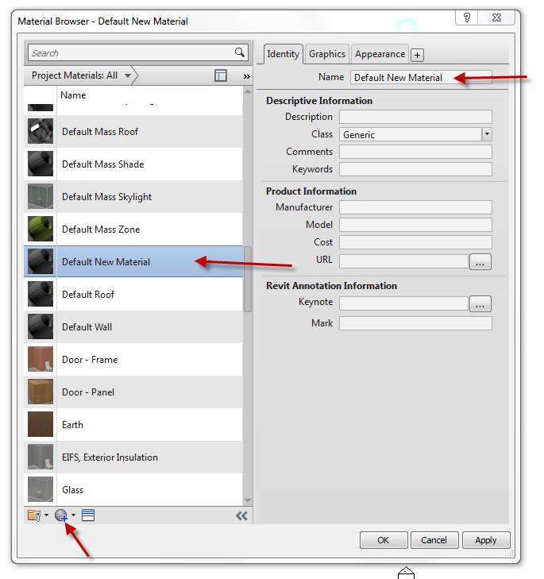

We will start by creating a teal carpet
Find a good teal carpet swatch on the internet…save as a .jpg or .png
RC on Default New Material….Rename
Name it SHS Teal Carpet

Identity Tab
Description: Bolyu Ocean Teal 348 Carpet
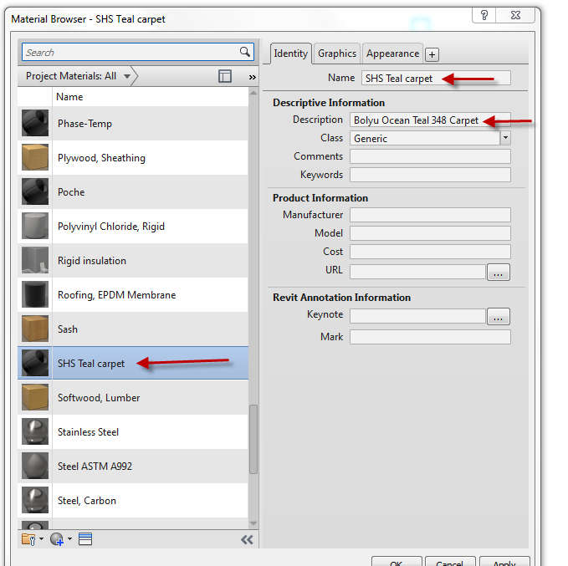

Graphics( tab)
Shading Color: Pantone….3265
OK
OK
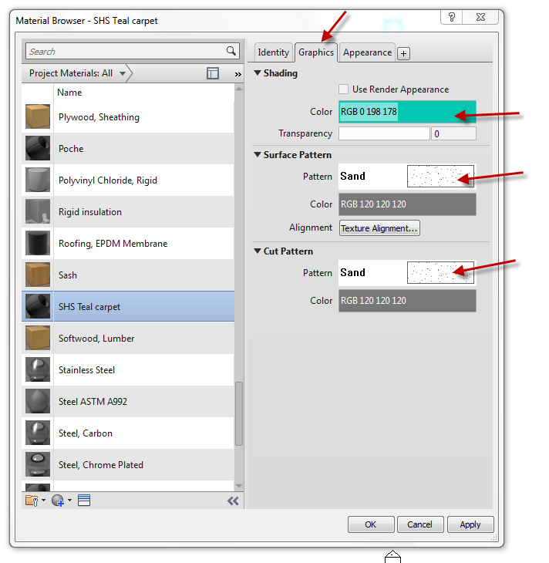

Appearance
Open Information arrow to see contents
Name: SHS Teal carpet
Image: Assign captured Teal Carpet image.
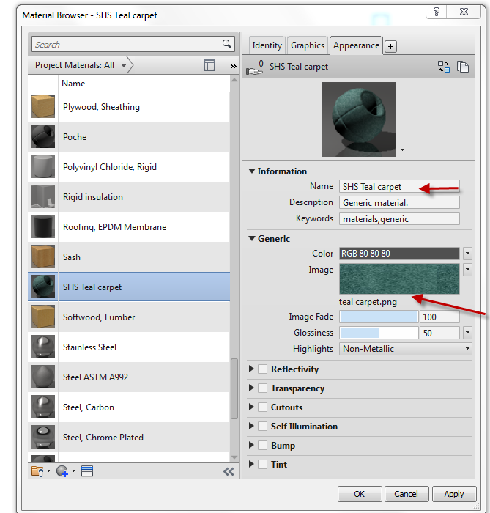
OK…one down!

Let’s make a Terrazzo material. Remember….we are just making the materials. We have not applied them to floors, countertops, etc.
Manage
Materials
Create New Material
Identity: name it SHS Terrazzo (from Default New material)
Description: Western Terrazzo 78C
Graphics (tab):
Shading: Pick a color resembling your terrazzo. Since it is multi-colored, it won’t be perfect.
Surface pattern: Concrete
Cut Pattern: Concrete
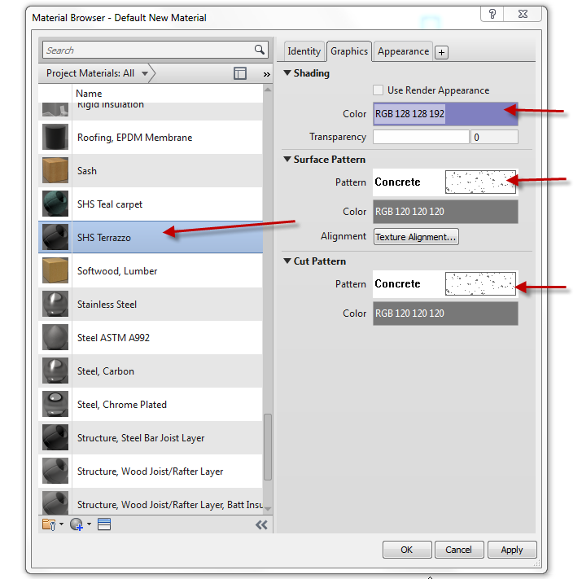
Appearance
Name: Terrazzo
Image: Captured picture of Terrazzo
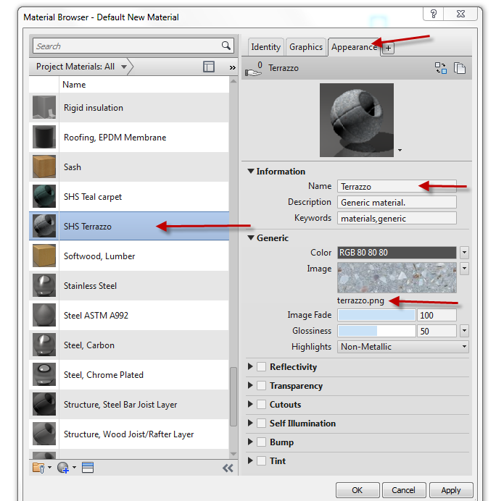
OK

Let’s do one more….
We will make a 4” Terracotta colored Ceramic Tile
Manage
Materials
Create New Material
Identity: name it SHS 4” Terracotta Ceramic Tile (from Default New material)
Description: 4” Terracotta Ceramic Tile
Graphics (tab):
Shading: Pick a color resembling terracotta. I used Pantone 7526 OK
Surface pattern: Model (button) …4” tile. Explain the difference between drafting pattern and model patterns. Remember…model patterns are “true size”.
Cut Pattern: Drafting…Crosshatch
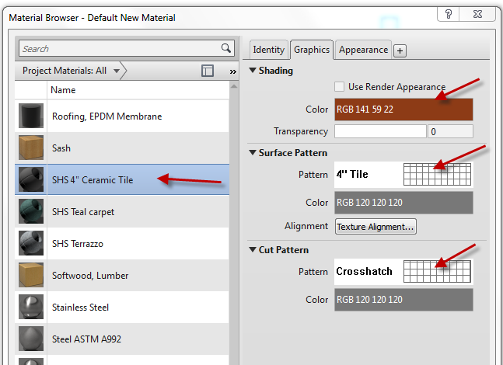
Asset Browser
Open Appearance Library
Ceramic
3” Square Terracotta (close enough!)
Hit arrow to right
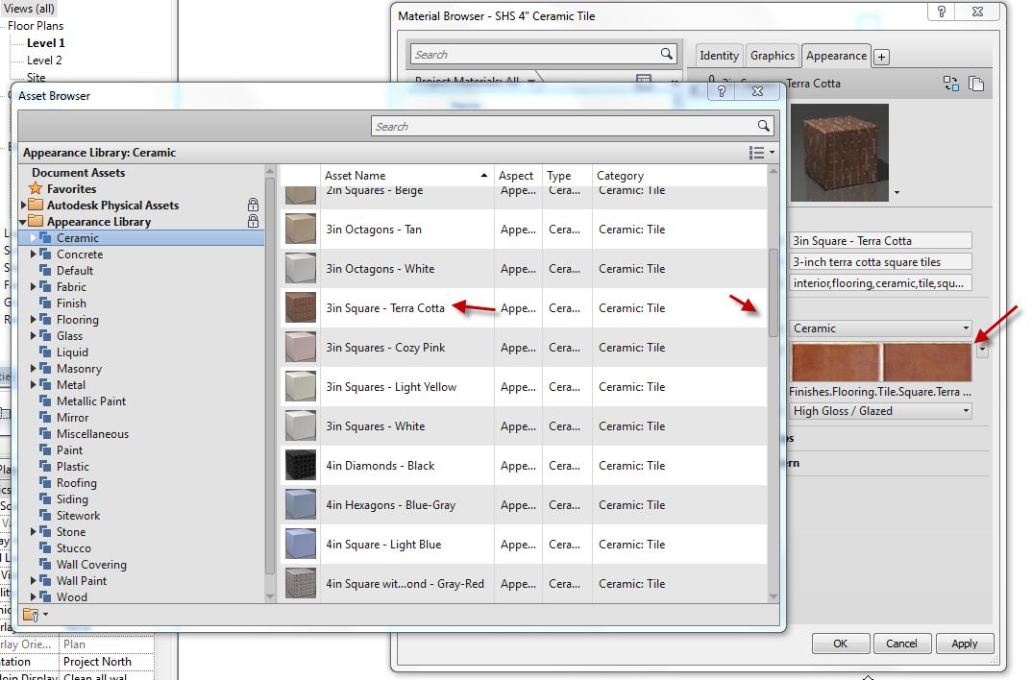

See appearance??

So you can use the “assets” in Revit, or create your own Render appearances!
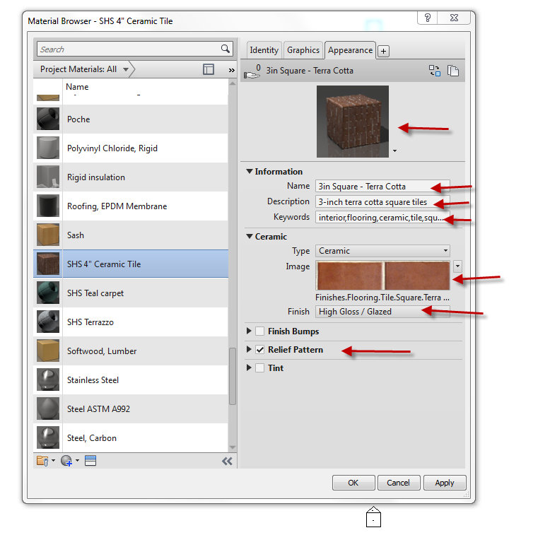

Material Browser Controls
These double arrows close the properties info
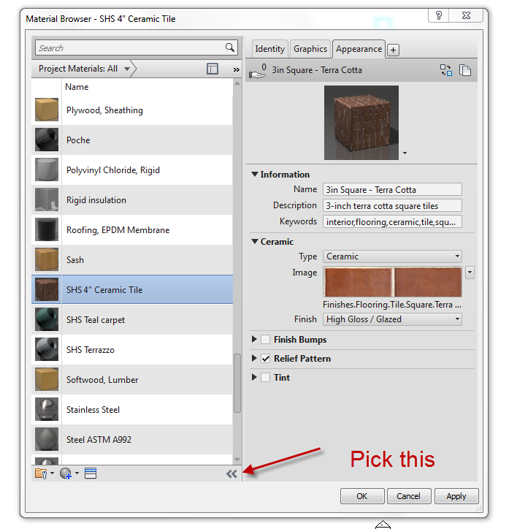
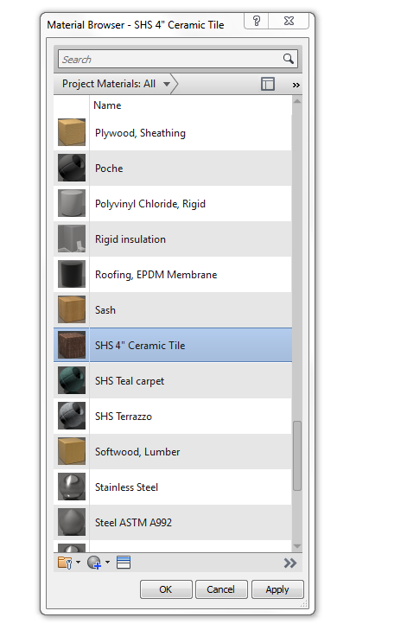
Note the arrow direction changed… and just the materials list is showing.
These double arrows control what you are seeing in the materials palette. The default is:
Show all
List View
By name
32X32
Play with the settings!
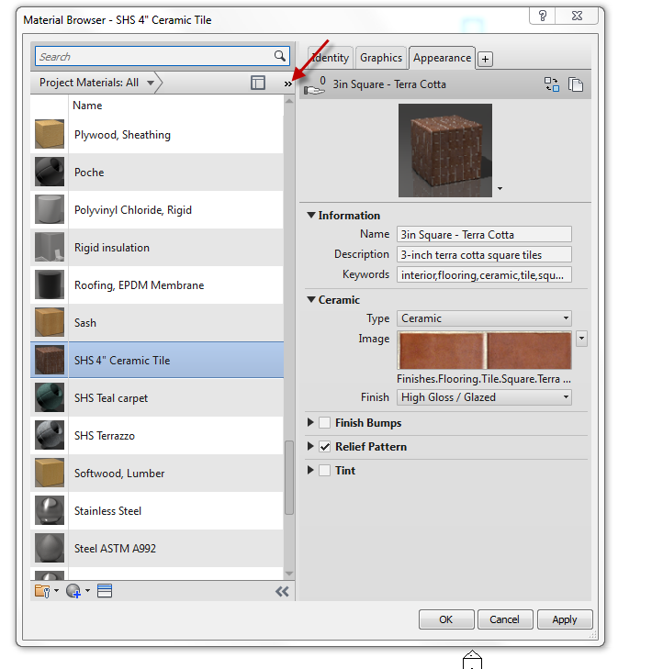
Pick this one. It opens the Asset Browser materials (below materials).
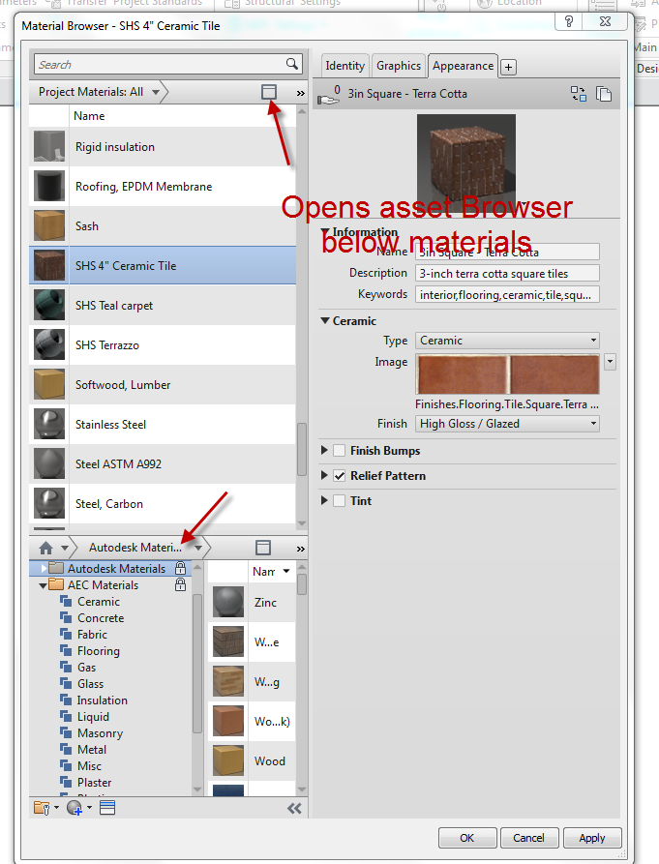
Changing the scale of the picture you created as a material
Carpet is an easy one to bring in at the wrong scale.
SHS Teal carpet
Appearance
The carpet is too detailed. It would look cartoonish as a floor in our model…..
Pick on image…see image texture??
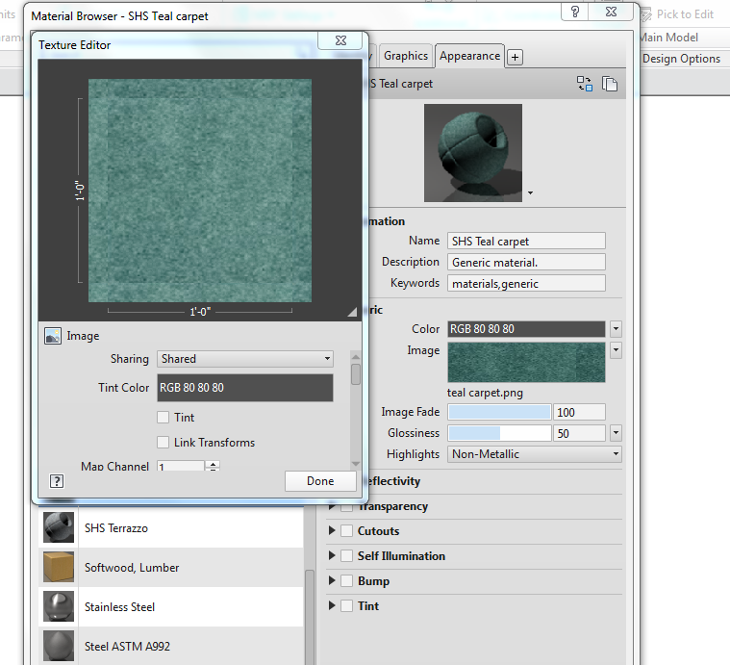
That is the picture that would be repeated in a 1’X1’ area of your floor.
Drag texture editor box down so you can see the editing options.
See size X?
SAee size y?
Let’s change to 48 (from 12). Now that same image would fill a 4’X4’ space.
Done!
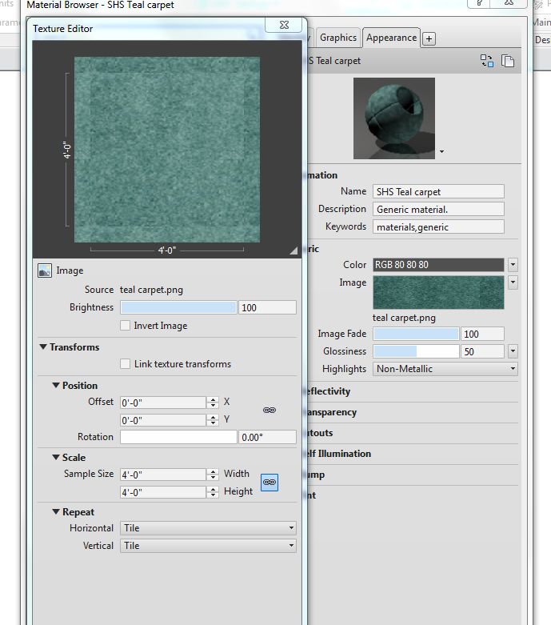

Save as Revit2018demo19.rvt
Material Tags: Label Your Smart Materials With Smart Tags

Creating intelligent materials and tags can save you a lot of time and headache annotating your drawings. Coordination can be amazingly controlled with a little work up front. We will first create a smart material tag, then create some objects with smart materials, then smart tag the smart objects!

Ceiling Plan Level 1
Pick the ceiling over the garage
Change it from a 2X4 Compound to a GWB on Mtl stud
Edit Type
Structure Edit
Finish: Gyp Wall Board (pick material)
Material Editor comes up
Gyp Wall Board
Pick pencil to right
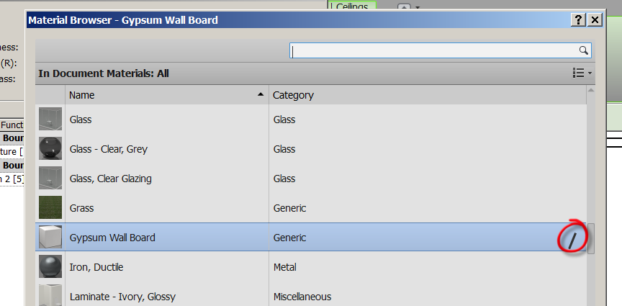

Material Editor comes up
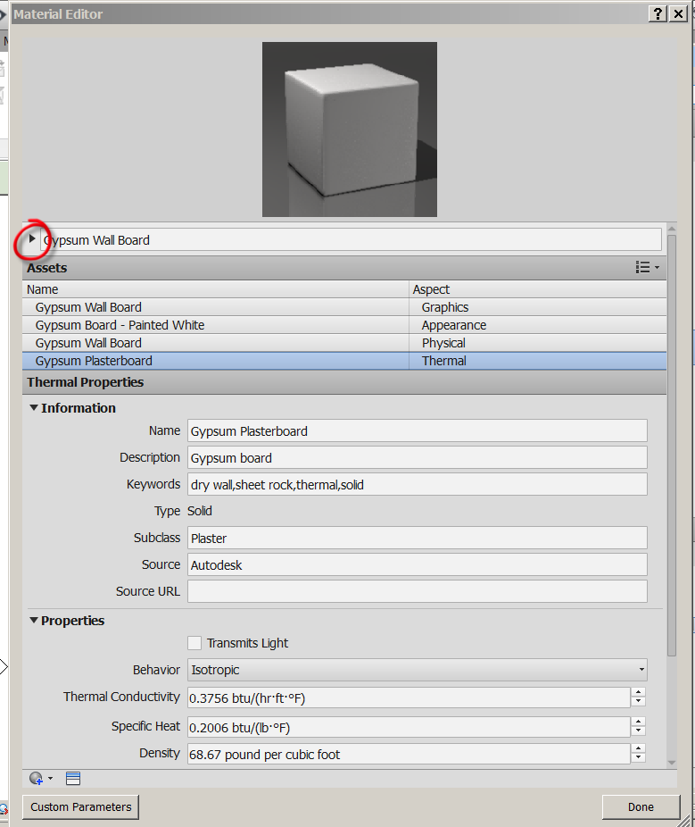
Pick the arrow to the right of the material name
Descriptive Editor comes up

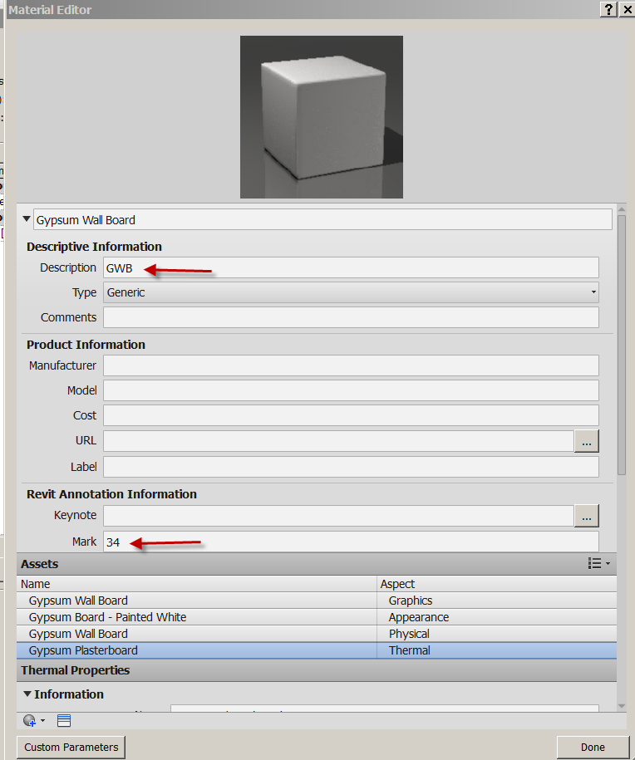

Set Description to GWB
Set Mark to 34

Note: We will use these two parameters when we tag our materials
GWB is the material
34 is the color

Graphics
Set Gyp Wall Board Graphics
Color: Orange
Surface Pattern: Sand (so we can see a little texture at ceiling)

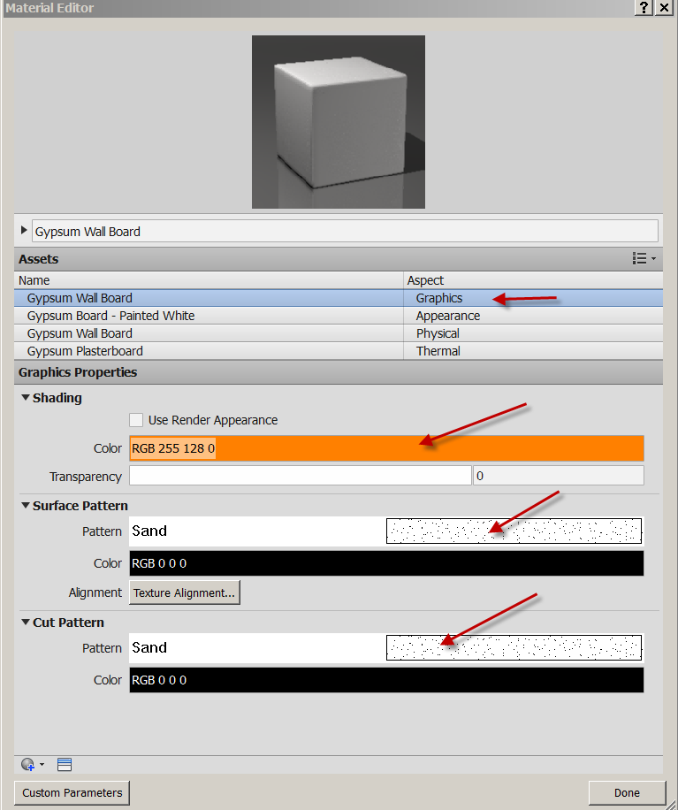
Done
OK…OK….OK
You have created a smart material!

Annotate
Material Tag
Check Leader
Material
Pass mouse over ceiling (attempt to material tag the ceiling)
It tags “GWB” ….remember?? Smart….but not done.
Making the Custom Material Tag
Select on “GWB”
Edit Family (or you could have double-clicked on the tag)
Open material tag for editing: Yes
LC on Material Description
Edit Label
See sample Text?
Note Parameter Name: Description
See Category Parameters on left? These can be labels.
Cancel

Making a Custom Tag

Let’s create a custom material tag that looks for 2 parameters: Description and Mark
Description will be the material abbreviation and Mark will be a color code number.

Still in the family Editor….
Pick on Material Description
Edit Label
MTL for Sample Value (we will have 3 letter acronym for materials)
OK…

We need to see the reference planes to properly set up out text…

VV
Annotation categories
Check Show Annotation cat in view
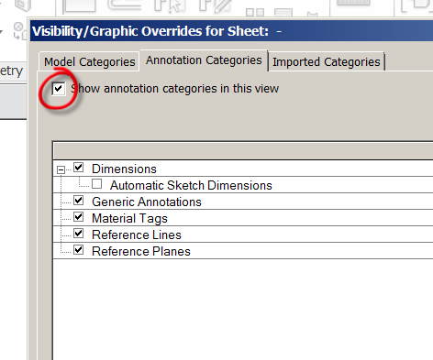
See ref planes, dims come on

Horiz Align: Right
Our first label is done.
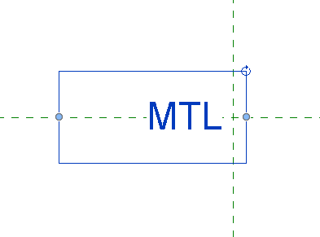
Create
Label
Click into space to the right of Description
Under select parameter: choose Mark
Hit green arrow to send to Label Parameters
Sample Value:123
Left Justify
OK
Make surrounding boxes work so 2 parameters do not run into each other…but are close together.
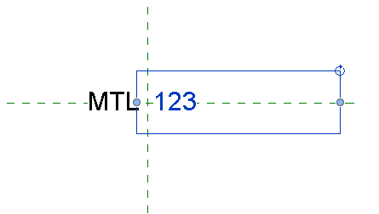
Save the tag as SHS Material Tag in your Families folder
File
Save as
Family
SHSMaterialTag.rfa (family files are .rfa)
Load into Project

These two labels are what the tag is looking for. If we give our materials this information, the SHS Material tag will pick it up!

Now let’s tag the ceiling:
Pick the first material tag
Properties
Switch to your SHS Material Tag
See the GWB 34 ???
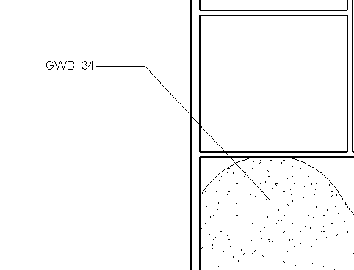

The tag is looking for “Material Desc” and “Mark”, which our material has!
(you may need to modify the family to keep the letters/numbers spaced properly)

Consider the drawing coordination issues solved if you create smart materials and tag them smartly….

You have learned to create a custom material, apply information to the parameters of the material that will be picked up by annotation tags. You applied the material to a system family (ceiling). You have learned what an annotation tag is and how it works. You created your own tag to “hunt” for chosen parameters.

Save as revit2018demo20.rvt

Applying Smart Material Patterns to Floors

Patterns and Materials

Model vs Drafting
Model:
* Represents ACTUAL element appearance on building. Brick, Ceramic Tile, etc.
* They scale with model
* You can Move, Rotate, Align, Dimension to create size
Drafting:
* Represents in symbolic Form
* pattern stays same size regardless of the size.

What does this mean?
Drafting Pattern: Let’s say you put a (common) gyp-plaster drafting pattern in a space at 1/8” = 1’0”…. There might be 1000 dots in the space.

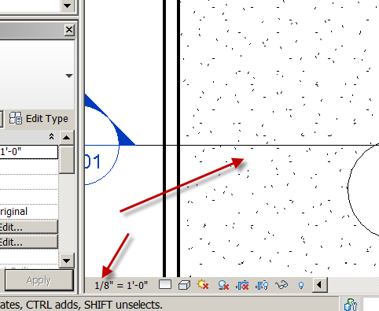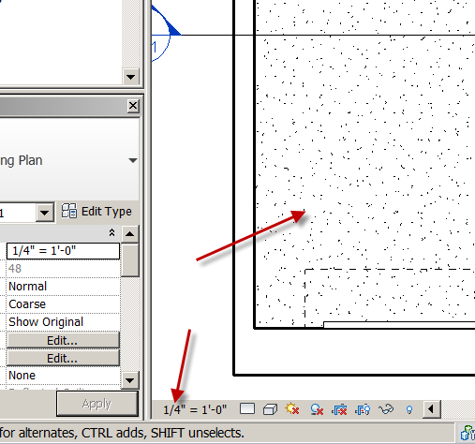

If you change the scale to 1/4”=1’0”, there would be 4000 dots and the pattern would look muddy.

If you changed the scale to 1/16”=1’0” you would have 250 dots and the space would be less “dotty”.
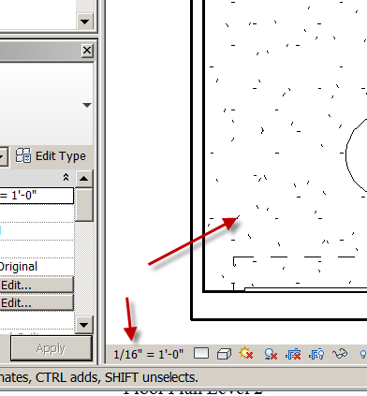
Hint: If you have a very dark area (that has a pattern applied to the material) in you view, the drafting pattern is the culprit. You may need to turn the pattern off or ½ tone it.
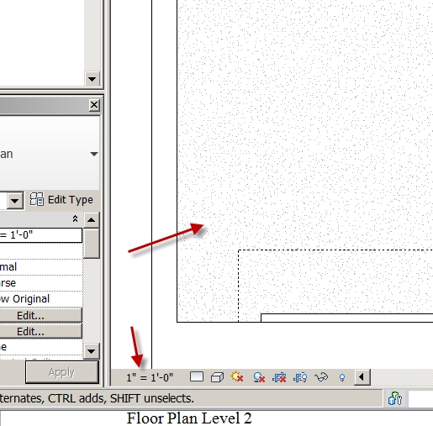

Model Pattern: The Smarter of the two. They are “real size”. Let’s say you put 1’0” square tiles in a 100 square foot room. Yes math wizards…that’s 100 tiles! If the scale is 1/8” = 1’0”, there will be 100 squares in the room. If the scale is 1/16” = 1’0”, there will be 100 squares in the room. If the scale is 1/4” = 1’0”, there will be 100 squares in the room.

Floor Plan Level 2
Pick the floor we created previously
Properties
Change to Wood Joist 10” Ceramic Tile
Edit Type
OK
Structure: Edit
Pick on Tile Mosaic Pencil
Surface Pattern: Find the 12” Tile…OK
Make an annoying green color…OK
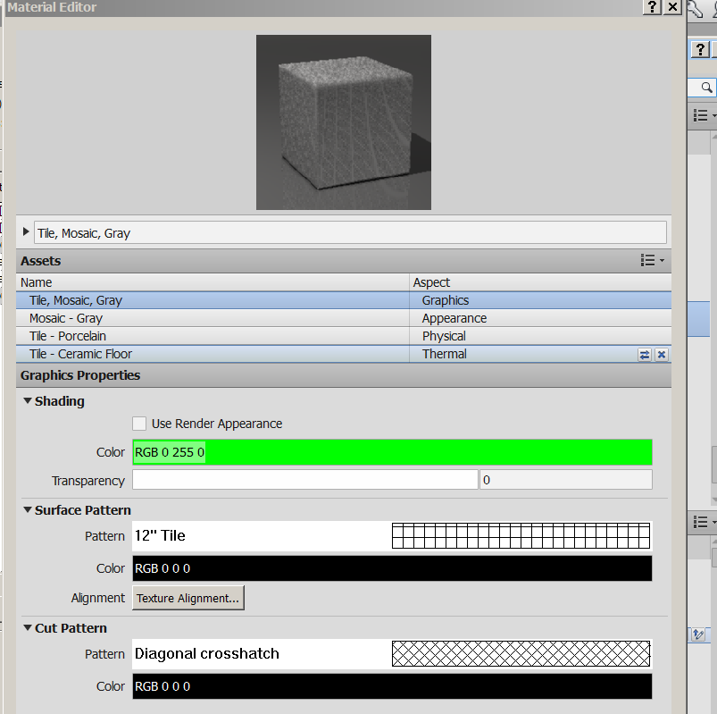
Identity
Description: CT
Mark: 13
Done
OK
OK..OK
See the tile floor?
SD…yucky green??
HL

Tag it

Annotate
Material Tag
SHS Material Tag
See the CT13 display??

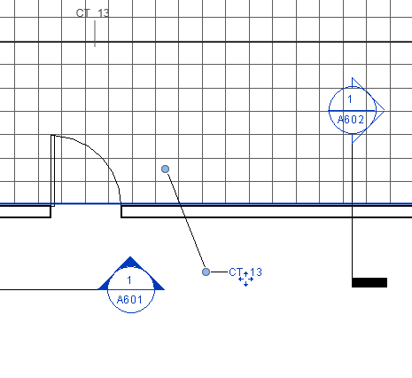

Save as revit2018demo21.rvt

Creating Fill Pattern

You can create your own custom “fill patterns” by leveraging your AutoCAD .pat files.
Manage
Materials
Tile Mosaic Grey Pencil
Pick Pattern
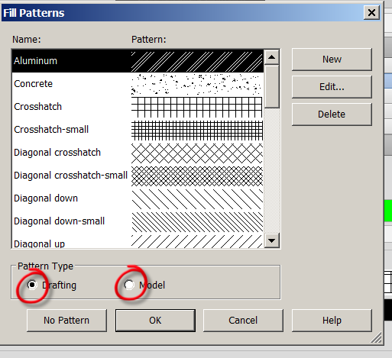

See the materials on the left?
See the Surface pattern on the right?
Surface patterns are applied to Materials.
Some patterns are “Drafting Patterns”…and some are “Model Patterns”
Cancel…Done
You should be in the Materials Editor
Make a new Material
Default….New Material
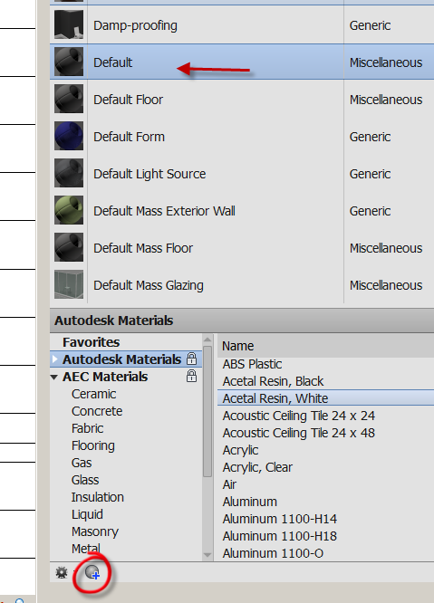
Name the material: SHS TEST MATERIAL……OK
Surface Pattern hit none
Check Model
New…..Check Custom……Import
Fldstn MODEL
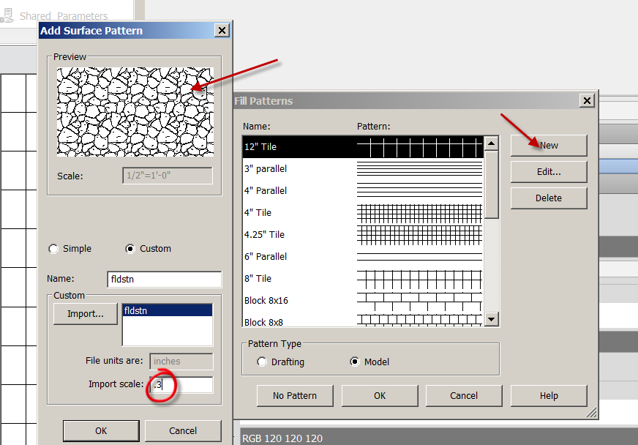
OK…OK…OK…Done
Any AutoCAD pattern can be made into a Drafting Pattern in Revit.
If you want to make the AutoCAD pattern a Model Pattern, you must add the following line after the title of a custom hatch…like this:
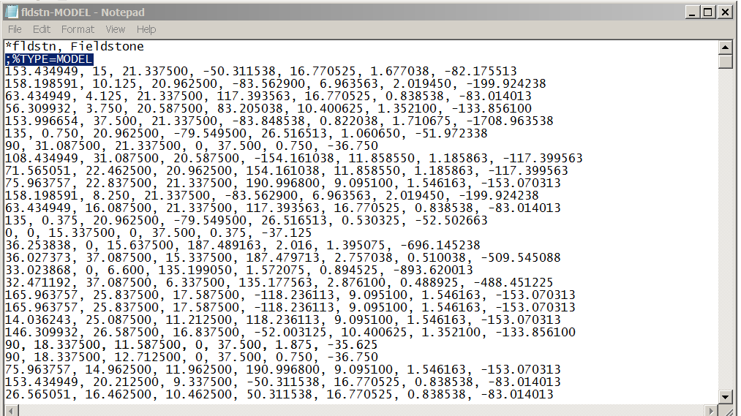
Here is an example of an AutoCAD pattern file that is converted to a model pattern for Revit:
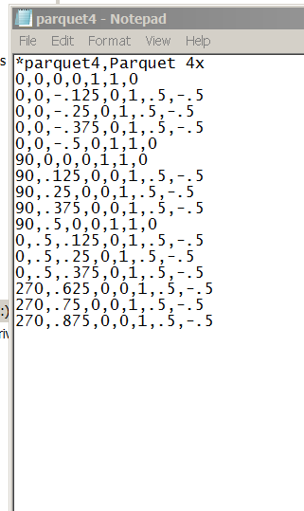
Notice the first 2 lines……and the save name.
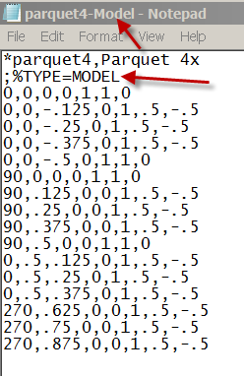
Notice the first 3 lines…..and the save name!
OK…back to the pattern:
Path to the model pattern you created
Open
Rename it if you like…or keep the same
See Import Scale? You can change….
OK
See the new Pattern in the Fill Patterns box?
OK
The Surface Pattern is assigned to the material.
Note: This pattern will NOT appear in a rendering
Let’s test it:
Create a generic wall, with the scale of the drawing at 1/8”=1’0”
Modify
Paint
Pick the SHS TEST MATERIAL
Paint the wall.
Note: If the pattern is too dense or too sparse, you will have to change the scale of the pattern! Bigger scale numbers make the pattern bigger….. decimal numbers make it smaller.
See it OK?
Note the number of patterns….
Now change the scale to ¼”=1’0”
Note the SAME number of patterns!
I assume you have A LOT of AutoCAD hatch patterns….so you now have A LOT of Revit patterns!

You have learned there is a difference between model and drafting patterns. You applied the patterns to custom materials. You created a custom family tag to look for a targeted parameter. You applied the custom materials to a system family (floor). You learned to control the display of the pattern on the floor.

Save as revit2018demo22.rvt

Applying Materials To Interior Elevation Surfaces: Your 2 Options

Option 1: You have a material like Paint, Wall Paper, Mirror, (flat stuff) to be placed on the wall.

Option 2: You want a wall to have “thick” material like stone, wood, or brick.

Let’s talk about Option 1 First.

In this option, we will simply apply a material pattern over the face of our element or family:

First let’s make a custom material.
Manage
Materials
Glass (notice there is no surface pattern and the glass is a bluish color).
Rc on Glass….Duplicate
Call it GL-36 Pencil
Apply an Aluminum surface pattern
Identity
Description: GL
Mark: 36
Done OK
You now have a new material called “GL-36”

West Elevation
SD to show color
See the horizontal siding
Modify….Geometry
Paint (icon)
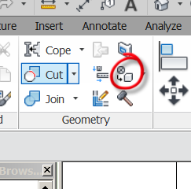
Material:
Sort by text view

GL-36
Select the first floor west wall See the pattern?
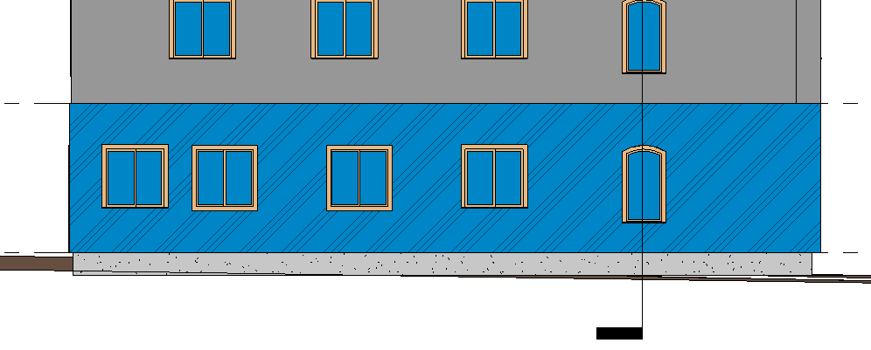

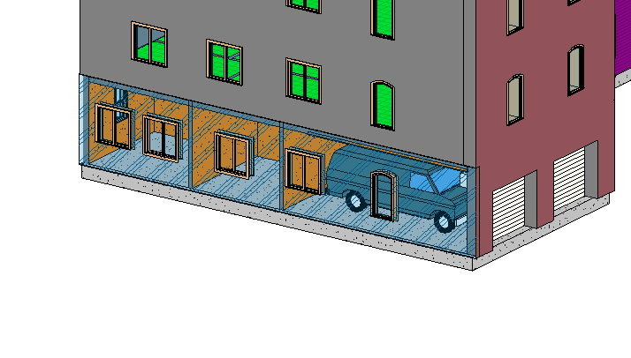
See in 3D…..it’s GLASS!
Back to West Elevation
Use your SHS Material Tag on it
Annotate
Material
See it??
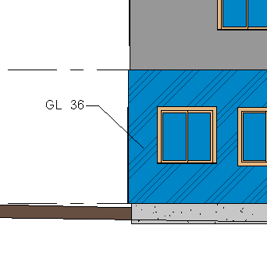

Undo to cancel placing the material on the entire wall.

Split Face

Let’s say you want to apply a material to part of the wall or use different materials on the wall:
HL…back to black and white.
Modify
Split Face (icon top right)
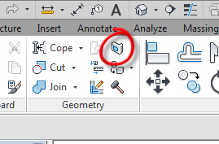
Use white arrow to pick wall (again, you may have to use the tab key to pick it)
The wall should turn orange-like…this means you are in sketch-mode
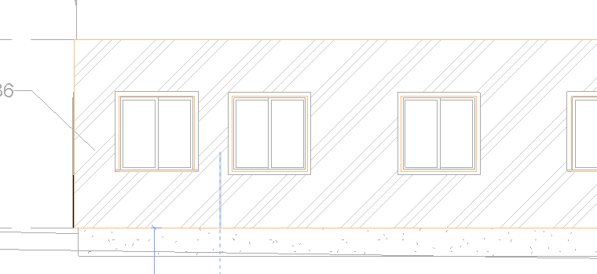
Lines
Make a rectangle inside wall.
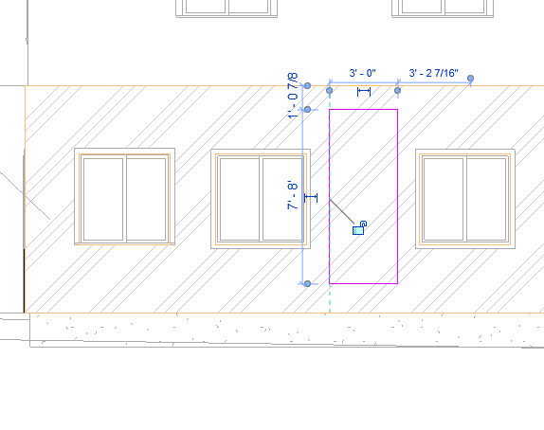
Finish Split Face
The wall is split into two parts, the rectangle area and the rest of the wall.

Modify
Paint
Brick Common
Pick rectangle just created. See pattern?
SD….Red bricks
HL

Split Face
Use white arrow to pick wall
The wall should turn orange-like again
Make a vertical line from top of wall to bottom of wall
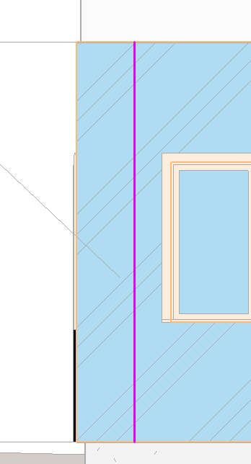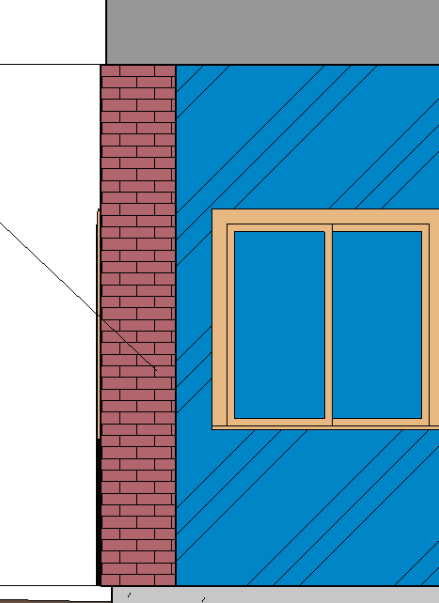
Finish Split Face
You can split a face this way….using the edges of the wall as a boundary

Paint
Brick Common
Pick vertical line we just created so the rectangular area we desire is highlighted
LC…See it?

Let’s try a paint:

Manage
Materials
Metal Paint Finish Blue Sky
RC….Duplicate
Rename to: PT-68
Apply

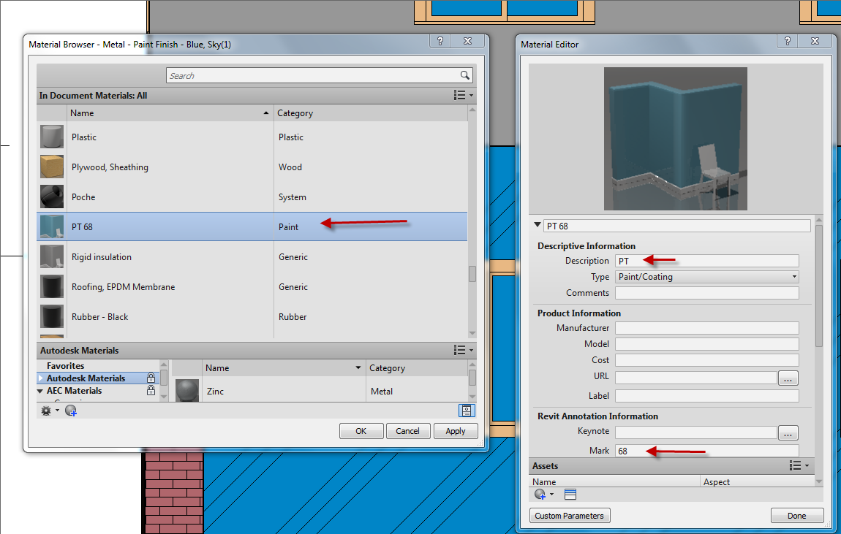

Add PT for Description
Add 68 for Mark

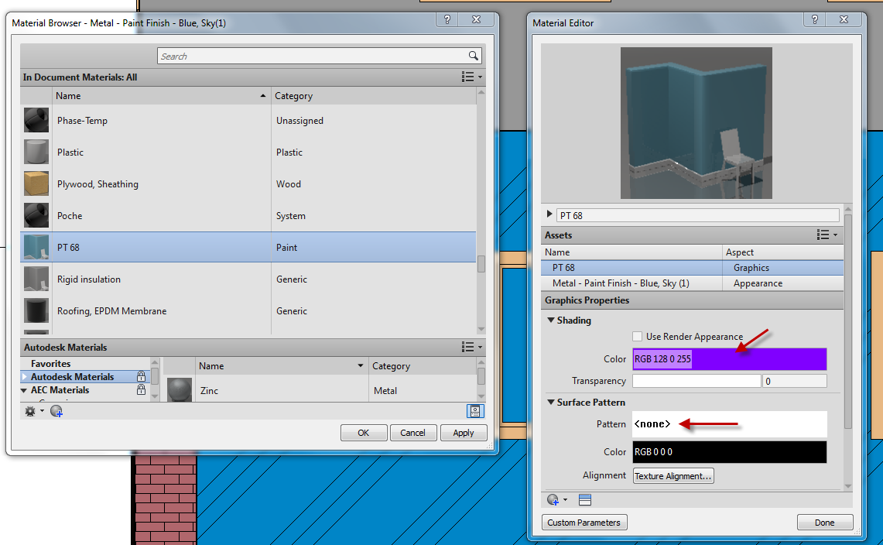Surface Pattern: None DISCUSS
Shading: Pick a purple color
You now have a paint material

Back to elevation view we worked on earlier
Paint
PT-68
Select the glass wall we did earlier.
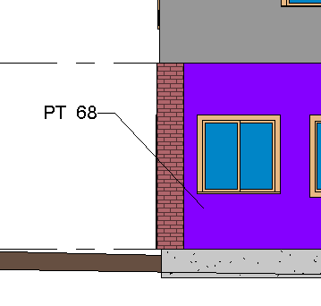
In HL mode it should look WHITE. Elevation Views are not generally colored….

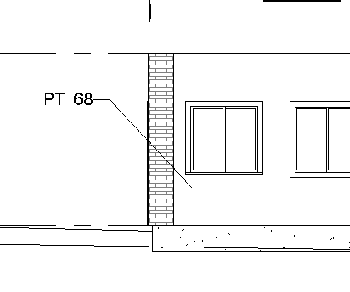
Now see 3D view.
Discus this as one alternative to annotating your materials systematically
Option 2: You want a wall to have “thick” material like stone, wood, or brick

You will have to decide what thickness of material really needs to be modeled. Paint is so thin, modeling it would be crazy. Same with wall paper. But what about wall paneling? Maybe depends on how thick??
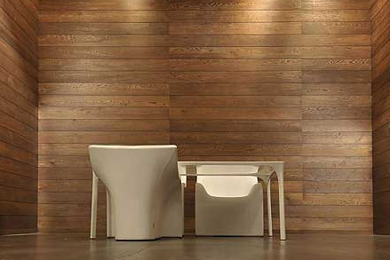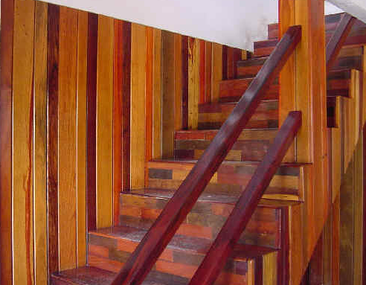

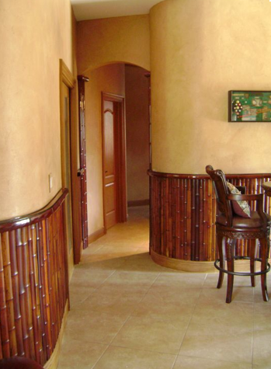

Floor Plan Level 1
Turn off lineweights…..View….Thin Lines
Detail level: Medium
Scale: 1/4”=1’ (this will allow us to see the components of the wall more clearly)
Pick wall between Bed 1 and Bed 2
Properties
Edit Type
Duplicate (explain why)

Note: Companies generally have a wall naming convention. Refer to your manual when creating new walls

For the demo, we will call the wall “SHS 1/2rdw 5/8gyp3.5core5/8gyp1/2rdw”
OK
Structure: Edit
Click on the preview button

Note the materials on the wall and the core boundary. The structural layer is typically within the core boundary…the 3.5” stud in this case. Gyp board, finish materials, air layers, etc would be placed outside the core boundary.

You will build the (system) family with material included.

We will do a custom wall as follows:
Fin 5 Redwood ½”
Fin 4 Gypsum Wall Board 5/8”
Core Boundary
Structure 1 Timber C16 3.5” ( real 2X4 @ 16” OC)
Core Boundary
Fin 4 Gypsum Wall Board 5/8”
Fin 5 Redwood ½”
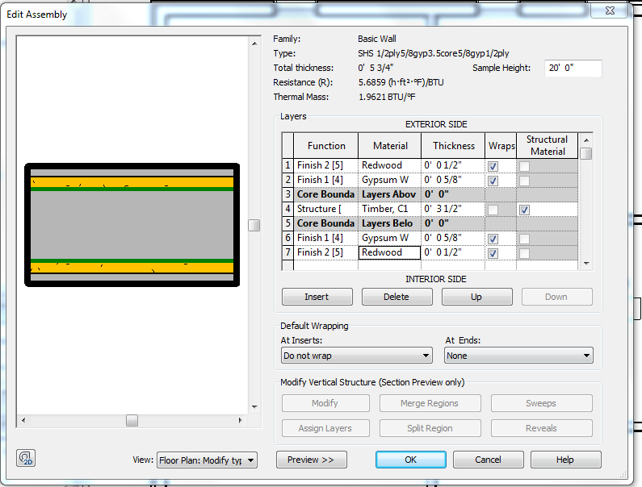
Note: You will need to add C16 Lumber and Redwood to the library)
OK….OK

See the wall update with the new components??

Notice how the wall is joining. That is the “function” at work. Finish 4 wraps with Finish 4. Cores are first in the wrapping hierarchy….cores MUST wrap with cores!

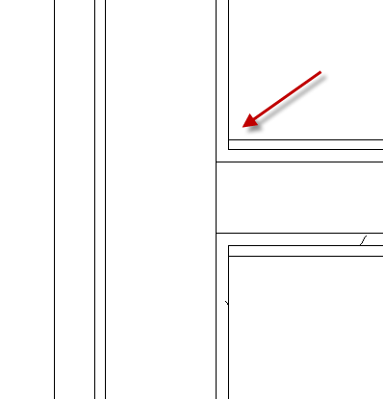

You learned there are 2 strategies for applying materials to objects. You learned to use the paint bucket for thin materials and add components to walls to accurately represent thicker materials. You learned to control surfaces with multiple materials utilizing “Split Faces”. All materials can be “SMART” and be tagged easily with custom or standard Material tags.

Save as Revit2018demo23.rvt

View Templates

Once you have a view’s graphic settings perfect, you may want to apply those SAME settings to other views.

For example: On an electrical plan, dimensions, window tags, door tags, furniture, and elevation marks are turned off. The scale may be set to ¼” = 1’0”. The display level is Medium. You can save those settings! The tool is a “View Template”

You should have several floors

Floor Level 1
Duplicate…Duplicate with Detailing
Rename it Level 1 Electrical
VH the door and window tags, elevation marks, furniture, and dimensions.
VV
Make sure all of the items above are off

Set the view scale to 3/16”=1’0”
Set the detail level to Medium
Visual Style: Hidden Line
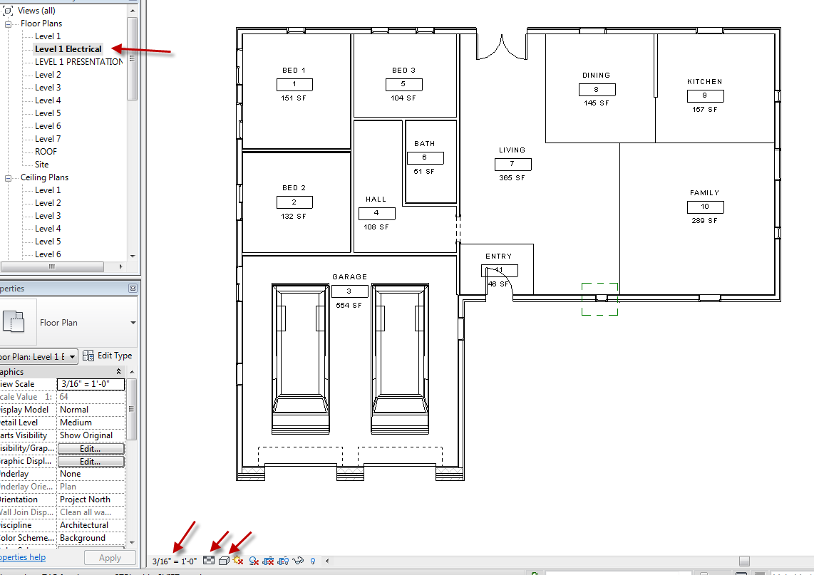

View (from pull down)
View Templates
Create Template from Current View
Name it: Electrical
OK
V/G Overrides Model: Edit
See doors furniture off?
V/G Overrides: Annotation
Note the Scale and Display Level
See dimensions, door tags, window tags, elevations turned off?
If they are not….turn them off here!
So you set how you want the view to show in the View Templates box
OK

Floor 2
Notice sections, elevations, material tags are visible…
View
View Templates
Apply Template Properties to Current View
Select Electrical
Apply
OK
Notice annotations are gone and anything else the template turned off….

Floor 3
View Templates
Apply Template to Current View
Notice Architectural Plan is default (FYI)
Select Electrical
Change View template back to Default View template

Floor 2
View
View Templates
Apply Template Properties to Current View
Select Architectural Plan

You learned to save time and ease of getting view consistency by using View Templates to control view visibility.

Save as Revit2018demo24.rvt

Creating Custom Linestyles

Open Revitdemo12.rvt
You can create your own linestyle ala hidden, phantom, etc
There are loaded line patterns like solid, center ¼, and Dash. We will make a line pattern…which will be used in a new linestyle.
Manage
Additional settings
Line Patterns
There are actually quite a few out of the box!
We will make a property line with a longer line in the “line-dash-dash” pattern.
Pick “Double dash 5/8”
See Line pattern Properties box?
Notice there is a space between each element AND one space at the end.
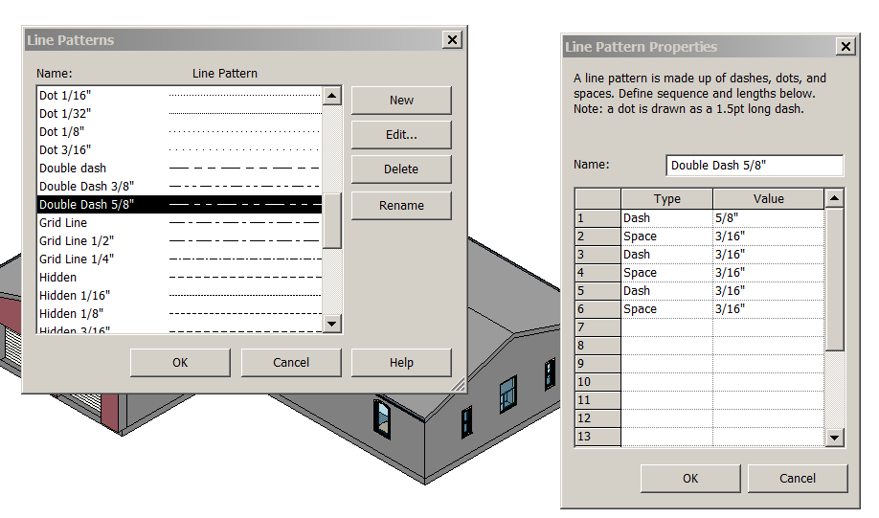

New
Name it Double Dash 1”
Dash 1”
Space 3/16”
Dash 1/8”
Space 3/16”
Dash 1/8”
Space 3/16”
OK…OK
Applying a Line Pattern to a new Linestyle
Manage
Additional Settings
Linestyles
New
Name it”1” by 7 weight prop line”
OK
Change Lineweight Projection to 7
Change Line Pattern to Double Dash 1”
OK
You now have a CUSTOM linestyle!
Turn off the topography
Modify
Linework
Linestyle: 1” by 7 weight prop line
Pick the property Lines
D O N E !

Filters

Filters are a really cool way to isolate what you want in a “busy” drawing.

Presentation Plan Level 1
Window in the entire drawing
Hit the filter icon (at top, right of screen)
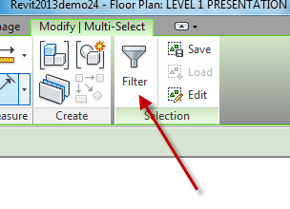
Note: it shows you how many of each Category you have!!
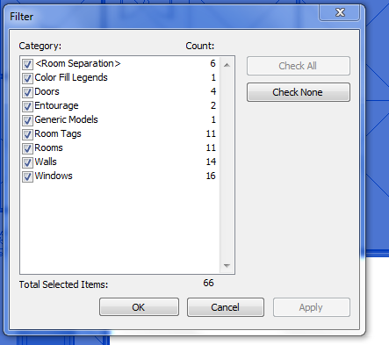
Check None
Check room tags
OK
Notice ONLY the room tags are selected!
Properties
Edit Types
Uncheck Room Number
OK
They ALL update!
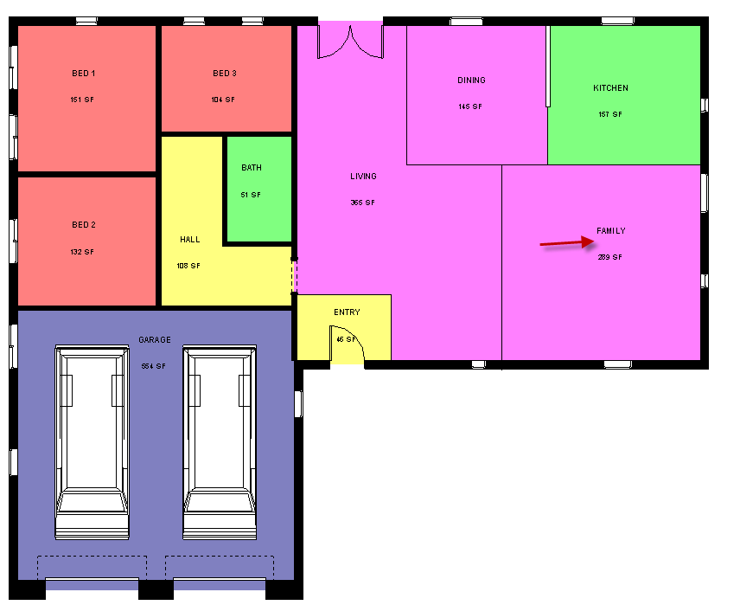
We will fix that gap in the family later….

Note: If you select a bunch of objects and DO NOT see the filter icon…..consider the fact that all of the objects are the same….

You have learned to control the display of your annotation using Custom Linetypes and View Templates, and select objects more efficiently using a Filter.

Save as revit2018demo25.rvt

Electrical Plan

Open Revit2018demo25.rvt
Level 1 Electrical
Architecture
Component
Place a Component
Load Family
Electrical
Architectural
Electric Power
Terminals
Choose:
Outlet Duplex
Outlet GFI
Switch Single
Switch 3-way
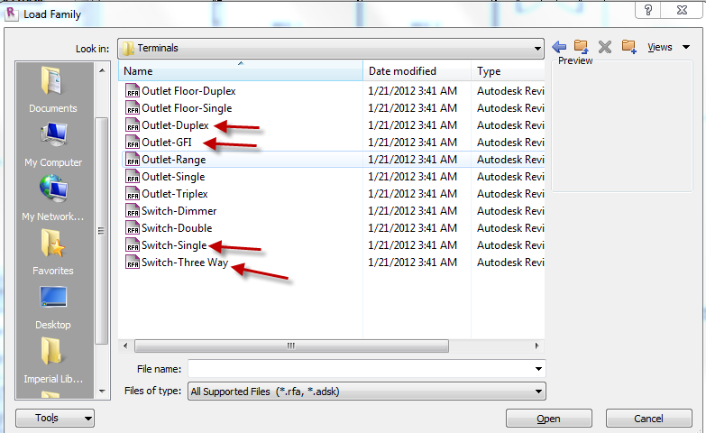
Open

Load Family
Lighting
Architectural
Internal

Choose:
Ceiling Light Flat Round
Downlight Recessed Can
Troffer Light 2X4 Parabolic

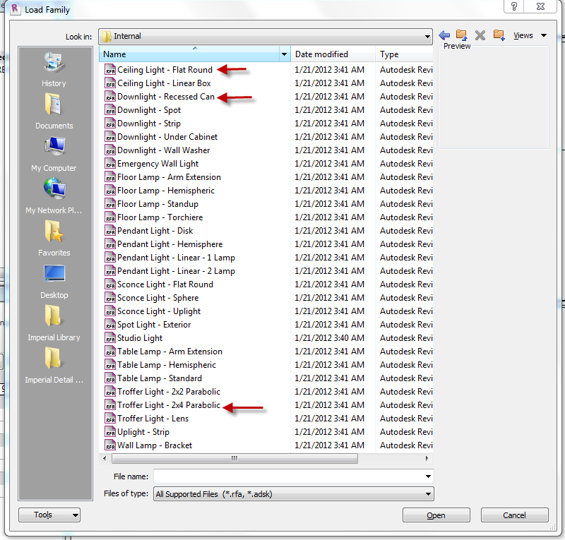

Open

Set Electrical Level 1 scale to ¼”=1’0”
Ceiling Plan Level 1
See 2X4 Ceiling and GWB Ceiling?
Set Scale to ¼”=1’0”

Let’s start by deleting the 2X4 Ceiling to the right…we have changed the building since we did that….
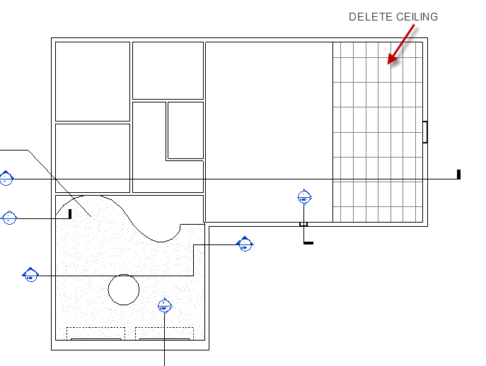

Ceiling Level 1
Pick Ceiling…delete key

Let’s put a 2X4 ceiling over the Kitchen. You may notice we can’t see the Kitchen from the ceiling view because the pony wall (short wall) and the room separation lines are not showing in the ceiling view. What to do???

Underlay

Properties
Underlay: Level 1
Underlay Orientation: Plan
See everything now?
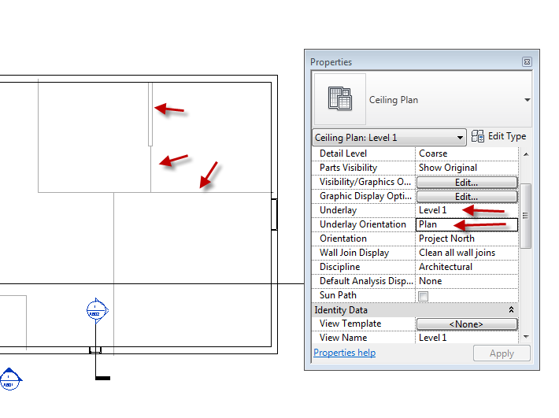

Create the 2X4 Ceiling
Architecture
Ceiling
2X4 Act
Use “Sketch Ceiling”
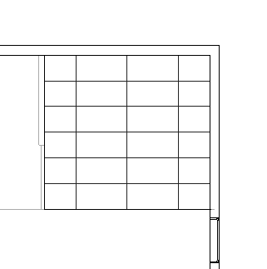
Component
Place a Component
Properties
Troffer Light 2X4 120V
Place 2 lights
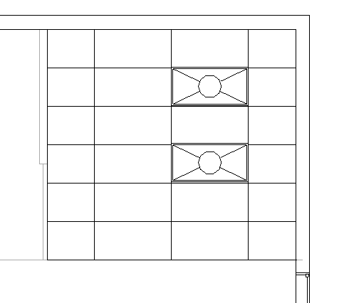

Floor Plan Level 1
Do you see the light?
No!

Place a switch:
Architecture
Component
Place a Component
Switch Single
Place two switches at the Kitchen wall

Ceiling Plan Level 1
Place GWB Ceilings in the 3 Bedrooms
Note the sand texture we created earlier…
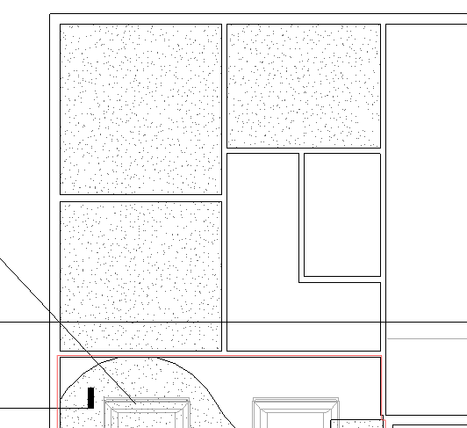

Place 4 Can Lights in each Bedroom (yea..I know it’s overkill…)
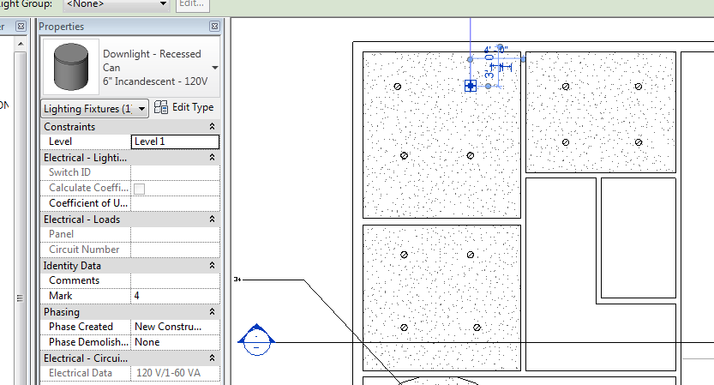

So now the problem….how do we show the switch connecting to the light? Hmmmmm!
Step 1:
In Electrical Plan Level 1
Properties
Underlay: Level 1
Underlay Orientation: Reflected Ceiling
See the ceiling now? It’s grey.
Add the bedroom doors with proper swing
Place the switches in the 3 Bedrooms

Draw swing lines from switch to light:
Annotate
Detail Line
<Hidden>
Start End Radius Arc
Connect the lights
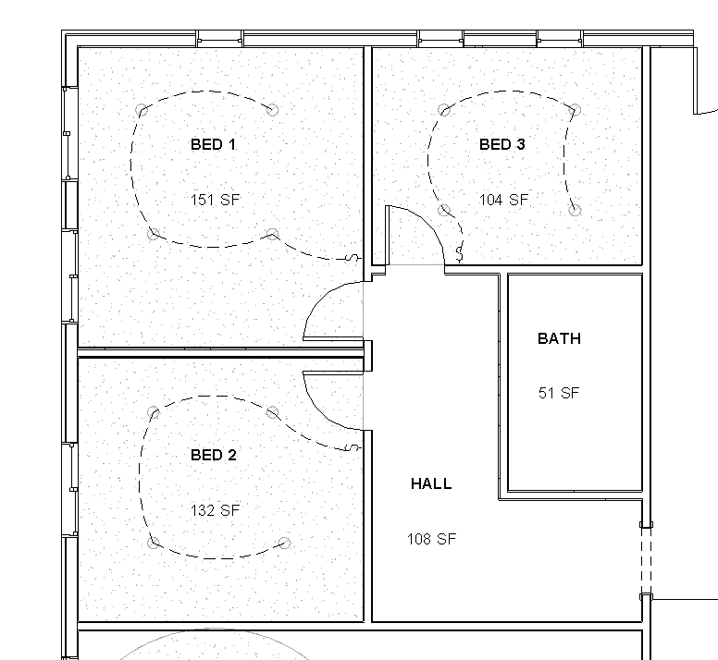
Great…..but you don’t want to see the ceiling or the lights as grey in the Electrical Plan!

Turn off underlay
Properties
Underlay: None

So now you have the switches and swing lines, but no lights…..

Select Ceiling Plan Level 1
RC….Duplicate….Duplicate w/ Detailing
Rename “Copy of Level 1” to “Trick Ceiling Level 1”
OK
VH everything but the lights. Use the filter!
See JUST the lights?

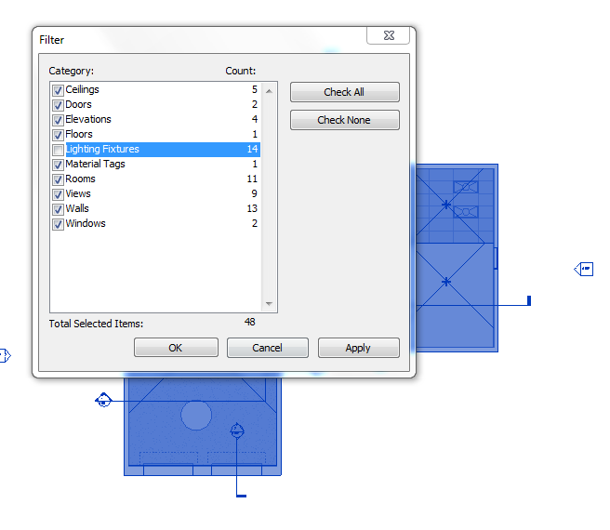

Create a new D- Sized sheet
Name it A202 Electrical Plan Level 1
Drag “Electrical Level 1” onto the sheet
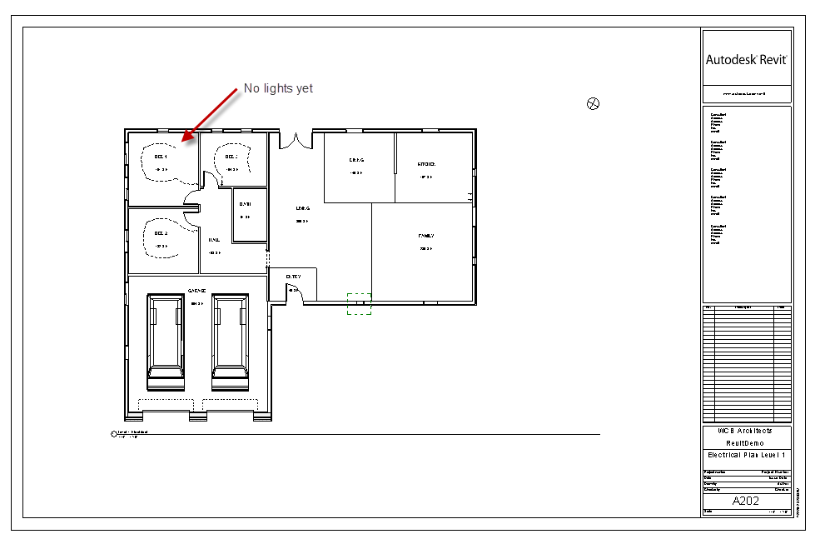
Now the cool part….

Drag Trick Ceiling Level 1on the same sheet, taking care to line up the green, dashed lines.
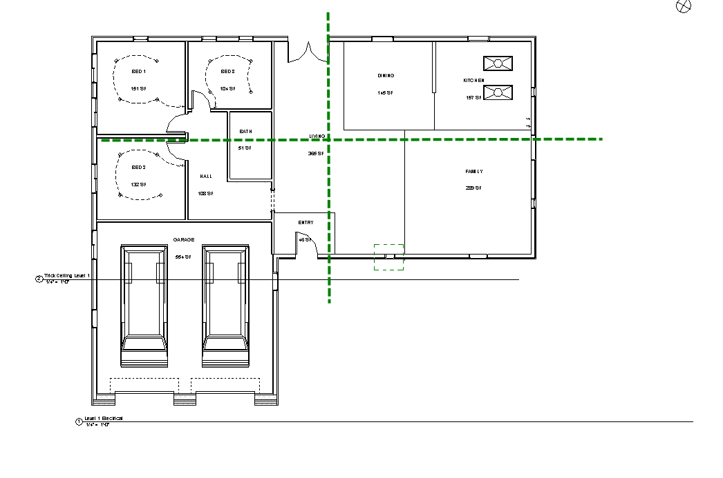

NOTE: This trick only works if the Ceiling Plan and Floor Plan are at the same scale.

Cool!

You will have 2 title bars
We want to keep Level 1 Electrical

Pick on Trick Ceiling Title bar
Viewport 1
Edit Type
Duplicate
Name it: SHS Viewport No Title
OK
Show Title: No
OK

So now you see the ceiling lights and the floor plan electrical stuff at the same time.

Continue adding electrical components and lights. You will need to (temporarily) turn the underlay on to see where you are going with the swings.

Save as: Revit2018demo26.rvt

Electrical Legend

Legends provide a way to display a list of the various building components and annotations used in a project. The two most common types of legends are annotation legends and building component legends. In this tutorial, we will create an Electrical Component Legend.

We have a few Electrical fixtures loaded from the last exercise….

View
Legends
Legend
Name it: “Electrical Legend”
Scale: ¼” = 1’0”
OK
You have a blank sheet (Legends are not Revit-like…..maybe someday…)

Annotate
Component
Legend Component
Up to top of screen in Option Bar
Family
Electrical Fixtures …Pick the outlet GFI Single…bring down to screen
(The host length is the wall holding the object….3’0” is OK)
Bring in several…use green lines to align

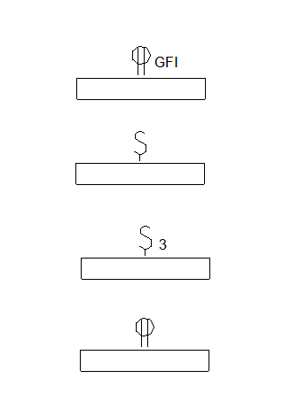

Text
3/32” Arial
Create text descriptions to the right of the symbols
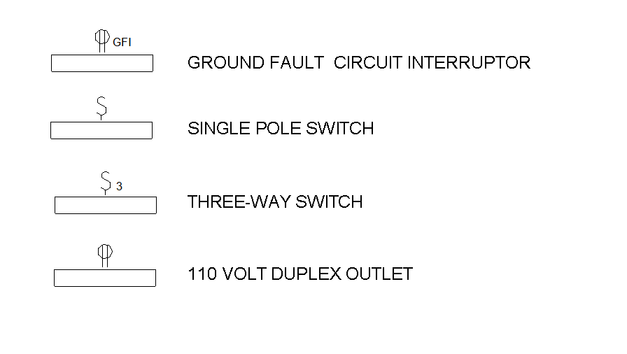

Drag the Electrical Legend on to the Electrical Plan
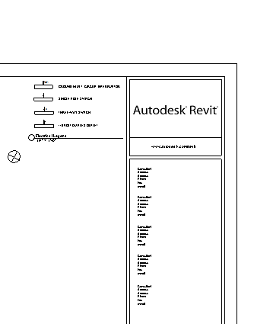

You can use the legend in other drawings. Copy to clipboard. Paste into another legend. You can also create a legend and add it to your company template.

Wall Type Legend

View
Legends
Legend
Name it Wall Type Legend
Set the Scale to 1”=1’0”
OK
Set Detail Level to Medium
Annotate
Component
Legend Component
Up to top of screen…Family
Pick one of the walls YOU created …bring down to screen

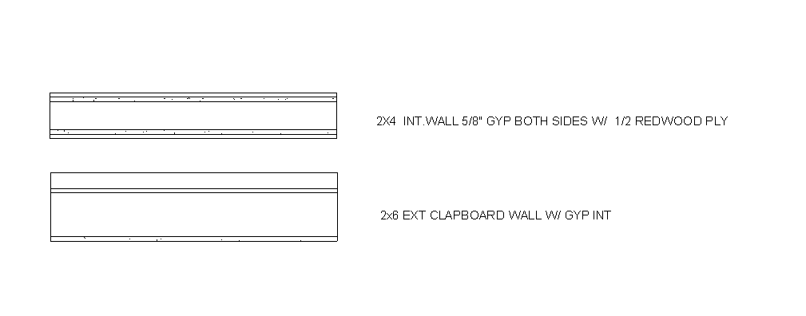Drag onto a Floor Plan sheet…

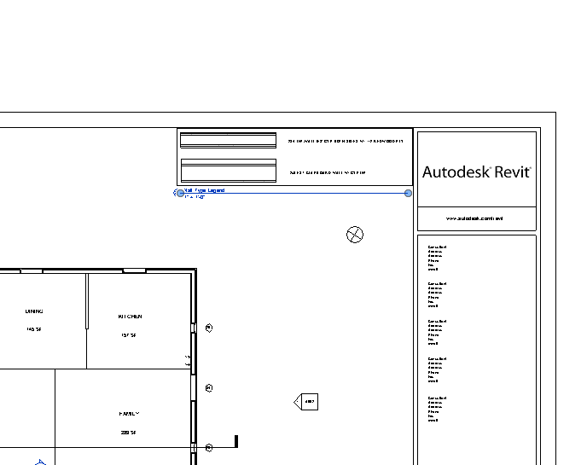
Save as: Revit2018demo27.rvt

Creating a Gypsum Board Ceiling

We will use the GYP Board (also called “dry wall”) Ceiling to hide the 2nd floor (subfloor), to attached ceiling-based elements like lights, ceiling fans, air conditioning diffusers, and smoke detectors. We will also use the gyp ceiling on the 2nd floor. It would be attached to the bottom of the roof joists.
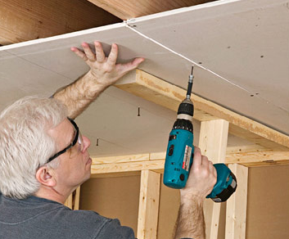
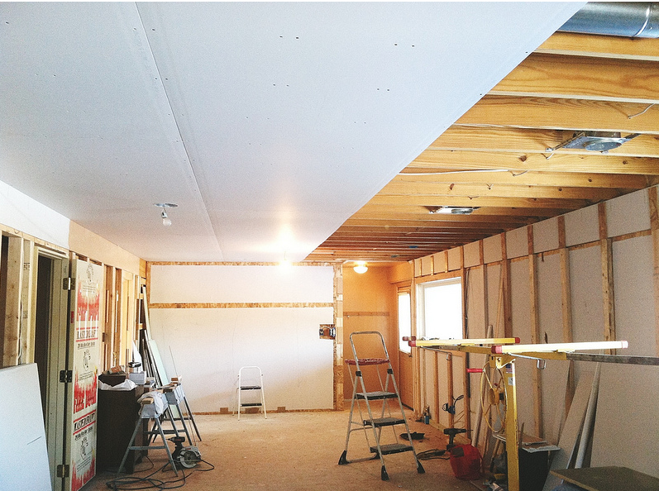

We will make a 5/8” drywall:
Architecture
Ceiling
Compound Ceiling: GWB on Mtl Stud
Edit Type
Duplicate
Name it: SHS 5/8” GYP
OK
Structure: Edit
Delete Layer 4
Change Layer 2 to 5/8” thick and apply SHS gyp material
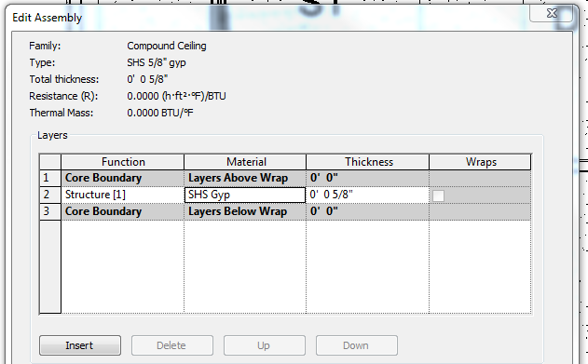
The SHS Gyp should be Flat White Paint and have a surface pattern of “sand”.
OK OK
Let’s add a ceiling to the Den
Ceiling plan Level 1
Use Sketch Option
Note Height Offset from Level is set at 8’0”. It’s wrong, but we will use it for now.
Make the rectangle
Green Check to finish. See the pattern?
Now cut a section through the room to see where the ceiling is relative to the floor above.
Set Display level to Medium
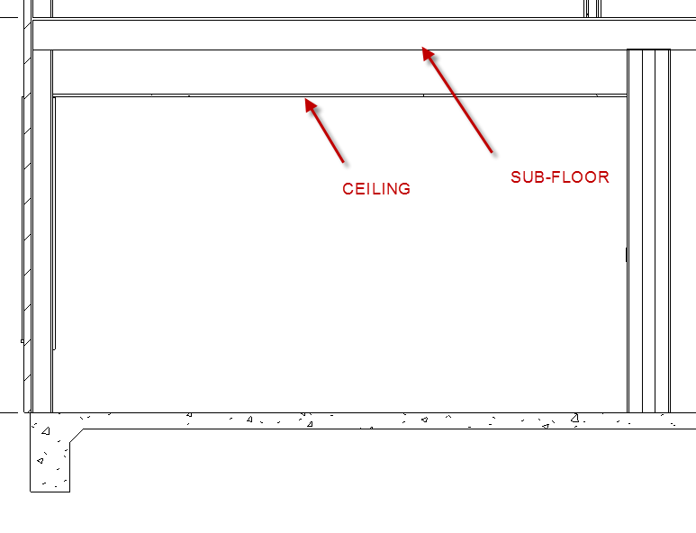

See how there is space between the ceiling and the subfloor? This is called a “dropped ceiling”. We are not going to drop this ceiling, so we will align the top of the ceiling with the bottom of the sub-floor.
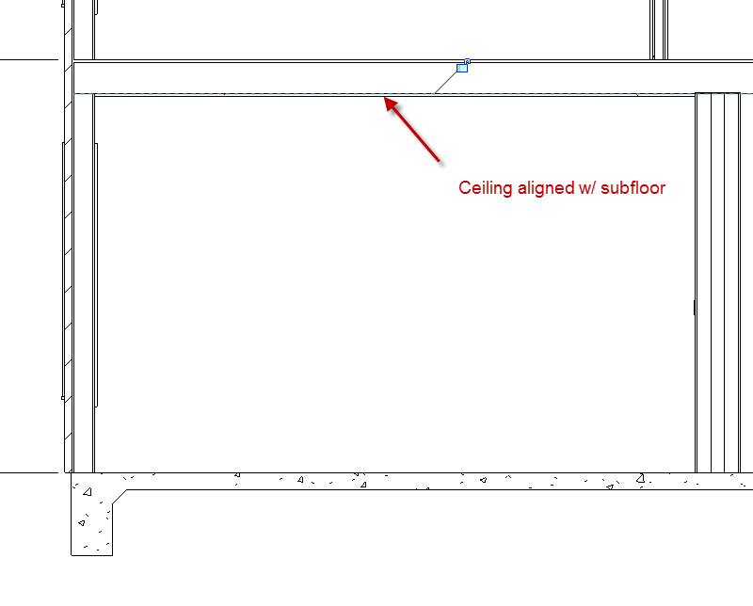

Now for Rooms on the 2nd Floor:

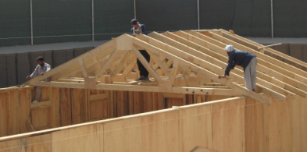
The Truss was not modeled in Revit (the engineers generally do the Truss calculations….. but we would attach our ceiling to the bottom of the truss, which is at the Roof Level Line.
Let’s do Bed 3 on the 2nd Floor.
Cut the section Vertically to get the best view
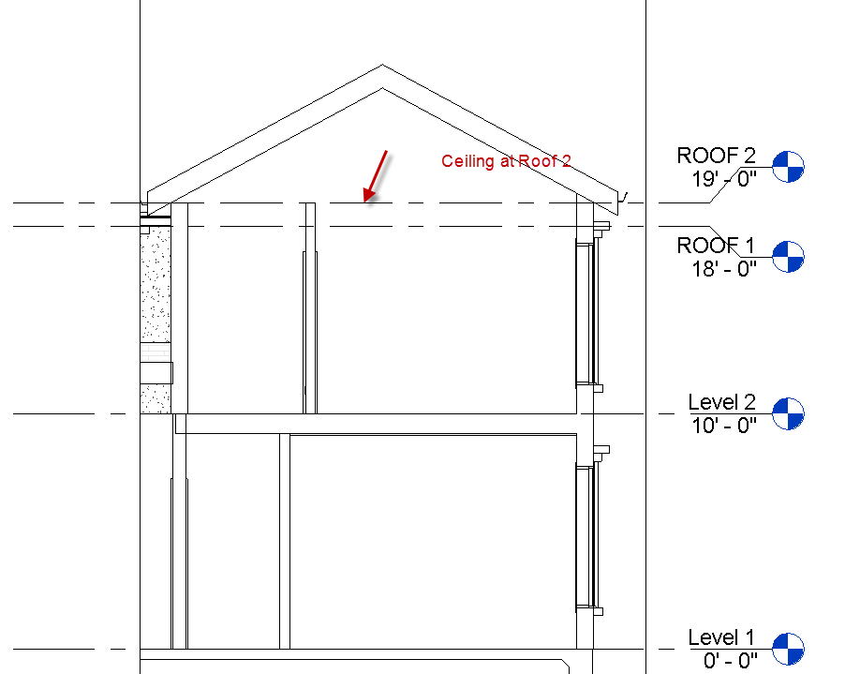
Back to Ceiling plan Level 2
Let’s add a ceiling to the Bed 3
Ceiling plan Level 2
Architecture
Ceiling
Compound ceiling: SHS 5/8” GYP
Use Sketch Option
Note Height Offset from Level is set at 8’0”. Again, it’s wrong, but we will use it for now.
Make the rectangle
Green Check to finish. See the pattern?
Now go to the vertical section.
Set Display level to Medium
It is too low…align the top of the ceiling with the level line.
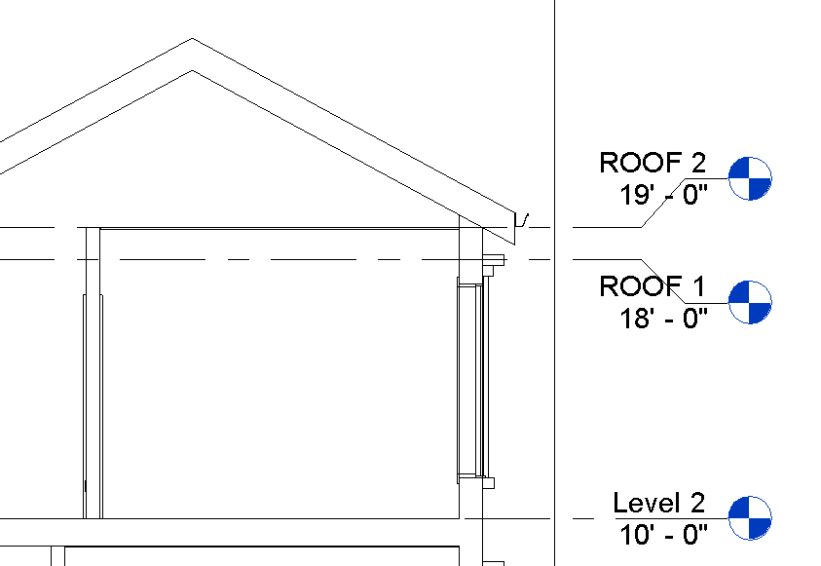
Note: Ceilings can be “dropped” when we want to bring the ceiling lights closer to us or create less volume in the space. Bathrooms, Kitchens and closets use dropped ceilings a lot.

Wall Sweeps

Open Revit2018demo3 (we just need a few walls for this one)
South Elevation
Wall
Wall Sweep
Pick wall
LC to place
See it in 3D
It’s a rectangular extrusion coming out of the wall
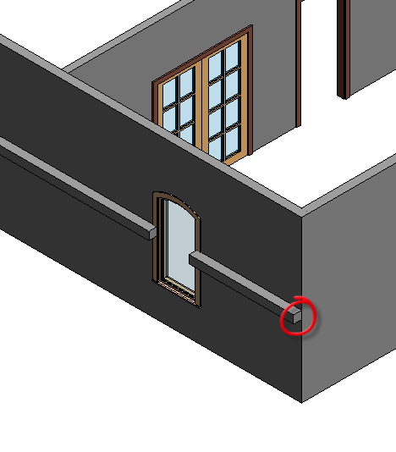

South Elevation
Wall
Wall Reveal
Pick wall a bit higher
See it in 3D
Get it?
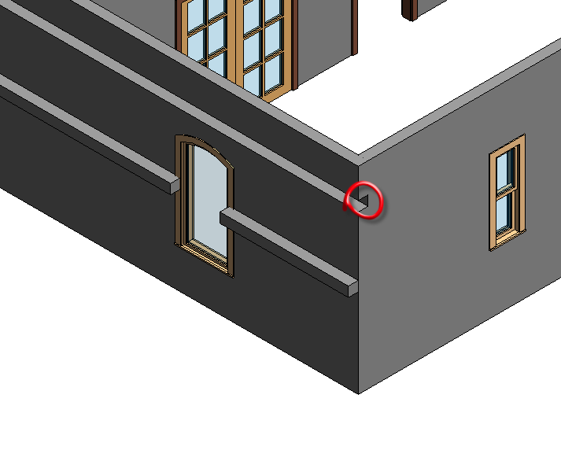

Select the wall sweep
Properties
Edit Type
See Cornice (default)?
See Profile: Default ?
The default profile is a rectangle
See Material: Default (look familiar?)
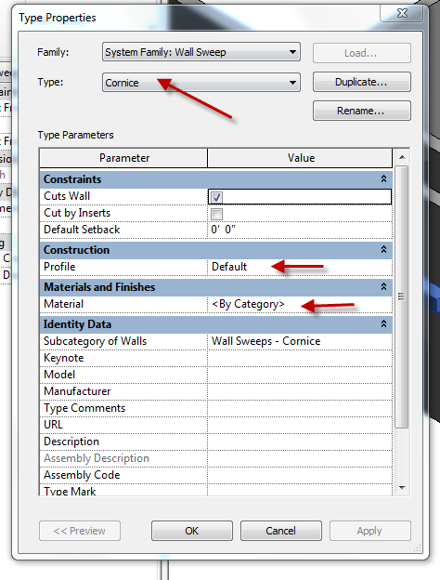
Cancel to get out of Element Properties
Delete the sweeps
See the walls clean up.

Wall Sweeps: Base and Crown Molding

You should have made both the finish flooring and ceiling for the room.
Base Molding is a transition piece between the floor and wall.
Crown Molding is a transition piece between the ceiling and wall.
You must load the profile family of the shape you want for the molding first….
Insert
Load family
Profiles
Finish Carpentry
Let’s load Base 1 and Crown 4
Create an Interior Elevation to view the walls of the Den
View
Elevation
Elevation
Interior Elevation
Place it.
Check all 4 blue boxes
Should look like this:
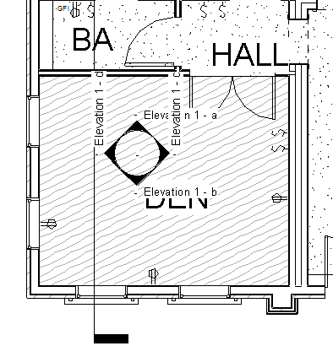
Go to each elevation and drag crop box up to see ceiling and adjacent walls.

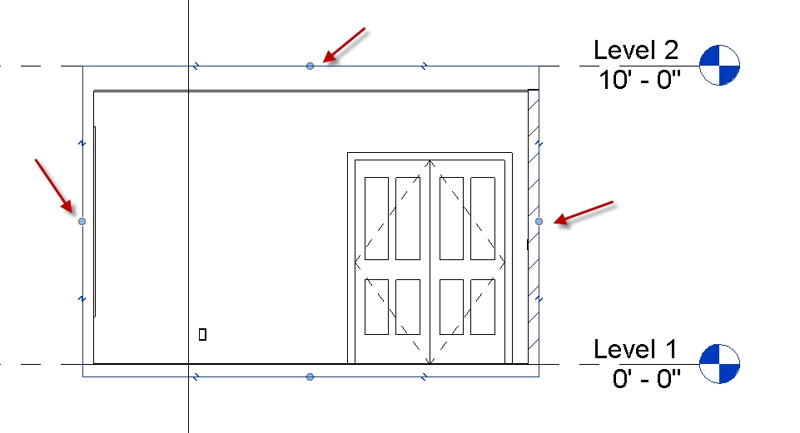
Architecture
Wall
Wall Sweep
Cornice is the default…we need a base molding:
Edit Type
Duplicate
Name it SHS Base 1 White
Profile: Choose the 4-1/2” Base 1
Material: SHS Semi Gloss White (you may have to make this on the fly…)
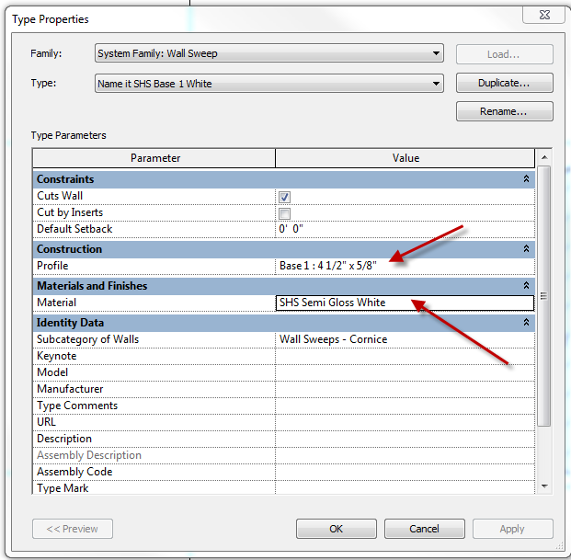

OK
Attach to wall.
Align the bottom of the base molding with the top of the finish floor
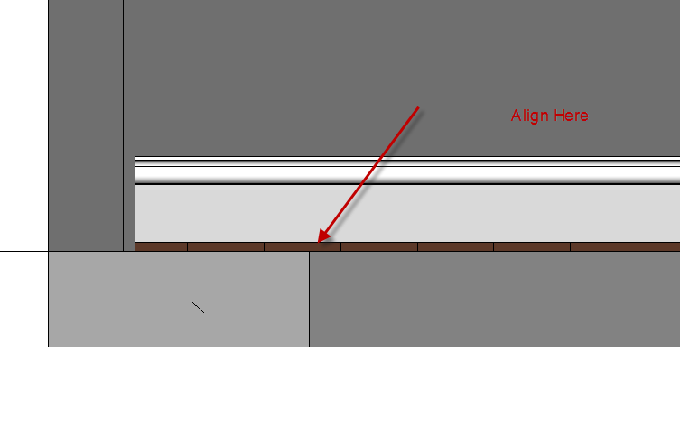
Continue on the other walls in the room. Note you must be in a section or elevation view to add wall sweeps….no plan views.
Crown Molding:
The Crown Molding will be created almost exactly the same as the base molding…..we will actually start with the base molding…
Architecture
Wall
Wall Sweep
SHS Base 1 White
Edit Type
Duplicate
Name it SHS Crown 4 White
Profile: Crown 4
Material: SHS Semi Gloss White (keep same)
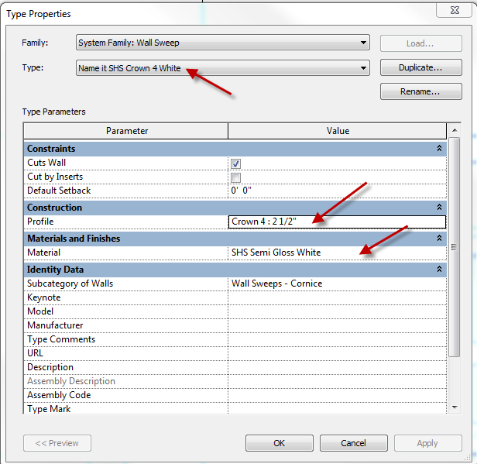

OK
Place on wall

Align top of molding with bottom of ceiling
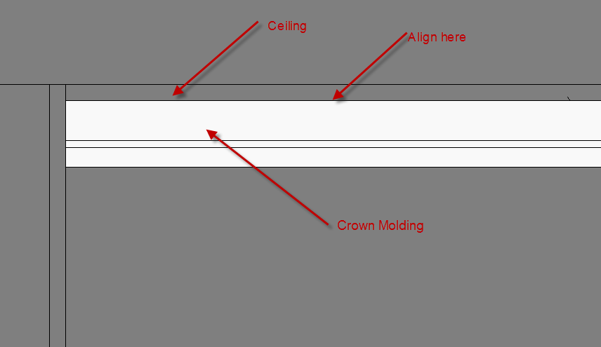
Continue process on other walls in room…..be careful to keep the sweeps aligned!
Hint: Once you have one wall sweep made, use “Create Similar” to make the others.
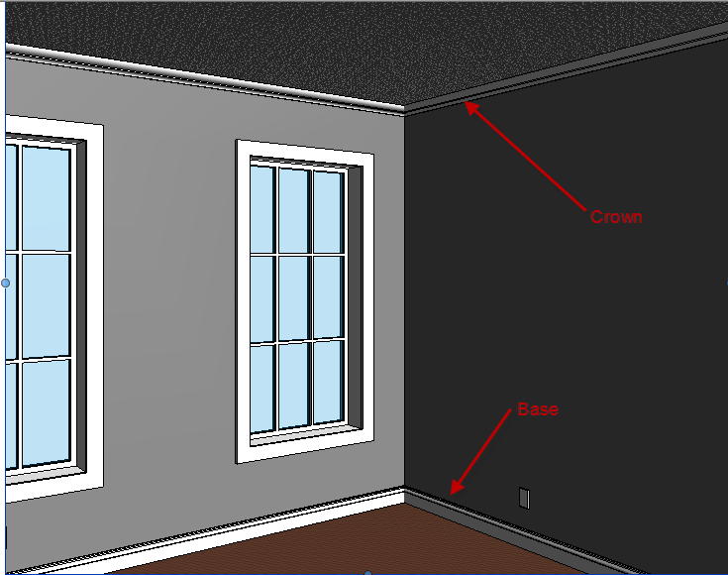
The room will look better once you apply paint and furnishings!

Creating a Profile Family

File
New
Family
Profile
Open
Picture the vertical line as a wall
Picture the horizontal line as a ceiling or floor (let’s say floor in this case)
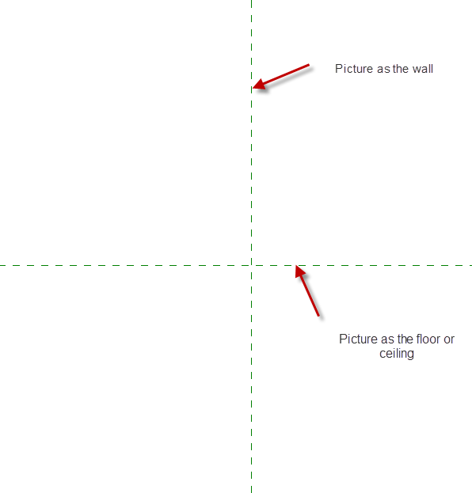
We will create a simple base molding profile:
Lines
We will work in the upper, right quadrant
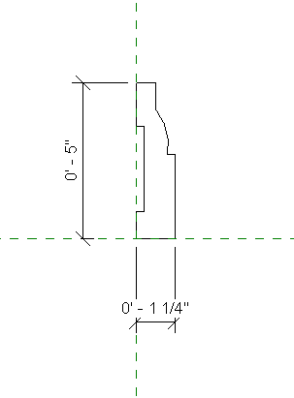
File
Save as
Family (note the .rfa file extension)
Base Molding 5 X 1-25.rfa
Load into Project

Creating the new Sweep

South Elevation
Wall
Wall Sweep
Type Properties
Duplicate
Name it: SHS Base Sweep 5
Profile: Base Molding 5 X 1-25
Material:
Make an off white color: You will need to load: Misc Paint Set the color
Ok…OK
Place the sweep on the right wall
See in 3D
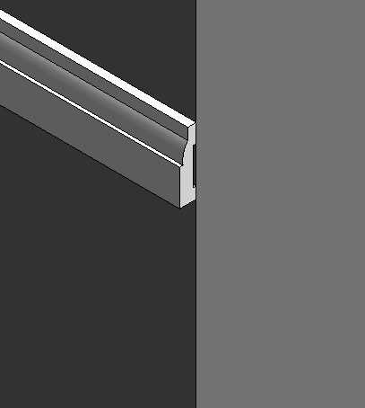
Turn lineweights off to see better
RC
Change Orientation (flip)
Do side wall (East Elev) too
Show align tool to join
3D to see
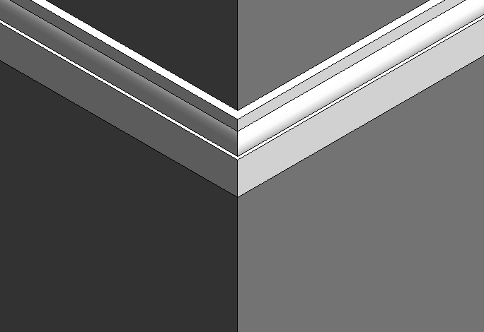

Reveals

Now let’s create a Reveal:
First let’s make a simple profile shape we can use as a reveal
File
New
Family
Profile-Reveal
Open
Note the subtle wall inference
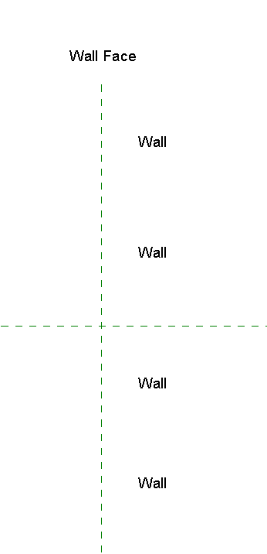
The reveal needs to go into the wall
Make a simple cove shape (closed) starting from the wall face.
Save as “Simple Cove Shape”
Load into project
South Elevation
Architecture
Wall
Wall Reveal
Type Properties
Duplicate
Simple Cove
OK
Note no material….
Set profile to “Simple Reveal”
OK
Place on wall
See in 3D
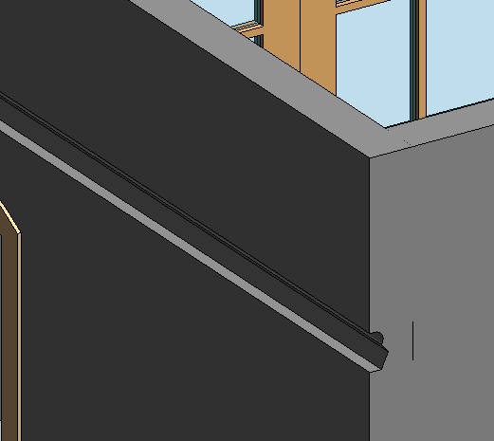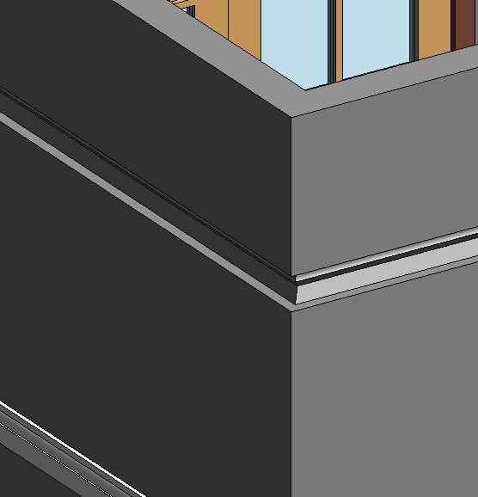

Place reveal on East wall
Try to match
See in 3D
Show: Modify…..Geometry…..Edit Wall Joins
Show grips to edit sweeps around doors and windows
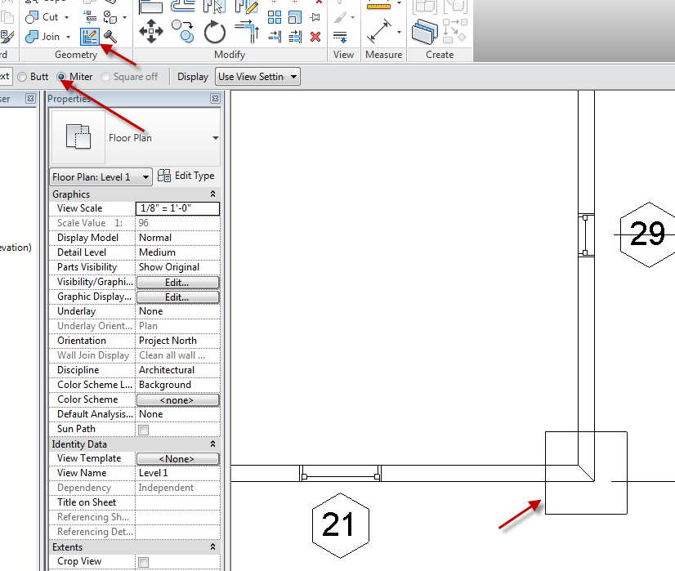

Creating a “Smart” Furniture Family

Families can be created or found that work in one instance but sometimes need to be modified. What if we only had one size of window, and had to create a new window each time we wanted a different size? We would be AutoCAD! Revit allows you to create modifiable families, so you have the ability to change certain selected properties (like width, length, thickness, radius, etc) to meet your needs. We will create a simple table. We will be able to adjust its length, width, height, top thickness, and base thickness. The strategy of family creation will be emphasized.

File….New…..Family….Furniture.rft (.rft are family templates)
Open
Show reference planes
Cen FB
Cen LR
Ref level

Floor ref level
Make 4 ref planes parallel to axis
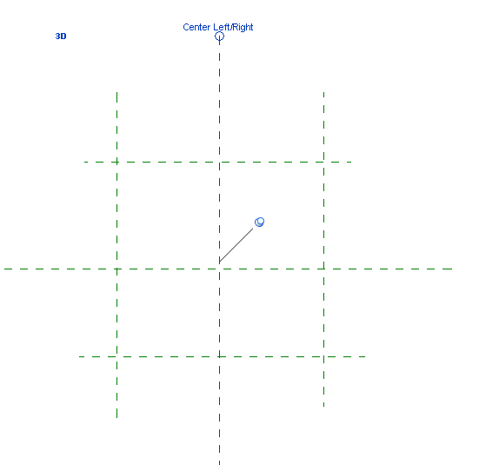
Dim EQ to center planes
Dim overall width (do not worry about size)
Dim overall length (do not worry about size)
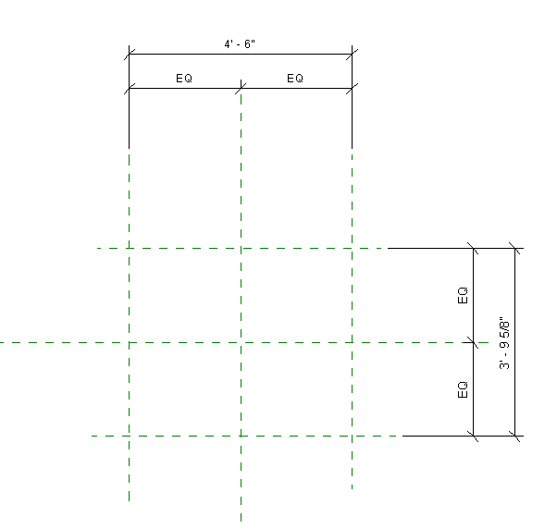

Note: We have not created any geometry yet

Front view
Reference plane
Create Top reference plane
Name it “TOP”
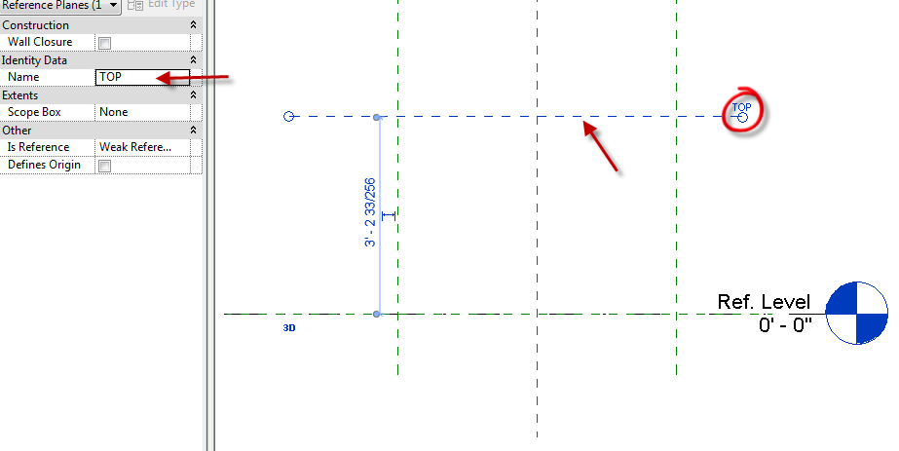
Create Bottom of Top reference plane (a little below “TOP”)
Name it “BOT”
Create a horizontal reference plane between BOT and Ref Level
Name it “TOP OF BASE”

Note: We still have not created any geometry yet

Dimension from: TOP to Ref Level ref plane (tab to get it)
Ref Level ref plane (tab to get it) to TOP OF BASE
TOP to BOT
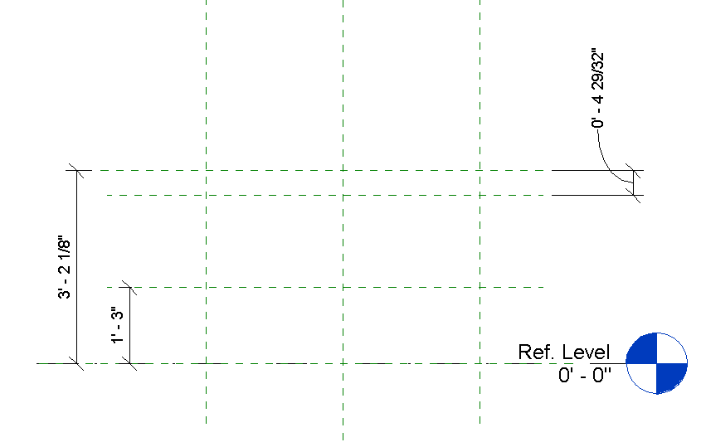
Move reference planes around. See dimensions change?
Concept: We will be moving the reference planes when we adjust the sizes of our table. The geometry of the table will be locked to the reference planes.

Family Types
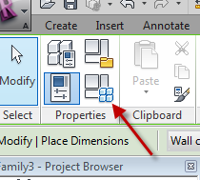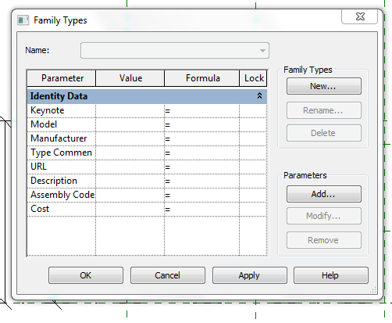
Notice there are no dimensions here (yet)
Cancel
Floor ref level
Select the overall length dimension
Label…add parameter
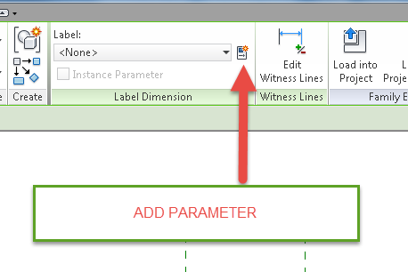
Name it “LENGTH”
Group: Dimensions
OK
Select the overall depth dimension
Label…add parameter
Name it “DEPTH”
Group: Dimensions
OK

Types
See 2 dimensions? LENGTH and DEPTH
Change Length to 6’
Change Depth to 4’
Apply
See ref planes move and dim update. Notice they moved equally from the center planes?
Change Length to 5’
Change Depth to 6’
Apply
This is called “FLEXING”
Cancel

Front view
Select Height dimension
Label…add parameter
Name it “HEIGHT”
Group: Dimensions
OK
Select top thickness dimension
Label…add parameter
Name it “THK”
Group: Dimensions
Select base thickness dimension
Label…add parameter
Name it “BASE HEIGHT”
Group: Dimensions
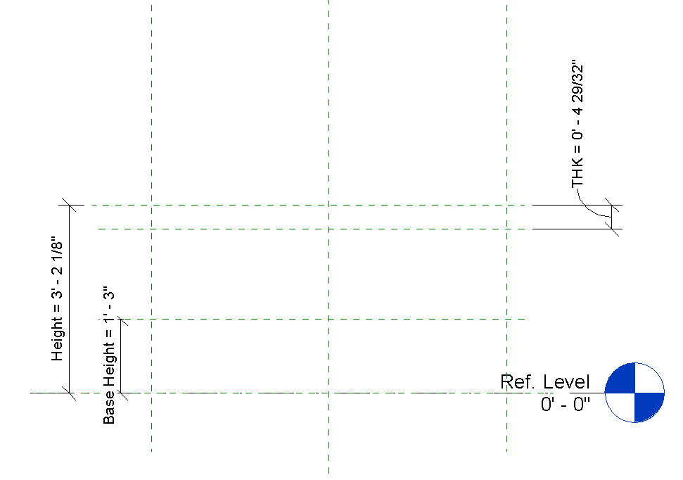
OK
Family Types
Base Height: 1’ Apply
Height: 4’ Apply
THK: 1”
See the ref planes move?

Note: We STILL have not created any geometry yet!

File
Save as:
Family
Table Ref Layout

OK…Let’s create some geometry

Floor ref level
Create
Set (you must do this first)
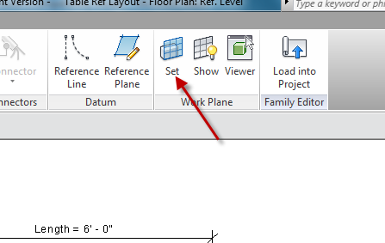

BOT OK
Forms
Extrusion
Make a rectangle inside the ref planes
Align and lock the rectangle to the 4 ref planes
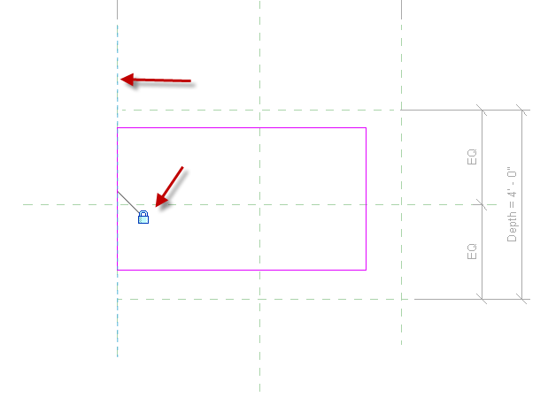

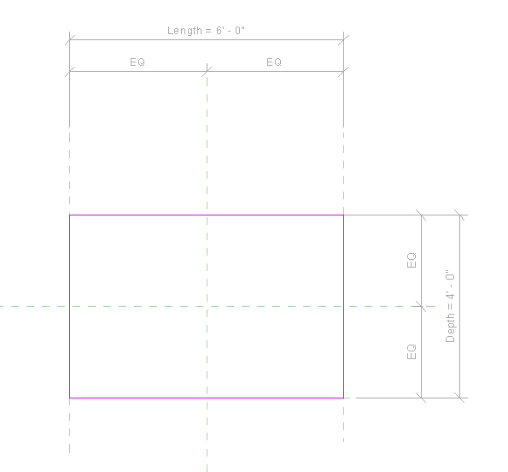
Green Check
Front view
Drag the top down with the blue arrow and lock the rectangle to the TOP ref plane.
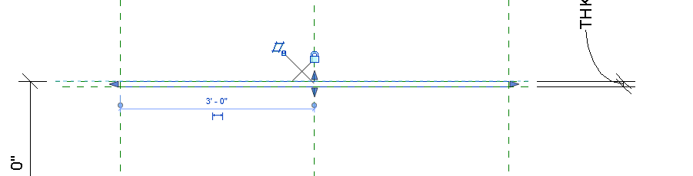

See in 3D…SD

Types
Depth to 2’
Length to 4’
THK to 2”
Apply
See the change?

Try:
Family Types
Depth to 4’
Length to 8’
THK to 3”
Apply
See the change?
This is called FLEXING the model. If your model did not change, you need to review the process you used and troubleshoot.

Select the top extrusion

Properties
Material: Glass
3D
SD
See material?

Now let’s do the trapezoidal base

Floor ref level
Make (interior) parallel ref planes about where the base might be
Dimension the same way we did the Top, with EQ’s and overall dimensions
Name overall dim as “BASE LENGTH”….dimensions
Name overall dim as “BASE DEPTH”….dimensions
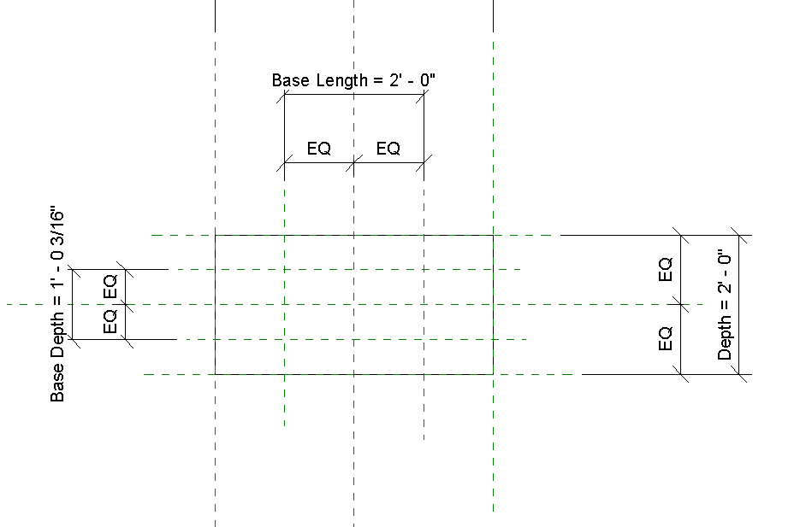

Create
Set
Level: Ref Level
OK

Create
Blend
Make rectangle
Lock sketch lines to ref planes
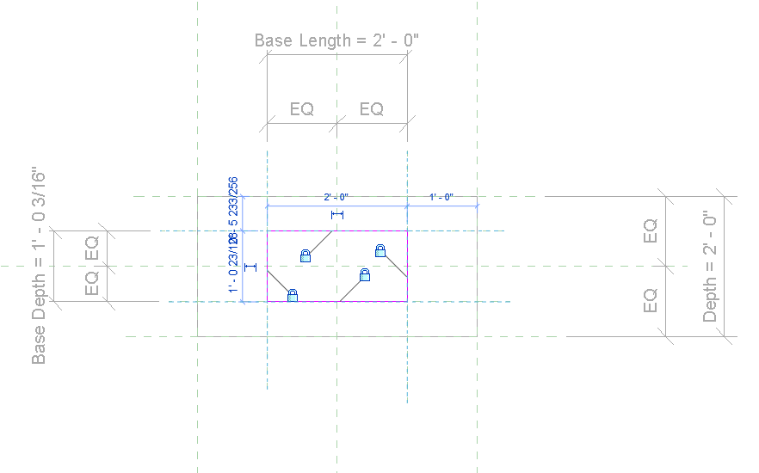
Depth: 1’ (will be adjustable)
Edit top
Offset 3”
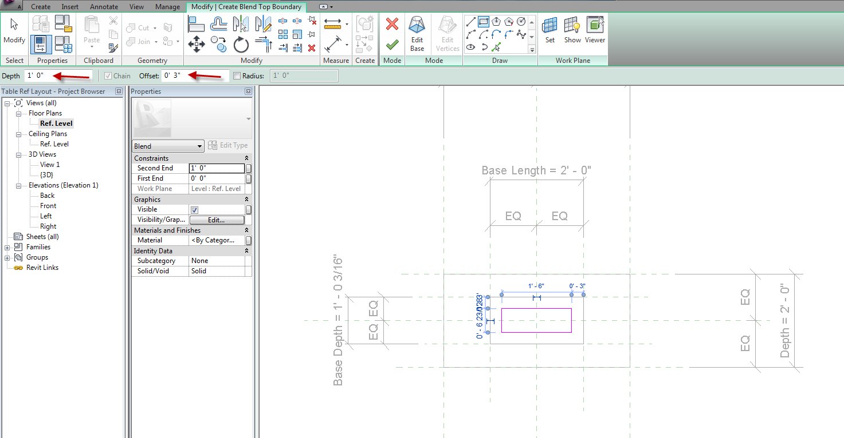

Use existing lines to create smaller box
Green Check
Front view
Align and lock top of trapezoid to TOP OF BASE ref plane
Modify
Align
Pick Ref Plane….Pick top of lend
Lock it
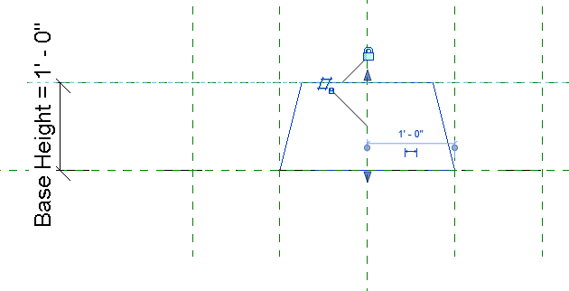

Time to FLEX!
3D
Types
Base height: 6”
Apply Did it flex?
Base Length: 3’
Base Depth: 2’
Apply Did it flex?
OK

Front view
Pick base (trapezoid)
Properties
Material (we will create our own)
Default….duplicate
Name it: COPPER
OK
Shading: pick a copper color
OK
Green Check
3D view
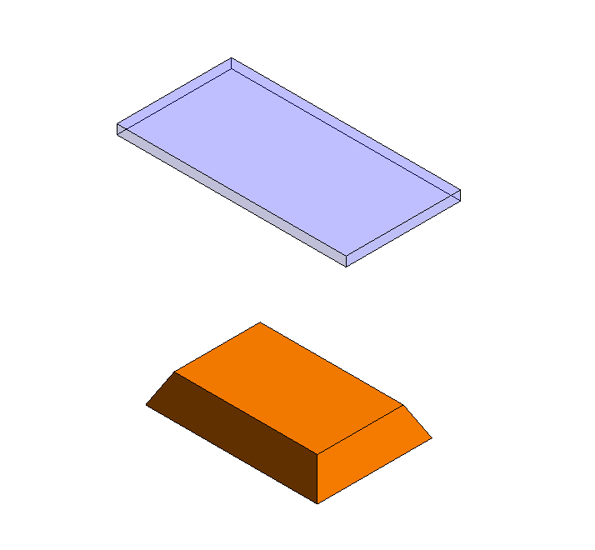

Center piece of table

The center piece will be a revolution (like a turned-spindle)
Front view
Create
Set
Center Front/Back
Forms
Revolve
Axis Line
Make along center…vertically
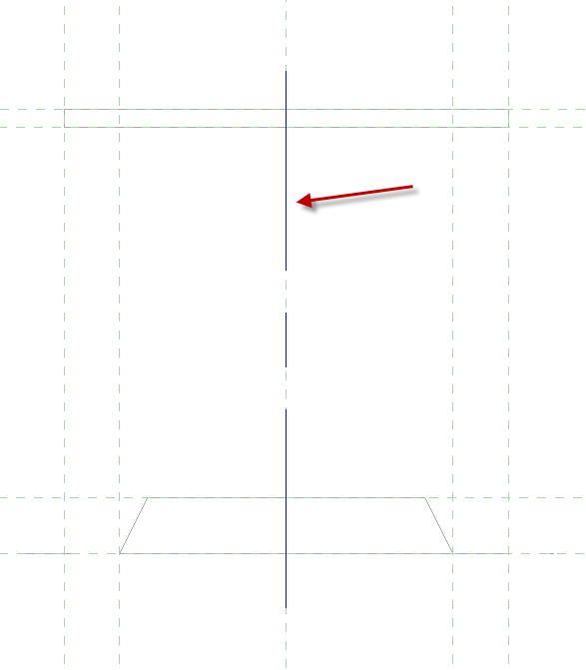
Lines
Create ½ (profile) object between BOT and TOP OF BASE planes on left side of axis
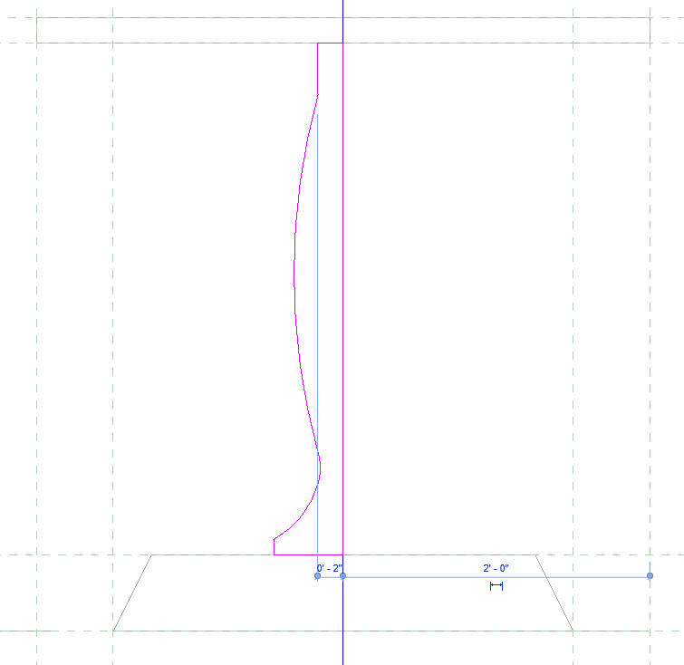
Align and lock the top line of sketch to BOT
Align and lock the bottom line of sketch to TOP OF BASE plane
Properties
Material: Red Aluminum
Double Click on Red Aluminum
Set Shading to Use Render Appearance
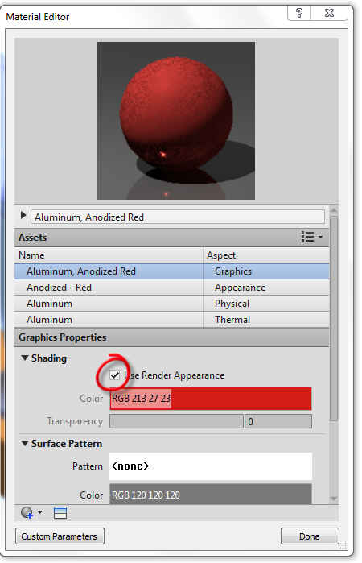
Done OK
Green Check
3D view

Flex it…all of it
If it works in the family, it will work in the project.
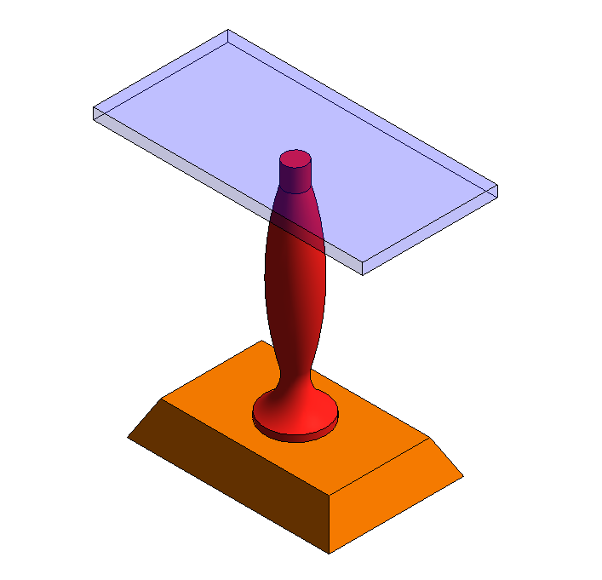

Visibility Settings
You can control what objects you see from particular Views. Example: We may not want to see the revolution from Plan View…..too busy, especially at the smaller scales.
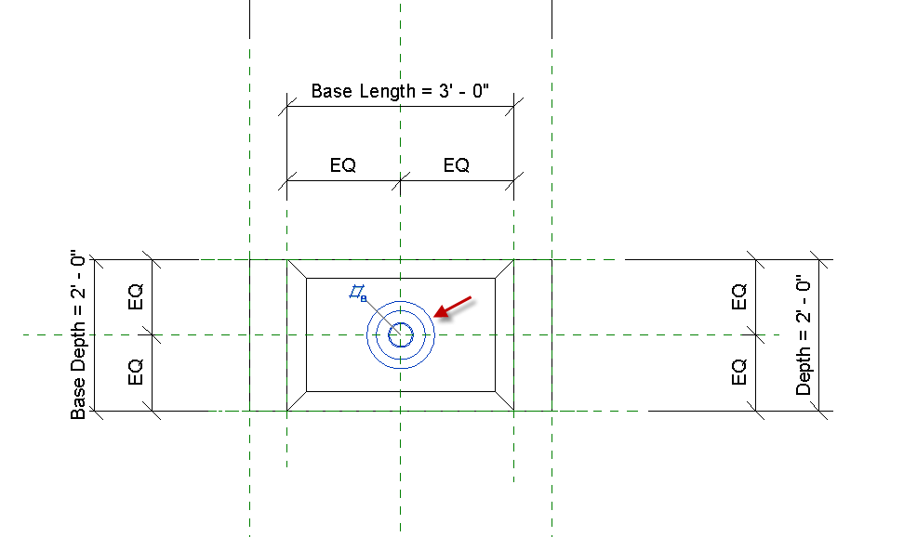
Let’s turn off the revolution from Plan View:
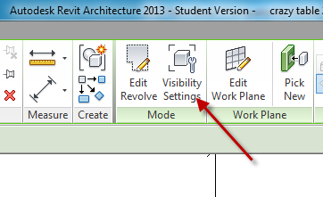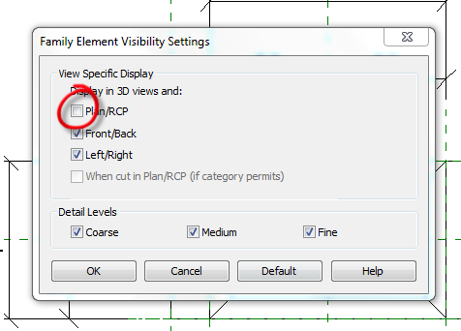
Pick the revolution
Visibility Settings
Uncheck Plan RCP OK
Discuss Detail Levels Hiding too

Save it as: CRAZY TABLE.rfa

Types

Let’s Create 3 “types” of Crazy Table: Small, Medium, Large
Family Types
New
Name it: SMALL OK
THK: 2”
Depth: 2’9”
Length: 4’0”
Base Length: Length-1 (in Formulas)
Base Depth: Depth-.5 (in Formulas)
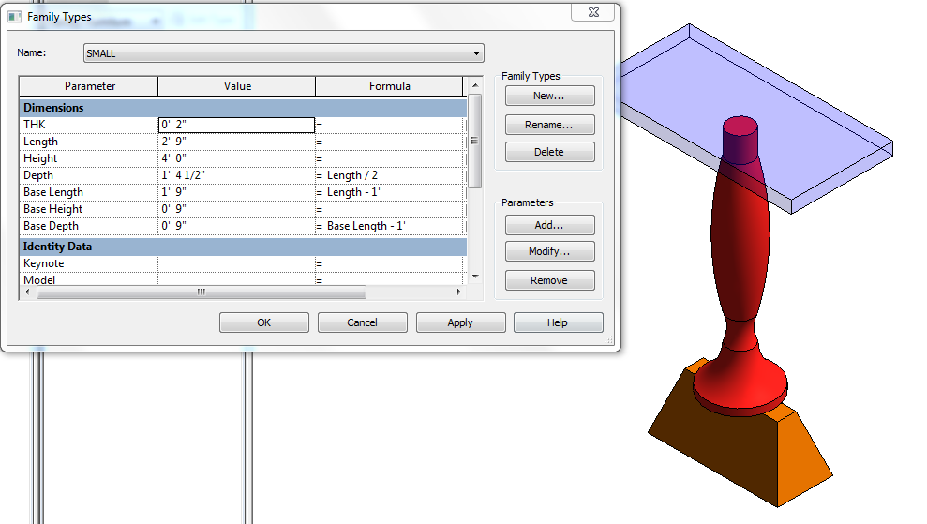

Family Types
New
Name it: MEDIUM OK
THK: 2”
Length: 5’0”
Height: 4’0”
Depth: Length/2 (in Formulas)
Base Length: Length-1 (in Formulas)
Base Height: 1’0”
Base Depth: Base Length-1 (in Formulas
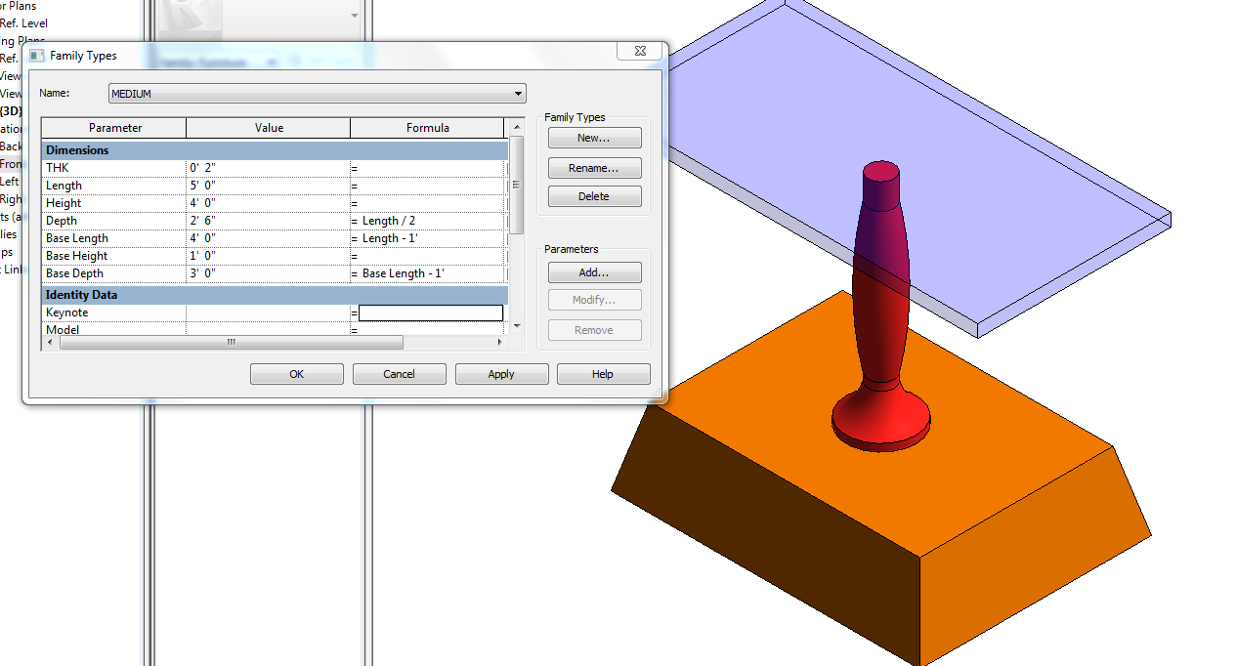

Family Types
New
Name it: LARGE OK
THK: 2”
Length: 7’0”
Height: 4’0”
Depth: Length/2 (in Formulas)
Base Length: Length-1 (in Formulas)
Base Height: 1’0”
Base Depth: Base Length-1 (in Formulas
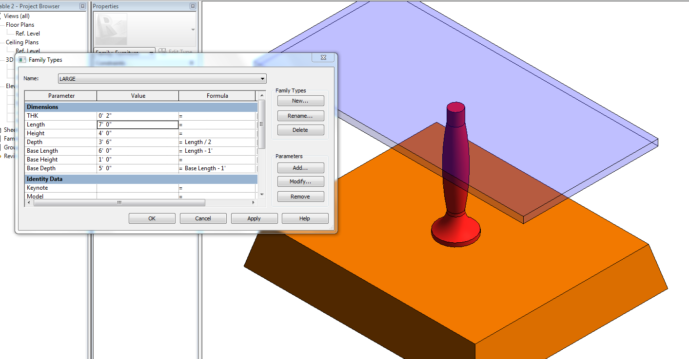

Make some Height changes…Discuss design…GIGO!
How could you adjust formulas?
How could you control sizes (revolution stretching….)

Save it as: CRAZY TABLE.rfa

Load into Project

Component
CRAZY TABLE
Load into Project
Place it…It will be a Component
Properties
Edit/new
Duplicate
This is where you can set up even more sizes for the table. Notice you have options to change sizes based on the PARAMETERS we set up. When we change the parameters, we are actually moving the reference planes….which move the objects locked to them.

You have learned to create a furniture family with modifiable parameters and materials. You learned to create extrusions, revolutions, blends, lock geometry to reference planes, and FLEX the model to check to see if your parameters work.

Material as a Parameter: Family

File….Open
Open “CRAZY TABLE”
Select table top
Edit Extrusion
Properties
Material
Pick the far, right box
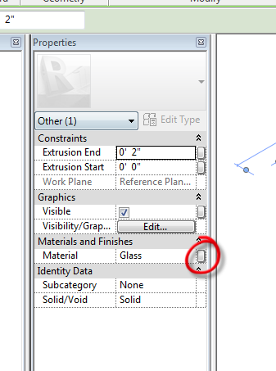
Associate Family Parameter box comes up
Add parameter
Instance (bullet)
Group/Parameter under Materials and Finishes
Name it: Table Top Material
(notice type of parameter is grayed out)
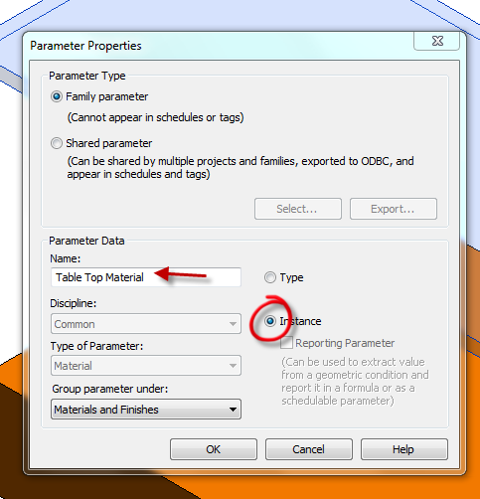
OK…OK
Save it as: Smart Table w/ material parameter
Load into project
Bring in “Component”
3D….SD
LC on object…
Properties
See Material Parameter?
You can make the top any material you want that is loaded in the project.
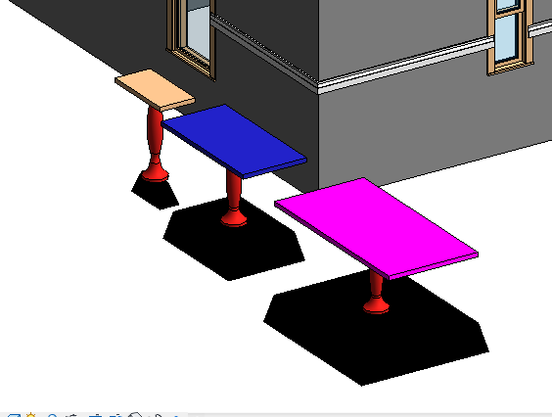

Discuss advantages of having material as a parameter when multiple materials are in a family or the material will be changed in the project often.

Families: Steps to Creating Families

- Sketch it
- Do the math
- Make the associations (formulas)
- Create the parameters
- Instance or Type
- Add the formulas
- Draw the reference geometry
- Dimension the reference geometry
- Turn the dimensions into labels
- Flex it
- Draw the masses and linework
- Align and lock the linework to the reference planes and reference lines
- Flex it

Title Block Family

File …..New…..Title Block
C 24x18 (Family Template .rft)
Open
Dimension existing lines horizontally and vertically. These lines represent the edge of the paper and will not be printed. Confirm 24X18. Delete the dimensions.

Custom Linestyle for Title Block
(We need a thicker line for the border than is out of the box)

Manage
Object Styles
New

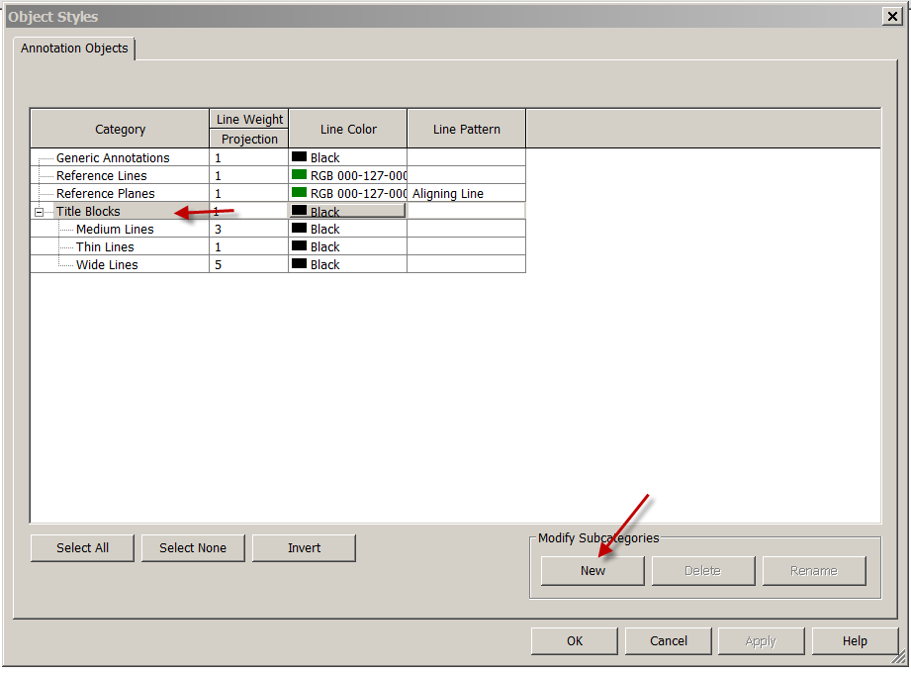
Name it Border9
Subcategory: Titleblocks
OK
Set Lineweight to 9
Linecolor to Black….Solid

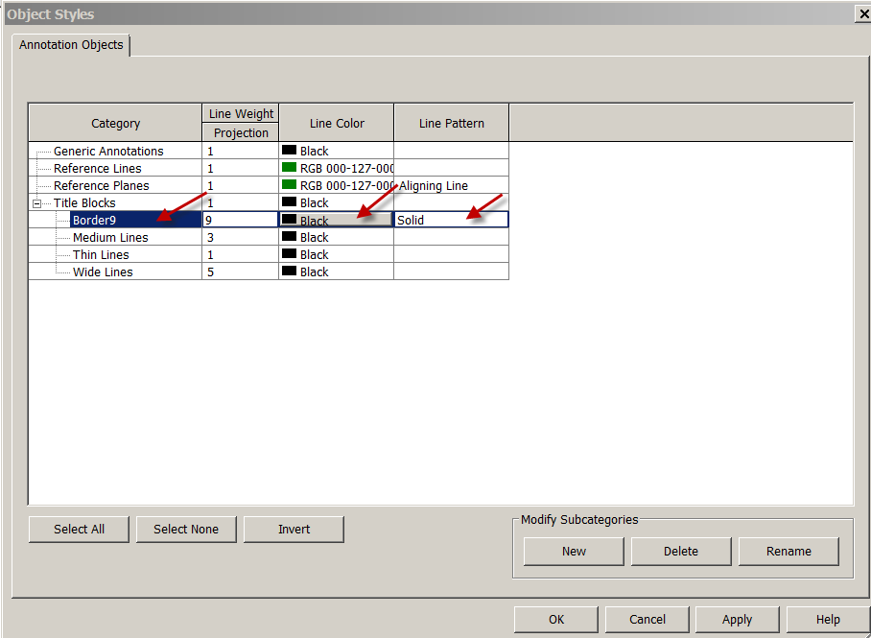

Create the borderlines
Create…..line….Subcategory: Border9
½” in from edge of paper
Turn Lineweights ON
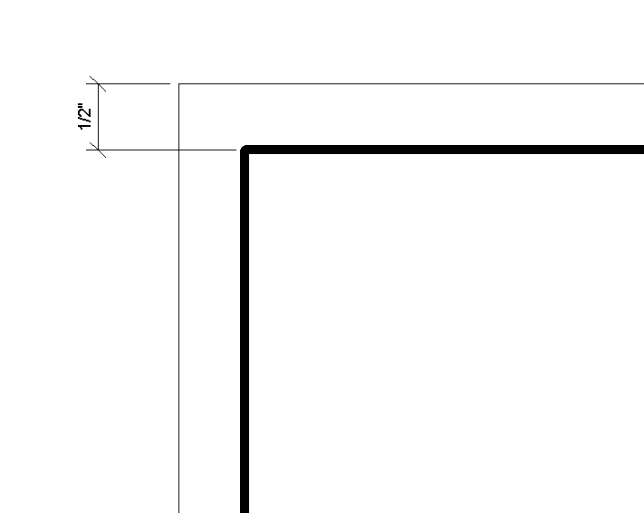
Labels and Text

Create
Label
Place Label
Pick somewhere in the center of border to place (temporarily) the label
Sheet Name
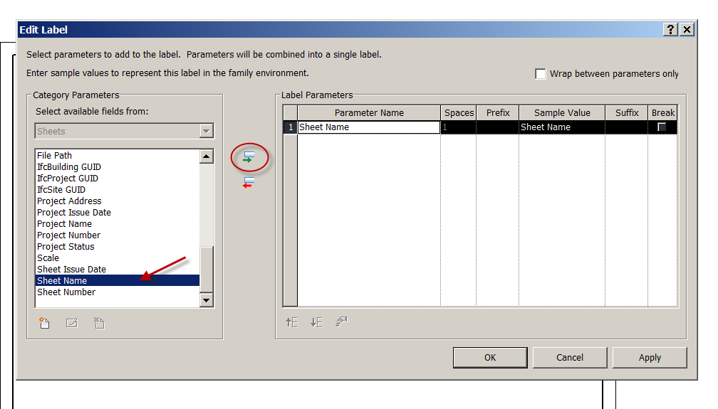

Show Rotate
Label Sizes

Pick label tag 1
Edit type….duplicate
Name it : ¼ Arial Bold….OK
Check Bold
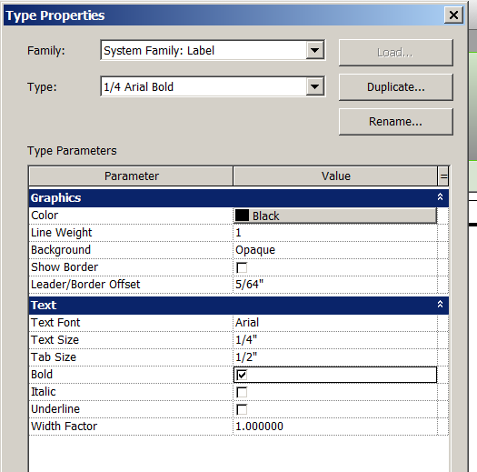

Create the following types w/ corresponding text heights
1/16 Arial
3/32 Arial
1/8 Arial
1/4 Arial

Show justification of Labels

I need the following labels with font on your title block:

Label Font
Project Name 1/4” Arial Bold
Sheet Name ¼” Arial
Sheet Number ¼” Arial
Scale: 3/32” Arial
File Path: 1/16” Arial
Client Name: 1/8” Arial
Drawn By: 1/8” Arial
These are LABELS. We need text in front of them to identify the labels.

Create….. Text
Text Note1
Edit Type…Duplicate
Name it: 3/32 Arial

Create the following text notes (in CAPS):
PROJECT NAME:
SHEET NAME:
CLIENT:
DRAWN BY:
FILE PATH:
SHEET:
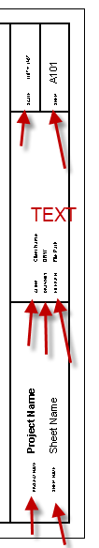

Adding a Logo. It can be a small picture or your initials.
Insert…..Image
Save as:FirstLastCBorder.rfa

Smart Window Tag

Let’s create a useful SMART window tag. One that will give us the width and height of the window in inches. A 1’8”(20”) by 3’4”(40”) window would be a 2040 on our tag.
File
New
Family
Annotation
Window Tag
Open
Label….Type Name
Sample Text: WD” X DP”
Place it above the horizontal ref plane
Label….Family Name
Sample Text: Window Type
Place it below the horizontal ref plane
File
Save as: WindowXXXXTag
Load into project

Tag a window with your new tag. Remember, you can move tags!
Annotate
Tag by Category
Pick a window
See it!
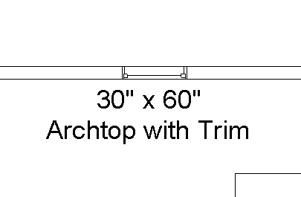

You have learned how to create an annotation family from a template, edit an existing annotation family to make it look for what YOU want, and create “smart” and “dumb” annotation.

Smart Window Tag: Tag by Instance

Let’s create another useful SMART window tag. One that will give us the ability to tag a window by instance. As you know, window tags are type mark tags. 3 exact windows will have the same tag number.

File
New
Family
Annotation
Window Tag
Open
Label….Mark
Sample Text: A
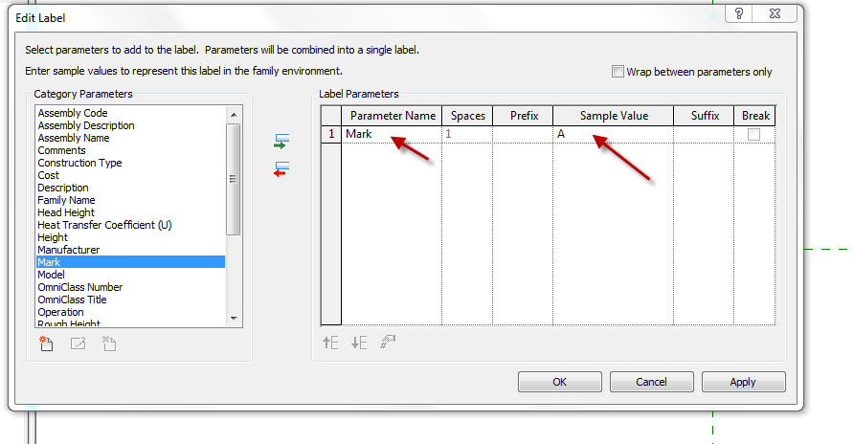
Place it at the intersection of the reference planes
Create
Line
Polygon
Place the polygon at the intersection
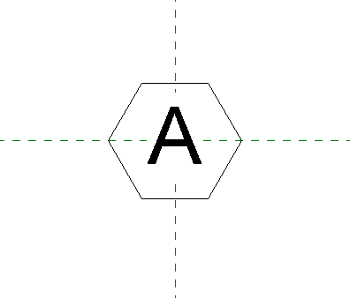
Name it SHS Window Instance tag
Load into project

Pick a window
Properties
Mark:C

Tag a window with your new tag. Remember, you can move tags!
Annotate
Tag by Category
Pick a window
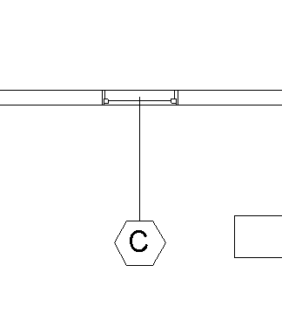

Drafting Views

Revit needs a place to put .dwgs, .jpgs, etc. Drawings and images that are not attached to the building model. Drafting views provide this opportunity.

Open Revit2018demo8.rvt

I have 2 items that need to go into my Revit drawing, condiment.dwg and Elevation Concept.jpg.

View
Drafting View
Name it: Concept Elevation Views
Scale 1-1/2”=1’0” (it’s a scan)

Insert
Image
Concept Elevation
Open
Place in screen
See it?
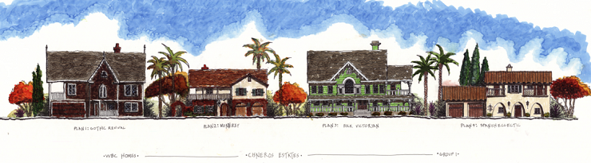
Create a new sheet
D size
Drop Drafting View on sheet
You can change the scale by activating the view, just like other Revit views.
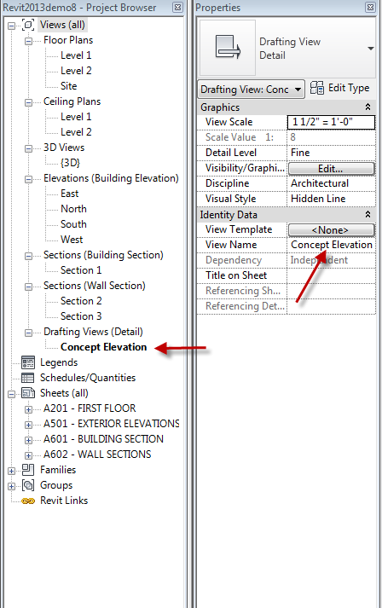

Create a new drafting view. Name it”Condiment Bar”
Scale:1”=1’0”
OK
Let’s bring in an AutoCAD file.
Insert
Import CAD
Name it Condiment Bar Details
Scale: 1” = 1’0”
Ok
ZA to show (sometimes they come in out of the view area)
Also, toolbar on top, right corner of drawing area has zoom tool.
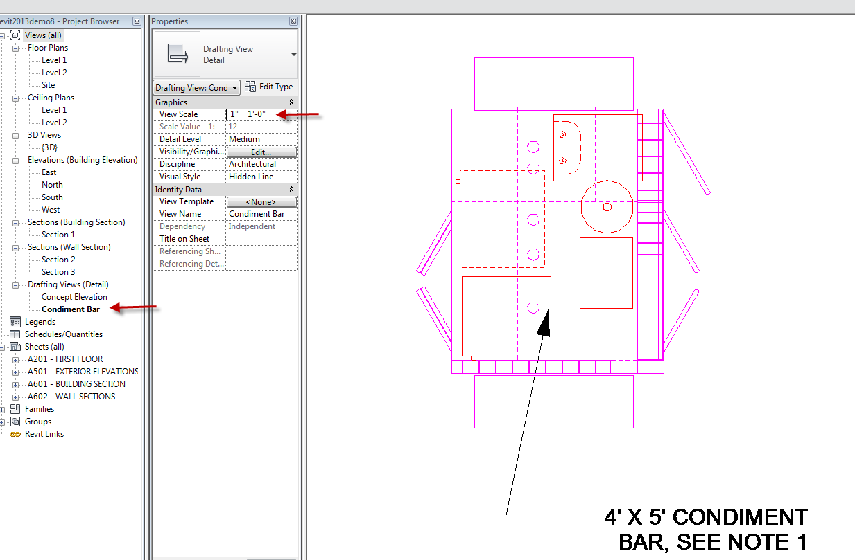

VV
Imported categories
See layers? They can be turned on and off ala AutoCAD layer control
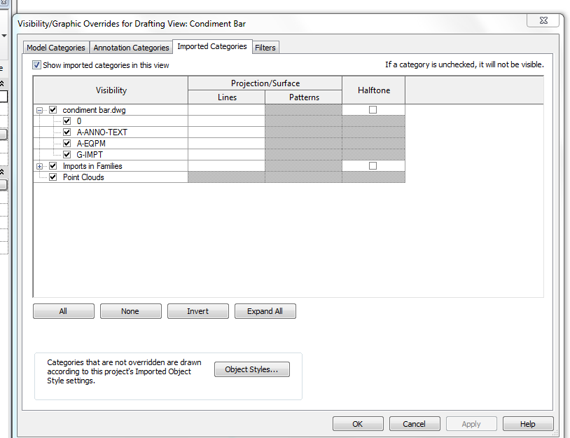
Cancel
Drag onto a sheet
You can bring in standard AutoCAD details into Revit this way. Details that are not attached to the building model. You can even create sheets of standard details and save them to your template file for use on each project!

Note #1: You can do a full or partial explode when bringing in .dwg files…just look for the boxes at the top of the drafting view. You can also delete layers in that view.

Note #2: Revit CAN NOT import a Microsoft Word .doc

Note #3: Revit CAN NOT import a .pdf

Note #4: Revit CAN import .gif .jpg .jpeg .png .tif files. If you can get your image into one of those fomats, Revit WILL import it.

Did I mention to watch your file size when importing images?? They can make a manageable project a nightmare by making the file oversized!

Keynotes

Types of Keynotes

Element. A keynote can be applied to an entire element, such as a wall, detail component, or door.

Material. A keynote can be assigned to a material that has been painted on a surface, and to materials assigned to the component layers of an element. Material keynotes are not supported for the insulation drafting tool, the detail components line and filled region, or wireframe views.

User. This option provides a way to use commonly used notes or phrases to address documentation issues. These additional user notes must be added to the provided keynote text files or included in one that you create. See Adding Additional Categories.

Assigning Keynote Values to Materials

- Keynote selection can be applied to materials. Keynotes are assigned to materials on the Identity Tab of the Materials dialog. To access the Materials dialog, click Manage tabSettings panel (Materials).
- When materials are assigned a keynote value, the objects that use these materials inherit the keynote value accordingly.
- A great deal of time can be saved if the materials of a project have their keynote values applied before you apply keynote tags to materials. See Changing Material Identity Data.

Assigning Keynote Values to Elements

- All elements have a Keynote Type parameter. These can be supplied in advance using the Type Properties dialog (see Element Properties), or selected when the tag is placed.

Assigning Keynote Values Using Tags

- After you apply a keynote tag to an element, you can select the keynote tag and click over the keynote value or empty value to open the Keynotes dialog. Select the desired keynote for the element.
- Note If you click OK, Revit Architecture uses the keynote value that is currently selected. If you click Cancel, the keynote value remains empty.
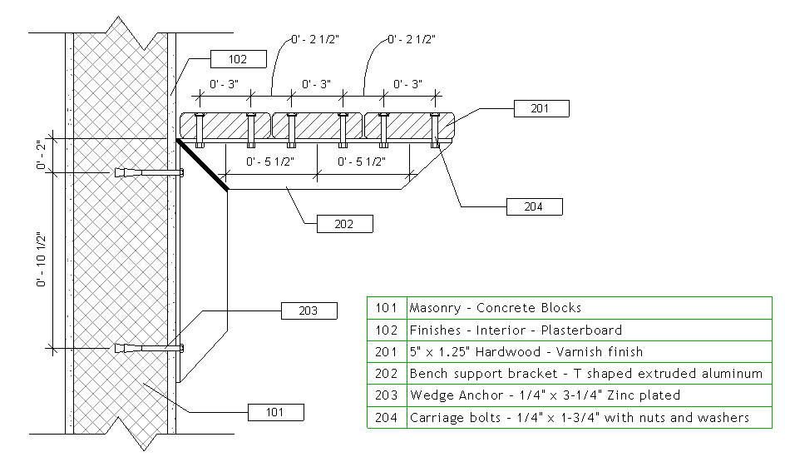
See CSI Masterformat.pdf for categories on the common drive
The Keynote File
(It’s just a little .txt file)
Note the 1 tab between the items
Note the last number is the group heading
Example: Concrete Forming 03 11 00 is under Concrete Forming and Accessories 03 10 00
Concrete Slip Forming 03 11 13.13 and Concrete Shoring 03 11 13.16 are under
Structural Cast-in-Place Concrete Forming 03 11 13
It’s an organizational system….

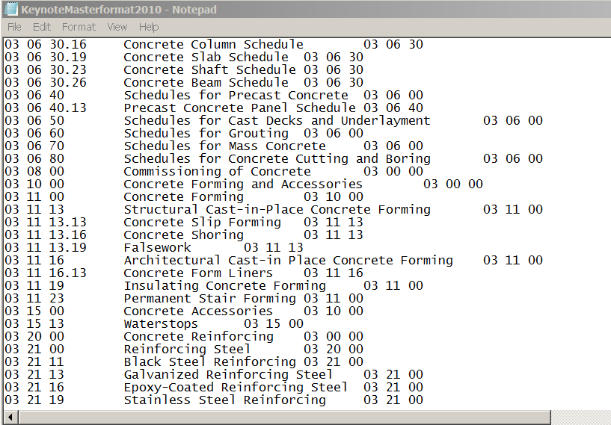
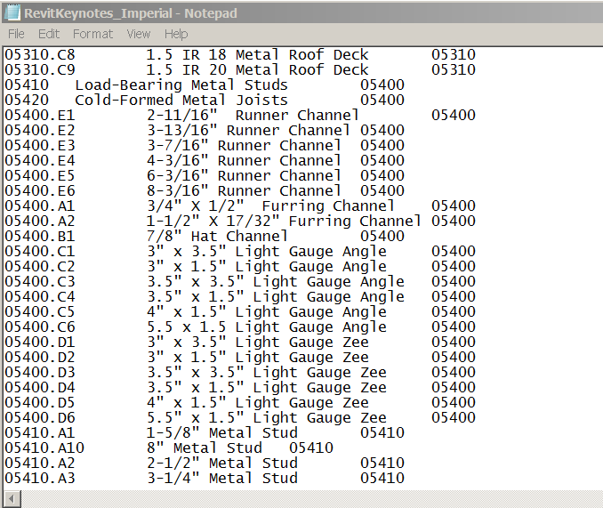

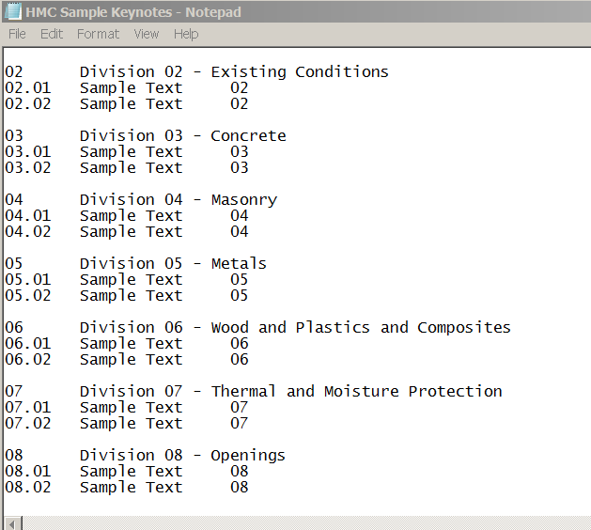

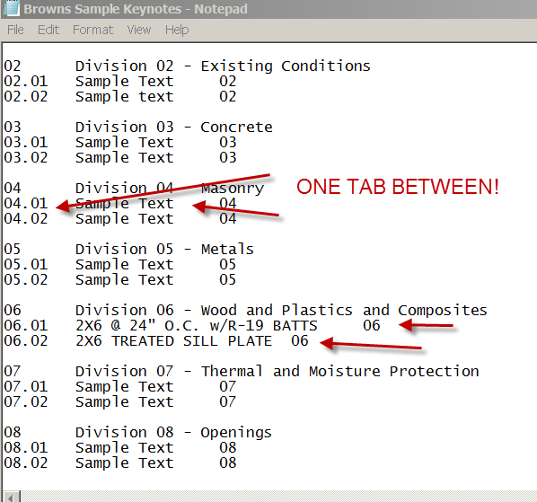
Let’s get started!
First we need to point to the Keynote file we want to use.
Annotate
Tag
Keynote Settings
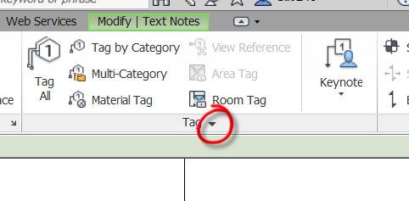
Choose path to Keynote file
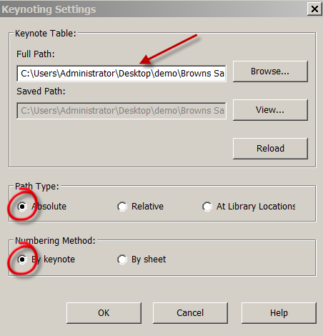

Annotate
User Keynote
Keynote Number-Boxed-Small is OK
Pick the treated Sill Plate
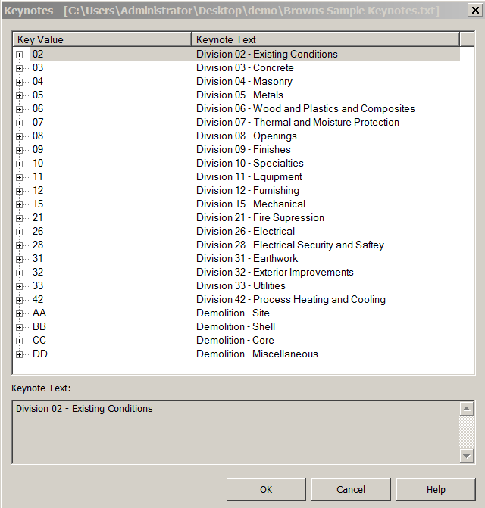
Open +06
Pick 06.02….OK
Done
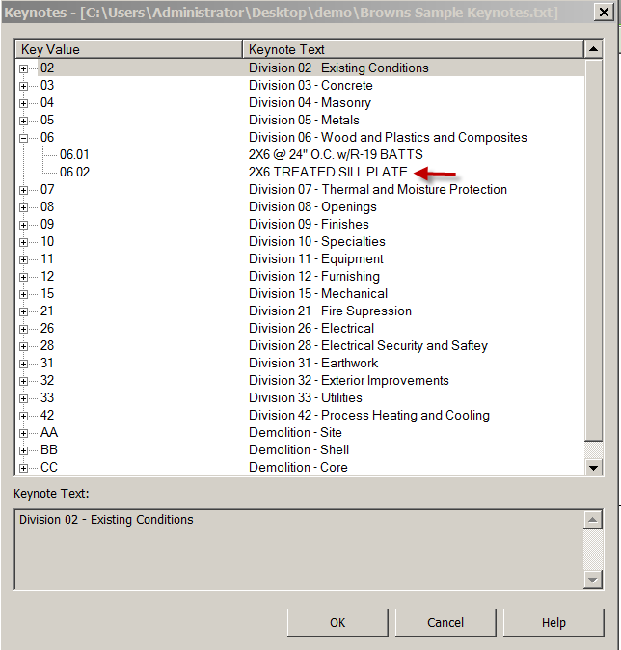
Now pick insulation (command continues)
Pick 06.01…OK
Done

Creating the Keynote Legend
View
Legend
Keynote Legend
Name it “Keynotes” OK
Notice Key Value and Keynote Text are ready to go in the schedule! OK
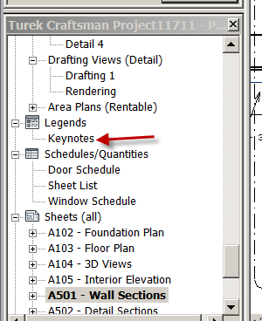
Open sheet that has the Wall Section
Place the Keynote Legend on the sheet!

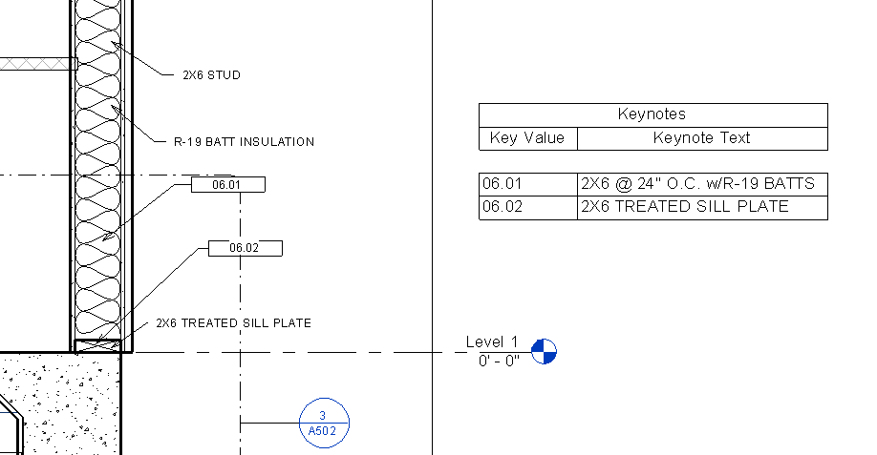
Open Keynote txt file
Under 09 Finishes, we are going to spec a countertop material
Put ¾” Willow Green Corian”
Be sure only ONE tab….then 09
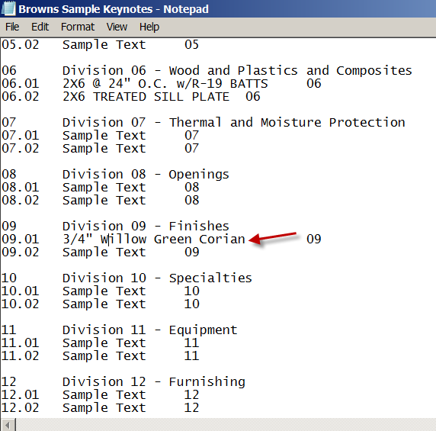
Element Keynotes
You can assign Keynotes to Elements too.
Element Keynote
Pick the countertop
Edit Type
See Keynote?
Not there????? Why????
We updated the .txt file, but Revit doesn’t know it was updated yet.
Tag
Keynote settings
Reload
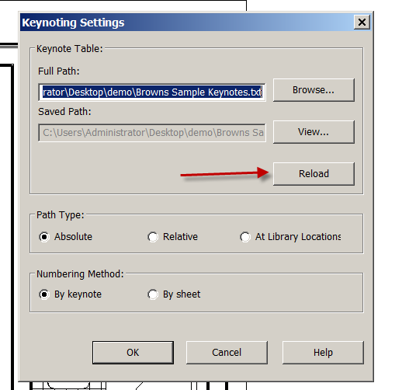
OK
Try again…
Pick the countertop
Edit Type
Keynote
09
See Keynote? Ahhhhh…there it is!
Pick Willow Green 09.01 OK
Now the element has a keynote.

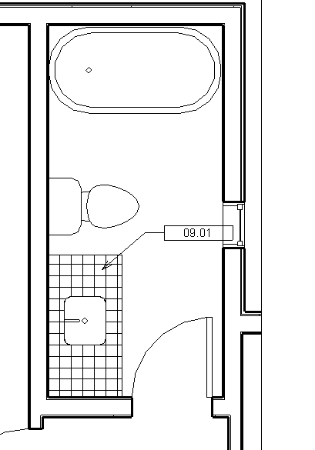

Applying the Keynote to the object
Keynote
Element Keynote
Pick the countertop….see it?
Check the keynote schedule

NOTE: You can create the keynote legend by sheet, so only the keynote you used on that sheet are applied to the keynote legend on that sheet.

Grouping

Grouping is similar to blocks in AutoCAD. You can put items together and :Group” them, so they come in as one smaller object.

Open Revitdemo 22.rvt

We will start by making a “group” with no special challenges…..

Floor Level 1
In a Bedroom, bring in a Double Bed, Chair and Desk.
Set them up in a Typical Layout
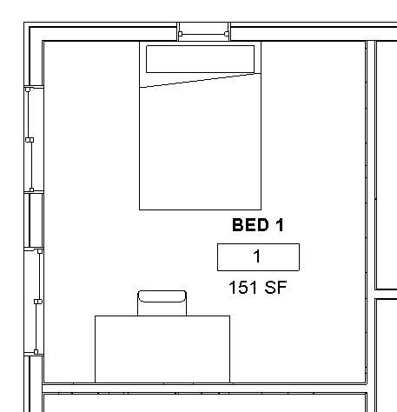

Select the Double Bed
Modify Furniture pull-down comes up
Create
Create Group
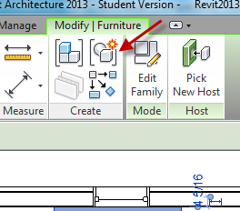
Name it Typ Double Bed Layout
Check open in Group Editor
OK
+Add
Select the Desk
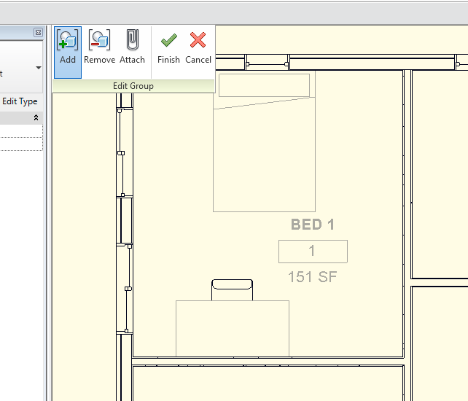
Select the Chair….notice when you add it, the component grays out.
Finish
Select the group you should see a dashed box around the group
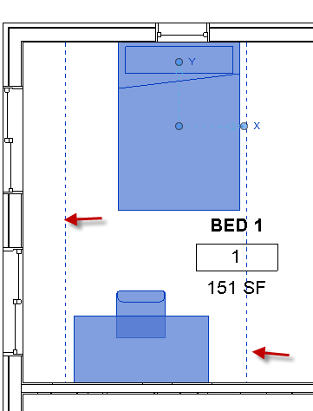
See it is ONE “object”, that can be used over and over again, like an AutoCAD block.

Use it….
Architecture
Model Group
Place Model Group
Place the Group in another Bedroom
(Note: you can Rotate the group)

Editing the group

Let’s make a design change….. swap out the double beds and replace them with King Beds.

Select the group
Group
Edit Group
Pick the bed
Properties
Pick the Queen Bed
Finish
See all the groups change??

Now let’s eliminate the chair
Pick the group
Edit Group
Pick the chair
-Remove
Finish
Note: All we have done is removed the chair from the group……note the chairs were not deleted….
Undo that….so the group has the chair

Edit group
Pick the chair
Delete the chair
Finish
Note the chairs are gone in all the groups!
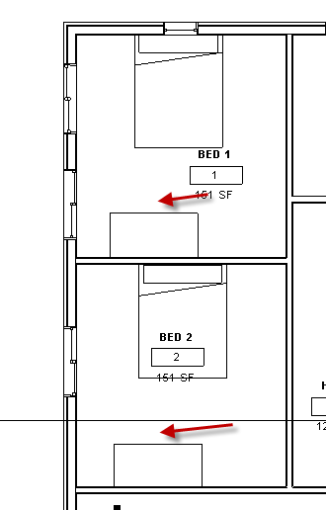

Adding to the group

Component
Place a component
Pick a dresser
Place it
Pick the group
Edit Group
+Add
Pick the dresser
Finish
All the groups update!

Note: All the groups update in the ENTIRE PROJECT…..FYI

Creating Custom/Shared Parameters

As you create and use families, you may find the parameters listed or are available to you are not complete. You have a length and width parameter, but need one that is not listed.
You can create a “shared parameter”…that can be added to ANY family, regardless of category. The parameter is stored in an external file, ensuring consistency across families and projects.

We will start by making a Window Schedule (with a few challenges)

We will create a custom parameters called SHGC, U- Value, and VT. They will be numbers. We will create a yes/no value for LEED CERT. We will create a parameter for “Oracle #” (a client database number)

We will then apply it to our window schedule

We will then apply it to a window family.

We created the window schedule previously. Open that file bldg w schedules.rvt

Adding Parameters

Let’s say there is a field you need that is not in the schedule: we will use the bold/underlined parameters above…..

Manage
Shared Parameters
Create
Let’s place in on the desktop and call it DWE Shared parameters 2.txt (there should be a good place on the network drive normally to store this file)
Save
Groups…New
Enter name DWE Window

Note: You can set up many groups in the DWE Shared Parameters 2.txt file. Examples might be: Sustainable Design Parameters, Electrical Parameters, Specialty Equipment Parameters, Annotation Parameters. Each group can hold a bunch of your custom parameters

Parameters….New
Name: Oracle #
Show Discipline
Show Type of Parameter
We will take “Common” and “Text” on this parameter
OK….OK
You have created a “shared parameter”!!
Parameters….New
Name: SHGC
Show Discipline
Show Type of Parameter
We will take “Common” and “Number” on this parameter
OK

Parameters….New
Name: VT
Show Discipline
Show Type of Parameter
We will take “Common” and “Number on this parameter
OK

Parameters….New
Name: U-Value
Show Discipline
Show Type of Parameter
We will take “Common” and “Number” on this parameter
OK

Parameters….New
Name: LEED CERT
Show Discipline
Show Type of Parameter
We will take “Common” and “YES/NO” on this parameter
OK….OK

In Window Schedule
Add Parameter
Shared parameter
Select
(Edit will path to a different location)
Pick Oracle #

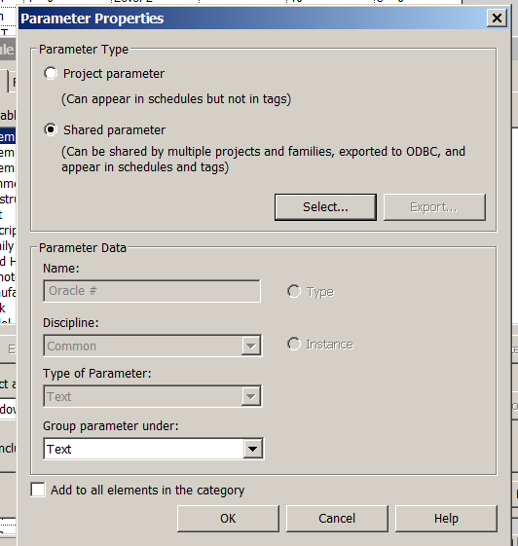

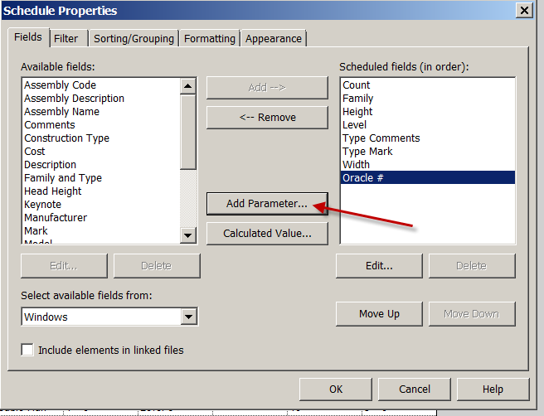
Continue adding the shared parameters…
Group under Green Building Properties
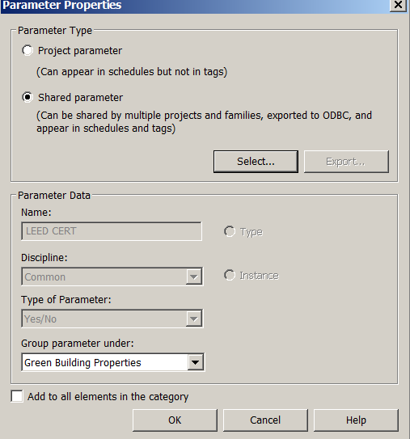

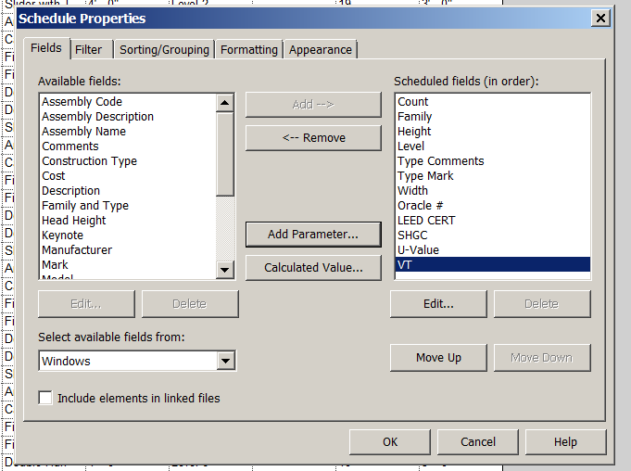

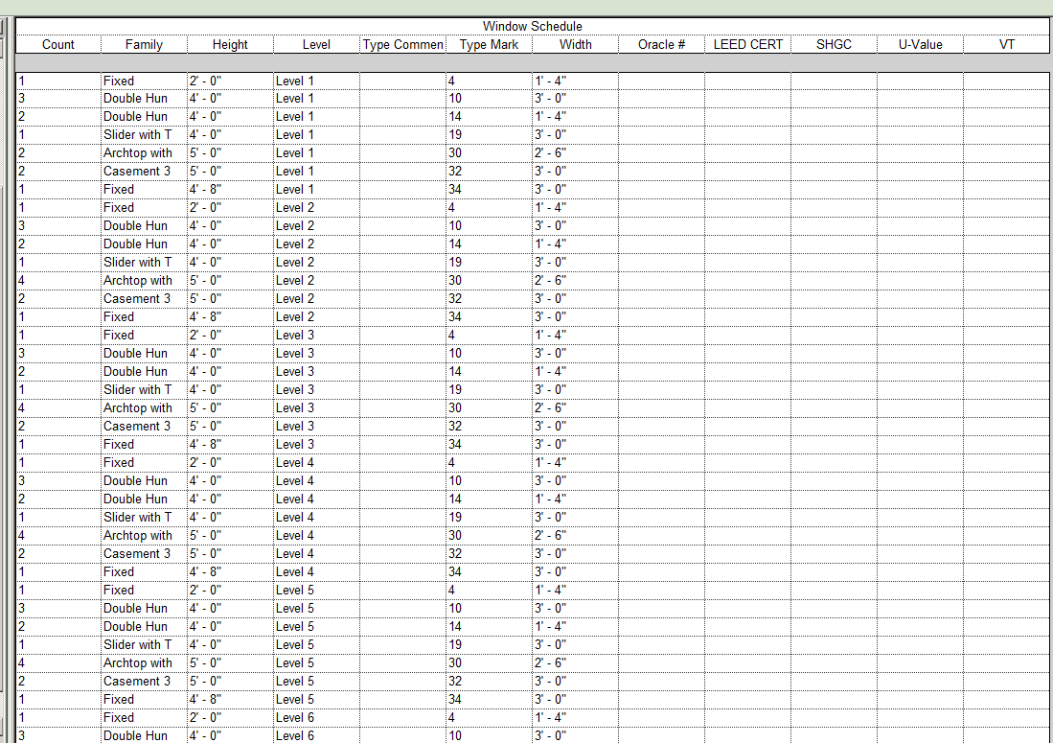

Let’s use it.

Floor Plan Level 1
Select a Window FG3656 on East wall
Edit type
See the parameters out of the box? (remember that)
Cancel
Edit family
Yes
Family Types
Note the Parameters….Remember??? These are your “out-of-the-box” parameters
Parameters : Add
Shared Parameter (Family will not show in schedules)
Discuss “Type” and “Instance” choices
Select
See LEED CERT
Put under Green Building Properties
OK….OK….
See LEED CERT Parameter you created??
Do the others
Add the data
Question: Would SHGC, U-value, VT, Oracle # be instance or type????
OK
File
Save as
Family
Save the Family as DWE 3656

Putting company info in name distinguishes your smarter company family from the “out-of-the-box” families. Some firms have a special folder for their company developed families, so when upgrading, locating the company files is easier.

Load into project
Swap the window with the DWE window

Back to the Window Schedule

Discuss shared parameters in families before schedule is made

Discuss Project Parameters

You have learned to create a custom parameter called a “Shared Parameter”. You learned that shared parameters can be put in schedules and families. You know the shared parameter file is a .txt file and can be updated with new groups and new parameters as time goes on. The shared parameter file can be used on future projects too.

Room Schedules

Room schedules are very powerful data extraction tools in Revit. A typical project may have many variations of Room Schedules based on needed data….

Open revitdemo23.rvt
View
Schedules
Schedule/Quant
Rooms
OK
Area
Dept
Floor Finish
Level
Name
Number
Perimeter
ADD
(do not hit OK)

Sort/Group
Sort by: Name
> Grand Totals

Formatting
Area>Calc Totals
Perimeter> Calc Totals
Name> Calc Totals (greyed out…can’t add names???)
OK

Looks good, but order is off and Floor Finish data has not been entered (GIGO) yet…

In the Room Schedule , Add Tile in Service areas
NOTE: Only enter the data once…then use the arrows. This is important (really) because the text is case sensitive. “Tile” and “TILE” will be 2 different materials to Revit

Add Wood in Living Areas
Add Carpet in Sleeping areas
Add Painted Concrete in Non-Living areas
Add Tile for Corridor and Service Areas
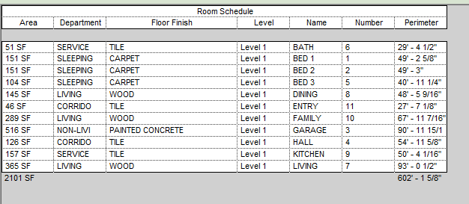

RC over Room Schedule
Properties
Fields…Edit (let’s re-order)
Level
Number
Name
Dept
Area
Perimeter
Floor Finish
Check result
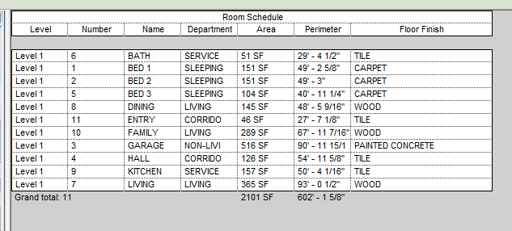

Why only Level 1 on Room Schedule?

Let’s organize by Room #
RC over Room schedule
Properties
Sorting/Grouping
Number
Check Grand totals
OK….Ok

Back to Level 1
Select a Room
Properties
Notice the Floor Finish is populated.
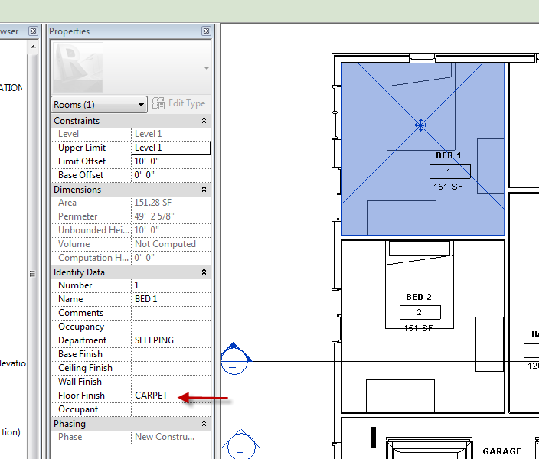
It’s a BIM!

Room Bounding…Controlling where your Room Goes

Let’s say you have a room with a strip closet enclosed by a wall and you don’t want Revit to see the room as 2 rooms:
Create a dividing wall
Add a door

Select the dividing wall(s)
Properties
Uncheck “Room Bounding”
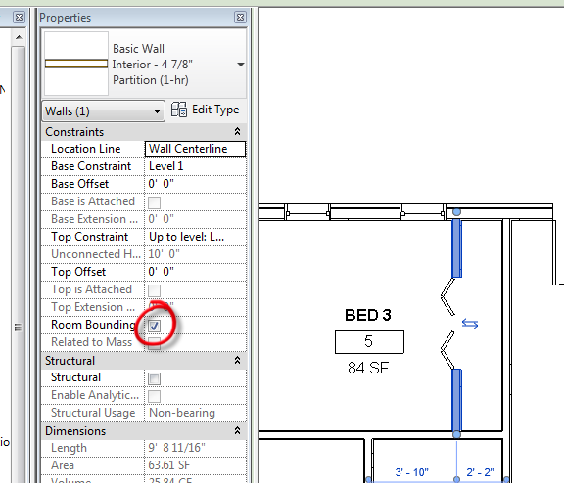
OK
Pick the Room now…..
See it flow into the closet
Notice the Area change??

Discuss Splitting walls when the wall goes into multiple Rooms

You have learned to create room schedules to pull data from the project. You learned how to control your room boundaries.

Sheet List

You can create a list of drawings for your sheet set that will update as you create them.

View (from pulldown)
Schedules
Sheet List
Add
Sheet Number
Sheet Name
Sheet Issue Date
OK
Done!

RC on Drawing List
Properties
Sorting and Grouping
Sort by: Sheet Number
Check Ascending
OK…OK

You can take out a drawing from the list of drawings (of course it is still in the file):
RC over Drawing List
Filter
Filter by: Sheet Number
Does not equal: A900.01
OK…OK
Note A900.01 is not in the Drawing List

You can filter by Sheet Name too:
RC over Drawing List
Filter
Filter by: Sheet Name
Does not equal: Unnamed
OK…OK
Drag Drawing List on Cover Sheet Title Block

Shared Coordinates Demo
Open: FLSITE.rvt
Site view
Hide the topo

Shared Coordinates Demo

A Revit project has internal coordinates for all the elements that compose the model in a project. Those coordinates are known to this project only. This is acceptable if you have a standalone model whose position is not relevant to other models or to a site. However, if you want the position of the model to be known to other linked models, you need to share coordinates.

Open: FLSITE.rvt
Site view
Hide the topo

Discuss Project Base Point: A convenient location in the project, like the corner of the building.

Discuss Survey Point: A known point on the site like the intersection of property lines.

Use filter to show/isolate survey point
See N/S E/W Elev
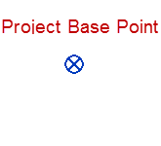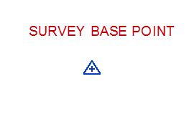
Pick the survey point
Keep it clipped
Move it to the top, right corner of the site…where the 50’00 and 82.50 line intersect
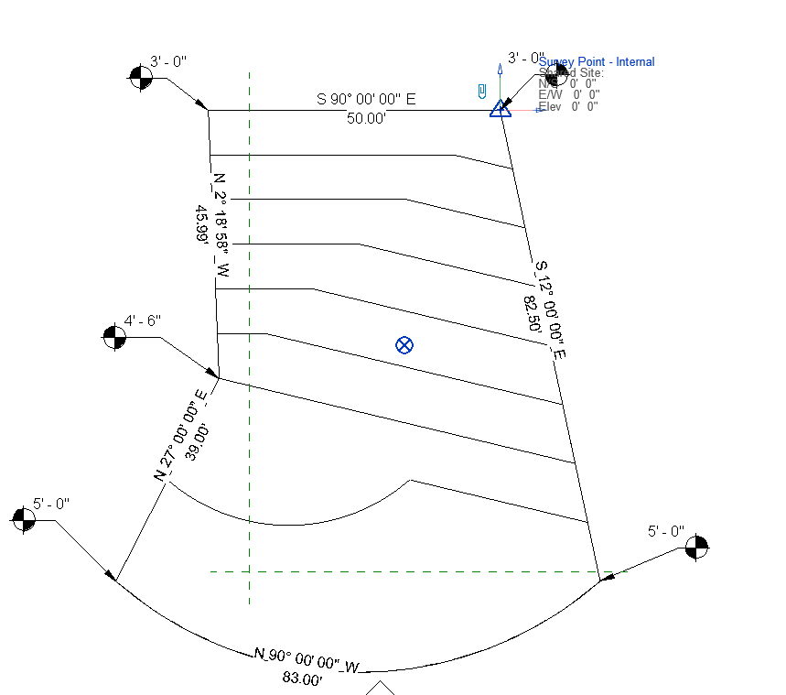

Turn the topo back on
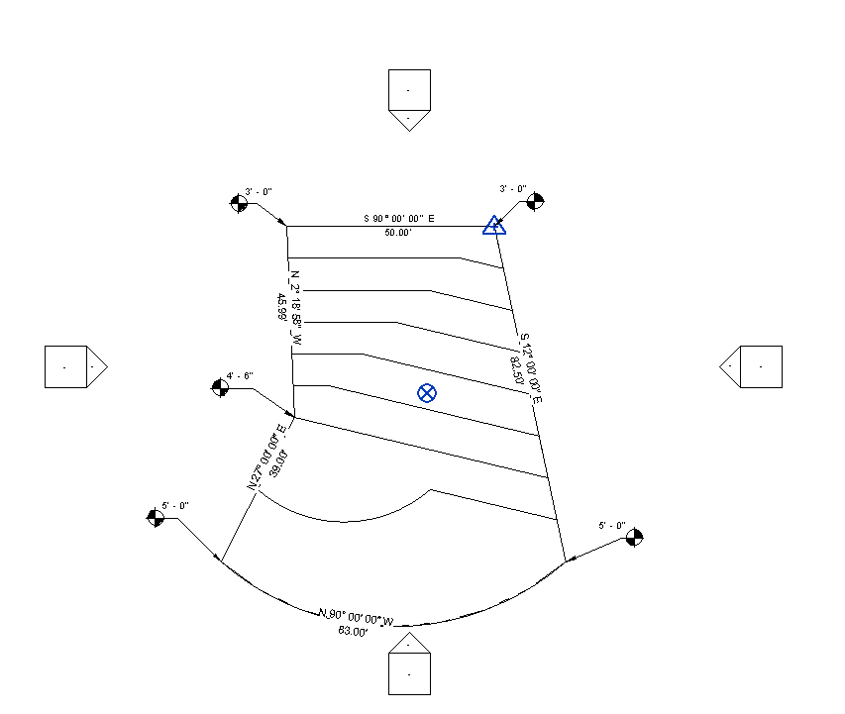
Save the file as FLSITE.rvt
Close it
Open Revit2018demo10
Site view
VH the elevations

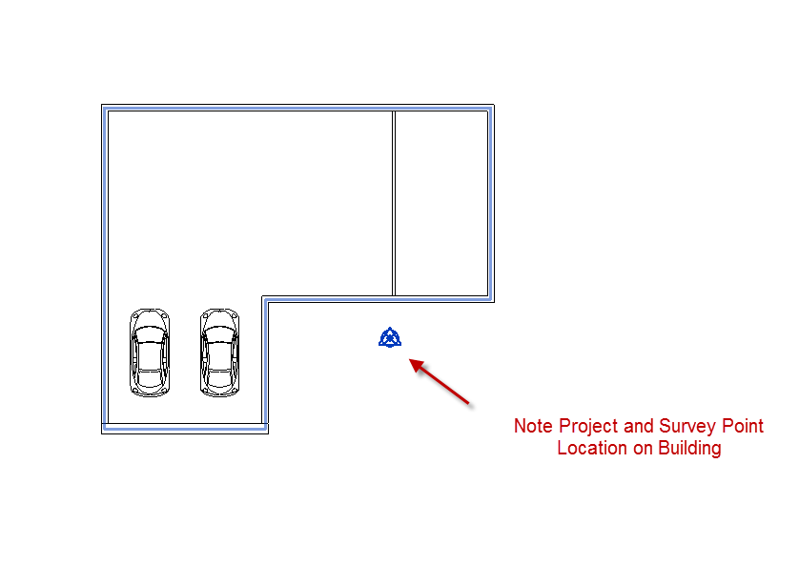
Save as BLD4Coordinates.rvt

Close it
So we have 2 files:
FLSITE.rvt the site plan
BLD4Coordinates.rvt the building
We have set the survey point at the corner of the property lines in the Site plan…our “known point”
We have our project base point in the front of the building.
Open FLSITE.rvt (make sure the building file is not open)
Insert
Link Revit
BLD4Coordinates.rvt
Positioning: Auto center to center (We will move the building, anyway)
Open
Position the building model so it looks like this in the Site Plan view:
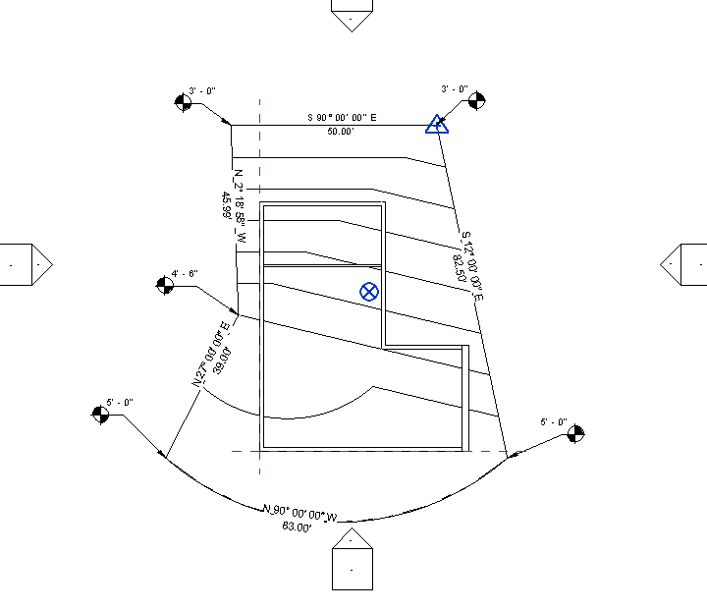
Move the site plan levels up 5’
Align the building Level 1 with the Site Level 1. Lock it.
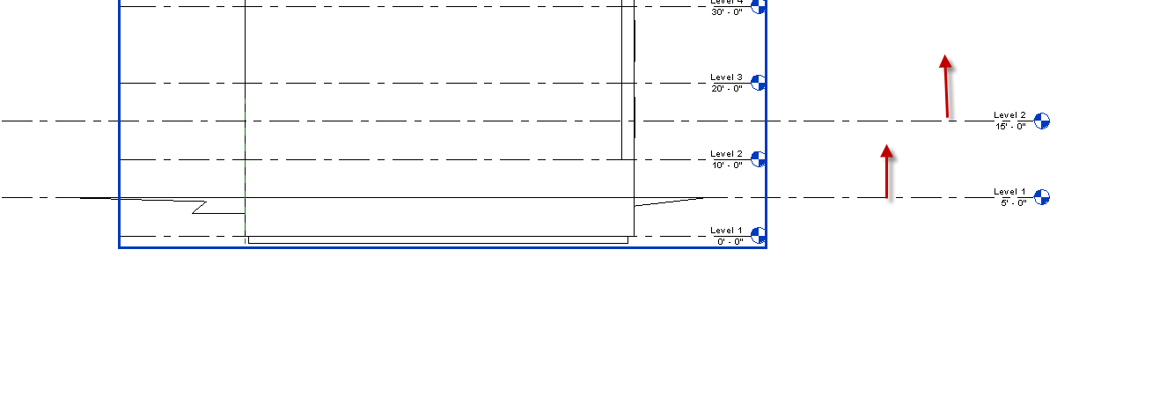
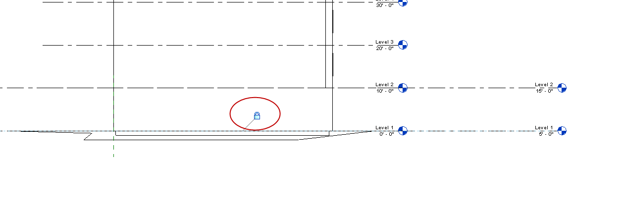

Now the good stuff….
Manage
Coordinates
Publish Coordinates
Pick the link (the building). We are sending the location of the known point …the Survey point…to the building file!
You can keep the Internal (current) name
OK
Save the file
Close it
Open the building file BLD4Coordinates.rvt
Site View
See the Survey point? See the base point?
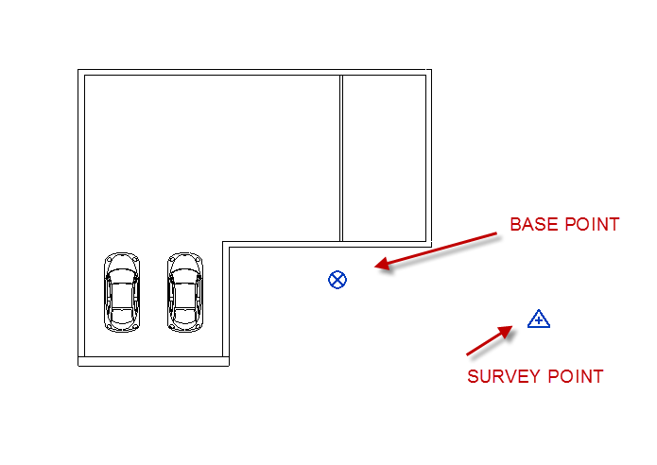
Let’s test it…
Insert
Link Revit
FLSITE.rvt
Positioning: By Shared Coordinates
Open
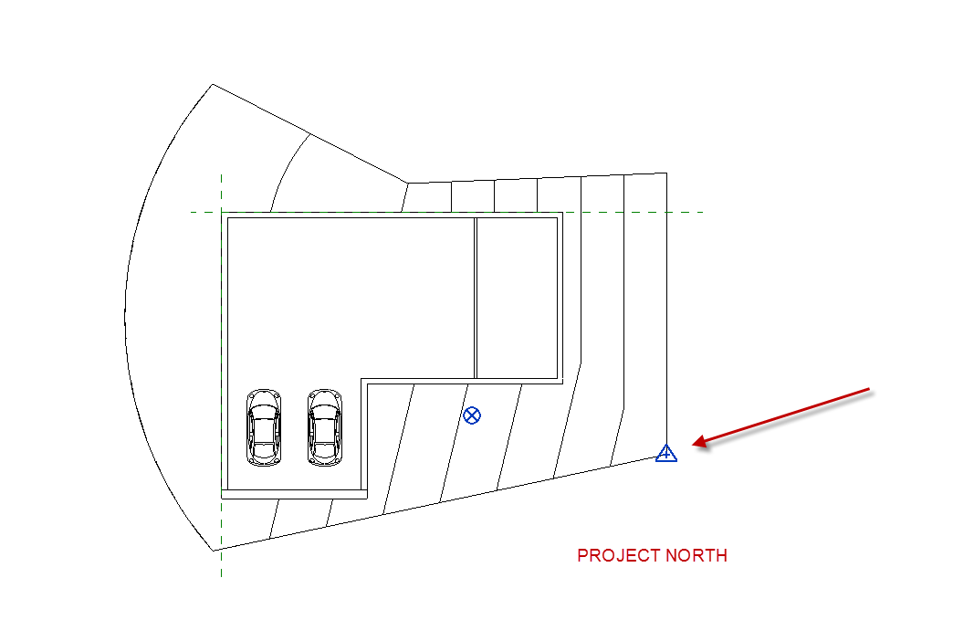Change the orientation to True North
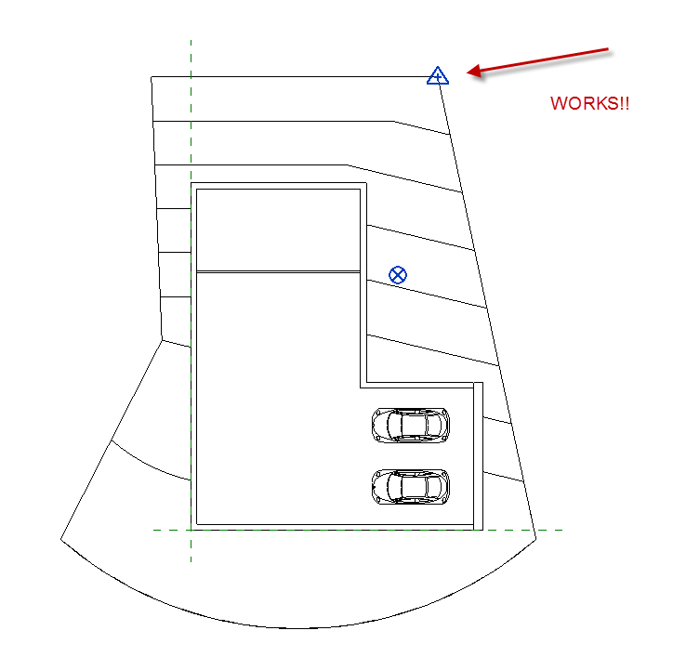

Note Blocks

Note Blocks (also called an Annotation Schedule) are a list of construction notes.

You can create a note block and place it on a sheet.

The “trick” is to load a generic annotation family into your project, then assign parameters to the family.

We will add a parameter called “Key #” (that will be our tag #) and a parameter called “Construction Notes” (that will list ummmm construction notes)

File
New
Annotation Symbol
Generic Annotation
Open
Family Types
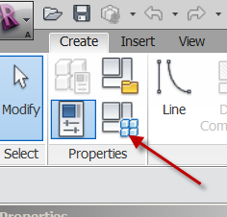
Parameters
Add
Check INSTANCE (explain)
Name: Key #
Type of Parameter: Text
OK
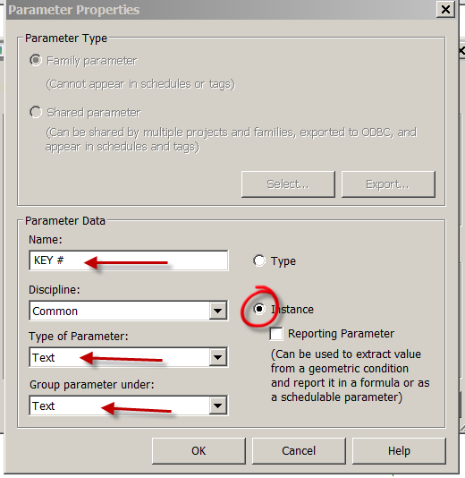
Add
Check INSTANCE (explain)
Name: Construction Notes
Type of Parameter: Text
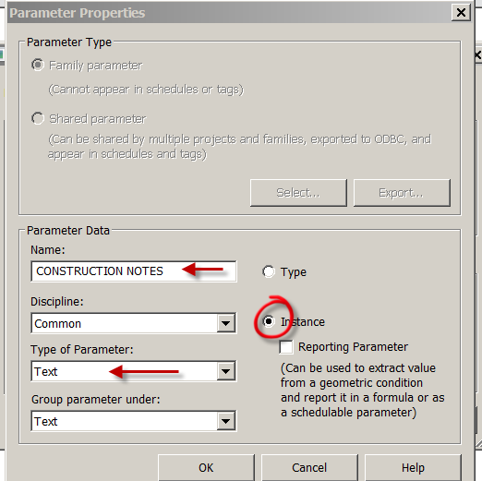
OK…OK

Delete the red text
Create
Label
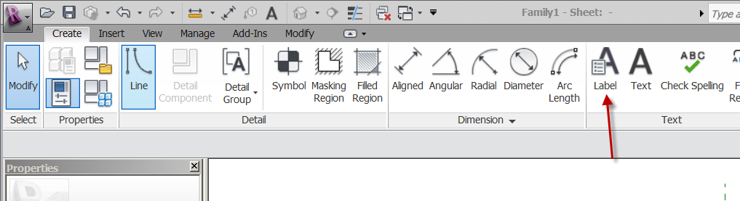
Place at intersection of planes
Key # >
Sample Value: A
OK
Create a hexagon around the A
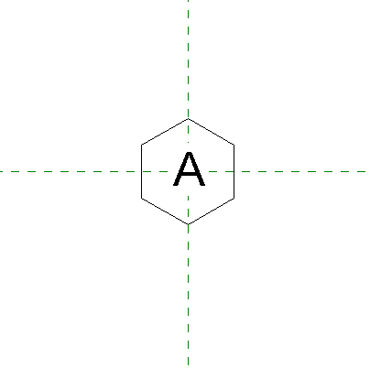
Save as: SHS Key # tag
Load into project

South Elevation
Annotate
Symbol
SHS Key # tag
# of leaders: 1
Place the tag
Stretch the horizontal line to the window
LC on tag
Properties
Note we are in INSTANCE parameter (explain)
Key #: A
Construction Notes: Bullet Proof Glass
Apply
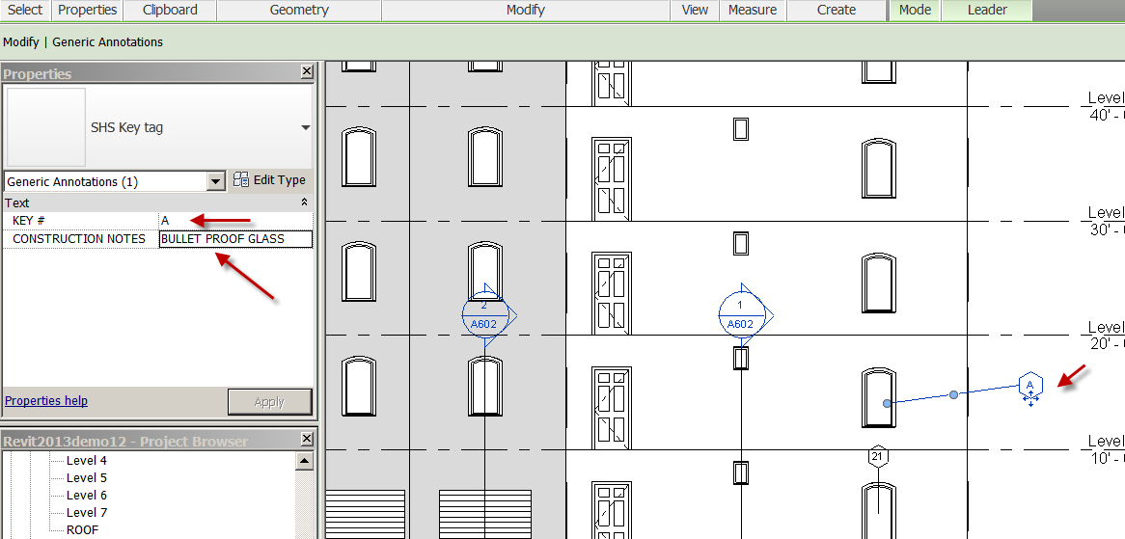
Notice A is in the tag…but there’s more….

View
Schedules
Note Block
Select: SHS Key # tag
OK
Key #.... Add
Construction Notes….Add
OK
See the note block with our key # and Construction Notes?!

Back to South Elevation
Select our key # tag (with the A inside)
Copy
Paste
Move the copy to the window above
LC on the tag
Element Properties
Key #: B
Construction Notes: One-way glass
See Note Block…updated? YES!

Go to Ext Elev’s Sheet A500.01
See the key # tags on the South Elevation?
Drag the Note block near it..on the sheet.
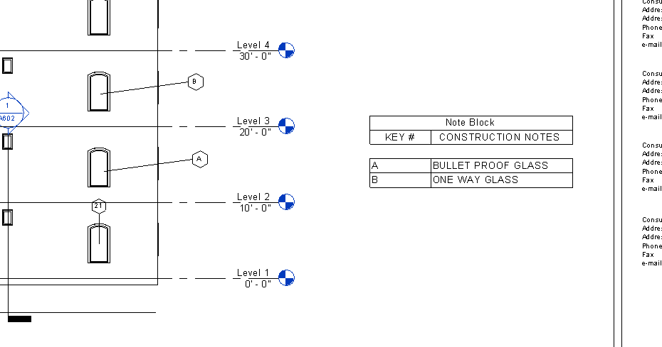

Is this a good option to Keynoting??

Phasing

Objective: An introduction to PHASING in Revit. We will use Revit phasing to do a little bathroom remodel. The remodel will be to make the Men’s Restroom bigger, eliminate the Closet next to the Women’s Restroom.
Open Phasing Demo 2018.rvt
Manage
Phases
There are 2 out of the box: Existing and New Construction
Show Phase Filters (they define how objects will show graphically)
Escape out of phasing.
Show that all the elements in the model were drawn in “New Construction”
The “Existing” phase is in a time BEFORE the building was built….get it???

Setting up Phases
Manage
Phases
Rename “New Construction” to “AS-Built”
“Demo” after As-Built
“Bath Remodel” after Demo
OK

Creating “Phased” Floor Plans
RC on Level 1
Duplicate w/ Detail
Rename to Level 1 As-Built

RC on Level 1
Duplicate w/ Detail
Rename to Level 1 Demo

RC on Level 1
Duplicate w/ Detail
Rename to Level 1 Bath Remodel

Set up Phasing in the Views
Level 1 As-Built
Properties
Phase: As-Built
Phase Filter: Show All

Level 1 Demo
Properties
Phase: Demo
Phase Filter: Show Previous + Demo

Level 1 Bath Remodel
Properties
Phase: Bath Remodel
Phase Filter: Show All

Demolishing
Back to Level 1 Demo
Modify….Demolish
Pick items to demolish:
Men’s Bathroom fixtures
2 Closet walls
Women’s west wall (note doors go too)
Wall between Men’s and Women’s

Level 1 As Built….still the same
Level 1 Bath Remodel…..note demolished elements are gone!

Creating the New Elements
Still in Level 1 Bath Remodel
Create a new plumbing wall at ref plane “New wall”. RC …”create similar” with the other plumbing wall.
Notice it is black. That is the phase filter.
Pick on the new wall. See phase created: Bath Remodel.
Use the “Create Similar” technique to make the Men’s toilet, sink, towel holder. Bring in the Urinal (there is one loaded)
Note we have no West wall at Women’s and part on Men’s….we demolished it, remember?
Select Men’ s wall….RC….Create similar
Make the wall.
Note the join issue at the bottom. Joins are a little weird in phasing…
Here is a little trick to fix it:
Select wall
RC on blue grip at end of wall
Disallow join
Now you can drag or Align the wall.
Add the Women’s door

Notice the tile floor has a gap (where the old wall was)
RC on Floor……yes, you guessed it…..create similar. Place floor….align the tiles.
(Yes, we probably should have demo’d the tiles under the new wall….)
Home….Rooms…Add rooms. Name them Men’s, Women’s
Note: Rooms do not copy over in Phasing…….for obvious reasons……

Copy Monitor

Copy creates a duplicate of a selected element in the current project and monitors it to a selected element in the linked model or current project.

Monitor compares two elements of the same type against eachother, either from a linked model to the current project or within a current project.

We are going to use the copy/monitor system to trach changes to our levels, grids, columns, walls, and floors. If they change in the architecture model, we want to know about it in our MEP model!

For this demo, we are going to work with a linked architecture model for a Mechanical discipline.

Open a new file. Let’s use the Mechanical Template
Be in Floor Plan Mech 1
Insert
Link Revit
MEP-Elementary-School-Architectural.rvt
Positioning: Auto-Origin to Origin
Open
Pin the model
Check Room Bounding button on link so spaces can be added.
Move the Exterior Elevation tags out….careful with blue lines!
Go to the South Elevation
Drag the 2 Project Level lines to the right
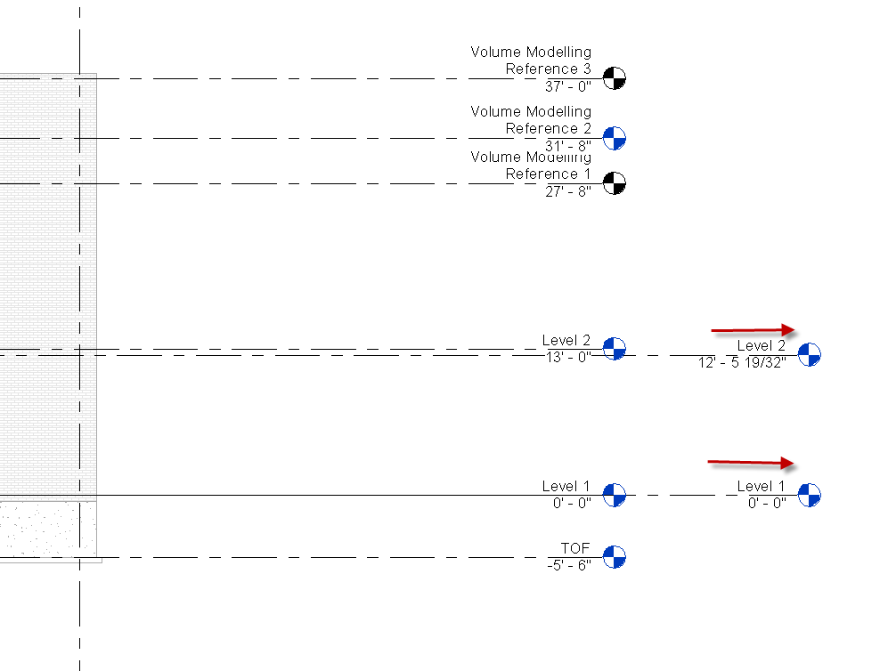

Align the Mechanical Level 2 with the linked Level 2. Both should be 13’0”
Collaborate
Copy/Monitor
Select Link
Pick on Arch underlay
Tools
Monitor
Select our Level 1 (mechanical)
Select the Arch Level 1
Select our Level 2 (mechanical)
Select the Arch Level 2

Copy
Check multiple
Cntrl Select Levels: TOF and Volume Modelling Reference 2
Finish Button (ignore the warning)
Check Finish
Select Levels….move to right so you can see them
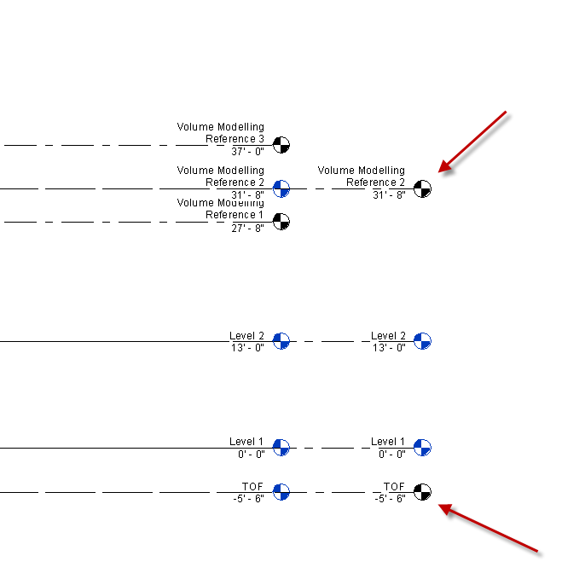
Change Level type from Plenum to ¼” Head
Save as copymonitor1.rvt

Create the Mechanical floor plans:
View
Plan View
Floor Plan
Pick
TOF and Volume Modelling Reference 2
View
Plan View
Reflected Ceiling Plan
Pick
TOF and Volume Modelling Reference 2
So the Mechanical Plans went in great.
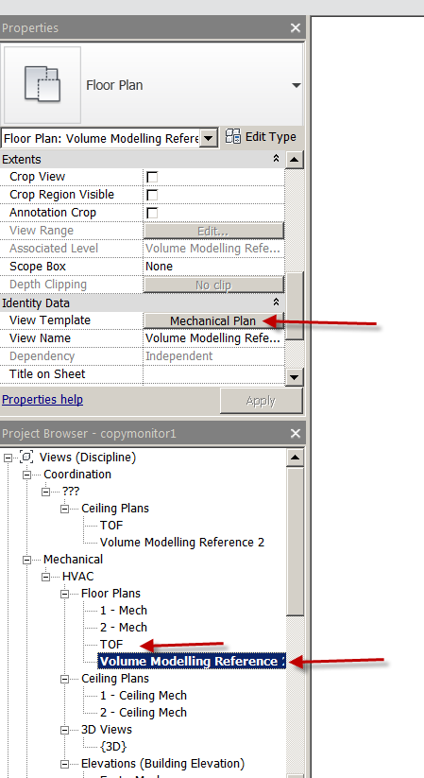

The Ceiling Plans did not go where we want!
Open Coordination (see above)
Change the Discipline TOF to Mechanical
Change the Subdiscipline to HVAC

See it now?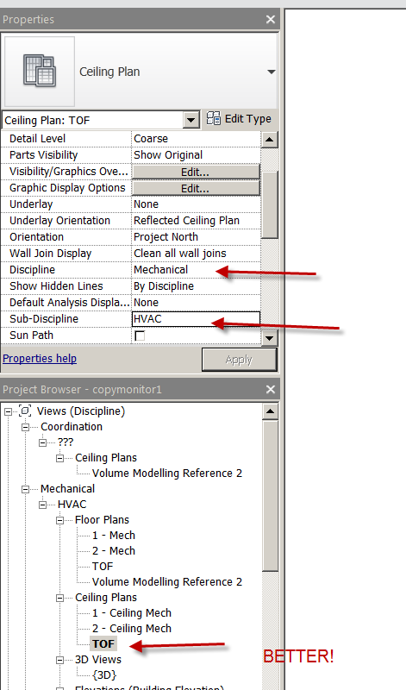
Do the same with Volume Modelling Reference
Change the view template of each RCP to Mechanical ceiling
Save the file
Close copymonitor1
Open MEP-Elementary-School-Architectural.rvt
Change Volume Modelling Reference Level to from 31’8” to 32’4”
Change TOF Level from -5’6” to -6’0”
Save the file
Close it
Open copymonitor1.rvt
You immediately get a Warning box!!
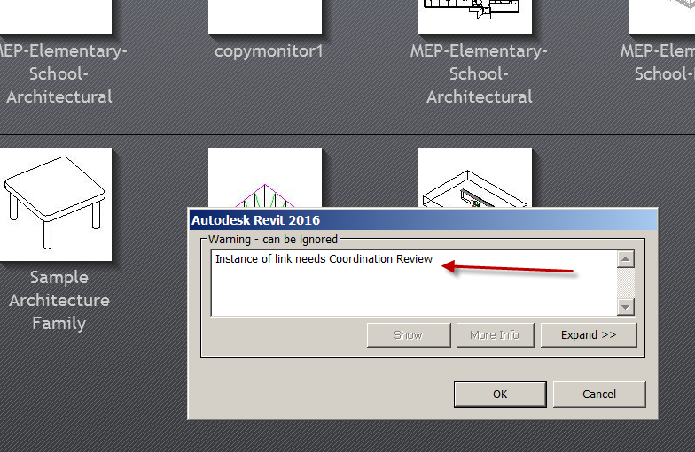
Expand it
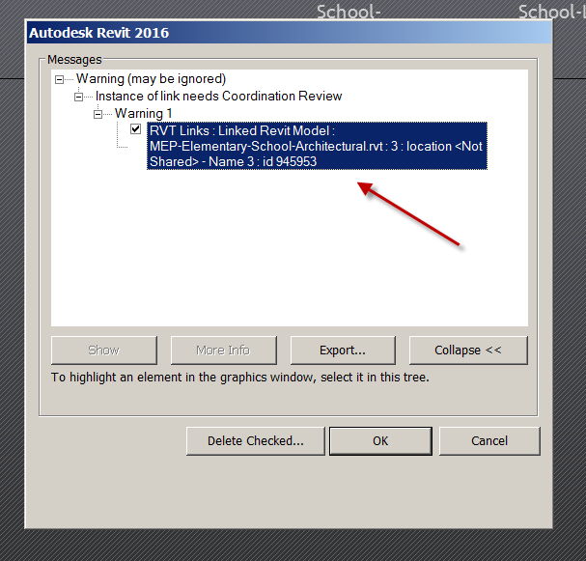

OK
The Architect moved the levels…..we know about it…we were warned.
Collaboration
Coordination Review
Select Link
Pick the linked file
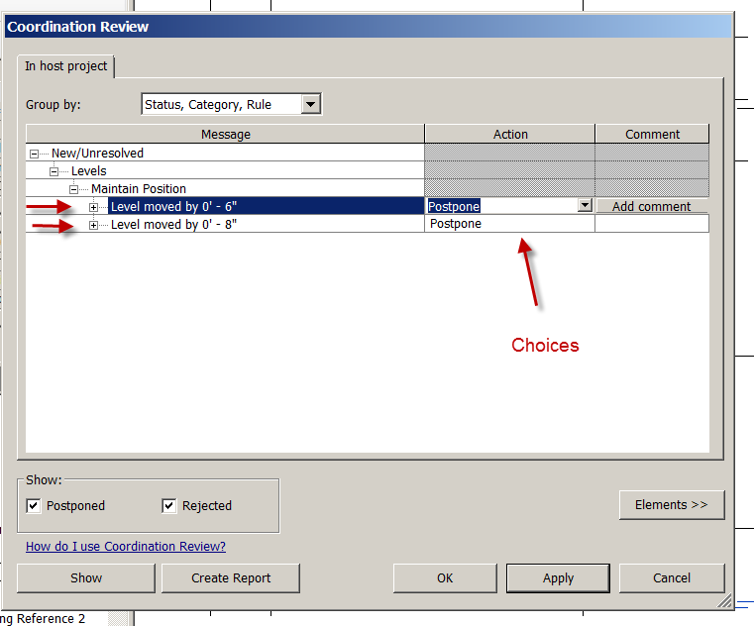

Under Action, let’s choose:
Move Level TOF on the first one
Reject the second one
Apply
OK
Let’s copy monitor the grids
Collaborate
Copy/Monitor
Select Link
Copy
Multiple
Select all of the grids
Finish (in option bar)
Ignore warning
See the heartbeat symbol (monitor)
Green Check to finish
Drag Grids away from each other to see duplicates
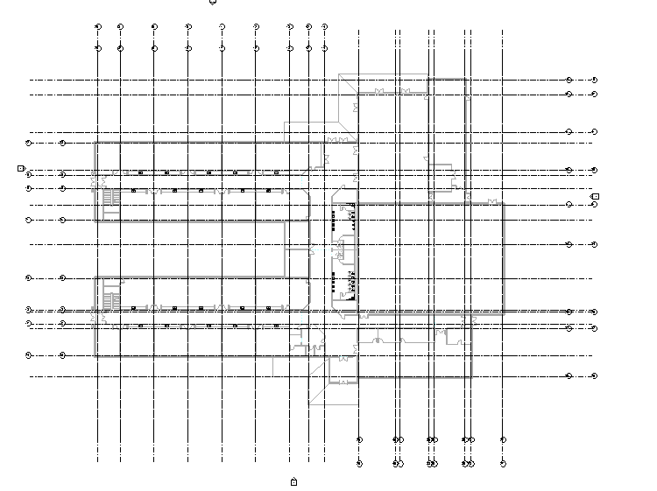
Save as copymonitor1.rvt
Close the file
Open MEP-Elementary-School-Architectural.rvt
01 Floor Plan
Turn on the grids
Move grid 19 up 1’0” (it’s at the top, right corner)
Save the file
Close the file
Open Copymonitor1
There it is again!
Collaborate
Coordination Review
Select Link
Note is still is warning us about that level…as well as the Grid 19 being moved.
Let’s fix them both.
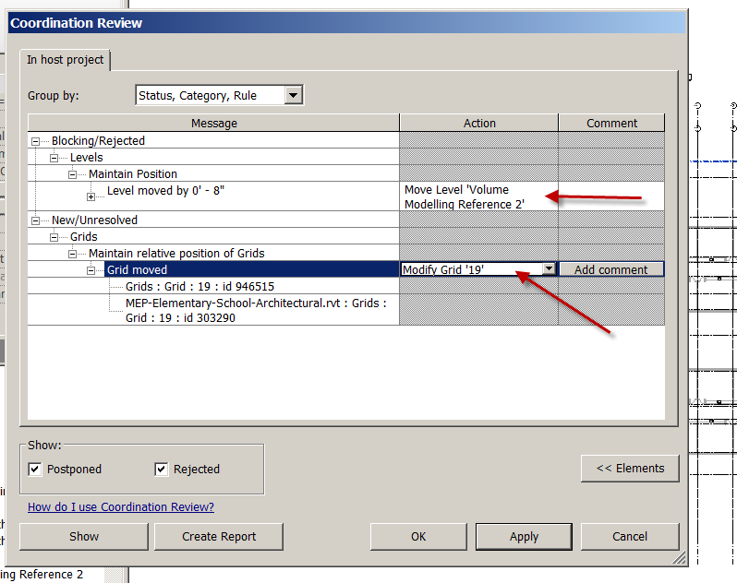
Note: Sometimes when the Architect moves something…it’s a mistake….or it impacts the MEP plan in such a way as communication between the MEP Engineer and the Architect must happen.
This is a much better process that just looking for variations!

Purging

You can purge unused items in Revit to make your drawing smaller in size.

Save you drawing as Revit2018demo27.rvt
Check the size by doing a File: Save as
Mine is 16000KB (that’s 16 MEG)

Manage
Purge Unused
Open Annotation Symbols
See checked boxes?
Those are unused in Revit. Note you have hundreds of unused families!
You can ONLY purge unused items….
OK
File
Save as: Revitdemo27Purged.rvt

Do a file save as again to see the new file size….
Mine is 6800KB………….that’s 6.8 MEG….a significant difference!!
Like with AutoCAD, purging …especially with large files can speed up your project and lighten the file. You can always load the families again if you need them. Don’t purge often….your file saving advantages reduce on each purge.

Transfer project Standards

You can copy project standards from one project…and apply them to another project. For example, you may have Company Materials in Revitdemo21 that you need in Revitdemo2.

Standards could be things like:
Family Types
Lineweights
Materials
View Templates
Object Styles

You must have BOTH projects open…the target and the source

Open Revitdemo2 and Revitdemo 27.

In Revitdemo2:
Manage
Materials
Note what you have…NO custom materials like PT101

View
Switch Windows

In Revitdemo27:
Manage
Materials
Note what you have… custom materials like PT101

We are going to transfer the materials from Revitdemo24 to Revitdemo2!

View
Switch Windows

In Revitdemo2:
Manage
Transfer project Standards

Careful….Check NONE…Discuss
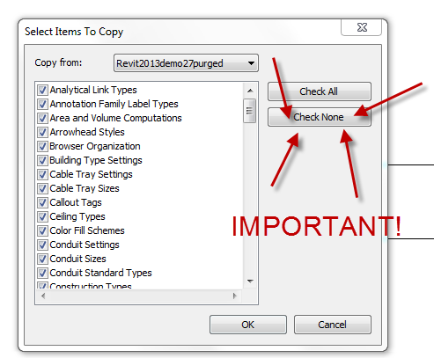

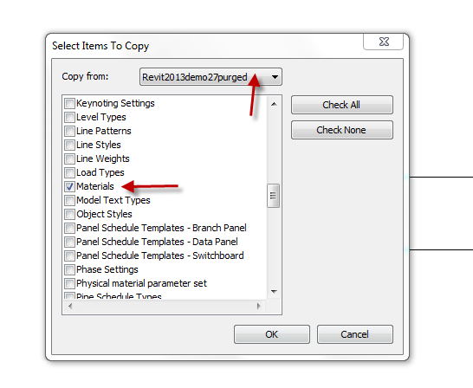

See all that could come over?
Check Materials
See “Copy From” (above) Revitdemo27
Take “New Only”

Now look at the materials in Revitdemo2….see the new materials?

Transferring one wall type from one project to another

In Revitdemo24, select the custom wall we created (Bills Wall)
Clipboard:Copy

View
Switch Windows

In Revitdemo2
Modify
Clipboard: Paste
Put it anywhere.
Delete it
Architecture
Wall
Wall
Change Element Type
In selection bar see “Bills Wall”?

You have learned you can copy a wall type, roof type, ceiling type …system family stuff…from one project to another.

You could create a file called FG Walls.rvt and put all your created walls in it. You would copy and paste needed walls from FG Walls.rvt to your target drawing!

Note: Putting all the walls you ever created in your template file will make your project file bigger than it needs to be.

Phasing for Tenant Improvements

Set up Level 1- As Built
Level 1-Demo
Level 1-Construction

Manage
Phases
We will ignore “Existing” for now
Rename New Construction to “As-Built”
Insert “Demo” Phase after As-Built
Insert “Construction” Phase after Demo
Your phases should be:
1. Existing
2. As-Built
3. Demo
4. Construction
(Note Past and Future in Phasing box)
Level 1 As Built
RC….View Properties
Phase Filter: Show All
Phase: As Built

Level 1 Demo
RC….View Properties
Phase Filter: Show Previous + Demo
Phase: Demo
You should use the Demolish tool in this (Demo) view!

Level 1 Construction
RC….View Properties
Phase Filter: Show Previous + Demo
Phase: Construction

To create an infill appearance:
In Level 1 Construction
Select demo’d object
RC
Override Graphics in View
By Element
Cut Patterns
Pattern…
Solid fill
OK

“Stealing” From Other Revit Projects

If you have a Revit file that was completed previously, you can “steal” the following:

Drawing Sheets
Drafting Views (the ones with the AutoCAD files in them)
Schedules
Legends

So if you did a perfect equipment schedule in 7-11.rvt, you can steal it …and use it in Mobil.rvt. The actual equipment families will (of course) not come over…just the parameters and setup.

If you have AutoCAD drawings placed in drafting views (as typ. Details) in 7-11 Riverside.rvt, you can steal them..and use them in 7-11 Buena Park.rvt!

In Target File
Insert
Insert from File
Insert Views from File
Find the source file (the ones with the views you want)
Open
“Insert Views” Dialog box comes up
Check Views and Sheets that you want
OK

If you select a bunch, it will take a few minutes.

You can steal 2D Elements from a file too

In Target File
Create a Drafting View
Name it Header Detail
Insert
Insert from File
Insert 2D Elements from File
Find the source .rvt file (the ones with the views you want)
Open
“Insert 2D Elements” Dialog box comes up
Pick Detail 0
OK
The elements will be placed in the current view and on the clipboard
Finish

Creating a .PDF of your Revit Sheet

We will create a 24 X 36 .PDF for the client.

Restore down Window (so you are not maximized)
Adjust window so you are cropped proportionally with the Revit sheet.

File
Print
Adobe PDF
Properties
Layout: Portrait
Advanced
Postscript Custom (just to right of Paper Size)
Postscript Custom Page Size
Width: 36
Height: 24
Check Inch
OK
OK
Paper Quality: Black and White
OK
Set up place to save file (Browse) in Project folder
Save
Setup
Zoom:100%
Paper Placement: Center
Preview
Print

Note: If you set up all the sheets by:
Restore down Window (so you are not maximized)
Adjust window so you are cropped proportionally with the Revit sheet….

You can print a SET by checking Selected Views and Sheets and choosing the sheets you want to print.

Key Schedule

OK….Schedules can have the same characteristics. A room schedule might have 100 rooms with the same floor, ceiling, and base finishes. Rather than add all this info for ALL 100 ROOMS (yuk)….you can define keys that automatically fill in the information (better).

If a room has a defined key, then as that room is added to a schedule, the fields in the schedule automatically update

You define keys using “key schedules”

When you create a key, it is listed as an Instance Property for the element.

When you apply a value for the key, the keys attributes are applied to the element.

Let’s try it………..

Open revit2018demo20.rvt
It should have rooms in it ….but no data added to the rooms yet.

Let’s copy The Master Bedroom ROOM and surrounding walls to the clipboard…then paste level by name…so we have some common rooms.

Select the walls first
Clipboard:Copy
Pick in white space
Clipboard:Pasted Aligned
Select levels by Name
Level 2-7
OK
See in 3D
Back to Level 1
Select the Room
Clipboard:Copy
Pick in white space
Clipboard:Pasted Aligned
Select levels by Name
Level 2-7
OK
The rooms are there..just not tagged

View
Schedules
Schedule/Quantities
Name: Room Style Schedule (def)
Rooms
Check Schedule keys
Key Name: Room Style (def)
OK
“Key Name” is already there….
OK
See the small schedule??

Modify Schedule/Quantities tab comes up (not much there)
Schedule:New
Each row creates a new value for the key….
New
New
New
You should have 4 rows

RC on Room Style Schedule in Browser
Let’s add:
Department
Floor Finish
(Remember having to add Department names for the color fill plans?)
OK
The schedule opens….

Key Name Dept Floor Finish Ceiling Finish Wall Finish
Patient Room Sleeping Carpet GYP PL235
Common Area Living Wood 70’s cot cheese PLAM
Restrooms Service Tile 2X4 ACT CT567/PL234
Storage Non-Living Concrete NONE PL101

OK….Lets test it…
Floor Plan level 1
Let’s try it on the Master Bed ROOM

Select the room
Properties
See the choices in the Identity Data??
Room Schedule
Properties
Fields
Room Style…Add
Change the key names
That’s pretty cool!!!
Show Room Schedule
Show adding Room Style to schedule…..hidden field.

Demo: Structural Components in Revit

Objective: Students will be able to setup a basic steel structure with concrete floors and footings utilizing Revit software. Students will be able to identify structural steel components such as columns, beams, braces, footings, and concrete/steel flooring.

The setup: Grids
When setting up a steel structure, start with Grids. They are set up horizontally with letters from left to right and vertically with numbers top down. The top, left corner will be Grid A1.
Architecture or Structure Tab
Grid
Make the grid line from bottom to top, vertically. Name the Grid “A”
Grid
Use the “pick lines” tool and offset grids B, C, D, E 25’0” apart
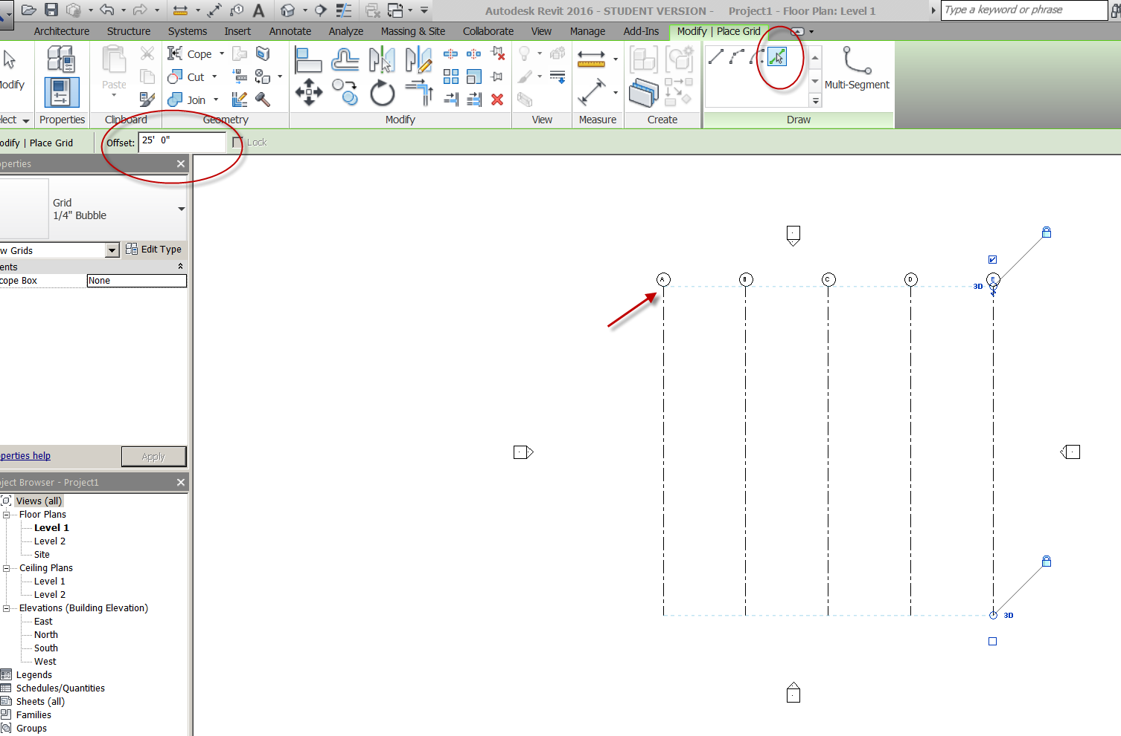

Grid
Create a horizontal grid from right to left
Name it “1”
Use “pick lines” tool to offset Grids 2, 3, 4 20’0” apart
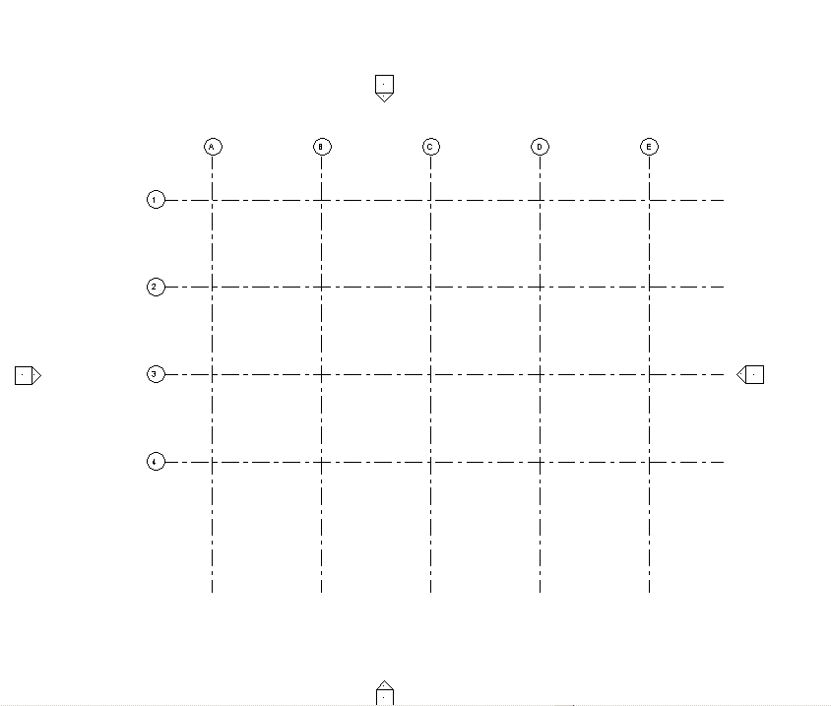

Show toggle for turning on Grid bubbles on opposite side of grid line
Show “edit type” on grid line to add grid bubbles on end 1
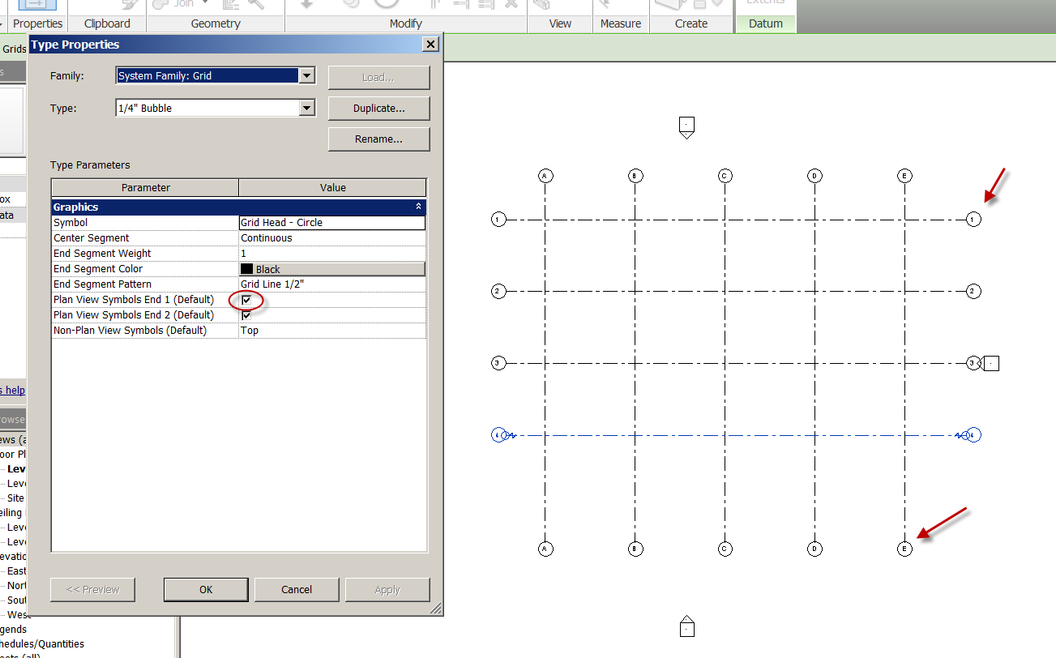
Structural Columns
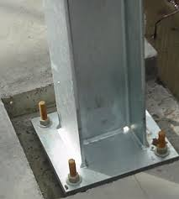
Note: Structural Columns are generally placed from top-down
Specify Height/depth in option bar BEFORE adding column
Floor Plan Level 2 (to place columns between Level 1 and Level 2)
Structure
Column
We’ll take the W10x49
Depth: Level 1 (get it….top-down?)
Place the column at Grid A1
Go to level 1. Is it there?
Cut a section to see the column. You may need to turn off the lineweight to see it clearly
Set the Display to Fine
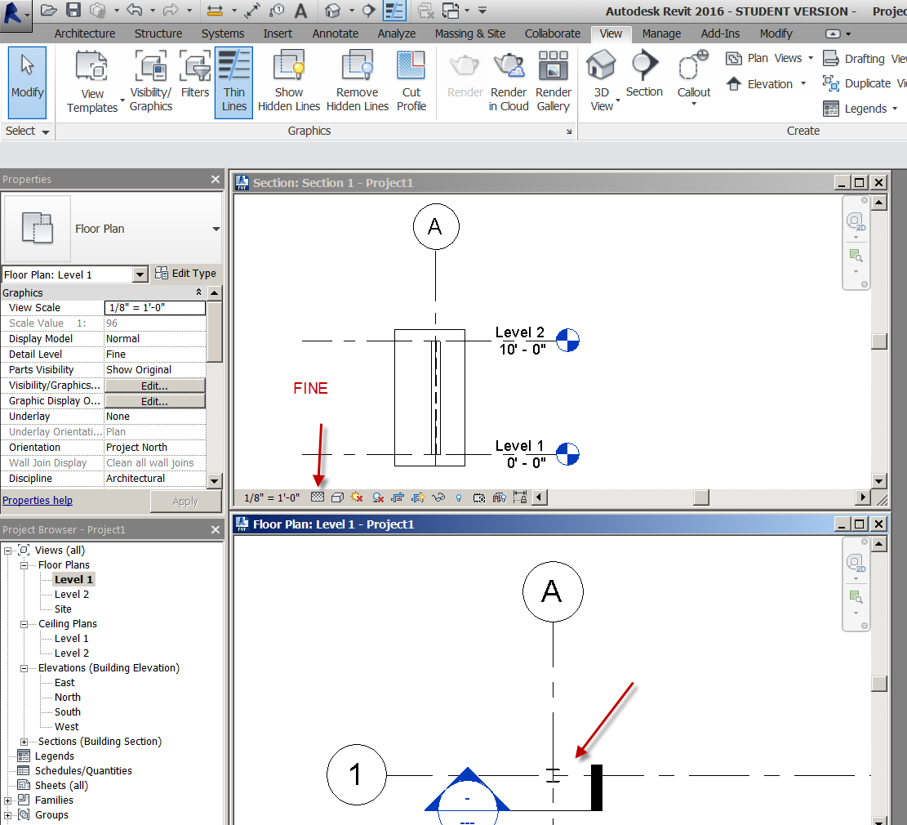

Back to Level 2
Let’s place the columns “by grid”….it’s faster!
Structure
Column
W10x49
At Grids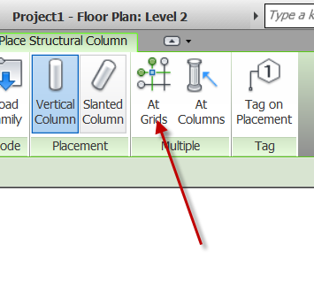
Use a crossing window to select the grids (bottom right to top left). You can hold the control key to select the remaining grids not picked up by crossing.
Depth: Level 1
Green Check
See in 3D!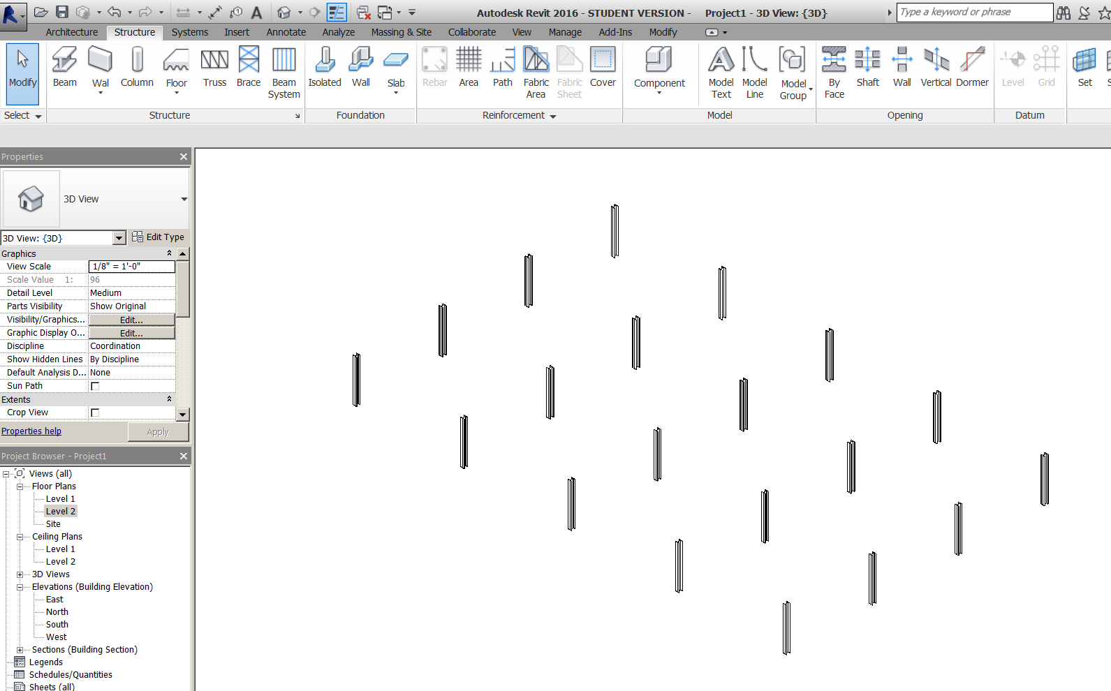

Add Footings for Columns
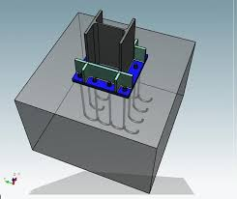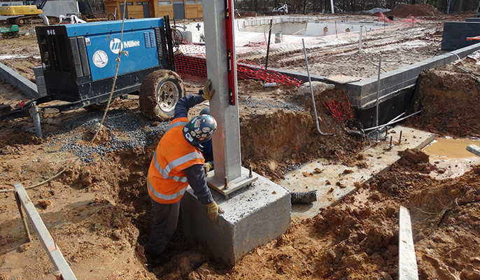
Floor Plan Level 1
Structure
Isolated
Sat “YES” to load family
Structural foundations….Footing rectangular….Open
Edit type….duplicate
Name it F3.0
Make the sizes: 3’0x3’0x1’0
Place at grids…..Finish
Note: You will not be able to see them because they are below Level 1!
Set Level 1 view range to view 2’0” lower
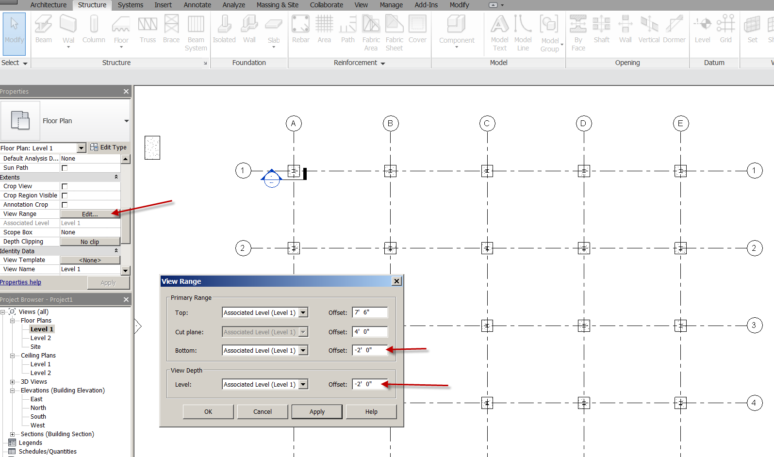

Save as structure1.rvt
Foundation Plan
Duplicate with Detailing Level 1
Name it “Foundation Plan”
Confirm the view Range is set to -2’0” (so we can see the footings)

Creating an exterior wall
Architecture
Wall
Basic wall generic 8” Masonry
Height: Unconnected 20’
Draw the wall 1’1 outside the grid line

Creating the footing
Structure
Foundation panel
Select: Foundation wall: Bearing Footing 36x12
Place on/attach to exterior walls
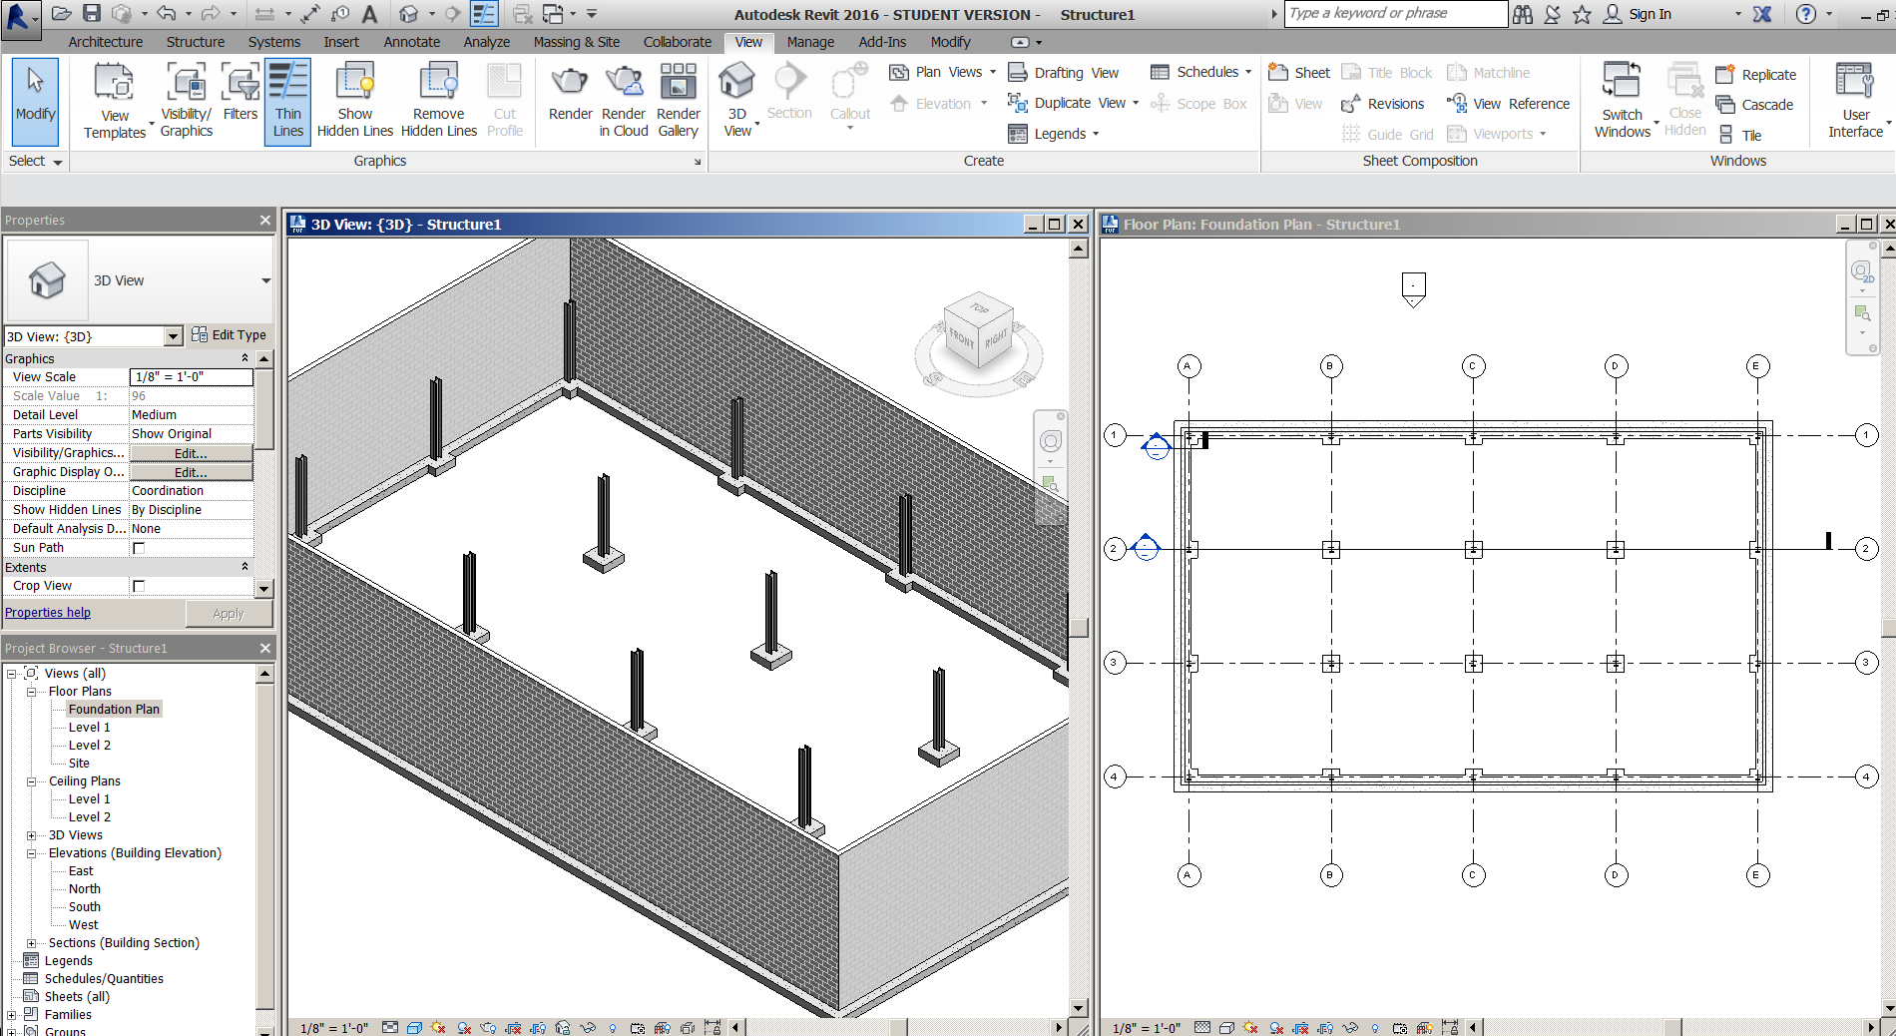
Save as: structure2.rvt

Creating Beams
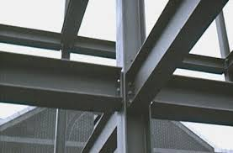
Level 2
Set view range to -2’ depth, like we did on foundation. The beams will be between level 1 and Level 2.
Set display to Fine
Structure
Beam
W12x26
Draw a beam from Grid A1 to B1
Draw a beam from Grid A1 to A2
OK
Show “change reference” button to extend beams to web instead of flange.
Continue to draw beams horizontally and vertically between gridlines.
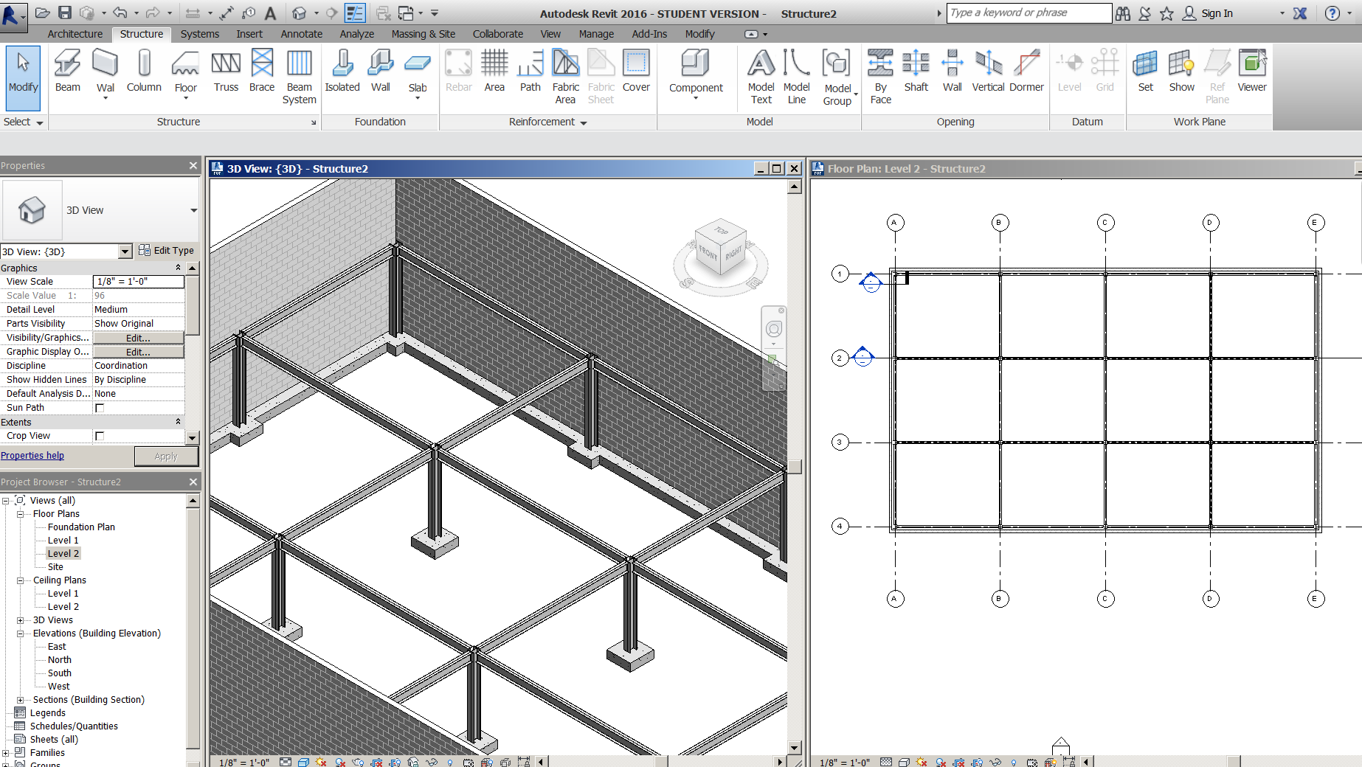

Creating a Beam System
Insert
Load family…structural framing….steel…..W-Wide Flange
W8x31….OK
Structure
Beam System
Automatic Beam System….W8x31
Fixed distance: 5’0
Pick inside top, left area between Grid A1 and B2. Note direction of beams
Set Elevation at 0
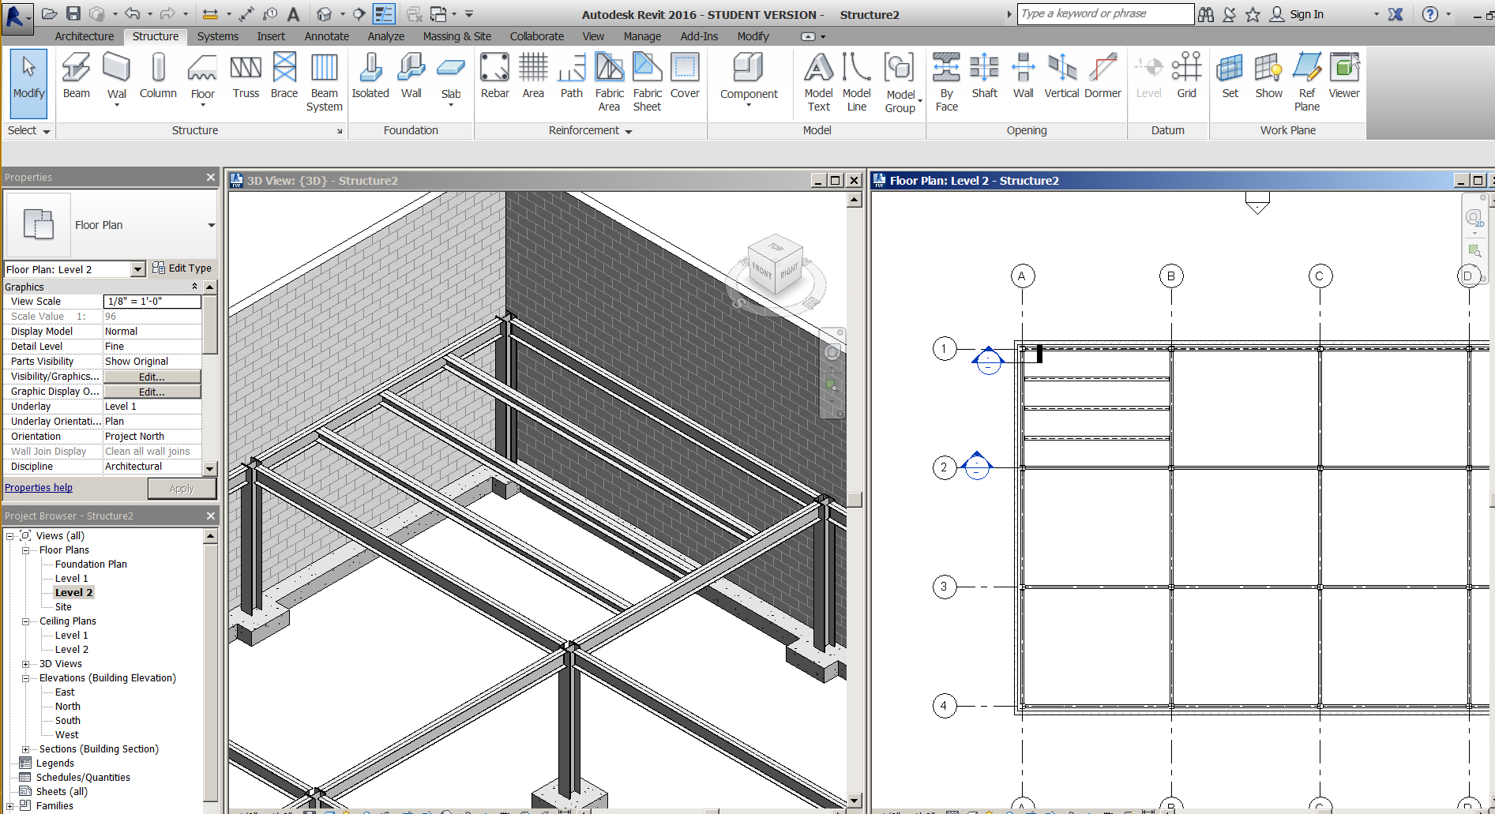

Create the rest of the beam systems (do not try to do all at once)
Note: No beams should be spanning the entire building!
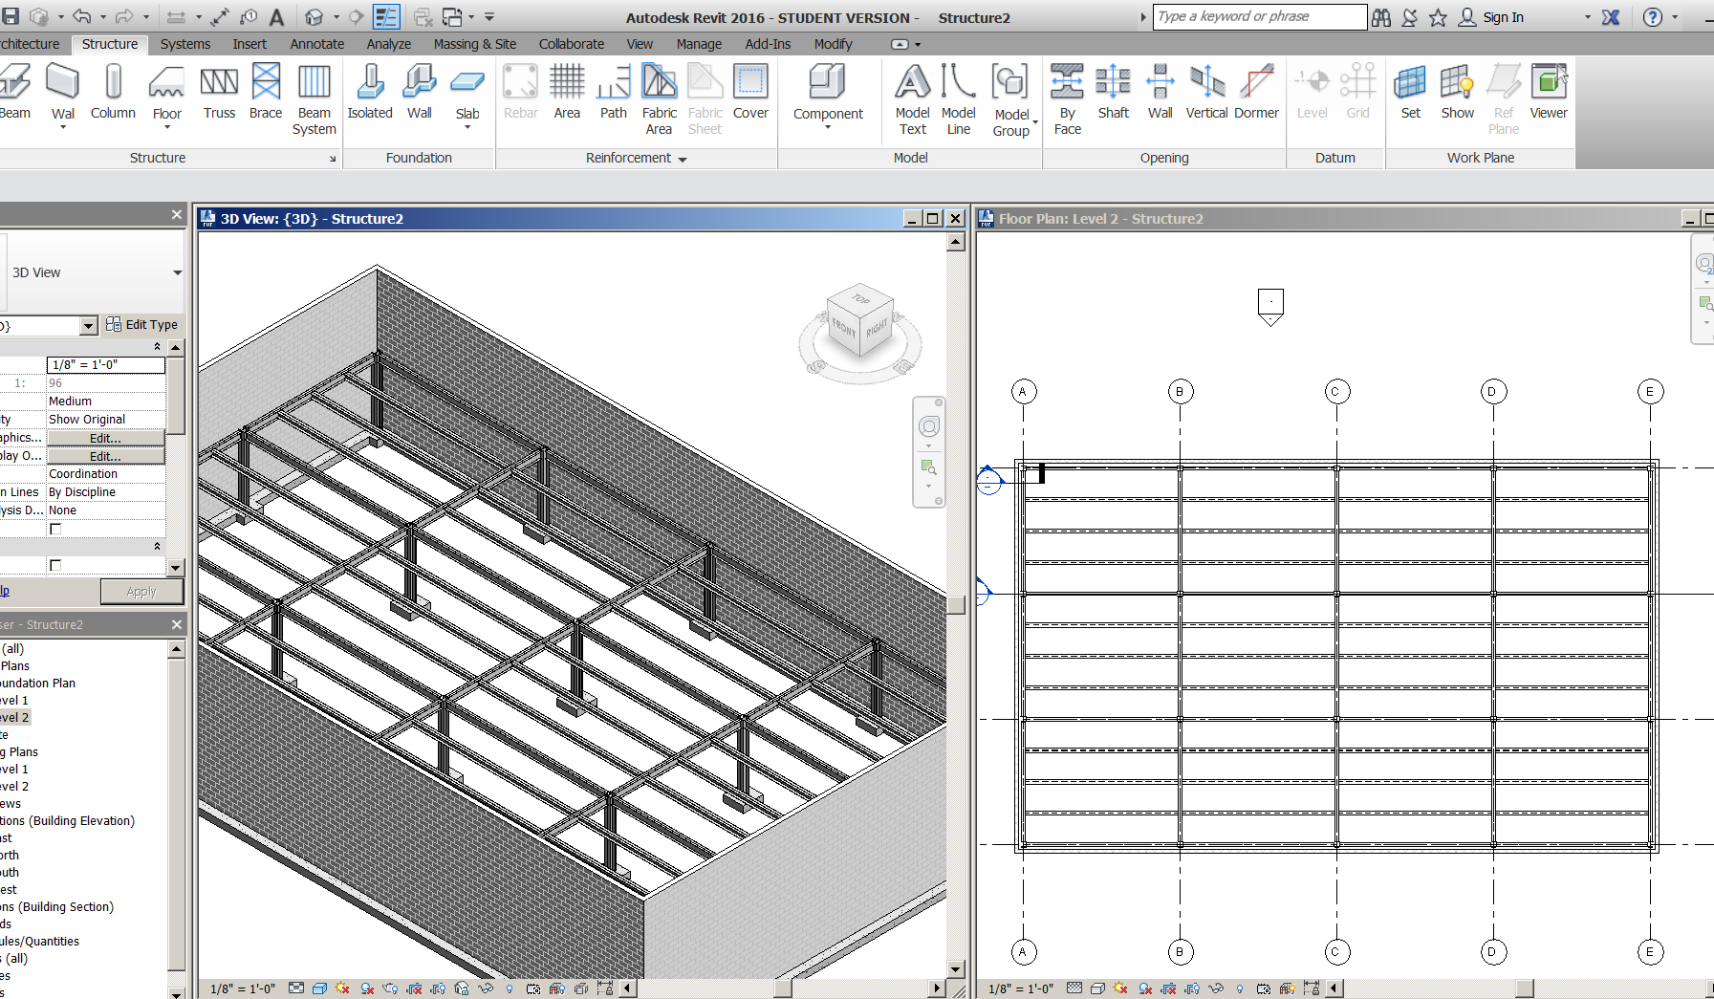

Creating the Structural Floor
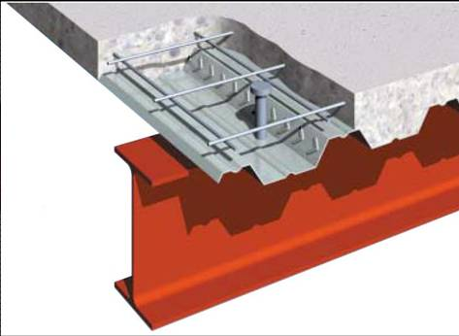
The structural floor is made of a metal deck w/ concrete poured on top.
Level 2
Structure
Floor: structural
3” LW Conc on 2” metal deck
Offset 5” (the thickness of the deck)
Make the boundary to the face of wall, not to gridline.
Cut a section to show the flooring and steel structure
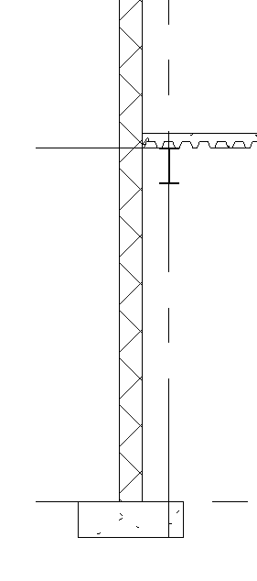
Save as: structure3.rvt
Creating Framing Elevations
Framing elevations are generally used to create (diagonal) bracing.
Level 1
View….. Elevation…..Framing Elevation
Note: these work differently than regular elevations
Pick a spot on Grid B between Grid 2 and 3
See how the framing elevation snaps to it?
Go to elevation View
Display: Fine

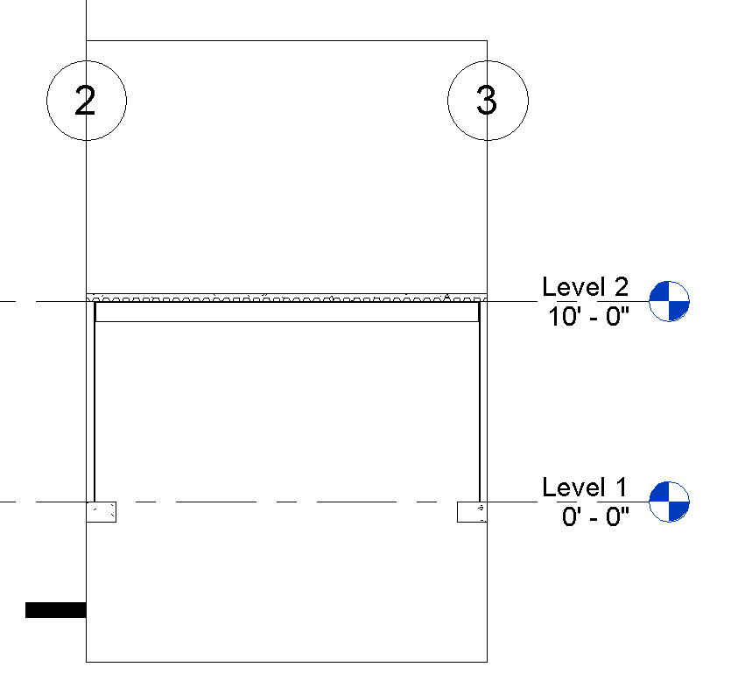
Note only one bay in the grid is selected! The framing elevation is ready for “Bracing”

Bracing
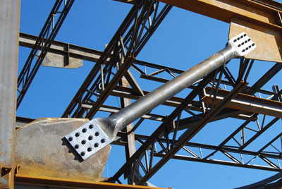
In Elev 1a you just created:
Insert….load family….Structural framing….Steel….
LL-Double Angle……2L6x4x3/8LLBB
OK
Structure
Brace
Create at 45 degree angle
Show in 3D (no connection brackets yet)
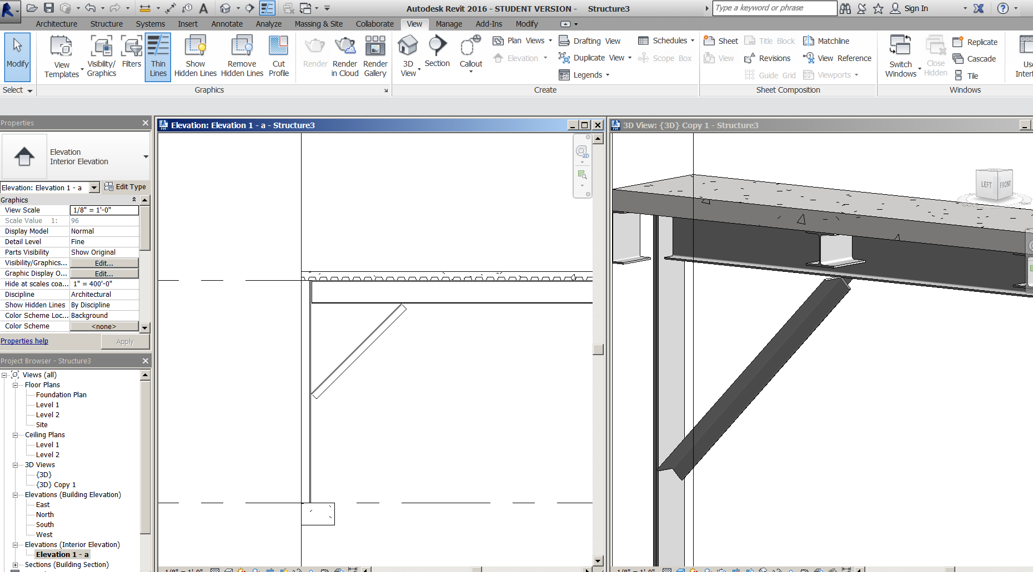

Revit 2018 Path Issues Solution

Windows….Control Panel…..Appearance and Personalization….Folder Options: Show hidden Files and folders….Show hidden files, folders, and drives
In Revit Architecture software:
R…Options….File Locations
Project template Files
It is empty
+
Should be: C:\ProgramData\Autodesk\RVT 2018\Templates\US Imperial\default.rte

Default Path for Family Template Files
It is here: \Templates
Should be here C:\ProgramData\Autodesk\RVT 2018\Family Templates\English_I\
Places
Library Path
It is here: C:\Program Files\Autodesk\Revit 2018\
Should be here: C:\ProgramData\Autodesk\RVT 2018\Libraries\US Imperial\
Detail Library Path
It is here: C:\Program Files\Autodesk\Revit 2018\
Should be here: C:\ProgramData\Autodesk\RVT 2018\Libraries\US Imperial\

Spanish Character Floor Plan 2017-18

Software: Revit 2018

Design a one story home to the following program:

Spanish Architectural style (authentic as possible).
One story
Spanish massing.
2100 square feet +/- 50 square feet
Footprint no bigger than 70 feet long and 50 feet deep (this includes 2-car garage)
Living
Family
Kitchen
Entry
Dining Room
3 Bedrooms (one is the Master)
2 ½ Bathrooms
2-car attached garage (22’ X 22’does not count against square footage) 9’ plate height, two 9’0” wide X 7’6” high garage doors match style of front door
Entry Tower 13’-15’plate height (does not have to be part of internal area)
Authentic Spanish details for doors, windows, surrounds, roof, etc. Research!
Standard closet in secondary bedroom, WIC in master bedroom
Indoor laundry
Fireplace in Living or Family Room
10’ plate height.
8’0” head height for doors and windows
Courtyard (front and/or back)
Loggia off Master Bedroom.
Colors and exterior materials authentic to Spanish character

Step1: Bubble Plan. This is where you will organize your room placement, traffic paths, and roughly design your house (not) to scale. Add Roof Plan w slope arrows (color pencil).

Step 2: Detail Sketches: This is where you “study” the Spanish character and get your details together. Doors, windows, Gable, wrought iron, shutters, etc.

Step3: Elevation Sketches. Create 3 character elevation sketches (not to scale) with proper massing, potential details, and materials. These should be loose sketches.

Step 4: Elevation Blockout. Create 1/8”=1’0” scale elevation drawing with red pencil/pen. Details, correct roof, exterior materials, doors and windows should be included. Turn in copy for grading.

Step 5: Rendered Front Elevation Sketches. Three Spanish concept elevation sketches. Looking for different details…alternate ideas of the same house

Step 6: Draw construction documents in Revit. See next page for required drawings.
Revit Drawings required: See Checklists for Requirements

- Cover page (4 3D Views + List of Drawings)
- Foundation Plan.
- Floor Plan
- Electrical Plan
- Exterior Elevations
- Building Sections
- Concept Sketches taped to B-size paper
Drawings will be printed on B (11x17) sized paper on the HPM750 at 38% scale and saved to
X:\labs\brown\submit\Period 2 Arch Design

Presentation: Projects will be stapled top, left corner. Pages will be numbered according to provided class standard.

A Home for Mr. Bond

Builder: WCB ARCHITECTURE

Software: Revit 2018

Specific Character (ex: French, Craftsman, Greek Revival, etc)
2 Story
4400 square feet (+/- 100 sq ft) does not include Garage
4 bedrooms total
4 bathrooms (one will be powder, one in Guest quarters, one in master)
“Guest” quarters: bedroom, bathroom, kitchenette, closet, private access
Home Office
3 Technology Spaces
“Bill Paying” Space
Living Room
Family Room
Formal Dining
Kitchen: Modern. Island, double oven, range or cooktop, microwave, ref, dw, wine chiller, double sink, vegetable sink in island.
2-car attached Garage
Indoor laundry
Mechanical Room (HVAC, Water Heater, Circuit Breaker Box)
Master suite (include WIC, bathtub, shower, his/her vanities, private watercloset)
Gas or “fake” Fireplace
Storage cabinets:
clothes
linens
books (maybe recessed into wall?)
Furniture (for spatial assistance)
Stairs authentic to the character

Sketches Required
1-2 Bubble Plans for 1st and 2nd Floor in pen Your name, Character Name, SHS

3 Front Elevation sketch (pen on flimsy) Black and White, foliage, shadow, GL, Your name, Character Name, “A HOME FOR MR. BOND”, black out windows. 1/8” = 1’0” scale
4-5 2 Colored, rendered Front Elevations (different options), foliage, shadow, GL, Your name, Character Name, “A HOME FOR MR. BOND”, black out windows.
1/8” = 1’0” scale

Drawings Required (you will have close to 20 sheets!)
All drawing on D size paper with Arch border. Create own Revit title block. Proper sheet numbers.

(1) Cover (4 3D views NE, NW, SE, SW, rendered 3D, “A HOME FOR MR. BOND”, Table of Contents/Sheet List)

(2)Site Plan Use provided Site Plan. See Site Plan Checklist. Link Building into Site

(3)Foundation Plan See Foundation Plan Checklist.

(4)1st Floor Plan See Floor Plan Checklist.

(5)2nd Floor Plan See Floor Plan Checklist.

(6)1st Floor Plan Electrical See Electrical Plan Checklist. Include Electrical Legend.

(7)2nd Floor Plan Electrical See Electrical Plan Checklist. Include Electrical Legend.

(8,9)Exterior Elevations See Exterior Elevation Checklist

(10)Building Section 1, 2 with 3D sections (room labels, proper annotation)

(11) 2 Wall Sections w/ annotation. Include 3D Section boxes (small) of each. All one sheet.

Detail Sections w/ annotation (cornice, sill, garage, special wall framing).
Scale ¾” = 1’0”? All one sheet. Make fit. Apply “callout” strategy where applicable.

(12)Interior Elevations Kitchen See Interior Elevation Checklist

(13)Interior Kitchen Plan 3D. 2 w/section boxes NE, SW and 4 interior renderings utilizing Enscape (NE, SE, NW, SW)

(14)Interior Elevations Baths, Office, Tech, Bill Pay, and Laundry See Interior Elevation Checklist

(15)Interior Baths, Office, Tech, Bill Pay, and Laundry 3D. w/section boxes and interior renderings utilizing Enscape

(16)Door Schedule (Tahoma font) same contents as last project

Window Schedule (Tahoma font) same contents as last project

Room Schedule (Tahoma font) Finishes, Dept, Area

(17)Written Proposal Required
400-500 words “explanation paper” describing what you did and why you did it….both inside and out. Use architecture terminology and resources if necessary. This would include explaining your details and why you used them. Copy word doc and paste on sheet 17 in 3/16” text.

Rendered Sketch. Put it on a Drafting View. Name it “Character Elevation Sketch”

I will grade the project in segments to make sure you are progressing to my timeline. No late work. You will have 1 week to revise work for re-grade. That work will likely need to be completed during after school hours. HINT: If you can get ahead……deadlines will be less stressful!
Evaluation

This will be 60% of your 2nd semester grade, and be your main portfolio component. It will be broken down as follows:
Sketches 15%
Written Proposal 10%
Technical Applications (Drawings) 30%
Creative Applications and Accuracy of Character (Drawings) 25%
Rendering 10%
Presentation (mounting, clean/neat, etc) 10%
Extra Credit (ONLY if all above is COMPLETE) 0-20%
SkillsUSA (regional and state) (applied to 1st and/or 2nd semester grade) points assigned by effort, attendance after school, and results
ACE Mentors participation (applied to 2nd semester grade) points assigned by effort, attendance after school
Revit User Group meeting(s) (applied to 1st and/or 2nd semester grade) points assigned by attendance and verbal participation.
Characters:
- Andalusian (Southern Spain)
- Colonial Revival
- Craftsman
- Cuban
- Dutch Colonial
- American Farmhouse
- Folk Victorian
- French Country
- French Eclectic (Formal French)
- Georgian
- Gothic Revival
- Greek Revival
- Italianate
- Japanese
- Mexican
- Mission Revival
- Monterrey
- Prairie
- Queen Anne
- Richardsonian Romanesque
- Second Empire
- Shingle
- Spanish Colonial/Santa Barbara
- Stick
- Tudor
- Tuscan

Residential Floor Plan Checklist

- Location of all doors, windows and walls (dimensions)
- Length of walls (sub-dimensions or overall)
- Dimension walls to face of core
- Door and window tags (for schedules)
- Properly designed hallways leading to bedrooms
- Kitchen designed with all necessary elements to include: sink, stove/range/oven, dishwasher, refrigerator, pantry, upper cabinets, base cabinets
- Fireplace (fake or Gas). No more wood burning fireplaces in California!
- Entry/Foyer
- Stairs (must be functional and match style of character)
- Linen closets
- Storage space: clothes, books, etc. Would like to see creativity here…recessed walls, surprise spaces.
- Properly designed hallway endings
- Bedrooms: Guest, Master, 2 secondary
- Bedroom closets
- Bathrooms with a minimum of: lav, W/C, tub and or shower with adequate space to move
- 4 bathrooms total: one in Guest Bed, one in Master bed, one for the 2 secondary bedrooms, and a powder room downstairs.
- Laundry room
- List square feet on drawing (4400 SQ FT+-100). Show 1st floor, 2nd Floor, and Gar. totals
- Living Room
- Family Room
- Home Office
- Tech Spaces
- Bill Paying Space
- Formal dining
- 2-car Garage
- Room labels: underlined, capitalized, include all rooms, hallways, key exterior adjacent features like porte-cocheres, loggias, tandem garage, courtyard, etc
- North arrow
- Doors: proper size, swing direction, and fit
- Marketable design
- Interior elevation marks
- Building Section marks where needed
- Wall section marks where needed
- Furniture will be later….just freeze for now. Just need fixtures
- Flooring: if tile, wood, stone, marble, etc show ½ tone gray (kitchen, bathrooms, dining, etc)
- Notes for dropped ceilings: give height at location
- Print medium detail (I want to see your wall construction)
- Complete title block with character name, scale, Santiago High, your name, Mr. Bond’s name, First Floor Plan, Second Floor Plan, etc. Logo OK.

Bathroom Elements: Checklist

Toilet/Water Closet
Tub
Tub surround including splash on walls
Tub faucet
Shower (base with drain)
Shower glass door
Showerhead
Shower ceramic or glass tile surround
Vanity w/PLAM applied
Sink (lavatory)
Faucets (separate from sink)
Countertop (2’5 1/2” to start)
Splash
Towel Rack
Medicine Cabinet near sink(s)
Mirror over sink(s)
Paint: Semi-Gloss
Vanity Light
Fan/Light Combo
Vapor resistant light over shower and Tub
Ceiling Gyp (paint semi-white) same as Kitchen
Adjust flooring under Tub, Vanities.
Base molding where appropriate (best to do after placing bath fixtures)
Material colors should complement each other.
GFCI Outlets
Switches
Flooring (not under casework or fixtures)

A HOME FOR MR. BOND: Floor Plan Design Notes

Area of each floor. You can get this by creating an “Area Plan”. Remember to count the stairs only once. Give total area (less Garage) on each Floor.
Turn Underlay off. RC. View Properties. Don’t want to see first floor walls on 2nd floor.
Title block family. You will create a custom title block.
Dimension Hallways. Looking for 3’6” wall face to face. No more. No less. Hallways should take you to rooms….that’s it!
Room size guidelines:
Master Bed: 225 sq ft. No less than 13’ clear.
Master Bath: ¾*225= 168 sq ft.
Master WIC 100+ sq ft
Secondary Bedrooms: 144 sq ft. No less than 11’ clear.
Guest Bedroom: 160 sq ft. No less than 12’ clear.
Office/Den Library: 160 sq ft. No less than 12’ clear. Try to keep “Open” (not 4 walls)
Tech: 20-50 sq ft
Bill Paying Space: 10-30 sq ft (generally a niche)
Mechanical Room: 50-80 sq ft. Clearance for tech to “service” fixtures
Living: 250 sq ft. No less than 15’ clear.
Family: 275 sq ft. No less than 15’ clear.
Kitchen: 200-250 sq ft. Make sizes divisible by 2’0”….10X12….12X14…..8X16…..etc
Stairs: 3’6 wide. Straight the least desirable. L and U shapes best. Authentic to character.
Garage: 22X22’ is typical 2-car. Can be 25’X25’ (“Full Double”) ATTACHED
Need: Fixtures and casework, closets/storage, furniture, doors and windows, smart walls everywhere, dimensions, room tags, North Arrow, etc. See Floor Plan Checklist
Residential Electrical Checklist
- GFCI’s in Kitchen.
- 20 amp GFCI in Bathrooms
- AFCI circuit in Bedrooms (use a text note to specify….”DEDICATED AFCI CIRCUIT IN BEDROOMS”)
- At least one wall switch in bedroom. OK to outlet or light.
- Smoke detectors in bedrooms
- Smoke detectors in hallways leading to bedrooms.
- Hallway lights w/ switches
- S3 for stairs to light (above and below).
- Hidden line swings arcs (not straight)
- Ceiling lights in Kitchen
- Ceiling light fixtures displayed as solid lines, circles
- Room Tags (no area)
- Switches not behind doors
- Garage: one GFCI outlet min.
- Duplex Outlets every 12’0” linear
- Front outlet GFCI water proof
- Rear outlet GFCI waterproof
- Laundry outlet 20 amp GFCI
- Hallway outlets when walls are >10’
- Porch light w/ switch inside
- Light in foyer
- Bathroom: no lights within 3’ horizontally to tub/shower unless Vapor Proof
- Range, DW, and REF outlet
- Service panel
- Casework, plumbing fixtures, specialty equipment half-toned (so electrical outlets show better)
- Turn off Floor Pattern
- Use overlay method to show ceiling fixtures on electrical plan

Cover Sheet Checklist

3D view of Building SE corner: Shaded View

3D view of Building NW corner: Shaded View

List of Drawings: In order of Drawing Sheets. “C” drawings first.

Rendering. Looking at the building from the Front view with a slight tilt to show depth.
Background pic file .png, Render materials applied to building, shrubs in front of building and cropping of building.

Title block to List: Your Name, Your Character, Client name, Santiago High Architecture. Large Text (use your best judgment). No border Lines. You will need to make a Title Block family.

Site Plan Checklist

We will use the Site from the “Tuscan Plan”.

- Property lines and their length and compass orientation
- Corner elevation marks
- Size and Location of dwelling on site
- Size and Location of additional structures on site
- Contour lines/slope of property
- Street(s) adjacent to property
- North arrow
- Scale
- Driveway size and location
- Sidewalk
- Fencing: Location, height, lineal footage
- Lot coverage %
- Legal address
- Type of Construction (V-NR)
- Occupancy (R-3)
- Square footage of dwelling and additional structures
- Year of building code
- Date of last revision
- Gas line
- Water line
- Electrical service panel
- Setbacks (dimensioned and labeled)
- Dimensions set to 0’0”. No small fractions.
- Property line and dwelling created with thick lines
- Title block completed and fit on paper correctly
- If building is on Site, turn off roof pattern
- 2D Site plan no color
- Materials on Site

Presentation Plan Checklist

- Room Labels with Name and Area. Capitalize. No number
- Color walls black. VV….. Walls… Cut pattern solid fill.
- No annotation (tags, dimensions, etc)
- Color Scheme by Sleeping, Living, Corridor, Non-Living, and Service
- Color Scheme Legend
- Pastel colors for Color Scheme
- List Gross Area of Level
- List Gross Area of Garage
- Show Furniture and Fixtures
- Turn off Floors

Interior Elevation Checklist

Kitchen, Baths, Tech, Bill Pay, Laundry

- Vertical and horizontal dimensions using assigned dimension style.
- Tag plumbing fixtures PF, Lighting Fixtures LF, Casework CW, and specialty equipment SE
- Upper Cabinets
- Base Cabinets
- Outlets and switches on countertop.
: 3/8”=1’0”
- No color

Foundation Plan Checklist

Dimension location of foundation footings with class dimension style
Overall dimensions
Garage to house footings display correctly: with hidden line-solid line-hidden line. The solid line would be where the garage drop is.
Section marks
No elevation marks
Interior bearing wall footings represented with hidden lines 12” wide
Exterior footings represented with a solid line (for exterior of slab) and a hidden line for edge of footing underground.
Block-out for garage doors displayed and noted.
North arrow proper direction (reference site plan)
Concrete notes:
- 5" CONC. SLAB , 6" BELOW HOUSE SLAB, 0VER 5" GRAVEL FILL - SLOPE 1/4" MIN. PER FT. FOR DRAINAGE
- 5" CONC. SLAB OVER 5" SAND FILL W/ 6X6-W2.0XW2.0 WWM PROVIDE .006 VAPOR BARRIER & 2" X 24"RIGID INSULATION AROUND ENTIRE PERIMETER
- BLOCK OUT FOR 8’0” GARAGE DOOR
- BLOCK OUT FOR 2’8” GARAGE DOOR
- 2 X 6 DFPT SILL W/ 7/8" X 20" A.B. @ 6'-0" O.C. 17" MIN. INTO CONC & 12" MAX FROM ANY CORNER W/ 3" DIA. WASHERS.
.

Exterior Elevation Checklist

- Vertical dimensions using assigned dimension style. Dimension from Floor line to top of doors and windows, not sills.
- NO horizontal dimensions, except for roof overhang
- Smart exterior materials to be tagged
- Model Rafter Tails 2’0” O.C. if present
- Model Shutters if present
- Model Balconettes if present
- Model Chimney.
- Use Model Lines for Wrought Iron on door and shutter dogs.
- Windows and Doors should look exactly like the elevation drawings provided
- Door and Window tags
- Roof Pitch symbols
- Roof Pattern lighter. Smart material tag to be applied
- Roof gutter applied where appropriate. Downspouts for ambitious students.
- Do not show stucco as pattern on elevation
- Freeze toposurface
- Hidden lines for foundation (detail lines)
- Thick ground-line (use 7 lineweight)
- Floor line is hidden (linework…may need to go to wireframe to set up)
- Lineweights should have “POP” on all elevations
- No color

Kitchen Plan Checklist

Assign appliances, flooring, plumbing fixtures, casework, island (optional), ceiling, lights, and countertops to the Kitchen.

Create a Presentation Plan for the kitchen to include:
- Rendered View of Kitchen
- Presentation View of the Kitchen Expanded Plan
- Two, 3D Section Boxes
- Two, Interior Elevations with “smart” material tags. You can duplicate the existing Kitchen Interior Elevations.

Section Checklist

Building Section Checklist

Scale: ¼” = 1’0”
Detail Level: Medium
NO COLOR
Room Tags
Callouts for Wall Sections and/or Detail Sections
Insulation
Turn Off furniture, fixtures
Roof Truss
“Title on Sheet”over-ride. Describe Section….Ex: “Section Thru Kitchen North View”
2X4, 2X6, etc as detail components
Ground under sand/gravel (as filled region)
2” Sand/gravel under slab(as filled region)
Ground line label
Ridgeboard
2X6 ceiling joist (detail lines)
2X6 double top plate
2X6 Sill Plate
2X6 under windows
4X6 Header over doors and windows
Slab thickness dimension
Footing width dimension

3D view of Section in color

Wall Section Checklist

Detail Level: Medium
NO COLOR
2X4’s, 2X6’s etc
Insulation
Annotation for wall and roof elements seen in this view (Example: 5/8 GYP, 2X4, 1/2PLY, .006” VAPOR RETARDER, 1” STUCCO)
Callout for Footing(s) Detail
Callout for Eave Detail
Scale: ½”=1’0”
“Title on Sheet”over-ride. Describe Section….Ex: “Section Thru Kitchen North View”
Turn OFF crop view
2X6 TREATED SILL PLATE (at foundation)
Footing Detail Section Checklist

Detail Level: Medium
NO COLOR
Copy to clipboard…paste same place…all 2D elements in Wall Section
7/8” Anchor Bolt - 20” DEEP @ 6’0” O.C.
#4 rebar
Welded Wire mesh: 6X6-W2.0XW2.0 WWM
Concrete floor and concrete footing should be joined (graphically)
POP of exterior footing
Annotation for wall and footing elements seen in this view
Scale: 1”=1’0”
“Title on Sheet”over-ride. Describe Section….Ex: “Section Thru Kitchen North View”
Break Line
Turn Off Crop view

Eave Detail Section Checklist

Detail Level: Medium
NO COLOR
Roof to wall elements (like double, top plate, ceiling, roof joist, brackets, etc)
Smart Roof Elements
Copy to clipboard…paste same place…all 2D elements in Wall Section
Annotation for wall and roof elements seen in this view
Scale: 1”=1’0”
“Title on Sheet”over-ride. Describe Section….Ex: “Section Thru Kitchen North View”
Break Line
Turn Off Crop view

Schedule Checklist

Door Schedule

Mark Door #
Family Door Style
Type Door Type
Level Floor #
Thickness THK
Height Height
Width Width
Head Height Head Height
Frame Material Fr. Mat
Comments Notes
From Room: Name From Room: Name
To Room: Name To Room: Name

Subdivide Thickness, Height, Width under category “Door Sizes”
Notes: “Hollow Core” or “Solid Core”
In this order.
Sort by Mark
Make sure schedule columns look proper on sheet!

Window Schedule
Count QTY
Type Mark Win #
Level Floor #
Family Window Style
Height Height
Width Width
Type Comments Notes

Uncheck itemize every instance
Sort by: Type Mark then by Level
Notes: “Dual Pane Glass, Gas Filled”
Make sure schedule columns look proper on sheet!

Project 2 Assignment

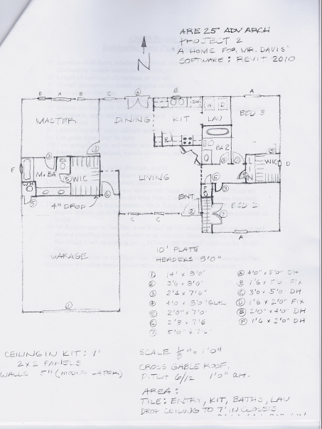
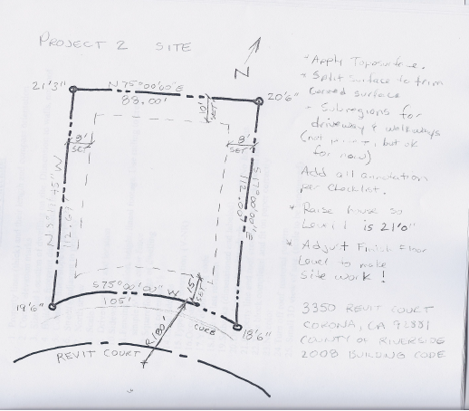
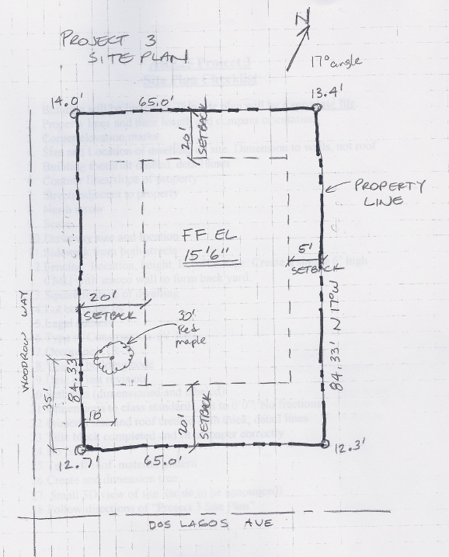
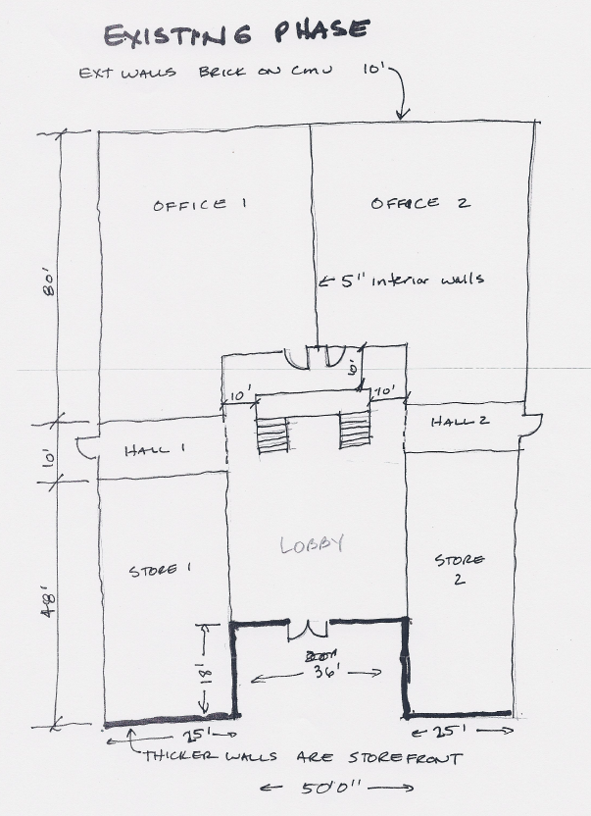
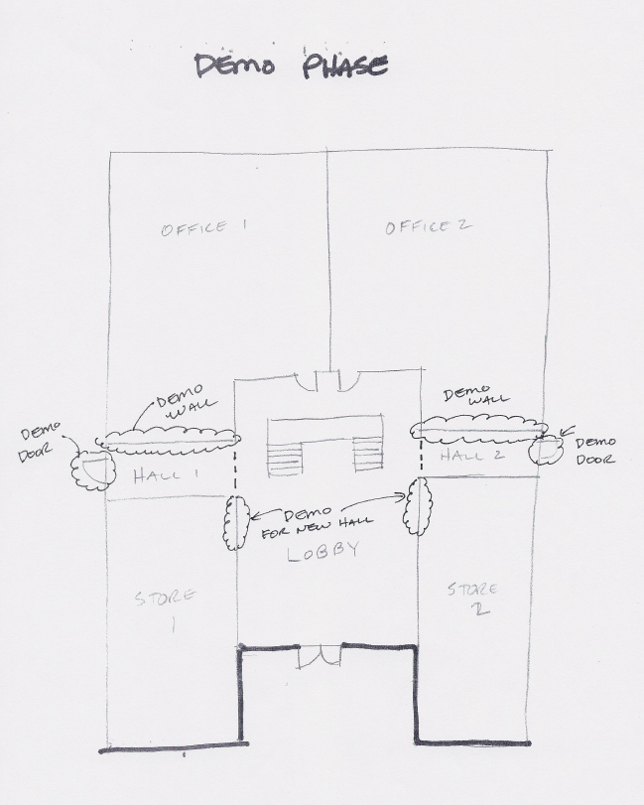
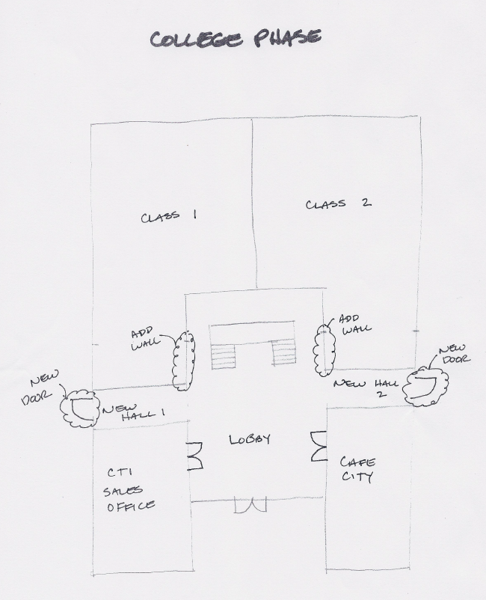
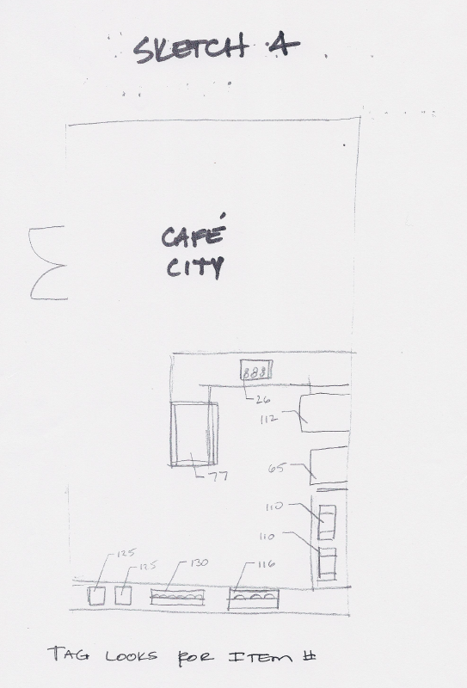
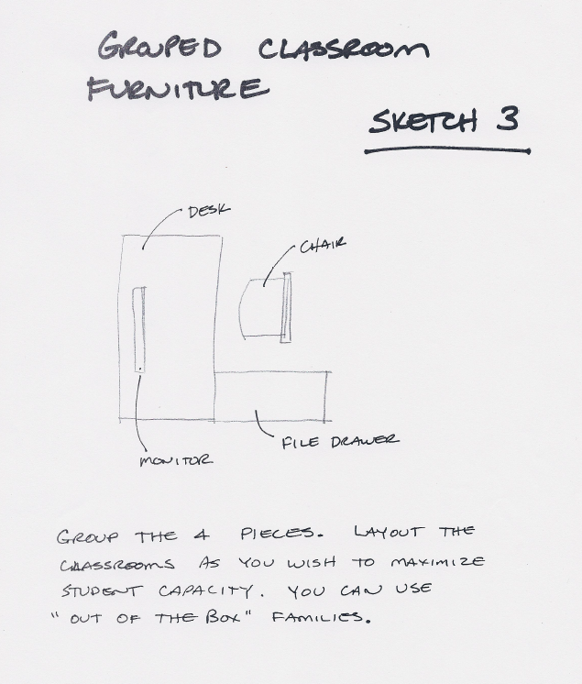

Revit Resources

Santiago Architecture’s website
http://www.green-architecture-corona.com/

Autodesk Education Community
This is where you can download Revit 2018 and AutoCAD 2018 for free. It is a 3-year license. Your computer will need at least 8 GIG RAM and a compatible video card. It takes a couple of hours…minimum.
https://www.autodesk.com/education/home

Revit City….for Revit content. (You will need to sign up….it’s FREE)
Note: you can download Revit families at Architecture…..you do not need Revit to download them. Just download to a USB drive or CD.
http://www.revitcity.com/index.php

bimobject
This is Autodesk’s place to get additional families. Families from this site are generally pretty good.
http://bimobject.com/en-us/product

AUGI-Revit
This is a great place to get your questions answered. Note the “Student Support” section!
http://forums.augi.com/forumdisplay.php?22-Revit-Student-Support

Revit User Group Inland Empire
This site will give you information about the monthly Revit User Group meetings in Rancho Cucamonga/Ontario
https://www.meetup.com/BUG-IE/

South Coast Revit User Group (SCRUG)
This site will give you information about the monthly Revit User Group meetings in Orange County
https://www.meetup.com/SC-RUG/

Big BIM Theory
This site will give you information about the monthly Revit User Group meetings in San Diego
https://www.meetup.com/Big-BIM-Theory/

Curtain Systems

Curtain systems are not walls, and they are not windows. Like walls, they can define space and separate the exterior from the interior. They are typically not load-bearing and are not cut for doors or windows. Like windows, they can usually include mullions and have glazed panels. Unlike windows, curtain systems are usually assembled on site as a single unit.

A typical curtain system comprises a wall, panel, grid lines, and mullions, and you can change these elements individually. This affects the entire curtain system. For example, to resize the system, you need to change the length of the wall. To switch panel types, you need to select a panel. To change grids, you select the grid.

You can add curtain systems with the wall command, or you can use a specific curtain system command.

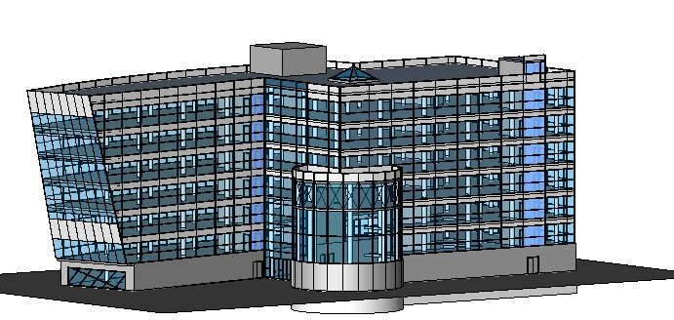

Flat Curtain System

In this lesson, you further develop the building information model by creating a flat curtain system at the entrance of the model.

Creating an Entrance

In this exercise, you create a curtain system using the wall command. This type of curtain system is also referred to as a curtain wall.

Provided Training File
■ Click File menu ➤ Open…..2014CurtainWalls.rvt
1 In the Project Browser, expand Views (all) ➤ Floor Plans, and double-click Ground Floor.
2 Zoom in to Grid F where it meets the arc in the floor.

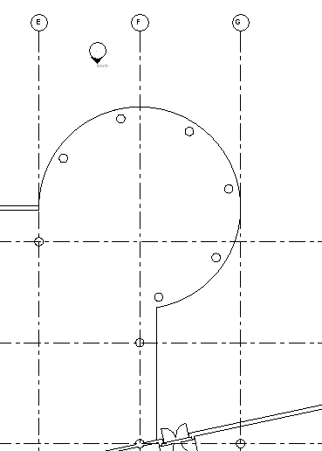

This floor edge will be the entrance to the building.

Creating a curtain system using the wall command

3 On the Architecture tab of the Ribbon, click Wall….Architectural Wall
4 In the Type Selector, select Curtain Wall: Curtain Wall 1.
5 Start the curtain system where shown.

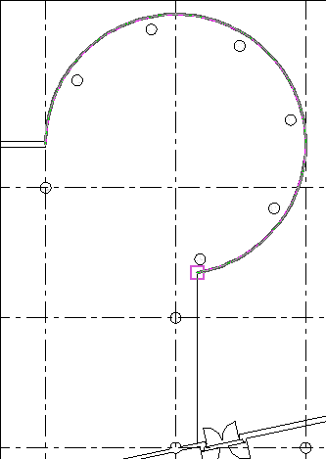

6 Move the cursor down along the edge of the floor, and finish at the outside face of the exterior wall as shown.

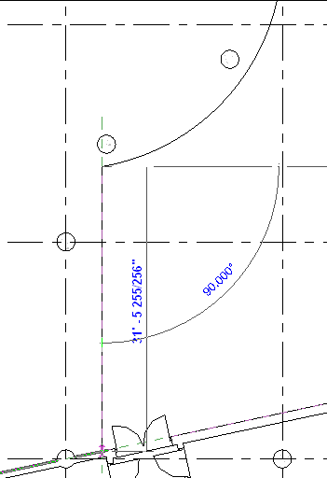

7 Zoom in to the join between the curtain system and the exterior wall.

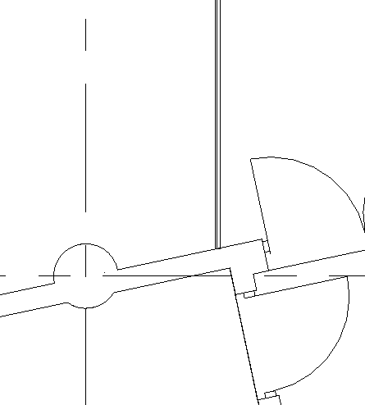

8 In the Project Browser, expand Views (all) ➤ 3D Views, and double-click Southeast Isometric.
9 View Cube: NE
10 Zoom in to the curtain system you just added.

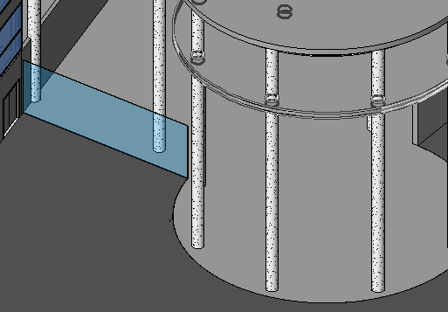

11 Select the curtain system…Properties
Note that a curtain system created from the wall command has similar properties to other walls:
base constraint, top constraint, top and base attachments, and room bounding. You want the curtain system to attach to the roof.
12 In the Element Properties dialog:
■ For Constraints ➤ Top Constraint, select Up to level: TOP OF ROOF.

■ For Top Offset, enter 4'0".

■ Apply

The curtain system is now at the same height as the other existing curtain systems.

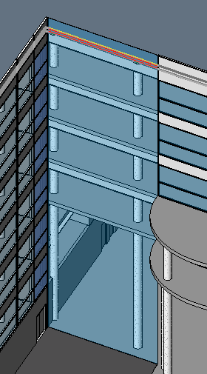

13 The curtain system is a single glazed panel; you are going to subdivide the panel into several smaller panels, using curtain grids.

Adding curtain grids

14 In the Project Browser, under Floor Plans, double-click GROUND FLOOR.
15 On the View tab of the Ribbon, click Elevation….Elevation…Building Elevation (properties)
16 Place the elevation symbol in front of the curtain wall and click Modify on the Ribbon.
17 Click the elevation arrow to display the crop boundary, and resize the crop boundary as shown.

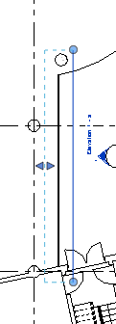

18 In the Project Browser, right-click Elevation 1 - a, and click Rename.
19 Enter Entrance Elevation, and click OK.
20 In the drawing area, double-click the elevation symbol arrow to open the new elevation view.
21 Architecture…. . Curtain Grid.
22 Move the cursor along the edge of the wall, and click to place a horizontal curtain grid 4'0" above the ground floor level line.

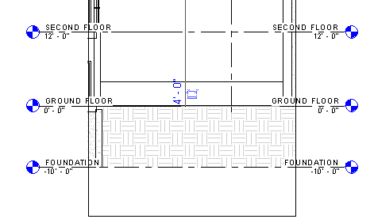

23 Place another grid 5'0" above the first grid.

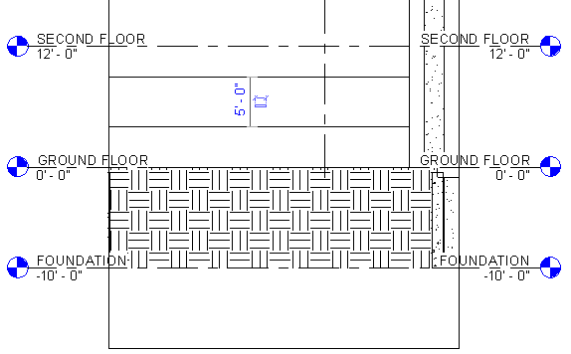

24 Place another grid so that it snaps to the SECOND FLOOR level line.
25 On the Ribbon, click Modify.
26 While pressing CTRL, select the 3 grid lines you just placed. Pick the 2nd Floor grid line first to make the process easier.
27 Click Edit menu ➤ Clipboard…Copy
28 Click Edit menu ➤ Paste ➤ Paste Alignedtoselectedlevels
29 In the Select Levels dialog, while pressing CTRL, select SECOND FLOOR, THIRD FLOOR, FOURTH FLOOR, FIFTH FLOOR, SIXTH FLOOR, and SEVENTH FLOOR, and click OK.
The selected grid lines are now at each of these levels.

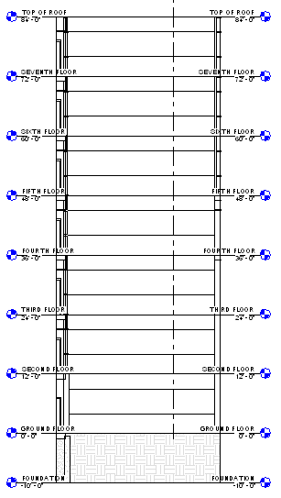

Save the file as: FirstLastCurtainWall.rvt

30 Architecture…. . Curtain Grid.
31 Place the cursor on grid 2 so that it highlights. Click to create a vertical grid.
This divides the curtain wall vertically into 2 panels, one larger than the other.

32 Move the cursor along the GROUND FLOOR level (left of the vertical grid line) until it snaps to the midpoint of the larger vertical panel. Click to place another grid line.

TIP To be sure that the curtain grid is at the midpoint of the panel, watch the tooltips and the Status
Bar.

33 Architecture…. Modify.

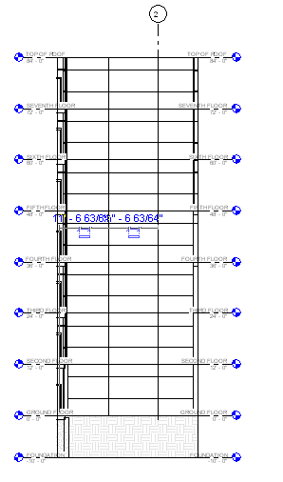

Next, you add a doorway to the curtain system. Instead of using the Door command, you set up a doorway on a curtain panel, and then you replace that panel with a curtain system door panel.

Try Placing Door
Ground Floor in Browser Architecture….Door…..Single door. Place in wall.
Did the door go in? Problem?

Adding the doorway

34 Zoom in to the ground floor level in the Entrance Elevation view.
35 Select the left vertical grid line, and on the Options Bar, click Add or Remove Segments.
You enter an editor that lets you select segments of the grid line to remove them.

36 Select the lowest segment of the left grid line, and then select the segment above it.
The segment line style changes to dashed.

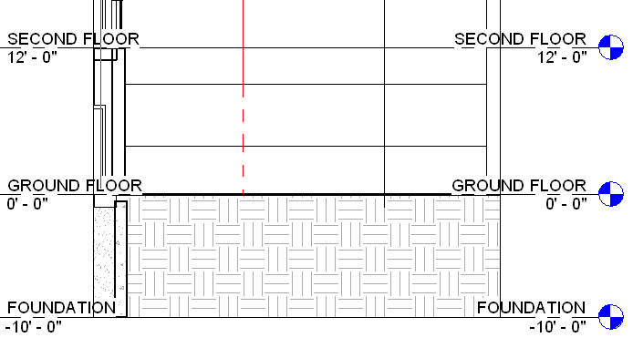

37 Click in any white space to exit the editor.
The two segments are removed.

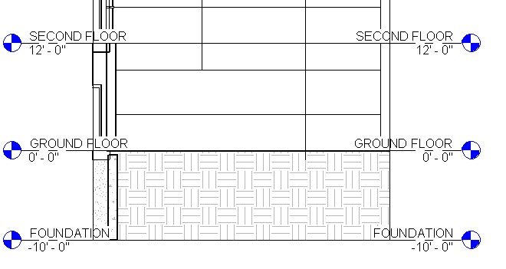

38 Using the same method, remove the horizontal segment that intersects the vertical segment removed in the previous step.

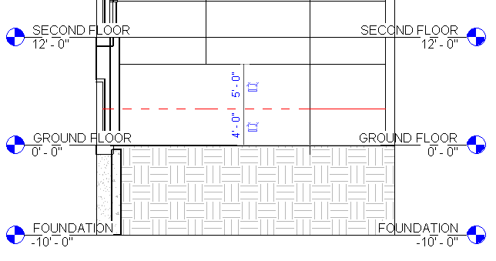

39 Architecture…. Curtain Grid.
40 On the Options Bar, select One Segment.
41 Place 4 vertical grid lines as shown.

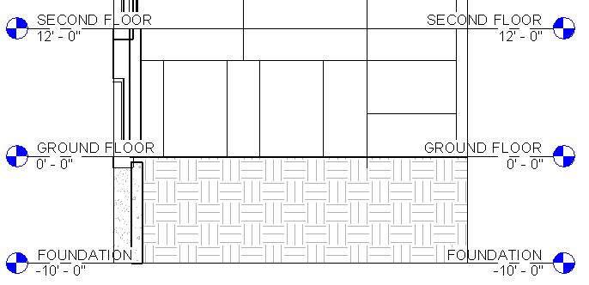

42 Place dimensions as shown. Remember, the line you pick is the line that moves. Pick the 1’6”
lines first!

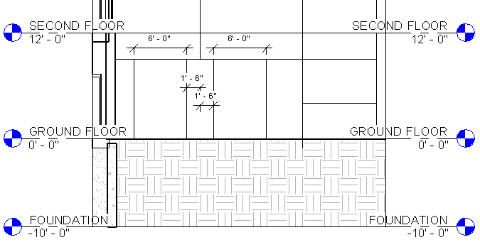

TIP You may need to adjust your zoom settings to view the dimensions.

43 Delete any dimensions.
44 You now have two 6-foot wide panels between smaller rectangular panels.

45 Select the horizontal grid line that is 4'0" above the ground floor.
46 Click Add or Remove Segments on the Options Bar.
You are going to add more segments to an existing curtain grid.

47 Click the horizontal grid line between the smaller panels. The line style changes from dashed to solid to indicate a grid segment has been added. Do not click between the 6-foot panels.
Use the following image as a guide.

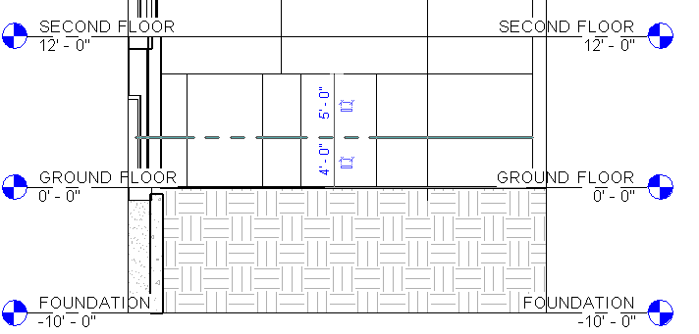

TIP The middle grid lines are centered between the long vertical grid above them. To get the horizontal grid to display between the vertical grids, click once to the right of the long grid and then click once to the left of it.

48 When the grids are placed (line style have changed to solid), click in any white space to exit the editor.

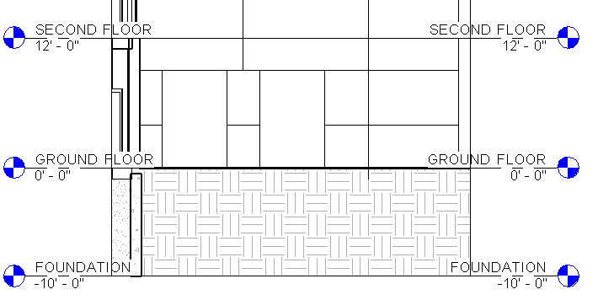

Next, you replace the 2 larger 6-foot panels with curtain system doors.

49 Insert➤ Load Family.
50 Doors….Curtain Wall-Store Front-Dbl.rfa….Open
51 Select the left 6-foot panel. You will have to press TAB to highlight it. Watch the Status Bar to be sure you are highlighting the panel.
52 On the Type Selector, click Curtain Wall-Store Front-Dbl: Store Front Double Door.
The panel changes to a double door.

53 Use the same method to replace the other panel with a double door.
54 On the Ribbon, click Modify.

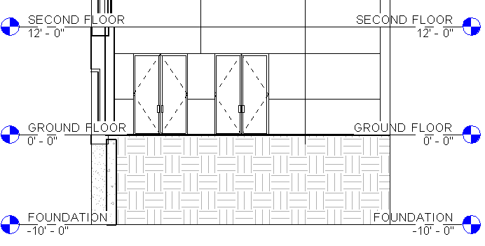

These panels schedule as doors, not as curtain panels. They are part of the curtain panel category.

55 In the Project Browser, under Floor Plans, double-click GROUND FLOOR to see the plan view door swings of the curtain wall doors.
Now, on the new curtain system you added, you replace some of the transparent panels with solid ones.

Save your file as: FirstLastCurtainWall.rvt

56 In the Project Browser, under Elevations, double-click Entrance Elevation.

57 On the View Control Bar, click , and click Shaded. This changes the graphics style of the view.
Next, you change panels in front of ceilings from glazed to solid.

Changing panels

58 Zoom in to the FIFTH FLOOR level.
59 Select one of the panels below the FIFTH FLOOR level line.

60 On the Type Selector, click System Panel : Solid.
The glazed panel is changed to a solid panel.

61 With the panel still selected, click P r ope r t i es
62 In the Element Properties dialog, click Edit/New to open the Type Properties of the panel.
The Offset property specifies the distance from the centerline of the curtain wall. Thickness specifies the depth of the panel, and Material specifies the shading and patterning.

63 Click OK twice.
64 Replace the two adjacent glazed panels with solid panels.
65 The glazed panels display in blue, and the solid panels display in white.

66 Change the remaining glazed panels in front of ceilings to solid panels.
67 A little trick! Modify….Match TypeProperties (paint brush)..Pick the solid panel….now pick the panel next to it. This avoids having to TAB TAB TAB to cycle to what you need (curtain panels. DISCUSS

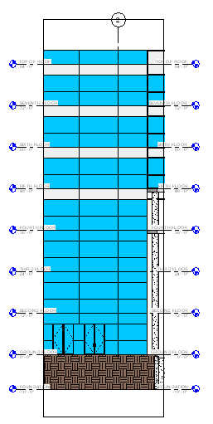

68 Save your file as: FirstLastCurtainWall.rvt
This completes the exercise for creating an entrance.

Adding Mullions to the Curtain System

In this exercise, you place mullions on curtain panel grids.

Training File: Open FirstLastCurtainWall.rvt

1 Architecture…. Mullion.
2 In Ribbon, select Grid Line Segment.
3 Place a mullion on the grid segment at the ground floor immediately to the right of the right set of doors.

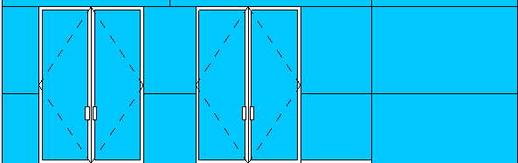

4 On the Options Bar, select Grid Line.
5 Place a mullion on the horizontal grid that is 4'0" above the ground floor.

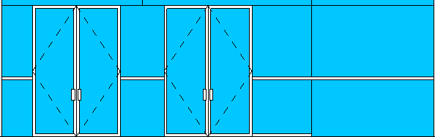

6 On the Options Bar, select All Grid Lines.
7 Place the cursor on any empty grid segment on the curtain system and click.

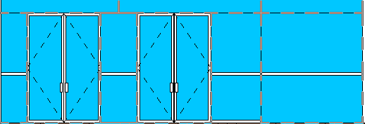

Now all empty grid segments have mullions on them; however, there are a few that you do not want, so you remove them next. The two mullions below the doors are not necessary, because their width reduces the size of the doors…..and people would trip over them entering the building!

Removing mullions

8 Zoom in to the set of doors.
9 Pick the mullion below the doors
10 Delete the mullions below them.

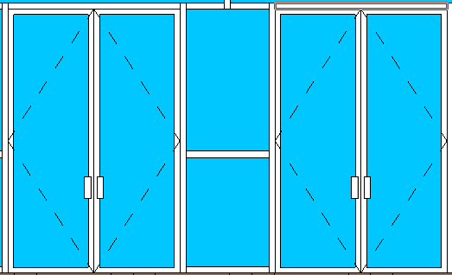

Mullions can change their joins to other mullions. You are going to change some mullion joins.

Changing mullion joins

11 On the View Control Bar, click Model Graphics Style ➤ Hidden Line.
12 Select the vertical mullion above and between the set of double doors.

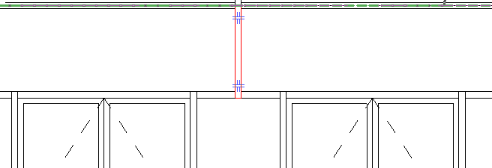

Two mullion join controls display.

13 Click the lower mullion join control.
The bottom of the mullion meets the top of the horizontal mullion.

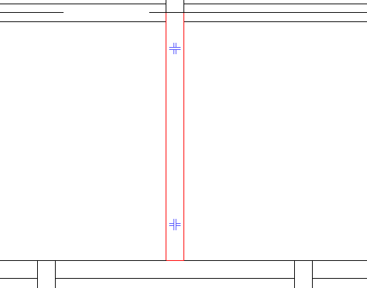

14 Click the top mullion control.

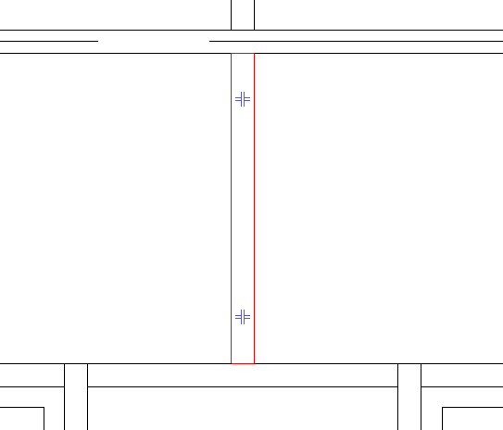

The top of the vertical mullion now meets the bottom of the horizontal mullion above.

TIP After selecting the vertical mullion, you can also right-click, and click Join Conditions ➤ Break at
Join to break the mullion at both joins.

15 On the Ribbon, click Modify.
16 In the Project Browser, double-click Southeast Isometric.
17 Save the file.

This completes the exercise for adding mullions.

This also completes the lesson on creating a flat curtain system. You learned how to create a basic curtain wall system and how to subdivide it with grids. You also learned how to modify grids and change panels. Finally, you learned how to add mullions and change their joins.

Save your file as: FirstLastCurtainWall.rvt

Curved Curtain System

In this lesson, you create a curved curtain system near the entrance of the model that was just completed. You also create a custom curtain panel for the system. Finally, you add both predefined and custom mullions to the system.

Adding a Curved Curtain System

In this exercise, you add a curtain system using the wall command. The curtain wall is sketched as an arc.

Training File: Open FirstLastCurtainWall.rvt

1 In the Project Browser, under Floor Plans, double-click GROUND FLOOR.
2 Zoom in to the circular space above the entrance that was just completed.
3 On the Architecture… Wall.
4 In the Type Selector, select Curtain Wall : Curtain Wall 1.

5/6 Properties (yea…I skipped a number…)
■ Under Constraints, for Top Constraint, specify Up to level: FIFTH FLOOR.

■ For Top Offset, enter 4'0".

■ Click Apply

7 On the Ribbon, click (Arc Start-End-Radius).
8 Start the wall by clicking at the left edge of the circle at the centerline of the intersecting wall.

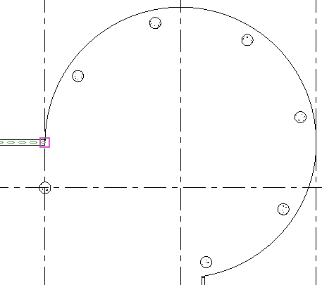

9 Place the second point at the lower right side.

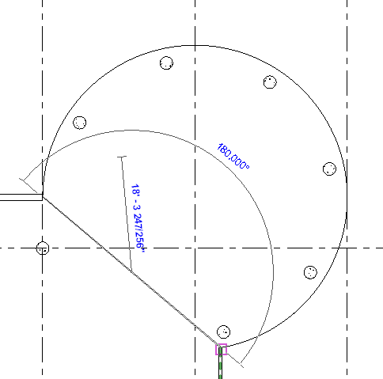

10 Finish the wall by clicking at the top of the arc.
(look for midpoint…like an OSNAP)
Check it out in 3D. See the arc wall? NO?

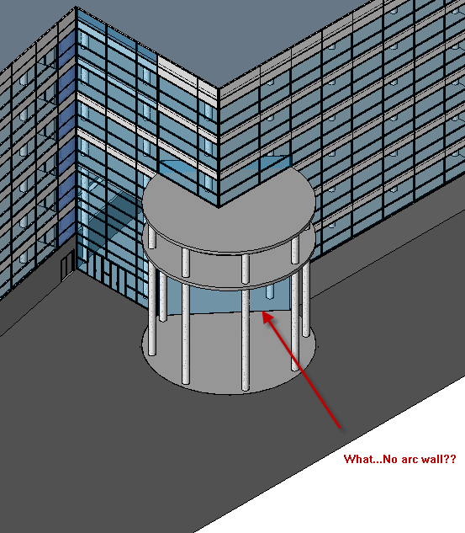

Back to Ground Floor

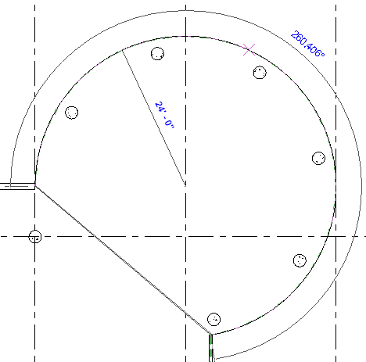

The curtain wall displays as one flat panel between the first and second points placed. Next, you place grids on the system. The curtain grid command snaps only to the curved arc. You are going to use one of these snaps points.

11 Architecture….Curtain Grid.
12 Snap the cursor to the midpoint of the curved arc and click. Watch the Status Bar at the bottom left corner of the screen to ensure you are at the midpoint.

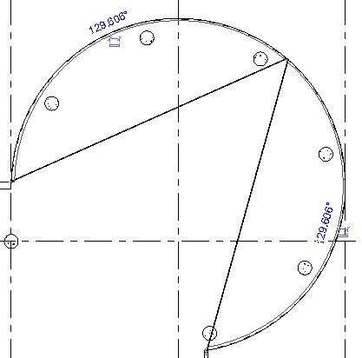

13 Continue to place more grids by using the snap points on the arc. Divide the halves into quarters, eighths, and then sixteenths. It gets easier as you attempt smaller segments.
14 In the Project Browser, under Elevations, double-click East.
15 Zoom in to the cylinder, and snap the cursor to each level line and click to add horizontal curtain grids. Do not add a grid on the GROUND FLOOR level.
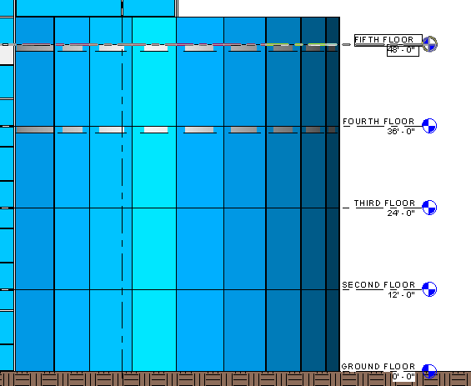

16 Next, you change some panels in the system.

Using walls as panels

17 Using a selection box, select the bottom layer of panels. Remember to click to filter out all other elements from the selection except Curtain Panels.
18 In the Type Selector, select Basic Wall: Generic - 12" .

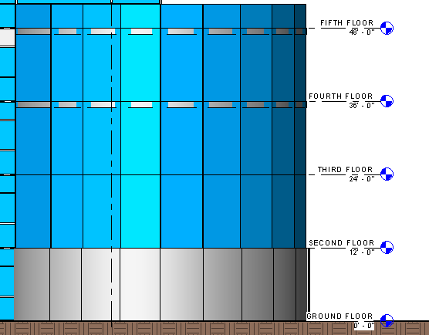

19 Save as: FirstLastCurtainWall.rvt

This completes the first exercise for creating a curved system. Next you create a custom panel and add it to the system.

New Features in Revit 2018

Railing hosted to Topography

Collaboration for Revit (work-sharing on the cloud)

Schedule Groups and Links

Global Parameters

Multi-story stair improvements (you can connect stairs to the levels)

“SDS2 Connect” Share your SDS2 Model with Revit. Sorry, connections do not come in

https://www.autodesk.com/products/revit-family/features

